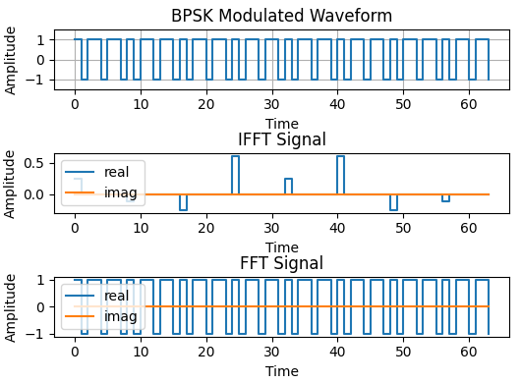

binary_sequence = np.full(length, 73)　 =>0100_1001

data_bpsk i_data_bpsk(

. decimal_data(8'b10010010),

. encoded_data(BPSK_wave)

);