**Windows Mixed Reality 6 DOF**

**Controller Non-hand-held Application**

**Document: H0XXXXX**

**Revision: A**

**Date: 6/1/2018**

Distribution:

**Internal Only**

**External All**

**External Restricted If restricted, specify restricted to whom:**

|  |
| --- |
|  |

Microsoft Confidential Statement

This document is considered confidential to and is maintained as trade secret by Microsoft Corporation. This document is disclosed pursuant to a non-disclosure agreement and/or other written agreement between the recipient and Microsoft Corporation (collectively, the “Agreement(s)”). Information in this document is restricted to Microsoft authorized recipients only and any reproduction, distribution, or public discussion of this material is subject to the limits described in the Agreement(s) with Microsoft Corporation.

Microsoft and its suppliers may have patents, patent applications, trademarks, copyrights, trade secrets and/or other intellectual property rights covering subject matter in this document. Microsoft’s furnishing of this document to recipient does not grant or imply any license to any patents, trademarks, copyrights, trade secrets or other intellectual property rights, and recipient’s permitted use of any such intellectual property rights, if any, is solely governed by the Agreements.

©2009, ©2010, ©2011, ©2012, ©2013, ©2014 Microsoft Corporation. All rights reserved.

Microsoft, Windows, Windows Media Center, Windows Server 2003, Xbox, Xbox 360, Xbox Live are trademarks of the Microsoft group of companies.

All other trademarks, if any, are property of their respective owners.

Table of Contents

Microsoft Confidential Statement 2

1 Introduction 5

Purpose 5

Use of this Document 5

Product Description 5

Product Features 5

2 Theory of operation 6

Mechanical Design 6

Electrical Design 6

Constellation Tracking 7

3 Controller Prop usage 7

Tracking System Guidelines 7

Prop Mounting Location 7

Mechanical 7

Electrical 8

Bluetooth Radio Guidelines 8

Host System 8

APPENDIX 1 9

**Revision History**

|  |  |  |  |
| --- | --- | --- | --- |
| Revision | Date | Description | Author/Revised by |
| A | 1 June 2018 | Initial Draft | timhober |
| B | 4 June 2018 | Revision based upon Dev feedback | timhober |
| C |  |  |  |
| D |  |  |  |
| E |  |  |  |

# Introduction

## Purpose

The purpose of this document is to provide the basic theory of operation of the Windows Mixed Reality 6 degrees of freedom (6 DOF) controller for non-hand-held applications. This document will also provide guidelines for controller non-hand-held applications.

## Use of this Document

This document is intended for use by individuals and/or companies intending to use Windows Mixed Reality 6 DOF controller for non-hand-held applications. The controller was originally designed as a hand held only device, however, after manufacturing release non-hand-held applications were requested by individuals and companies wishing to use the controller to track props in with Windows Mixed Reality systems. This document is intended to help guide individuals and/or companies incorporate the controller for this application.

## Product Description

The Windows Mixed Reality 6 DOF controller was created with the intention to provide for command, control, and hand tracking for the Mix Reality ecosystem. It is intended to be used only with Windows Mix Reality Head Mounted Devices (HMDs).

## Product Features

* High level features include:
  + Bluetooth Classic Wireless Radio
  + Capacitive Touch Pad with click input
  + Thumbstick with click input
  + Analog Trigger
  + Grip Button
  + Menu Button
  + Home Button
  + Bluetooth Pairing button
  + Haptic (Motor with rotating mass)
  + IMU (inertial measurement unit)
  + Dual AA battery powered
  + Constellation ring used for Tracking
* Usage
  + Maximum of 2 controllers per Windows Mixed Reality HMD
  + For best performance, at least 6 LEDs per controller visible to HMD camera in any usage orientation
* Operating Environment
  + Within 1.1 Meters within line of sight of the Windows Mixed Reality HMD.
  + Connected via Bluetooth radio to Windows Host
  + 2 Meter range from any other Windows Mixed Reality HMDs

# Theory of operation

## Mechanical Design

The Windows Mixed reality 6 DOF controller consists of three main mechanical elements; Constellation Ring, Input Controls, and Handle.

The constellation ring has 32 LEDs, 18 outside and 14 inside the ring. Two cameras on the Windows Mixed Reality HMD are used to visually track the constellation. The constellation has no external mounting or attachment features. The constellation is attached to handle via an arm. This arm is designed to hold the constellation in a specific location relative to the IMU located on a PCBA in the handle during use. The arm is designed to allow the constellation to move but return to the desired location after impact to the handle and/or constellation. It is not intended to carry any other mechanical loading.

The inputs for command and control are located on the handle. The controls consist of thumbstick with click, capacitive touch pad with click, hall effect trigger, and buttons. The buttons consist of Menu, Home, Grip, and Bluetooth pairing. The thumbstick has a cap to improve ergonomics.

The handle houses the controls, constellation attachment arm, batteries, battery door, PCBAs, haptic motor, and lanyard attachment. The handle is intended for hand gripping to hold the controller during use. The input control elements are located for thumb and finger actuation and usage.

## Electrical Design

The controller has two main electrical elements; Constellation LEDs and control boards.

The ribbon cable is housed in the constellation ring and provides mechanical and electrical attachment of the LEDs to the internal portion of the ring.

The control board(s) located in the thumbstick and capacitive touch pad area and contains the hall effect sensor for the trigger button, Bluetooth radio IC, Bluetooth antenna, some inputs, and captivity touch PCBA. The antenna is located between the thumbstick and the outside skins. The main board contains some input buttons and the IMU. The IMU uses a combination of accelerometers and gyroscope to help with tracking and controller orientation.

The electronical boards are provided power via 2 standard AA batteries located in the handle.

## Constellation Tracking

The constellation ring has 32 LEDs, 18 outside and 14 inside the ring. Two monochrome cameras located within the Windows Mixed Reality HMD are used to visually track the constellation. For best performance, at least 6 LEDs must be visible to at least one of the cameras at all times in any usage orientation. In the event that less than 6 LEDs are visible, the system can temporarily track the controller using the LEDs visible (if any) and the IMU data.

# Controller Prop usage

## Tracking System Guidelines

For the Windows Mixed Reality tracking system to work as designed the following is recommended:

* Reliable wireless connection between the Windows Mixed Reality controller(s) and Windows host Bluetooth radio
* IMU operation not incumbered by external elements in the proximity of the controller(s)
* At least 6 LEDs per controller viewable by at least one HMD camera at all times in any usage orientation
* Constellation within 1.1 meters of at least one HMD camera at all times within 170-degree FOV
* No other Windows Mixed Reality Controller(s) not paired to the HMD with in a 2 meter range
* Proper power (2 AA batteries) provided to the controller

## Prop Mounting Location

The controller mounting location on the prop should follow the above tracking system guidelines. Additionally, the location should insure that the controller and constellation ring is not damaged during usage, storage, prop drop, or misuse. Additionally, the location should insure there is not controller impact with environmental walls, floor, individuals, and other objects during use and storage.

## Mechanical

The constellation and handle have no external mounting or attachment features. The arm connecting the constellation ring and the handle was only designed to handle the mechanical loads from usage of the controller in hand held applications. The arm is designed to hold the constellation in a specific location relative to the IMU located on a PCBA in the handle during use. Care must be taken to preserve this geometry when the controller(s) is in use.

Should an external mount be desired, it is recommended that a sleeve be created to insert the handle into and hold the controller(s) in a safe manner and without damaging the controller(s) or interfering with the operation of the constellation ring, Bluetooth radio, IMU, and inputs. Any external mount should keep the controller from unintentionally coming out of the mount or the mount coming off the object is mounted upon. Mechanical CAD files of the controller(s) may be provided by the controller manufacture (ODM) and/or the reseller (OEM) the purpose of creating a controller holder/mount.

## Electrical

The electrical design has no features to allow external electrical connection to it. If an external power source for the controller is desired, it is possible to create a replacement element (battery blank) for the controller which replaces the AA batteries and provide power. Microsoft cannot provide any mechanical files for the creation of this battery blank.

## Bluetooth Radio Guidelines

The Bluetooth Classic 4.0 radio is used to transmit inputs from the controller and IMU data to the Windows Mixed Reality ecosystem. Due to the type of data and latency needed, a Bluetooth classic radio is used. The Windows host should have a Bluetooth Classic 4.0 radio to communicate with the controller(s). Please refer to online support Mixed Reality Bluetooth radio guidelines for host radio recommendations.

Please note, that care must be taken to not have elements like metal near the Bluetooth radio antenna which will affect its performance. Additionally, too many 2.4 Ghz (Bluetooth) radios operating within close proximity to one another can cause interference between radios.

## Host System

The host system should be running Windows 10 Creator’s edition or new with a Bluetooth Classic 4.0 radio. For PC and OS guidelines, see the online support pages for Windows Mixed Reality systems (<https://support.microsoft.com/en-us/help/4039260>).

## APPENDIX 1

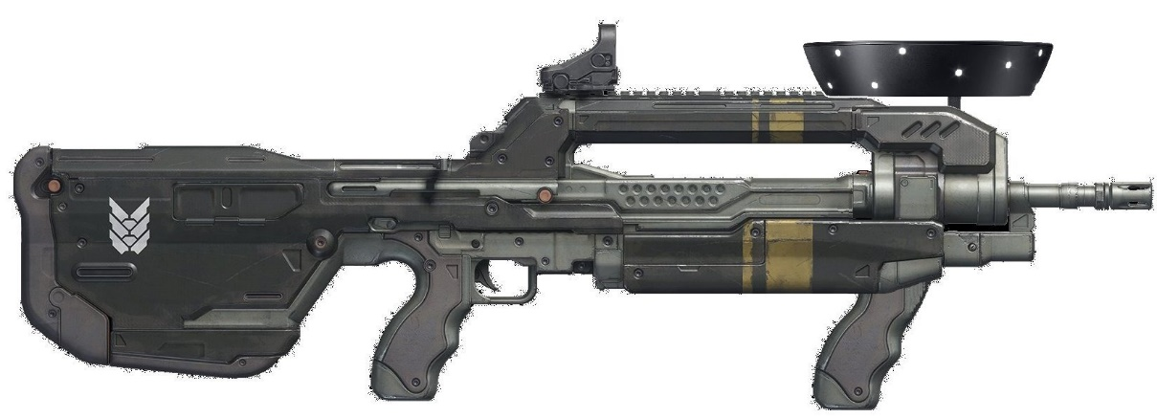

Figure 1: Possible Controller integration into a Prop

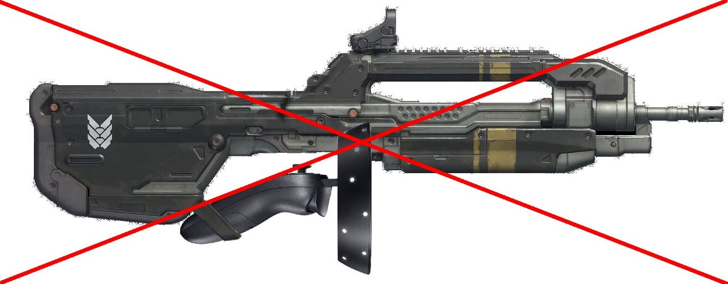

Figure 2: Not recommended Controller integration into a Prop