Testing EtherCAT using TwinCAT 3 and Visual Studio
Go to P21xx folder location (e.g. C:\Manufacturing\Firmware\PMFC_ECAT\P21xx)
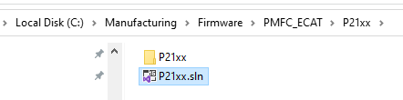
Double click on P21xx.sln to run Visual Studios.
On the right-hand side panel, select Device the right-click and select Scan
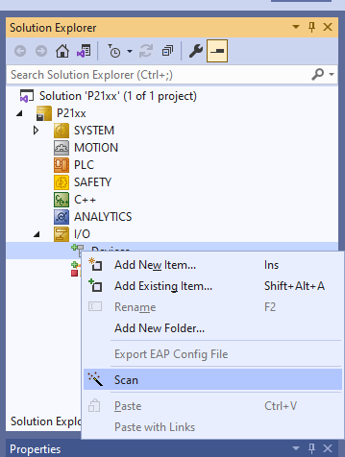
Select the Ethernet card to scan then click OK.
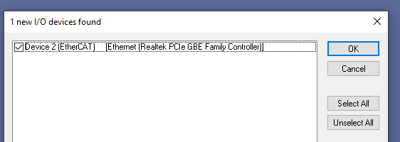

Click on OK on next information box
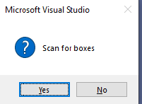
Click on OK to activate Free Run mode
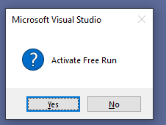
Once connection is established an no errors were reported, Solution Explorer window will look like this. The device is found as Box 1
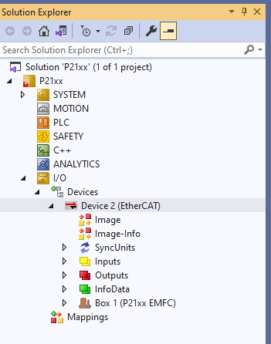

Double click on Box 1 (P21xx EMFC) icon. A new window will pop up. Verify that the readings are updating continuously.
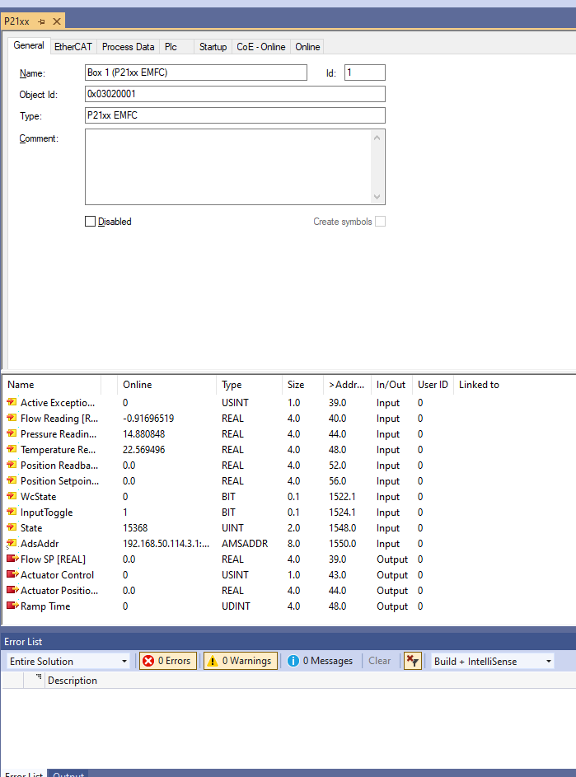

Close the entire application when done. Note: do not save the project file when prompt to do so

