**产品规格书**

**Specification**

**产品名称: UHF实时温度检测电子标签**

**Part-Name: UHF Current Temperature RFID Tag**

**产品型号Part-Number： RFID-TPG106**

**尺寸 Dimensions**

天线尺寸Antenna Size 93X19mm(±0.2mm)

标签尺寸Tag Size 98X24mm (±0.5mm)

成品跳距Product Skip Distance 30.0±0.4mm

成品边距Product Margin 4.0±1.0mm

卷料宽度Width of the Tape 106±1.0mm

**产品特性 Product Features**

衬底基材Substrate Material 聚酯薄膜Polyester Film（PET ）

天线材料Antenna Material 铝蚀刻Aluminum Etching

表面材料Surface Material 防水Waterproof Brittle Paper

外观特性Characteristics 乳白色标签 Milky white label

工作频率Operating Frequency 860MHZ～960MHZ

工作协议Protocol EPC Gen2v2 and ISO/IEC 29167-10

TID：112-bit

芯片内存容量 EPC：192-bit

Memory Capacity User：File_0 with 512-bit of data

Reserve: 112-bit

Secure segment with 512bit, 256bit for keys and 256bit for

data of P63 protocol (AES128 authenticate)

工作模式Operating Mode 清点或读写Inventory Read or Write

读写距离Read and write range ≥3 M

温度测量范围Temperature Measure -400C-850C

测量精度Temperature Accuracy ±0.50C(Typical)/± 0.1°C(Specific Calibration)

重复编程次数Programming Cycle100,000 cycles

个性化编码Personalized Coding 支持多种数据结构的内外组合编码方式（可 同步或离线式编码）；支持个性化密钥编码 Supporting multiple data structure of inside and outside combinatorial encoding（can be synchronous and offline encoding）；Supporting personalized key code

**环境参数Environmental Parameter**

数据保存Data EEPROM Retention: 10 years

静电保护ESD Voltage Immunity: ± 2KV

工作温度Operating Temperature -40℃～85℃

储存温度Storage Temperature 0℃～25℃

操作湿度Relative Humidity: 10% ~ 95%(As Less Reading As More Humidity)

**包装资料Packing Details**

卷数量Volume Number 1000～2000pcs/roll (依实际需求而定)

(According to actual demand)

包装材料Packing Material 防静电珍珠棉+气泡垫+防静电袋+外纸箱

Anti-static PE + Foam stuff + Anti-static Bag

**应用Application**

广泛应用于供应链，冷链，集装箱，物流，交通，运输等过程中的食品/药品/生鲜物品产品标识、温度检测，方便质量跟踪和溯源监管。

Widely used for items identification during the transportation, supply chain, Cold chain, Container, Logistics, cargo shipment, especially monitoring temperature control food/medicine/pharmacy/fresh items quality in sight, ongoing quality management, source traceablity & supervision management.

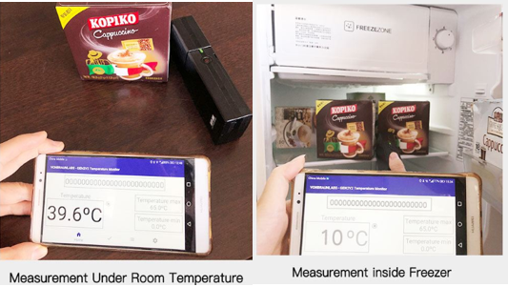

**参考图片 Reference Pictures**

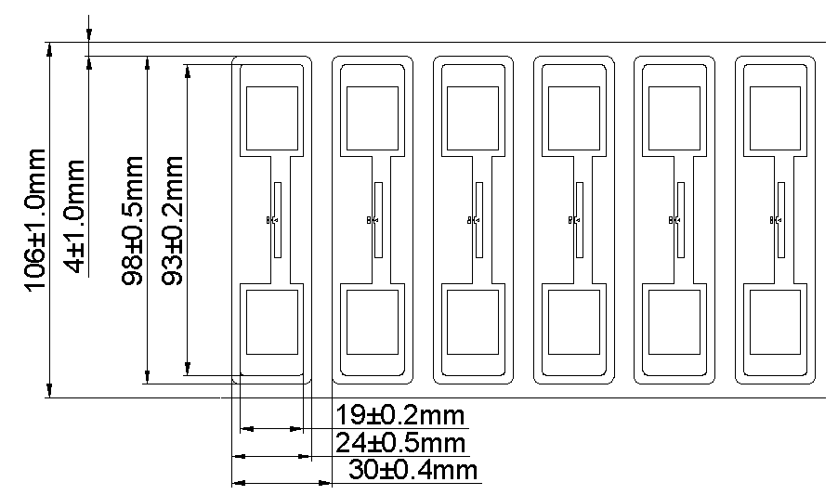

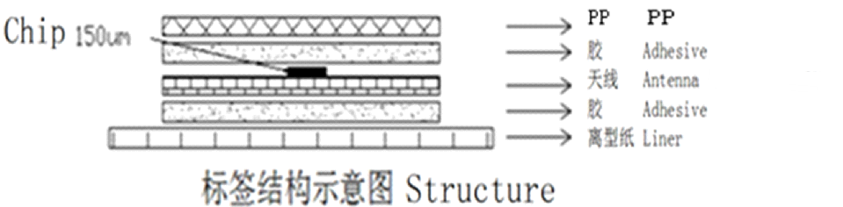=

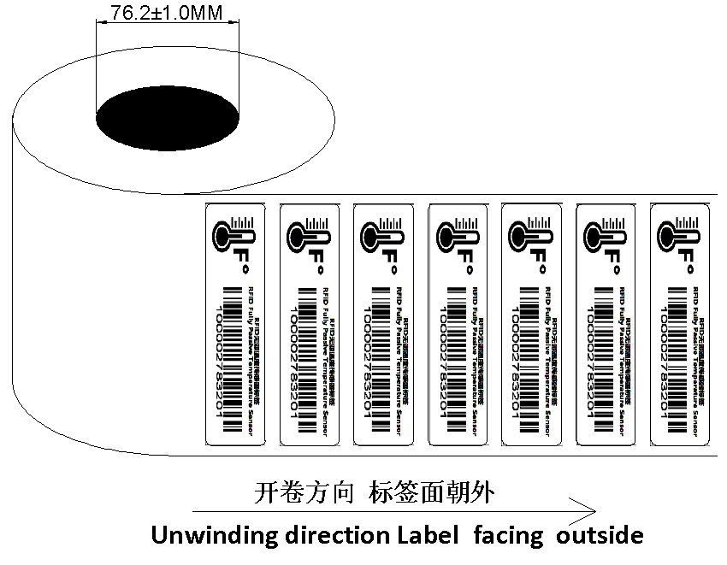

**性能曲线参考图Reference of Graphic Performance**

