**Flash SII on LAN9252 using EtherNET**

Apply power to EtherCAT board and connect Ethernet cable (CAT5 or CAT6) to any port of the board (on one end) and to any Ethernet port on PC. POWER LED should be ON. Once both ends of the cable are connected, verify that Link/Act LED is ON.

Power

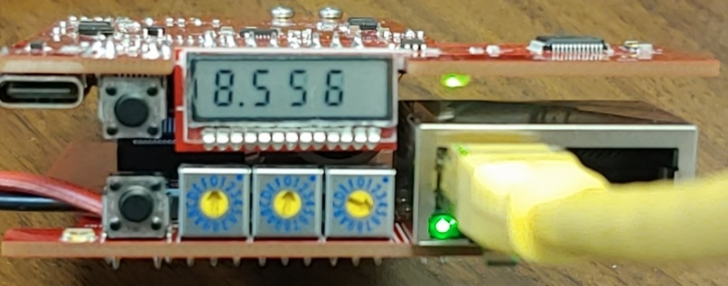

Link/Act

CAT5/6

Run SII EEPROM Programmer. Software should be under ***EtherCAT Slave Stack Code Tool***

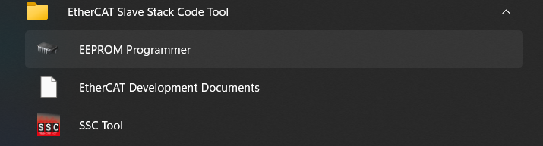

Click on *Slaves->Scan* or hit F5.

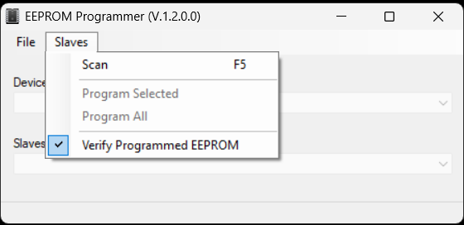

Select the Network card the device is connected to.

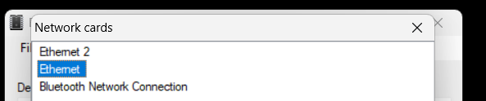

If successful, there should be 1 EtherCAT slave found indicated at the bottom status bar

Click on *File->Open* and load *P21.xml*. Once loaded, click on *Slaves->Program Selected*

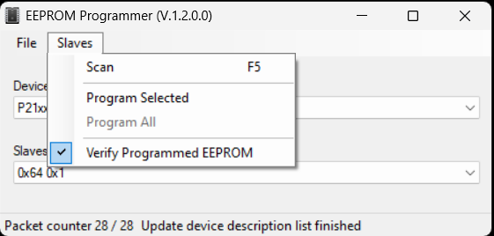

A wait instruction is displayed on the status bar.

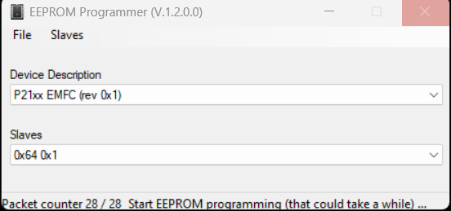

Once completed status bar will display the following:

Power Cycle the Device