Revised Causal Loop Diagram with Delays
EV Supply Chain ABM + SD Model

1. Analysis of the Previous Causal Loop Diagram
The earlier causal loop diagram correctly captured the main reinforcing and balancing feedbacks: demand pull, inventory replenishment, mineral scarcity pricing, and backlog catch-up. However, it was too instantaneous. The available model data show that delays are not secondary details; they are central mechanisms that explain overshoot, backlog persistence, and delayed recovery after shocks.
- Tier-1 lead times differ substantially: battery packs use a 4-week lead time, harnesses 6 weeks, motors 12 weeks, and inverters 16 weeks.
- Safety stocks also differ: harness inventory is lean at 2 weeks, while SiC-related inverter buffers are much larger.
- Financial calibration changes recovery speed, growth, buffer capacity, and shock absorption by agent.
- Capacity expansion is structurally delayed because investment, construction, qualification, and ramp-up cannot occur within one weekly step.
- Price signals reduce demand with a lag because commodity prices must pass through component costs, vehicle prices, and consumer purchasing decisions.

2. Revised Delay-Aware Causal Loop Diagram
The revised diagram adds explicit pipeline, capacity, and market-response delays. The symbol || marks delayed causal effects.
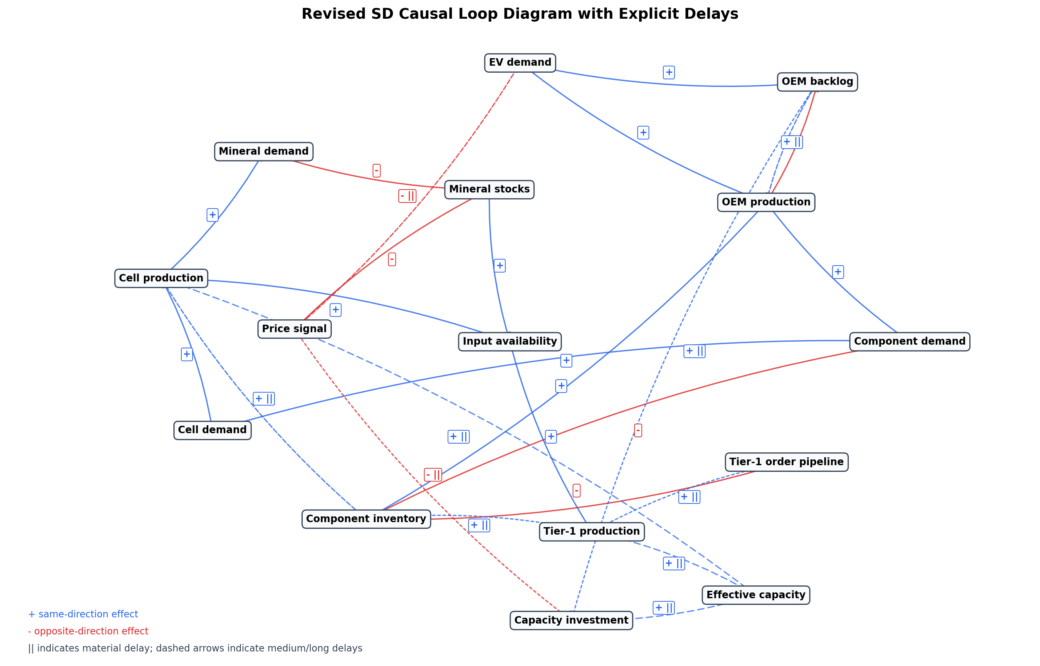

3. Revised Feedback Loop Interpretation
Loop | Description | Type | Delay interpretation
B1 - Scarcity price balancing loop | Mineral demand depletes mineral stocks; lower stocks raise the price signal; higher prices reduce EV demand; lower demand reduces mineral demand. | Balancing | Demand response is not instantaneous; price pass-through and purchasing decisions create a medium delay.
B2 - Inventory replenishment loop | Component demand reduces component inventory; low inventory triggers orders; orders move through the Tier-1 pipeline; production replenishes inventory. | Balancing with delay | Lead-time delays can create overshoot and oscillation, especially with bullwhip ordering.
R1 - Backlog pressure loop | EV demand increases backlog; backlog raises desired OEM production; production reduces backlog only if components are available. | Reinforcing until constrained | The loop is constrained by component inventory and input availability.
R2 - Capacity expansion loop | Backlog and demand encourage investment; investment increases effective capacity after a long delay; capacity supports higher production. | Reinforcing with long delay | Long construction and qualification delays mean the loop cannot solve short-run shocks.
B3 - Financial/investment discipline loop | Price pressure and weak margins reduce investment willingness; lower investment slows capacity growth and keeps bottlenecks binding. | Balancing / constraint loop | This loop links the new listed-company financial calibration to SD capacity dynamics.

4. Revised Causal Link Register
From | To | Polarity | Delay | Interpretation
EV demand | OEM production | + | short | Higher demand raises desired vehicle output.
EV demand | OEM backlog | + | short | Demand not immediately fulfilled accumulates as backlog.
OEM production | OEM backlog | - | short | Production fulfils orders and reduces backlog.
OEM backlog | OEM production | + | medium | Backlog creates catch-up pressure, limited by component availability.
OEM production | Component demand | + | short | Each vehicle requires packs, inverters, motors, and harnesses.
Component demand | Component inventory | - | short | Component use draws down inventory.
Component inventory | OEM production | + | short | Higher component inventory enables more vehicle output.
Component inventory | Tier-1 order pipeline | - | short | Low inventory triggers replenishment orders and bullwhip amplification.
Tier-1 order pipeline | Tier-1 production | + | delayed | Orders translate into production and deliveries after lead times.
Tier-1 production | Component inventory | + | delayed | Subsystem output replenishes component inventory after production/logistics delay.
Component demand | Cell demand | + | short | Battery pack demand pulls cell demand.
Cell demand | Cell production | + | short | Cell makers respond to demand subject to minerals and capacity.
Cell production | Component inventory | + | medium | Cell output supports pack availability.
Cell production | Mineral demand | + | short | Cell production consumes lithium, cobalt, graphite, and related materials.
Mineral demand | Mineral stocks | - | short | Material consumption draws down mineral stocks.
Mineral stocks | Input availability | + | short | Higher stocks improve input availability fractions.
Input availability | Cell production | + | short | Low mineral availability constrains cell output.
Input availability | Tier-1 production | + | short | Low REE or SiC availability constrains motor and inverter output.
Mineral stocks | Price signal | - | short | Lower mineral stocks increase scarcity price pressure.
Price signal | EV demand | - | medium | Higher prices reduce demand through elasticity with market response delay.
OEM backlog | Capacity investment | + | delayed | Persistent backlog encourages capacity expansion.
Price signal | Capacity investment | - | delayed | High input prices discourage or defer investment.
Capacity investment | Effective capacity | + | long | Investment becomes usable capacity only after construction/ramp-up.
Effective capacity | Cell production | + | long | More effective capacity lifts output potential.
Effective capacity | Tier-1 production | + | long | More effective capacity lifts subsystem output potential.

5. Delay Register Based on Available Model Data
Model element | Delay parameter | Buffer / safety stock | How it affects system behaviour
Tier-1 battery_pack | 4 | 3 | Order pipeline and subsystem replenishment delay.
Tier-1 inverter | 16 | 8 | Order pipeline and subsystem replenishment delay.
Tier-1 motor | 12 | 6 | Order pipeline and subsystem replenishment delay.
Tier-1 harness | 6 | 2 | Order pipeline and subsystem replenishment delay.
Mineral lithium | shock recovery dependent | 4 | Inventory buffer delays downstream shortage propagation.
Mineral cobalt | shock recovery dependent | 6 | Inventory buffer delays downstream shortage propagation.
Mineral graphite | shock recovery dependent | 4 | Inventory buffer delays downstream shortage propagation.
Mineral ree | shock recovery dependent | 8 | Inventory buffer delays downstream shortage propagation.
Mineral sic_wafer | shock recovery dependent | 12 | Inventory buffer delays downstream shortage propagation.
Cell makers | weekly capacity growth, shock recovery | 4-6 typical | Capacity and inventory response varies by firm financial profile.
OEM groups | weekly backlog catch-up | 3-6 typical | Backlog creates pressure but production is component constrained.

6. Modelling Implications
- The harness loop is fast to disrupt because safety stock is low, even though nominal lead time is shorter than inverters.
- The inverter loop is slower but more persistent because SiC supply and 16-week lead time create delayed replenishment.
- Backlog is not automatically stabilizing. It can reinforce demand pressure until component stocks or price signals constrain production.
- Financially stronger firms should recover faster and absorb shocks, but this does not remove physical lead-time delays.
- Capacity investment should be modelled as a delayed stock or pipeline rather than an immediate increase in weekly capacity.

7. Recommended Model Revisions
- Add explicit capacity-investment pipeline stocks for cells, inverters, motors, and OEM assembly.
- Separate order placement from delivery for cell suppliers, not only Tier-1 suppliers.
- Report effective delay by subsystem in every shock scenario.
- Use financial profiles to affect recovery and investment rates, while keeping physical lead times as independent constraints.
- Track backlog age, not only backlog size, to distinguish temporary demand accumulation from persistent unmet demand.

8. Current Model Scale
Model object | Count
Mineral groups | 5
Cell makers | 9
Tier-1 subsystem groups | 4
OEM groups | 7

