Northern Ireland Circular Minerals — Integrated Model Report
Prepared for: Department for the Economy (DfE) minerals & circular-economy consultation
Subject: an integrated Agent-Based × dynamic Input–Output × Computable General Equilibrium (CGE) model of the Northern Ireland minerals system, and its answers to consultation questions 2.1–2.7.
Status: Tier-3 (fully coupled), validated against the Minviro evidence and the NI baseline, CI-checked (58-check harness).
How to read this report. This is a *policy-scenario simulator*, not a forecasting tool. Real, sourced anchors are used for validation and control totals; most economic-structure coefficients and behavioural parameters are proxy values, flagged in model/data/data_register.csv. Every figure below is model behaviour under stated assumptions — not a prediction. Swapping the proxies for collected NI data (same model interfaces) turns this into a calibrated decision tool.
This report has three parts, matching the request:
- How the model is built — methodology, technical detail, the supply-chain structure & key players, and validation results.
- Data & assumptions — what data built the model and what was assumed about it.
- Answers to the seven questions — for each, the experiment logic, the data used, the results (tables/figures), and how the results produce the answer.

Part 1 — How the model is developed

1.1 Purpose and approach
The model simulates the NI minerals system end to end and asks not "mining *vs* recycling" but which mix of primary extraction, recycling, substitution, circular design, imports and public support delivers the best balance of supply resilience, GVA, employment, environmental protection and community acceptance:
primary extraction → processing/refining → manufacturing use → in-use stock
→ end-of-life arisings → collection → recovery/recycling → secondary material
→ (imports/exports close the balance)
- Horizon: 30 years (2026–2055), discounted at the HM Treasury / NIGEAE Social Time Preference Rate of 3.5%.
- Coupling style: *soft-linking* — the engines run sequentially on an annual step, passing objects between them. This is the debuggable, independently-validatable choice (vs simultaneous solving).
- Grounding: the agents are named NI firms (21 of them) and every policy lever maps to a named real-world instrument (NWF/UKEF, BICS, EU CRMA strategic-project route, etc.).

1.2 The NI minerals supply chain and its key players
The model is populated from a register of 21 named NI operators (company_register.csv), grouped into the five supply-chain stages below. The single most important structural fact — which drives most of the findings — is the midstream bottleneck: NI has strong upstream extraction and very strong downstream manufacturing demand, but only one critical-mineral processing/recovery asset (Ionic Technologies, 70 staff).
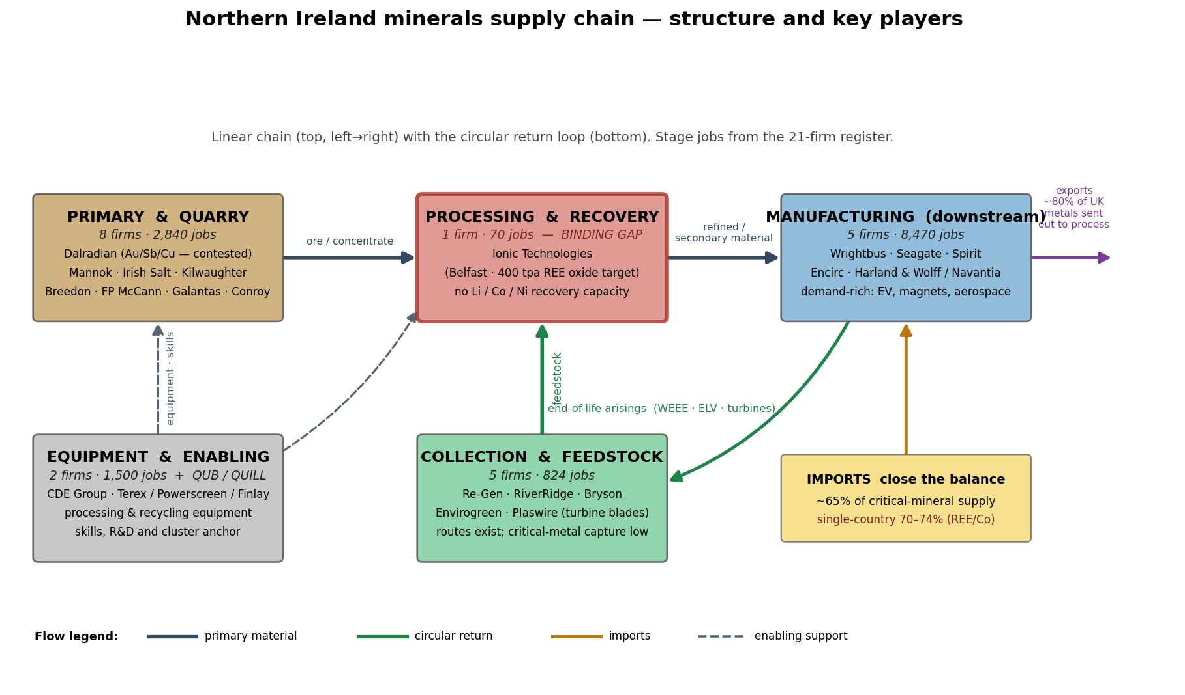
Figure 1. NI minerals supply chain — structure and key players. Linear chain (top, left→right) with the circular return loop (bottom). Stage employment is summed from the 21-firm register. The midstream processing/recovery stage is the binding gap.
Stage | Firms | Jobs | Key named players | Role in model
Primary / mining | 8 | 2,840 | Dalradian (Au/Sb/Cu, contested), Mannok, Irish Salt, Kilwaughter, Breedon/Whitemountain, FP McCann, Galantas, Conroy | deposit-quality & social-licence signal
Collection / feedstock | 5 | 824 | Re-Gen, RiverRidge, Bryson, Envirogreen, Plaswire (turbine blades) | feedstock-collection signal
Processing / recovery | 1 | 70 | Ionic Technologies (Belfast, 400 tpa REE-oxide target) | recovery-capacity signal — the binding gap
Downstream demand | 5 | 8,470 | Wrightbus, Seagate, Spirit, Encirc, Harland & Wolff/Navantia | demand + recycled-content uptake
Equipment / enabling | 2 | 1,500 | CDE Group, Terex/Powerscreen/Finlay (+ QUB/QUILL) | equipment, skills, cluster anchor
NI's distinctive assets: a real rare-earth recycling cluster (Ionic + QUB's QUILL + Plaswire), Belfast Harbour as an offshore-wind decommissioning hub (a magnet-feedstock pipeline), a £1,164m named-firm investment pipeline, and dual UK + EU market access via the Windsor Framework.

1.3 Architecture — the coupled engines
Three soft-linked engines run on a physical backbone, with spatial and indicator layers on top:
SCENARIO / POLICY LEVER LAYER (grants, permitting, ESG, finance, offtake,
collection, procurement, design standards, skills, stockpile, shocks)
│ policy parameters
▼
ABM (named NI firms) → signals: new_domestic, recovery_boost,
MiningFirm · RecyclerFirm · ManufacturerFirm · GovernmentCollector
│ physical signals ▲ behaviour ← prices/wages (CGE feedback)
▼ │
MFA (stock-flow per mineral; mass balance; supply shares; shocks)
│ final demand (£m)
▼
Dynamic Leontief I-O (GVA, jobs, CO₂, PM; Type I/II; coefficients evolve)
│ ▲ feedback (price, wage)
▼ │
CGE on NI SAM (Cobb-Douglas VA + Armington CES; prices, wages, GVA)
│
▼
Spatial layer (jobs → 11 councils) + Indicators (Q2.1–2.7 + validation)

1.4 Module-by-module technical detail
Material Flow Account (MFA) — the physical backbone. For each of 10 minerals and each year it tracks a stock-flow account from seed parameters (demand, lifetime, collection, recovery, domestic share, import concentration):
- End-of-life arisings = inflow placed on market lifetime years ago (ring buffer).
- collected = eol · min(0.95, coll + collection_boost); recycled = collected · min(0.98, rec + recovery_boost); secondary supply = min(recycled, demand).
- Domestic primary = demand · min(1, dom0 + new_domestic); imports close the balance, subject to a shock cap.
- Mass balance is checked every year, every mineral: domestic + imports + secondary + unmet = demand (±1e-6).
- Supply-security indicators: domestic / recycled / import shares, supply-gap share, and single_country_exposure = import_share · import_concentration.
- Upstream shock = an optional import_constraint (static {mineral: cap} *or* a callable f(t) for a time-varying onset) modelling a dominant-supplier loss. If capped imports + domestic + recycled cannot meet demand, the shortfall is recorded as `unmet_demand` (the supply gap) rather than silently imported — this is the threat that hits downstream firms.
Agent-Based Model (ABM) — firm-grounded (mesa 3.x). Every agent is a named NI operator parsed from the register.
- MiningFirm makes a yearly real-option development decision: it develops only if margin > dev_hurdle (0.45) and social_licence > 0.4, where margin nets deposit quality × price signal, grants and skills against ESG cost, project risk and a finance-eased WACC (11.26%), and social licence rises with a community-benefit package. So the best deposit (Dalradian, high planning-risk) stays blocked unless community benefit lifts its social licence — the central Q2.2 result.
- RecyclerFirm (processor like Ionic, or collector like Re-Gen/Bryson) raises a recovery_boost from a viability score driven by recycling/innovation grants, recycled-content demand pull, offtake support, energy cost and capacity.
- ManufacturerFirm raises recycled-content uptake (which shifts the I-O mining→recycling coefficient); equipment firms (CDE, Terex) provide static capex support.
- A GovernmentCollector runs policy-driven municipal collection. CGE feedback (Tier-3) raises the development hurdle with the wage index and feeds a mineral price signal back into mining decisions.
Dynamic Input–Output (I-O). Leontief production accounting, L = (I − A)⁻¹, on an 8-sector proxy table scaled by DOMESTIC_INTENSITY = 0.62 (the high import leakage of a small open region). Type I (direct+indirect) and Type II (adds induced, via a closed household row/column). Satellites per £m output give GVA, jobs, CO₂ and PM. Coefficients evolve annually from ABM signals (recycling substitution, local-procurement gain, productivity). Calibrated so a mining demand shock yields ~10 total jobs/£m and a Type-II mining output multiplier ~1.69.
Social Accounting Matrix (SAM) + CGE. NI has no published SAM, so one is constructed and balances by construction (row=column to ~1e-12), pinned to the real £108m mining-GVA anchor within ~£40,000m total NI GVA. The compact recursive-dynamic CGE uses Cobb-Douglas value added (calibrated to replicate the benchmark exactly), Armington CES (σ=2.0) for domestic-vs-import substitution and constant-elasticity exports (σ=2.0); flexible wages/rentals clear factor markets. It is solved with scipy.optimize.root; a partial-equilibrium fallback (PEPriceLabour) guarantees a result if the full solve ever fails. Feedback to the ABM: the relative mining price (clipped 0.8–1.5) and the wage index.
Spatial layer. Allocates sectoral jobs to the 11 NI Local Government Districts, blending population-tilted shares 50/50 with the actual named-firm geography (so mining concentrates in Fermanagh & Omagh, manufacturing in Belfast and Mid & East Antrim). District shares sum to 1 per sector.
Coupling loop (annual). price index → ABM step → strategic-stockpile drawdown → MFA step → I-O coefficient update → final-demand vector + impacts → CGE solve → spatial allocation + discounting. Demand growth optionally plateaus after 2035 so document-anchored CAGRs do not compound unrealistically over 30 years.

1.5 Policy levers
Sixteen levers, each mapped to a named instrument; default 0 so the baseline is undisturbed.
Lever | Acts on | Named instrument
finance_support | mining cost of capital | NWF + UKEF
exploration_grant | mining margin | exploration support
permit_years | mining delay | EA priority-tracked permitting
community_benefit | social licence | community-benefit / ESG scheme
recycling_grant | recycler viability | capital recovery grants (Vision 2035 DBT)
innovation_grant | recovery yield + design | CLIMATES £15m + Faraday/ReLiB £34m
energy_cost_index | recycler viability | BICS energy support
secondary_market_support | recycler + manufacturer | UKEF offtake + price floor (cf. MP Materials)
collection_infrastructure | collection rates | WEEE / Deposit-Return Scheme
product_passport | collection + design | digital passports / EPR
recycled_content_procurement | substitution | minimum recycled-content procurement
design_standards | substitution | ecodesign / design-for-disassembly
local_supplier_support | I-O local procurement | supplier development (Invest NI)
skills_support | capacity + mining | Skills England + DWP
strategic_stockpile | import buffer | defence stockpile (Japan/Korea practice)
diversification | single-country concentration | international partnerships (cuts effective concentration up to 50%)
The supply shock itself is not a lever but an import_constraint, with caps set to 1 − loss_factor × (single-country concentration).

1.6 Model validation results
(a) Validation against the Minviro independent evidence. The I-O core is validated by injecting a mining final-demand shock sized to Minviro's one-mine (£7.3m) and two-mine (£43m) total output, then comparing jobs and direct mining GVA like-for-like:
Scenario | Metric | Model | Minviro anchor | Result
One mine (3a) | Output (£m/yr) | 7.30 | 7.3 | ✅ exact (calibration target)
One mine (3a) | Jobs | 73.1 | 73 | ✅ within 0.1%
One mine (3a) | Direct mining GVA (£m) | 1.58 | 1.6 | ✅ within 1.5%
Two mines (4b) | Output (£m/yr) | 43.0 | 43 | ✅ exact (calibration target)
Two mines (4b) | Jobs | 430.4 | 430 | ✅ within 0.1%
Two mines (4b) | Direct mining GVA (£m) | 9.29 | 9.0 | ✅ within 3.2%
(b) Verification & continuous integration. A harness (verify_model.py) runs 58 checks on every change and gates the CI build (.github/workflows/verify.yml):
- *Invariant checks* — MFA mass balance (baseline + shock), supply-share bounds & closure, no NaN/negatives, determinism (identical config → byte-identical output), SAM balance (~1e-12) + the mining-GVA anchor, CGE benchmark replication (wage = 1.000), CGE partial-equilibrium fallback, spatial share closure, stockpile reserve non-negativity & depletion, register integrity, economic-sanity ranges, and the geopolitical features (diversification, time-varying shock).
- *Property-based / fuzz checks* — 30 random valid policy bundles (random lever subsets, demand growth, static/time-varying shocks, plateau, CGE on/off) must all preserve mass balance, share closure, no-NaN/negatives and a non-negative reserve.
All 58 checks pass. The model is deterministic and reproducible (python run_mvm.py; python verify_model.py).

Part 2 — Data used and assumptions

2.1 The provenance system
Every parameter carries a status in model/data/data_register.csv (~85 parameters):
🟢 real (sourced/audited) · 🟡 proxy (desk/scaled) · 🔴 gap (placeholder). The headline pattern is honest: the validation anchors and supply-concentration figures are real; most economic-structure and behavioural coefficients are proxy.

2.2 Real anchors and control totals (used to validate / pin the model)
Item | Value | Source
NI mining & quarrying GVA (2018) | £108m (0.27% of NI GVA) | ONS Regional GVA / NISRA via Minviro
NI mining & quarrying workers | 1,950 | NISRA BRES
NI total employee jobs (Sep 2023) | 816,562 | NISRA BRES
Minviro one-mine scenario | 73 jobs / £7.3m output / £1.6m GVA p.a. | Minviro Final Report
Minviro two-mine (4b) scenario | 430 jobs / £43m output / £9m GVA p.a. | Minviro Final Report
STPR (discount rate) | 3.5% | Green Book / NIGEAE
Mining cost of equity (WACC) | 11.26% | Minviro (CAPM)
Vision 2035 targets (2035) | ≥10% domestic / ≥20% recycling / ≤60% single-country | Vision 2035 (GOV.UK)
NI median FT wage (2024) | £34,632/yr | NISRA ASHE
2023 single-country supply concentration | REE 74% China, Co 70% DRC, Li 44% Australia | BGS / Idoine et al. 2025
UK metals exported for processing | ~80% | GSNI/BGS OR25042
NI municipal recycling rate (2024/25) | 50.4% (flat since 2019) | DAERA LAC municipal waste
Curraghinalt (Dalradian) resource | 3.79 Moz Au M&I (+Cu/Sb/Te/Bi/Co) | Dalradian 2021 feasibility study

2.3 Firm evidence (the ABM agents)
company_register.csv holds 21 named NI operators — 13 web-verified, 8 desk-verified — each with role, district, lifecycle stage, employees, investment, capacity, and eight 0–1 scores (resource, capacity, feedstock, demand, local-procurement, planning-risk, skills, circularity) that drive agent behaviour. Derived aggregates: £1,164m named-firm capital pipeline; 400 tpa installed REE-recovery capacity (Ionic). Firm scores are desk estimates and are the main *behavioural* calibration dependency (see §2.6).

2.4 Strategy-grounded demand and support data
Demand is derived from the Vision 2035 Technical Annex (Annex 2), not hand-set: the annex's cumulative UK demand at 2024/27/30/35 is differenced to annual increments and converted to a CAGR, cross-checked against IEA net-zero:
Mineral | Annex-derived annual CAGR | IEA cross-check
Lithium | 26.5% | ~9× by 2040
Nickel | 10.8% | ~2× by 2040
Aluminium | 9.3% | —
Cobalt | 9.2% | ~2× by 2040
REE_magnet | 8.8% | ~2× by 2040
Copper | 4.3% | ~2× by 2040
Support-mechanism evidence (used to design and cost the Q2.3/Q2.4 levers):
Item | Value | Source
Strategic-stockpile targets | Japan 60–180 days, Korea 100 days | IEA; CSEP 2025
FOAK cost-share | 20% prototype / 50% pilot | US DOE Critical Minerals Accelerator
Blended-finance fund | US$500m | US–Australia Critical Minerals Partnership Fund
Offtake + price floor | 10-yr / $110/kg NdPr | US DoD–MP Materials (CSIS 2025)
EU CRMA strategic-project permits | 15-mo processing / 27-mo extraction + finance + offtake | European Commission
Lever public costs (NI-scale) | CLIMATES £15m, ReLiB £34m, DBT £50m, DEFRA DRS £632m setup / £1.065bn/yr | Innovate UK / DEFRA / DfE
Japan post-2010 diversification | China REE dependence ~90%→~58% (JOGMEC $250m Sojitz–Lynas deal) | CNBC; WEF; IEA

2.5 Key calibrated parameters
Parameter | Value | Status
DOMESTIC_INTENSITY (A-matrix scaling) | 0.62 | proxy (import leakage of a small open region)
GVA_COEFF (mining) | 0.35 | proxy, tuned to Minviro direct-GVA anchors
EMP_COEFF (mining) | 11.5 jobs/£m | proxy, anchored to 1,950 jobs
Recovery yields REE / Li / Cu | 0.85 / 0.50 / 0.90 | desk-verified (Met4Tech, ReLiB, Ionic)
WEEE collection baseline | 0.25 | desk-verified (UN Global E-waste Monitor)
Concentration REE / Co / Li | 0.74 / 0.70 / 0.44 | real (BGS/Idoine 2025)
Dev hurdle / social-licence floor | 0.45 / 0.40 | proxy behavioural thresholds
CES elasticities σ(Armington)/σ(export) | 2.0 / 2.0 | proxy
Stockpile depth / release rate | 0.5 demand-yr (~180 d) / 0.30 | calibrated to JOGMEC/KOMIR

2.6 Assumptions made about the data, and limitations
The biggest assumptions are deliberately surfaced (full list in TECHNICAL_DOCUMENTATION.md §8):
- The I-O coefficient matrix is proxy, not a regionalised NI table — scaled for high import leakage and tuned to the Minviro anchors. *This is the single biggest calibration dependency.* (Replace with NISRA Supply-Use + Scottish 2017 I-O via FLQ + RAS.)
- The SAM structure is proxy (only mining GVA is a real anchor); the CGE is a compact reduced form with proxy elasticities.
- MFA stock-flow seeds are UK data scaled to NI — NI-level critical-mineral waste flows are a known gap. Commodity prices are indicative.
- Behavioural thresholds (dev hurdle, social-licence floor, risk→delay, lever→effect coefficients) are proxy and determine which marginal projects open — the first thing to calibrate with planning/licensing records and a firm survey.
- Demand CAGRs are UK-national, scaled uniformly to NI's base; the annex is read as *cumulative* demand (well-supported but not stated outright in the PDF).
- Public costs / ROI are NI-scale figures benchmarked to UK programmes by population, used only for *relative* ranking — not budget lines (a ±cost band is carried for sensitivity).
- Environmental satellites (CO₂, PM) are proxy; the water/land/biodiversity/waste indices in Q2.7 are dimensionless relative pressures — the model does not do site-specific impact assessment.
The honest bottom line: the model's structure, internal consistency and direction of travel are robust and validated; the absolute magnitudes are illustrative until the proxy economic/behavioural layer is replaced with collected NI data.

Part 3 — Answers to the seven consultation questions
Each question below gives: (i) the experiment logic, (ii) the data used, (iii) the results (table/figure), and (iv) how the results produce the answer. All scripts write CSVs + a findings memo to model/outputs/ and appear as tabs in the Streamlit dashboard.

Q2.1 — How can the Department support innovation for circularity?
(i) Experiment logic. Seven candidate interventions (materials-recovery capital, a circular-innovation R&D fund, smart collection/DRS, secondary-market offtake, ecodesign standards, a green-skills cluster, and the full package) are mapped onto the firm-grounded ABM and run individually and combined over 30 years. Each is ranked on recycled-share lift, recycling GVA/jobs, circular-design uptake, and GVA-ROI with a cost-uncertainty band.
(ii) Data used. Recovery yields (Met4Tech/ReLiB/Ionic), WEEE collection baseline 0.25 (UN E-waste Monitor), the UK Deposit-Return-Scheme uplift (container return 70–75%→>90%) to calibrate the collection lever, and NI-scale lever costs benchmarked to CLIMATES (£15m), ReLiB (£34m), DBT (£50m) and the DEFRA DRS impact assessment.
(iii) Results.
Intervention | Δ recycled share (pp) | Δ cum. GVA (£m) | Recycling jobs (end) | GVA-ROI (low–central–high)
Materials-recovery capital | 0.0 | 0.5 | 553 | 0.0–0.01–0.01
Circular-innovation fund | 0.0 | 0.5 | 554 | 0.0–0.01–0.01
Smart collection / DRS | +6.3 | +244.9 | 814 | 0.57–1.26–2.30
Secondary-market offtake | 0.0 | 0.6 | 554 | 0.0–0.01–0.02
Ecodesign standards | +2.3 | +92.5 | 653 | 1.10–2.21–4.43
Green-skills cluster | 0.0 | 0.0 | 553 | 0.0
Integrated package | +6.3 | +246.1 | 818 | 0.28–0.56–1.04
(iv) How this leads to the answer. Two robust results emerge: collection is the binding constraint, not processing capacity — smart collection/DRS is the *only* single lever that reaches the Vision-2035 20% recycling target (subsidising recovery *plant* alone moves nothing because NI's gap is feedstock); and ecodesign standards are the best value for money (~2.2× GVA per £, robust across the whole cost band, because they are mostly regulatory). The mix beats any single lever. Sequencing: *now* — recycled-content procurement + design standards + product passports (cheap, high return); *then* — a Circular Innovation Fund and collection/DRS to unblock feedstock.

Q2.2 — Key opportunities and challenges for sustainable development
(i) Experiment logic. A mineral-by-mineral opportunity score (demand pull, domestic geology, circular potential, strategic value, economic value) from the register + MFA; then constraint-relaxation scenarios that relax one barrier at a time (permitting, finance, community/social-licence, skills, energy) to find the *binding* constraint.
(ii) Data used. Firm register scores, GSNI/BGS geology (Curraghinalt 3.79 Moz Au + Sb/Te/Co; Mourne REE potential), import-dependence from the MFA, and BGS/Idoine concentration.
(iii) Results — what unlocks development:
Constraint relaxed | Mines opened | Δ cum. GVA (£m) | Project unlocked
Faster permitting | 0 | 0.0 | —
Finance (NWF/UKEF) | 1 | +1.7 | Baryte (geological-potential)
Skills availability | 0 | 0.0 | —
Energy competitiveness | 0 | 0.0 | —
Community benefit / social licence | 1 | +208.1 | Dalradian
All enablers together | 2 | +226 | Dalradian + Baryte
Top opportunity-ranked minerals: REE_magnet (0.62, recycling), Copper (0.60, primary+recycling), Lithium (0.55), Cobalt (0.49), Aluminium (0.45) — the critical-mineral opportunities are overwhelmingly circular.
(iv) How this leads to the answer. The binding challenge is social licence, not economics: NI's best deposit clears the commercial hurdle but is blocked by community opposition, and a credible community-benefit package is the only lever that brings it forward — worth roughly *ten times* finance, permitting or skills support alone (+£208m GVA, ~+600 jobs). Opportunities are led by the circular pathway (NI has little domestic critical-mineral geology), so critical-mineral security is mainly a recycling story. Bulk minerals (baryte, salt, aggregates) are the low-friction near-term opportunity.

Q2.3 — What support do businesses need to participate?
(i) Experiment logic. Vision 2035 warns supply chains are "vulnerable to shocks such as … war or geopolitical fallout". We model a dominant-supplier loss (per-mineral import caps = 1 − single-country share) + a price spike, map firms to supply-chain stages, and read outcomes by stage; then sweep shock severity (½× → 1.5× of the dominant supplier lost) and test a finite, depleting strategic stockpile.
(ii) Data used. 2023 concentration (REE 74%/Co 70%/Li 44%, BGS/Idoine); named support instruments (NWF/UKEF, BICS, FOAK cost-share, offtake+price-floor, DRS); stockpile sized to JOGMEC/KOMIR (60–180/100 days).
(iii) Results — support package under the shock:
Scenario | Early-5yr gap | End gap | Recycled share | Total jobs (end) | Δ jobs vs unsupported
No shock, no support | 0.00 | 0.00 | 0.147 | 1,148 | +78
Shock, no support | 0.051 | 0.204 | 0.135 | 1,069 | 0
+ Upstream support | 0.051 | 0.155 | 0.135 | 1,687 | +618
+ Midstream support | 0.016 | 0.136 | 0.204 | 1,421 | +351
+ Downstream support | 0.051 | 0.204 | 0.135 | 1,069 | −0.4
+ Enabling (stockpile) | 0.038 | 0.204 | 0.135 | 1,069 | −0.2
+ Full cross-chain | 0.013 | 0.112 | 0.204 | 2,039 | +969
The shock is acutely mineral-specific: per-mineral unmet gap = REE 73%, Antimony 70%, Cobalt 69%, Lithium 43%, Nickel 27%, Aluminium 19%, Copper 12%.
(iv) How this leads to the answer. Support must be sequenced and stage-specific. *Downstream support alone barely moves the dial* — manufacturers cannot buy recycled content that does not yet exist — so it must follow midstream investment. The participation barrier is the pilot-to-commercial "valley of death" (exactly Ionic's position); the evidence-based unlocks are FOAK capital with cost-share + blended finance and long-term offtake with a price floor (cf. DoD–MP Materials). The stockpile is a thin bridge, not a fix — it only trims the early gap, then depletes. A single "strategic project" front door (EU CRMA via Windsor + UK NWF/UKEF/BICS) lowers the cost of participating.

Q2.4 — What role should government have in securing supply?
(i) Experiment logic. Five government postures (light-touch, diversify-&-insure, domestic-autonomy, circular-leader, strategic-coordinator) are tested against an escalating dominant-supplier export ban *and* a Monte-Carlo of 120 uncertain shocks (random onset, minerals ∝ concentration, severity). Metrics: the Vision-2035 targets, an HHI-style supply-risk index, and the unmet-demand gap distribution.
(ii) Data used. Concentration (BGS/Idoine); Vision 2035 / EU CRMA targets; real-world effectiveness evidence — Japan's post-2010 diversification (China REE dependence ~90%→~58% via stockpiling + JOGMEC equity/offtake + recycling) as a validated natural experiment.
(iii) Results — resilience under uncertainty (Monte-Carlo):
Role | Mean gap | p90 gap | Worst gap | Single-country exposure | Public cost (£m)
Market / light-touch | 0.059 | 0.144 | 0.262 | 0.623 | 0
Diversify & insure | 0.056 | 0.135 | 0.252 | 0.400 | 122
Domestic autonomy | 0.048 | 0.120 | 0.208 | 0.602 | 121
Circular leader | 0.040 | 0.098 | 0.185 | 0.607 | 354
Strategic coordinator | 0.034 | 0.079 | 0.159 | 0.427 | 516
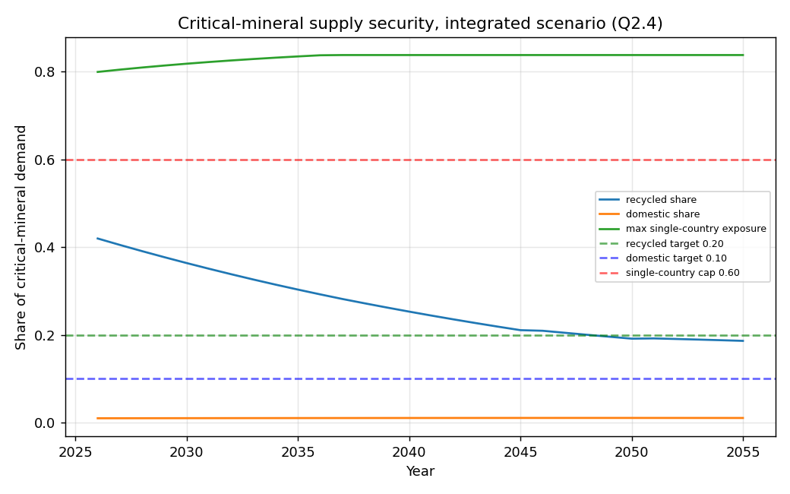
Figure 2. Critical-mineral supply security in the integrated scenario (Q2.4): recycled share and domestic share rise toward the Vision-2035 targets (dashed) while maximum single-country exposure falls.
(iv) How this leads to the answer. Light-touch fails the security test (highest tail risk; security is a public good the market under-provides — confirmed by the IEA observation that critical minerals are *concentrating*, not diversifying). No single instrument is enough. A balanced strategic-coordinator posture is the most robust — it roughly halves the 90th-percentile gap vs light-touch and is the only posture that moves all three Vision-2035 indicators at once while adding GVA. The role is an active coordinator/insurer (set targets; de-risk midstream; fix collection; diversify + hold a thin reserve; uphold high-ESG terms) — exactly the posture Japan used successfully.

Q2.5 — Local employment, skills and regional growth
(i) Experiment logic. The firm-grounded jobs-by-council output is split by skill level and wage band (ONS SOC/ASHE structure on the real NISRA median wage £34,632), with retained local employment (the Minviro leakage fix, rising with local-content + skills) and a skilled-training need, across four scenarios.
(ii) Data used. NISRA ASHE 2024 wage anchor; ONS ASHE-by-industry; NI skills backdrop (~7,500 skill-shortage vacancies, 5,000+ new roles/yr); Minviro retained-jobs estimates (Scen-2: 52 … two-mine 4b: 7,177); UK Industrial Strategy (Belfast named a critical-minerals cluster).
(iii) Results.
Scenario | Total jobs (end) | High-skill jobs | Wage premium vs NI | Local retention | Skilled-training need
Baseline | 1,148 | 206 | 1.11× | 70% | 193
Circular innovation | 1,513 | 262 | 1.09× | 80% | 283
Integrated | 2,010 | 390 | 1.17× | 86% | 698
Local-content + skills | 1,393 | 244 | 1.09× | 97% | 254
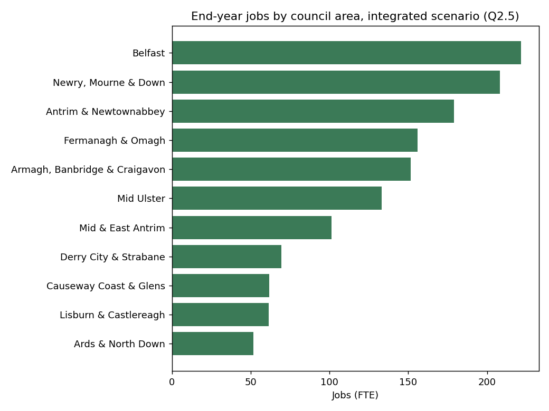
Figure 3. End-year jobs by council area in the integrated scenario (Q2.5) — growth is rural-weighted, concentrating where the named firms sit (Belfast plus the rural west and Mid Ulster).
(iv) How this leads to the answer. The sector offers quality jobs above the NI average (~9–17% wage premium), rural-weighted regional growth (Belfast + the west/Mid Ulster), and — crucially — local retention is a policy choice: it rises from ~70% to ~97% under a local-content + skills focus, directly countering the Galmoy/Lisheen leakage Minviro warns of. Skills are the binding enabler, so a green-skills/critical-minerals pipeline and apprenticeships are prerequisites, not add-ons.

Q2.6 — Economic benefits
(i) Experiment logic. The coupled Type-II GVA/output/jobs (discounted, 30 yr) are extended with Minviro's full benefit taxonomy — a tax proxy (~25% of GVA), exports, the named-firm investment pipeline, productivity, manufacturing resilience and avoided import costs (the import bill met by domestic + recycled supply). Value-for-money is reported on incremental GVA alone *and* with resilience.
(ii) Data used. Minviro multiplier basis (NI 2016 + Scotland 2016 I-O), scenario anchors and WACC; named-firm investment pipeline (£1,164m); Minviro retained-jobs/leakage analysis and CLCA carbon (~0.36% of NI CO₂).
(iii) Results.
Scenario | Cum. disc. GVA (£m) | Avoided imports (£m) | Tax proxy (£m) | Exports (£m) | GVA BCR | Resilience BCR
Baseline | 788 | 1,215 | 197 | 631 | — | —
Circular innovation | 1,019 | 1,567 | 255 | 842 | 0.79 | 2.00
Primary extraction | 790 | 1,218 | 198 | 632 | 0.02 | 0.04
Integrated | 1,153 | 1,789 | 288 | 874 | 0.86 | 2.21
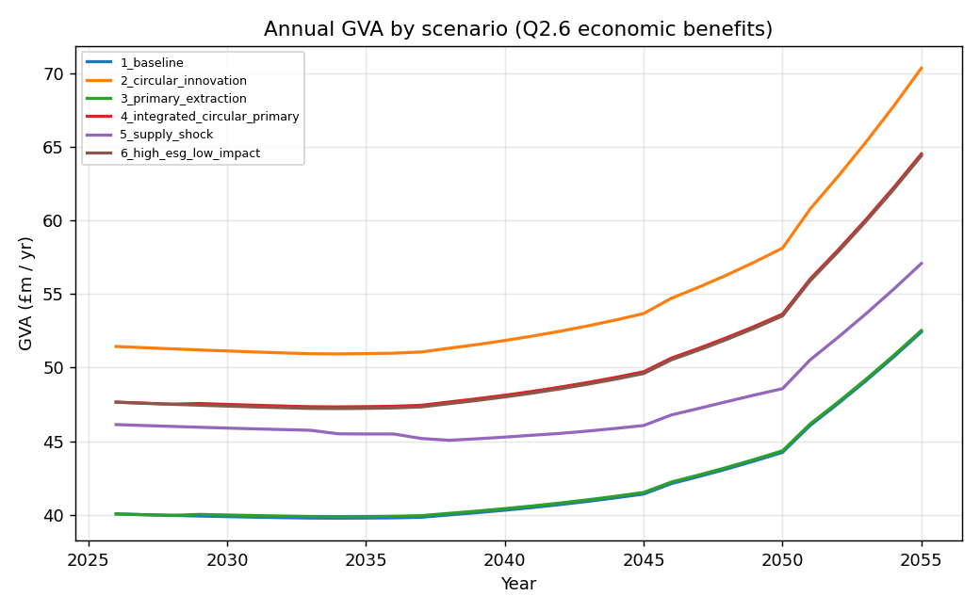
Figure 4. Annual GVA by scenario (Q2.6) — the integrated circular + primary scenario delivers the largest, rising benefit over the 30-year horizon.
(iv) How this leads to the answer. The benefits are substantial and broad — the integrated scenario delivers ~£1.15bn discounted GVA, ~£1.8bn avoided imports, ~£0.3bn tax and ~£0.9bn exports over 30 years, on top of the £1.16bn investment pipeline. The value-for-money is honest: on incremental GVA alone the capital-heavy scenarios return below £1, but once avoided imports / resilience are counted the return rises to ~2×. Pure extraction support is the weakest (little opens without social licence). Headline benefits are an upper bound — the *retained* share depends on the Q2.5 local-content + skills measures.

Q2.7 — Negative impacts and how to minimise them
(i) Experiment logic. The validated CO₂/PM satellites are reported alongside relative pressure indices for Minviro Appendix-A impact groups (water, land, biodiversity, tailings/waste) and eco-efficiency (impact per £m GVA), across baseline / circular / primary / integrated / high-ESG scenarios.
(ii) Data used. Minviro Appendix A (impact groups, site-specific receptors, avoid→mitigate→closure hierarchy); Minviro CLCA (most active mining ≈ 0.36% of NI CO₂, 0.24% of PM; recycling carbon ~30% of primary); I-O CO₂/PM satellites.
(iii) Results.
Scenario | Cum. disc. CO₂ (kt) | Land pressure | Biodiversity | Waste/tailings | Land per £GVA
Baseline | 1,592 | 3,813 | 2,979 | 18,178 | 4.84
Circular innovation | 1,974 | 4,024 | 3,120 | 18,882 | 3.95
Primary extraction | 2,234 | 5,959 | 4,696 | 28,908 | 5.97
Integrated | 2,487 | 7,338 | 5,781 | 35,568 | 6.37
High-ESG / low-impact | 2,433 | 4,822 | 3,768 | 22,988 | 4.25
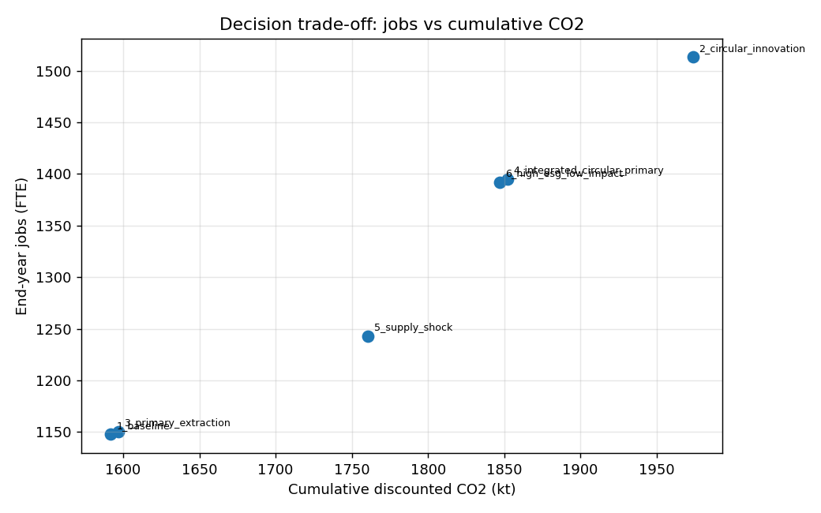
Figure 5. Decision trade-off: jobs versus cumulative CO₂ across scenarios — the circular routes sit on a better jobs-per-emission frontier than primary extraction.
(iv) How this leads to the answer. Primary mining carries the heavy, site-specific local burden (land, water, biodiversity, tailings, dust/noise, closure) concentrated on the host council area. Recycling is far lower-impact per £ of value (lowest land-per-£GVA; carbon ~30% of primary). High-ESG design materially mitigates the local burden (~35%). National carbon is modest (~0.36% of NI CO₂); the binding impacts are *local*. The order of preference is avoid (recycle/design) → mitigate (high-ESG) → manage closure (bonded), and any primary development needs project- and place-specific assessment.

Cross-cutting: demand outlook & the capacity gap
Running the strategy-derived demand (Vision 2035 / EU CRMA / UK Industrial Strategy, plateauing at 2035) under a supportive, sustainable stance, the NI opportunity grows to ~2,000 jobs and ~£1.25bn discounted GVA (combined-high-demand case) — but rising demand erodes the supply-security ratios unless capacity scales with it (recycled share falls 45%→43%, import share rises 47%→51%). The capacity audit is stark: NI has recovery capacity for REE only (Ionic, 400 tpa) and none for lithium, cobalt or nickel — the fastest-growing battery metals. The chain is demand-rich but capacity-poor; the midstream is the priority gap to fund. Demand sensitivity (±50%) moves end-year jobs across 1,539–2,398 but leaves the qualitative findings robust.

Part 4 — Synthesis and reproducibility
Six recommendations (detailed in EXECUTIVE_SUMMARY.md): (1) build the midstream (FOAK + blended finance + offtake); (2) fix feedstock collection (DRS/WEEE); (3) lead with cheap demand-side rules (procurement, ecodesign, passports); (4) make any extraction responsible and contained (community benefit + high-ESG + bonded closure); (5) tie support to local content & skills (70%→97% retention); (6) create one "strategic project" front door + a thin ~180-day reserve.
Reproducibility.
cd model
pip install -r requirements.txt
python run_mvm.py # main scenario pipeline → outputs/
python verify_model.py # 58 invariant + property-based checks
python q2_1_circularity_interventions.py … q2_7_negative_impacts.py
python q_demand_supply_strategy.py
python make_supply_chain_fig.py && python make_plots.py # figures
python export_word.py # this report + memos → ../word/
streamlit run ../streamlit_app.py # interactive dashboard
*All figures are model behaviour under stated assumptions, not forecasts. Parameter-level provenance and status are in model/data/data_register.csv; full method and equations in TECHNICAL_DOCUMENTATION.md.*

