Response to the Review of Mineral Licensing — Call for Evidence

Chapter 2: Economic Opportunities
To: Minerals and Petroleum Branch, Department for the Economy, 7th Floor, Adelaide House, 39–49 Adelaide Street, Belfast BT2 8FD · mineralsreview@economy-ni.gov.uk
Re: Review of Mineral Licensing — Call for Evidence (closing 28 June 2026), Chapter 2 — Economic Opportunities (questions 2.1–2.7)
Respondent: [Name] · [Organisation] · [Contact]

About this response
This submission provides evidence from an integrated model of the Northern Ireland minerals system built specifically to inform this review. The model couples four standard tools on an annual, 30-year horizon (2026–2055, discounted at the HM Treasury / NIGEAE 3.5% Social Time Preference Rate):
- a firm-grounded agent-based model whose agents are 21 named NI operators (Ionic Technologies, Dalradian, Wrightbus, Seagate, Re-Gen, CDE/Terex, …);
- a material-flow account (physical mass balance for 10 minerals, with supply-security and concentration-risk metrics);
- a dynamic input–output model (GVA, jobs, CO₂ on Type I/II multipliers, calibrated to the Minviro anchors); and
- a compact computable general equilibrium model on a constructed NI Social Accounting Matrix.
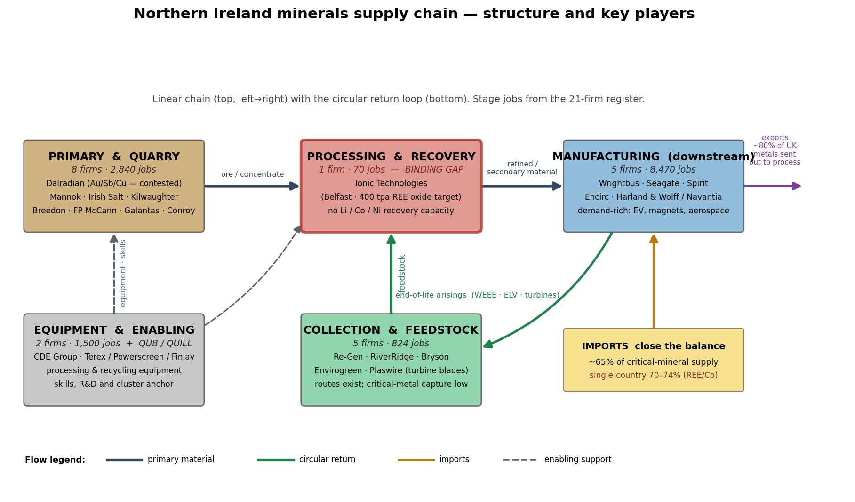
The NI minerals supply chain and its key players. The single most important structural fact is the midstream bottleneck: strong upstream extraction and very strong downstream manufacturing demand, but only one critical-mineral processing/recovery asset (Ionic Technologies).
Status and honesty of the evidence. The model is validated against the Minviro (2022) scenario anchors (it reproduces the one-mine 73 jobs / £7.3m and two-mine 430 jobs / £43m results) and passes a 61-check verification harness on every change. It is a policy-scenario simulator, not a forecast: control totals and targets are real and sourced, but most economic-structure and behavioural coefficients are proxy values (fully documented with provenance). The robust content is therefore the direction, ranking and relative magnitude of the findings, not precise point predictions. Full method, equations, data and assumptions are in the accompanying technical report.
Headline position. Northern Ireland's strongest minerals opportunity is circular — recovering and processing critical minerals from end-of-life products — paired with responsibly-conditioned primary extraction where the evidence and community acceptance support it. NI is *demand-rich but capacity-poor*: it has world-class research (QUB), a real rare-earth recycling firm (Ionic, Belfast), strong downstream manufacturers and a named place in UK strategy, but only one midstream processing asset. The single highest-leverage action is to build midstream processing/recovery capacity and fix feedstock collection.

2.1 — How can the Department support innovation that will support circularity, in particular materials recovery, secondary materials markets, recycling and circular design in manufacturing?
Evidence. We tested seven concrete interventions (each mapped to real instruments) individually and as a package over 30 years, ranking them on recycled-share lift, recycling GVA/jobs and value-for-money (discounted GVA per £ of public cost, with a cost-uncertainty band):
Intervention | Δ critical-mineral recycled share | Δ discounted GVA | Value-for-money (GVA per £)
Smart collection / deposit-return / WEEE | +6.3 pp (reaches the 20% target) | +£245m | 1.26× (band 0.57–2.30)
Ecodesign / design-for-disassembly standards | +2.3 pp | +£93m | 2.21× (best value)
Recovery-plant capital grant | ~0 | +£0.5m | ~0
Secondary-market offtake + recycled-content procurement | ~0 (design uptake ↑) | +£0.6m | ~0
Circular-innovation R&D fund | ~0 | +£0.5m | ~0
Green-skills cluster | ~0 | ~0 | ~0
Integrated package (all together) | +6.3 pp | +£246m | 0.56×
Findings. (i) Collection is the binding constraint, not processing machinery — a smart collection / deposit-return scheme is the *only single lever* that reaches the Vision-2035 20%-recycling target; subsidising recovery *plant* alone moves almost nothing because NI's immediate gap is feedstock. (ii) Ecodesign standards are the best value for money (~2.2× return, robust across the whole cost band, because they are largely regulatory). (iii) The mix beats any single lever. Against the stricter EU-CRMA 25% recycling benchmark (relevant to NI's potential EU-market access under the Windsor Framework) no single lever qualifies — the EU stretch requires the full circular build-out. (iv) As demand scales, processing/recovery capacity becomes the binding midstream gap (there is currently no NI lithium, cobalt, nickel, copper or aluminium processing capacity).
Recommendation. Sequence support: now — recycled-content public procurement + design-for-disassembly standards + digital product passports (cheap, high return); then — a circular-innovation fund (R&D with Ionic/QUB) and a collection/deposit-return scheme to unblock feedstock; then scale — first-of-a-kind processing/recovery capacity for battery metals.

2.2 — What are the key opportunities and challenges for sustainable minerals development?
Evidence. A mineral-by-mineral opportunity ranking, plus constraint-relaxation scenarios that relax one barrier at a time to reveal the *binding* constraint.
The strongest opportunities are circular (recovery of rare-earth magnets, lithium, cobalt, copper), reflecting high import dependence to displace and NI's named recycling capability. Copper ranks second but is a UK *growth* mineral, not a critical mineral (Vision 2035 Technical Annex) — it is reported separately so the *critical*-mineral position is not overstated. Northern Ireland is also the most prospective part of the UK/Ireland for precious metals (the Curraghinalt deposit: 3.79 Moz gold plus copper, antimony, tellurium and cobalt).
Constraint relaxed | Mines opened | Δ discounted GVA | Project unlocked
Faster permitting | 0 | £0m | —
Finance (NWF/UKEF) | 1 | +£2m | Baryte (geological-potential)
Skills availability | 0 | £0m | —
Competitive energy | 0 | £0m | —
Community benefit / social licence | 1 | +£208m | Dalradian (Curraghinalt)
All enablers together | 2 | +£226m | Dalradian + Baryte
Finding. The binding challenge is social licence, not economics: NI's best deposit clears the commercial hurdle but is blocked by community opposition, and a credible community-benefit package is the *only* lever that brings it forward — worth roughly ten times finance, permitting or skills support on their own. Critical-mineral security is therefore mainly a recycling/feedstock story (little domestic critical-mineral geology), while bulk minerals are the low-friction near-term opportunity.
Recommendation. Treat community benefit and high-ESG conditions as the central enabler of any contested primary development; pursue critical minerals primarily through midstream + recycling.

2.3 — What support is needed for businesses to participate in the minerals supply chain?
Evidence. We modelled a dominant-supplier loss (per-mineral import caps set to the 2023 single-country concentration — China 74% rare earths, DRC 70% cobalt, Australia 44% lithium) plus a price spike, and read outcomes by supply-chain stage.
The shock opens a critical-mineral supply gap of ~20% that lands on downstream manufacturers as cost and insecurity, while being an *opportunity* for upstream/midstream firms — *if* they have the capacity to respond. Support must therefore be stage-specific and sequenced:
Stage | Binding challenge | Support needed
Upstream (mining) | Finance, social licence, ~20-yr lead time | NWF/UKEF co-investment, faster permitting, community benefit
Midstream (processing/recovery) | The pilot-to-commercial "valley of death" | First-of-a-kind capital with cost-share + blended finance; long-term offtake with a price floor; energy-cost relief; collection
Downstream (manufacturers) | Input-cost/availability, secondary-material access | Recycled-content procurement, supplier development — *only after* midstream capacity exists
Findings. Downstream support alone barely moves the dial under the shock (manufacturers cannot buy recycled content that does not yet exist), so it must follow midstream investment. A strategic stockpile is a thin bridge, not a fix — sized to real practice (~180 days) it trims only the first ~1–2 years and then depletes. Full cross-chain support cuts the supply gap to ~11% and adds ~+970 jobs versus the unsupported shock.
Recommendation. Prioritise midstream scale-up finance (FOAK cost-share + offtake/price-floor, as in the US DoD–MP Materials model), structured as *recurring* institutions rather than one-off grants; offer a single "strategic project" front door (NI could access EU CRMA fast-permitting *and* the UK NWF/UKEF offer under the Windsor Framework).

2.4 — What role should we have in ensuring a secure supply of minerals?
Evidence. Five government postures were tested against an escalating dominant-supplier export ban *and* a Monte-Carlo of 120 uncertain shocks. Resilience (lower = safer) under uncertainty:
Government posture | 90th-percentile supply gap | Public cost
Market / light-touch | 0.144 (worst tail risk) | £0m
Diversify & insure | 0.135 | £122m
Domestic autonomy | 0.120 | £121m
Circular leader | 0.098 | £354m
Strategic coordinator (balanced) | 0.079 (most robust) | £516m
We also report the IEA-2025 midstream-risk view: top-three producer concentration reached ~86% in 2024 and China refines 19 of 20 strategic minerals — so beside single-country exposure we track top-three and refining exposure. Diversifying imports cuts single-country and partly top-three exposure but does not cut refining dependence — that falls only when NI builds its own recovery/processing capacity.
Finding. Light-touch fails the security test (security is a public good the market under-provides; the IEA confirms critical minerals are *concentrating*, not diversifying). A balanced strategic-coordinator role is the most robust — it roughly halves the 90th-percentile gap versus light-touch and is the only posture that improves all three Vision-2035 indicators while adding GVA. It should be read as the closest/most-robust portfolio, *not* a claim that every Vision-2035 target is met in every state (stable single-country exposure sits just above 60%, domestic share below 10%, some recycled results just under 20%).
Recommendation. Adopt an active coordinator/insurer role: set targets; de-risk midstream capacity (finance + offtake); fix feedstock collection; diversify imports and hold a thin strategic reserve; and uphold high-ESG/community-benefit terms — the posture Japan used to cut its Chinese rare-earth dependence from ~90% to ~58%.

2.5 — How can the sector contribute to local employment, skills development, and regional growth?
Evidence. Jobs are split by skill and wage band on the real NISRA ASHE 2025 anchor (NI median full-time £37,100/yr), with retained-local-employment and a skilled-training requirement, across policy scenarios.
Scenario | End-year jobs | Wage premium vs NI median | Local retention
Baseline | 1,148 | +11% | 70%
Circular innovation | 1,513 | +9% | 80%
Integrated | 2,010 | +17% | 86%
Local-content + skills focus | 1,393 | +9% | 97%
Findings. The sector offers quality jobs above the NI average, rural-weighted regional growth (Belfast plus the west and Mid Ulster, where the named firms sit), and — crucially — local retention is a policy choice: it rises from ~70% to ~97% under a local-content + skills focus, directly countering the leakage Minviro warns of (the Galmoy/Lisheen precedent, where imported specialist firms limited local employment). Skills are the binding enabler (against ~7,500 NI skill-shortage vacancies).
Recommendation. Tie public support to local-content and skills commitments, and build a green-skills / critical-minerals pipeline (FE colleges, QUB, apprenticeships) now — it is the gating constraint on capturing the jobs.

2.6 — What are the potential economic benefits of mineral development?
Evidence. The coupled model's Type-II GVA/jobs are extended with the full Minviro benefit suite — tax, exports, the named-firm investment pipeline, productivity and avoided import costs (the import bill met by domestic + recycled supply):
Scenario | Discounted GVA | Avoided imports | Tax | Exports | Value-for-money (GVA-only → with resilience)
Circular innovation | £1,019m | £1,567m | £255m | £842m | 0.79× → 2.00×
Primary extraction | £790m | £1,218m | £198m | £632m | 0.02× → 0.04×
Integrated | £1,153m | £1,789m | £288m | £874m | 0.86× → 2.21×
Findings. The benefits are substantial and broad — the integrated scenario delivers ~£1.15bn discounted GVA, ~£1.8bn of avoided imports, ~£0.3bn tax and ~£0.9bn exports over 30 years, on top of a £1,164m named-firm investment pipeline. The value-for-money is honest: on incremental GVA alone the capital-heavy scenarios return below £1, but once avoided imports / resilience are counted the return rises to ~2×. Pure extraction support is the weakest (little opens without social licence). In the NISRA NIETS 2024 trade frame the minerals system is small by *volume* (~0.3% of NI external exports) but high in *strategic value*, protecting a far larger downstream manufacturing base.
Recommendation. Make the economic case as a portfolio (circular + responsible primary + local content), counting resilience and avoided imports alongside GVA; do not fund extraction support in isolation.

2.7 — What are the potential economic negative impacts of mineral development?
Evidence. We quantify five economic downsides of (primarily) primary extraction, each grounded in the Minviro report, and the policy levers that mitigate them:
Scenario | Economic negatives (leakage + closure liability + displacement) | % of GVA | Stranded capital at risk | Net local GVA
Circular innovation | £162m (leakage only) | 17% | £0m | £780m
Primary extraction (lightly managed) | £359m | 36% | £125m | £639m
Integrated | £225m | 20% | £73m | £928m
Responsible, managed primary | £128m | 11% | £70m | £1,016m
The five economic negatives are: benefit leakage (GVA/jobs leaving NI via imported specialist labour/equipment), a closure cliff + remediation liability (a mine's GVA/jobs end at closure; remediation is a public cost if unbonded), agriculture and tourism displacement in the host area, boom-bust price-volatility exposure, and stranded/sunk capital on contested long-lead projects (e.g. Curraghinalt's ~£250m, ~21-year inquiry).
Finding. Lightly-managed primary extraction carries economic negatives worth ~36% of its GVA, and its net local GVA (£639m) can fall *below* the baseline (£653m) — extraction done badly can leave NI worse off. Circular activity avoids almost all of it; responsible, managed development cuts the negatives by ~64% and yields the highest net local GVA. *(Environmental impacts — carbon, air, land, water, biodiversity — are a separate matter; the model tracks carbon/air satellites but this answer addresses the* economic *negatives as the question asks.)*
Recommendation. Minimise the economic downside by: requiring local content + skills (cut leakage), bonded mine-closure and progressive rehabilitation (remove the public liability and shorten displacement), offtake/price-floor and diversification (damp boom-bust), and pairing any contested project with circular capacity as a hedge against stranded capital.

Summary of recommendations to the Department
- Build the midstream. Fund first-of-a-kind processing/recovery capacity (cost-share + blended finance + offtake/price-floor) — the binding gap and highest-leverage action.
- Fix feedstock collection (smart collection / deposit-return / WEEE) — the only route to the 20% recycling target.
- Lead with cheap demand-side rules — recycled-content procurement, ecodesign standards, product passports (high return, low cost), sequenced ahead of and alongside capacity.
- Make any extraction responsible and contained — community-benefit schemes (the binding constraint), high-ESG conditions, bonded closure and progressive rehabilitation; impacts are site-specific and need project- and place-specific assessment.
- Tie support to local content and skills — converting headline jobs into *retained* NI jobs (~70%→~97%) and building the skills pipeline that gates the benefits.
- Create one "strategic project" front door and a thin safety net — a single designation (accessing EU CRMA fast-permitting via the Windsor Framework alongside the UK NWF/UKEF offer), plus international diversification and a modest ~180-day strategic reserve for residual risk.
*Method, mathematics, data sources and assumptions underlying this evidence are set out in the accompanying technical report; parameter-level provenance and status are in the model's data register. All figures are model behaviour under stated, partly-proxy assumptions and are offered as directional, evidence-based input to the review, not as forecasts. The respondent would welcome the opportunity to calibrate the model with the Department's data (NISRA Supply-Use/SAM, NI critical-mineral waste flows and a firm-level survey) to convert it into a fully calibrated decision tool.*

