Supply Chain Resilience Findings 02/12/2024

Critical Textile Fibre Materials
The majority of textiles are produced from man-made fibres, with polyester accounting for 57 % of production. Global fibre production is broken down in Figure 1 below. The most critical materials are polyester, nylon and cotton.

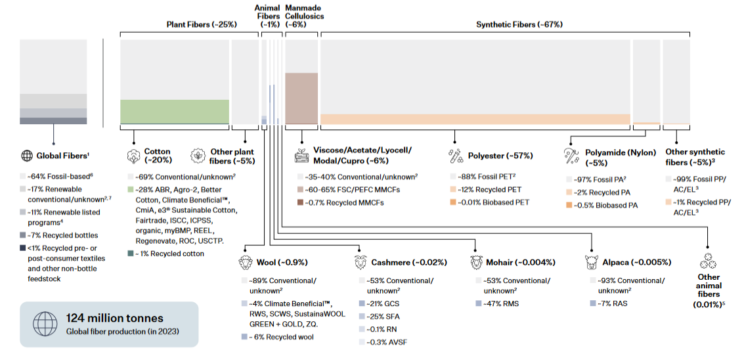
Figure 1. Breakdown of global fibre production by material type. (Taken from TextileExchange, 2024)

Raw Materials
Polyester
“Polyester” in textiles specifically refers to poly(ethylene terephthalate) (PET). It is produced from terephthalic acid and ethylene glycol. The raw materials to produce both monomers stem from crude oil, illustrated below:
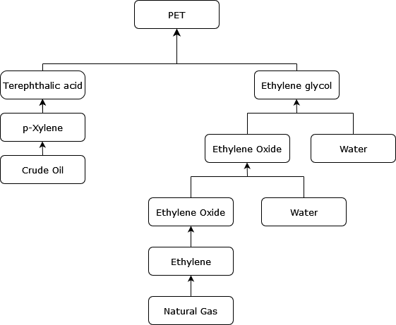
Nylon
Nylon (nylon 6,6) production is also heavily dependent on hydrocarbons:
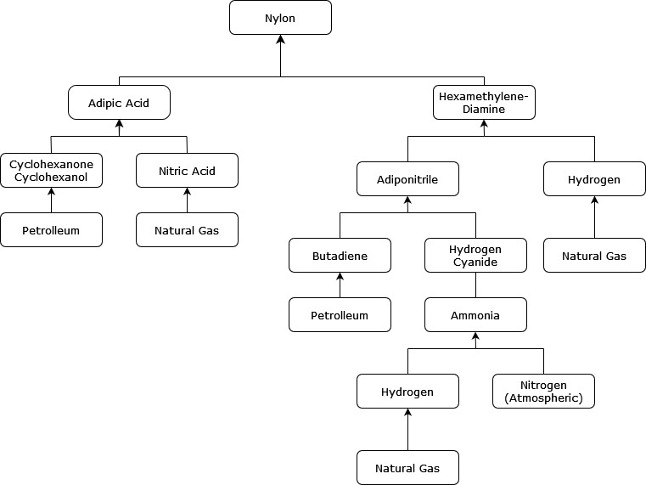
The main producers of adiponitrile, which is almost solely used to produce hexamethylene diamine for nylon production, are well known and the production is fairly centralised. The key players are:
    - Ascend Performance Materials, Alabama (US)
    - Invista, Texas, (US) – privately owned by Koch, Inc.
    - Butachimie (Owned by Invista and BASF), (France) – BASF is publicly listed
    - Asahi Kasei (Japan) (also produce nitric acid and other important chemicals – publicly listen on Tokyo stock exchange.
In 2018, the centralisation caused supply chain issues following factory fires - https://cen.acs.org/materials/polymers/chemical-industry-bracing-nylon-66/96/i40
Cotton
Cotton is a natural fibre – the worlds largest producers of which are China, India, and the U.S., representing 22.5 %, 22.5 %, and 14.7 % of global production, respectively (Liu and Hudson, 2022).

The UK Supply Chain
Company Level
There is a lack of transparency within the fashion industry regarding suppliers. However, some of the largest retailers have published lists of suppliers, though in most cases only direct suppliers are published; not the whole supply chain.
Notable companies who publish their raw material suppliers include ASOS, M&S, H&M, Tesco, The North Face, Timberland, Vans, and Wrangler. In the case of ASOS, 26% of their suppliers are based in China, 21.5 % in Turkey, 17.7 % in India, and 6.6 % in Bangladesh.
I have downloaded the raw data from ASOS and other companies but need more time to analyse. Cities are provided in addition to countries in some cases.
Industry Level
The UK fashion industry is highly asymmetric – there are many retailers but few manufacturers or producers. There are 10,870 companies (the majority of which are relatively small in terms of turnover and employee count) that manufacture apparel and textiles, representing a turnover of £9.4 billion. Major hotspots are the north west of England, the Midlands, and London. There are 11,230 fashion and textile wholesale companies, representing a turnover of £20 billion, similarly geographically concentrated. In comparison, there are 30,790 companies operating in fashion and textile retail with a total of £51.4 billion in turnover. All data from ONS – more data on this to analyse, including commodity imports by country, a more specific breakdown of each company’s activities in each location, their size, etc..

