RiSC+ Report – Overview
Vulnerabilities and Challenges to Resiliency
Initial analysis has revealed several vulnerabilities in the UK fashion supply chain. Broadly, the issues fall under the following categories:
- An over-reliance on imported clothing.
- Upstream, all clothing is entirely geographically bottlenecked.
- Key industries within the UK are dwindling.
The fashion industry is complex, and there are several barriers to making a more resilient supply chain. Briefly, the main issues are:
- Ever increasing volume of clothing consumption.
- Brand priorities oppose a diverse landscape.
- Brand image is extremely resilient, providing no incentive to change.
- Social media & influencer culture promote many shorter & smaller trends.
- Alternative supply routes, e.g. recycling, are poorly developed.
- Long term resiliency depends on reviving multiple industries.
- Environmental & emissions targets externalise chemical & polymer production.
Not Just Looks – Cross-Industry Impacts
Poor resiliency in the fashion supply chain impacts other key areas. For instance, purified terephthalic acid (PTA) is used to synthesise polyester, but PTA is also one of two monomers used to synthesise aramid fibres in a process similar to polyester production. Aramid, also known as Kevlar, is used in body armour, bulletproof vests, heatproof clothing, and jet engine enclosures, making it essential to national security.
Currently, plants in eastern China account for the vast majority global PTA production. By diversifying PTA production, be it domestic production or otherwise, simultaneously improves supply chain resilience in the fashion and defence industries.
PTA production is energy intensive like many processes in the chemical industry. The UK, like many developed nations, has been shifting its focus to being a service-based economy in lieu of its industrial history for the past half-century. The winding down of its industrial base has intensified recently as it targets net-zero emissions, but in doing so simply externalises the emissions and leaves supply chains centralised & vulnerable. Building a truly resilient supply chain is likely going to depend on coaxing key-players in the chemical industry back to the UK & Europe as the is the bottleneck in polyester production occurs immediately following oil refinement.
Chemical engineering generally takes raw feedstocks are used to create useful building blocks. Polymers are produced directly from these chemicals and are then shaped into their final form. By rejuvenating the chemical and polymer industry, resilience can be built among several other sectors. Notably, the chemical industry is only majorly reliant on raw material supply, or in some cases one or two process upstream.
Supply chains in several sectors are co-dependant with those in fashion. Building resilience would have beneficial effects in the following industries:
- Consumer goods - PET is a ubiquitous packaging material, and poly(ethylene) (PE) is the most common plastic in the world.
- Agriculture – improving the state of the chemical industry & supply chains would make the supply of pesticides and fertilizers more secure, likely leading to cheaper and more stably priced food, as well as reducing financial risk for farmers.
- Defence – Polymers and composites are ubiquitous in the defence industry as body armour, helmets, bulletproof glass and lightweight materials. Some examples rely specifically on the same upstream processes as those of polyester and nylon clothing.
- Aerospace – in aerospace, composite materials, which combine polymers with a small amount of ceramic or metal filler, have been used for reducing structural weight to great success.
- R&D – nanocomposites have attracted interested because of their excellent strength to weight ratios and novel properties. They have shown great promise in areas such as invisible paint on stealth aircraft, wearable electronics, and lightweight structures. They are anticipated to become important materials in many industries.
- Recycling – strong knowledge in the chemical and polymer industries would facilitate the innovations that are necessary to deal with the plastic pollution problem.
In brief, clothing supply chains being monopolised at the PTA production step presents a national security threat because PTA is essential in defence. Improving resiliency in UK fashion supply chains would provide security in key sectors while simultaneously providing economic benefits through export potential and job creation.
Setting the Scene – Clothing in Society
UK households are simultaneously spending less money on clothing and purchasing more items of clothing than ever before. Since 2000, clothing sales have approximately doubled from ca. 50 bn units per year to over 100 bn units (Figure 1), while clothing is worn 36 % less before being discarded according to Euromonitor International .
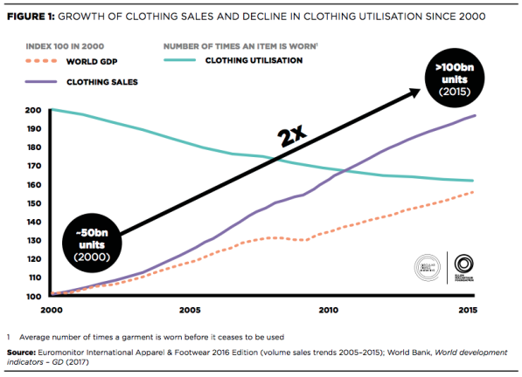
Figure 1 Clothing sales and utilisation from 2000-2015.
The world economic forum places current sales at 150 bn items per year, a further 40 % increase compared to the 107 billion in 2016 .
Despite significant environmental impacts, clothing continues to be seen as disposable, and recycling of used clothing is minimal.
Social media likely exacerbates the issue. With brands constantly trying to reduce lead times (Figure 2), promote micro-trends, feature in influencer videos, and reduce costs, a culture of overconsumption is practically unavoidable.
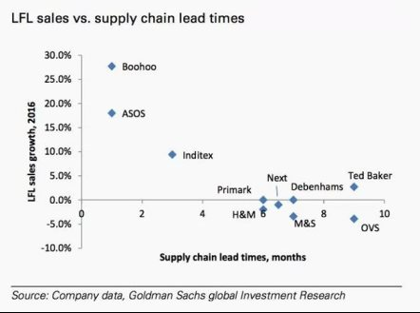
Figure 2. Sales growth and lead times for various companies in 2016.
Fashion brands have been practically immune to backlash despite the public being aware issues throughout the fashion supply chain. Reports of forced labour and unsafe working conditions , in addition to the environmental impacts, have not impacted consumer spending. Nevertheless, “greenwashing” has been prevalent in the industry – 60 % garments advertised as being made from recycled polyester (rPET) have been found to contain no rPET at all , and most rPET is from “pre-consumer” plastic. rPET usage is unfortunately low due to cost and availability of virgin plastics.
Ethics & Sustainability – Impacts on RiSC Aims & Objectives
Fast fashion, by the sheer volume of consumption, is problematic for supply chain resiliency. Diversification (at any stage) in the supply chain is one example to make a more resilient supply chain, but with volume growth accelerating, it is difficult to implement changes which impact a substantial fraction of the industry. It also dissuades the implementation of any change that is not rapidly scalable, making it difficult for recycled materials to become a new supply route. Brand-image resiliency is similarly problematic. If every major brand is sourcing low quality garments from unethical suppliers, it is not possible for consumers to “vote with their wallets”. Since profit margins from maintaining the status quo are so high, there is also no incentive to break it, perpetuating the same vulnerable supply chains.
From Earth to Consumer – How Clothing is Produced
Poly(ethylene terephthalate), known as PET or simply polyester, is produced by polycondensation of ethylene glycol (known as monoethylene glycol or MEG in the industry) and terephthalic acid (known as purified terephthalic acid or PTA). Ethylene glycol is produced by hydrogenating ethylene oxide (EO), which is oxidized from the natural gas extract ethylene. Production of ethylene glycol is energy intensive, so generally happens domestically where the gas is extracted. Ethylene glycol is exported via (liquid) chemical tanker and used for production of PET.
PTA is produced from para-Xylene (xylene) in specialised PTA plants. PTA production proceeds via multi-step synthesis of crude terephthalic acid, which uses toxic chemicals such as bromine, cobalt and manganese. It is then purified in another multi-step process.
MEG and PTA are then reacted to create the raw polymer, known as PET resin, which normally takes the form of pellets. The pellets are spun by melting the pellets and forcing the melt through a die containing several holes, not dissimilar to a showerhead. After the fibres come out of the die, they are stretched and spun to create yarn. The yarn is woven to create lengths of textile fabric. Dying can take place at any stage after spinning.
The woven fabric is prepared for assembly by cutting pre-designed “patterns”. For commercial pieces, this is done by laser-cutting for speed and accuracy. Once the segments of the garment are cut, they transported to factories where workers sew together the garments by hand. For garments with printed elements, this takes place after assembly.
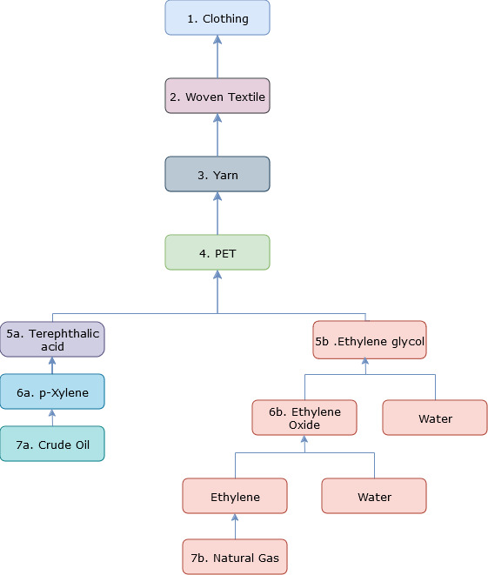

Reimagining the UK Fashion Supply Chain – Challenges and Opportunities
The context surrounding the fashion industry presents substantial challenges to improving the resilience of the UK supply chain. The most obvious suggestion is to re-establish the UK garment industry, but in order to be price-competitive with overseas suppliers, UK textile factories have paid their workers as little as £3 per hour in some cases . A multi-faceted approach is required to enact meaningful change.
Potential Industry Contacts
There are several contacts I think could have information that could help steer the project:
- Chemical/Process Engineering –
  - Ineos – the 4th largest chemical conglomerate in the world, operates several plants that are important in polyester, nylon and aramid production, and have joint ventures in the China PET industry. They are UK-based, and owner Sir Jim Ratcliffe has spoken publicly about UK policy issues that he believes are killing the industry.
  - Johnson Matthey – UK based. Holds IP and jointly developed a new PTA production method in conjunction with Dow. Could have insights on technical challenges and knowledge of UK chemical industry capabilities.
- Polymer Processing –
  - British Plastic Foundation – the foundation publishes a detailed and comprehensive list of plastic companies and their specialises. For example, it might be of interest to discuss yarn production and PET sourcing with a company that has experience in extrusion and working with PET.
- Fashion brands –
  - ASOS, Bohoo, H&M, M&S etc. – Fairly straightforward, they are known especially for fast fashion which I believe is a significant barrier to improving resiliency. Understanding their thought processes could give valuable insight.
- Recycling –
  - Roberts Recycling Ltd. – The largest in the UK market. Operates the collection, sorting and resale of used clothing. Could give insight into the difficulties of garment recycling and hurdles to overcome to achieve garment-to-garment recycling.
  - HissyFitClothing – A small business, but I believe could give a unique and valuable perspective. They are the only company that I am aware of that is completely sustainable. They take deadstock fabric (i.e. clothes and fabric that didn’t sell or be put on sale) and create new clothing with it. They would have knowledge on things like the scale of waste in the industry, the technical details about fabric, what can and can’t be recycled, feasibility of scaling the idea etc.. Their focus is on sustainability, but it is also a potential alternative supply route.
- NGOs –
  - TextileExchange – Previously gave parliamentary evidence on fast fashion and the information was extremely valuable to me in this project. TextileExchange is active in promoting recycled fibres and would have information on the supply chains in the recycling space.
- Garment Manufacturers –
  - UK Fashion and Textile Association – similar to above, they also gave parliamentary evidence. They represent UK fabric and garment manufacturers, and run B2B sales events where UK manufacturers showcase their products.

http://data.parliament.uk/writtenevidence/committeeevidence.svc/evidencedocument/environmental-audit-committee/sustainability-of-the-fashion-industry/written/88459.html#_edn21
https://fashionunited.com/statistics/global-fashion-industry-statistics/overview
https://www.bbc.co.uk/news/world-asia-22476774
https://www.gov.uk/cma-cases/asos-boohoo-and-asda-greenwashing-investigation
https://www.bbc.co.uk/future/article/20230206-fabric-fraud-how-to-spot-fake-fabric-claims
https://textileexchange.org/app/uploads/2024/09/Materials-Market-Report-2024.pdf
https://www.telegraph.co.uk/business/2017/03/04/fresh-powers-shut-uks-clothing-sweatshops/

