AMD GPU 在GCN之前的发展过程：
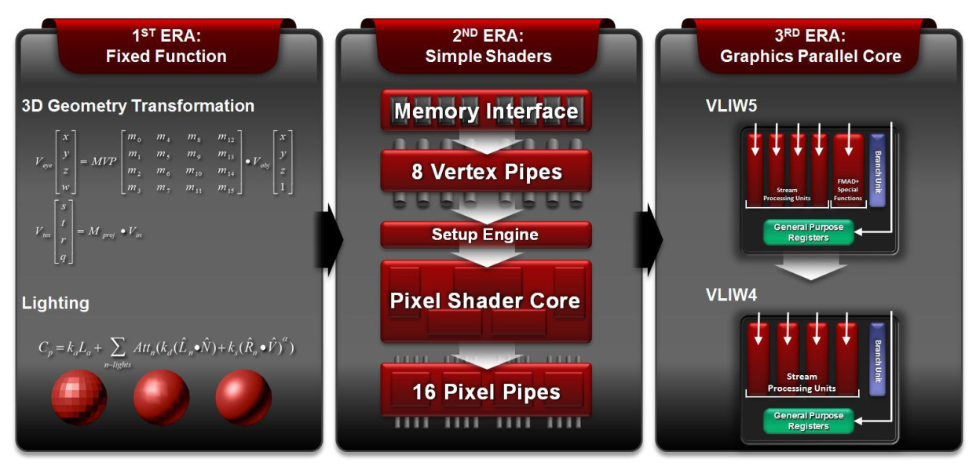

The shader arrays in earlier generations of AMD GPUs consisted of a number of SIMD engines, each of which consisted of up to 16 ALUs. Each ALU could execute bundles of 4 or 5 independent instructions co-issued in a VLIW (Very Long Instruction Word) format, with the shader compiler being largely responsible for scheduling and fnding co-issue opportunities. SIMD engines were issued groups of 64 work items, called wavefronts, and would execute one wavefront at a time. This design aligned well with a data ﬂow pattern is very common in graphics processing (for manipulating RGBA color values in a pixel shader, for example), making it possible to sustain high levels of utilization in most cases. However, the underlying data formats can be more complex and unpredictable for general purpose applications, making it more diffcult to consistently fnd sets of 4 or 5 independent operations that could execute in parallel every cycle and keep the processing resources fully utilized.
In GCN, each CU includes 4 separate SIMD units for vector processing. Each of these SIMD units simultaneously executes a single operation across 16 work items, but each can be working on a separate wavefront. This places emphasis on fnding many wavefronts to be processed in parallel, rather than relying on the compiler to fnd independent operations within a single wavefront.
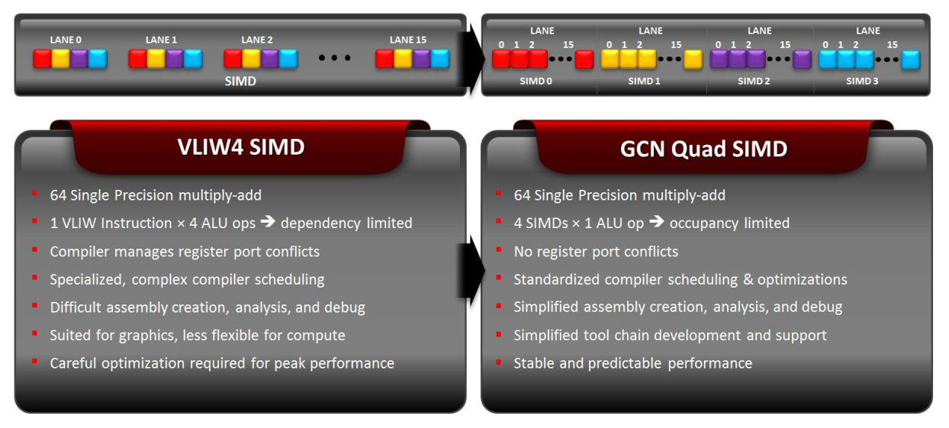
For effciency, the SIMDs in each GCN compute unit have a combination of private and shared resources. The instruction buffering, registers and vector ALUs are private for each of the 4 SIMDs to sustain high performance and utilization. Other resources, such as the front-end, branch unit, and data cache are shared between the SIMDs to achieve area and power effciency.
