Nvidia GPU 架构
Tesla 架构
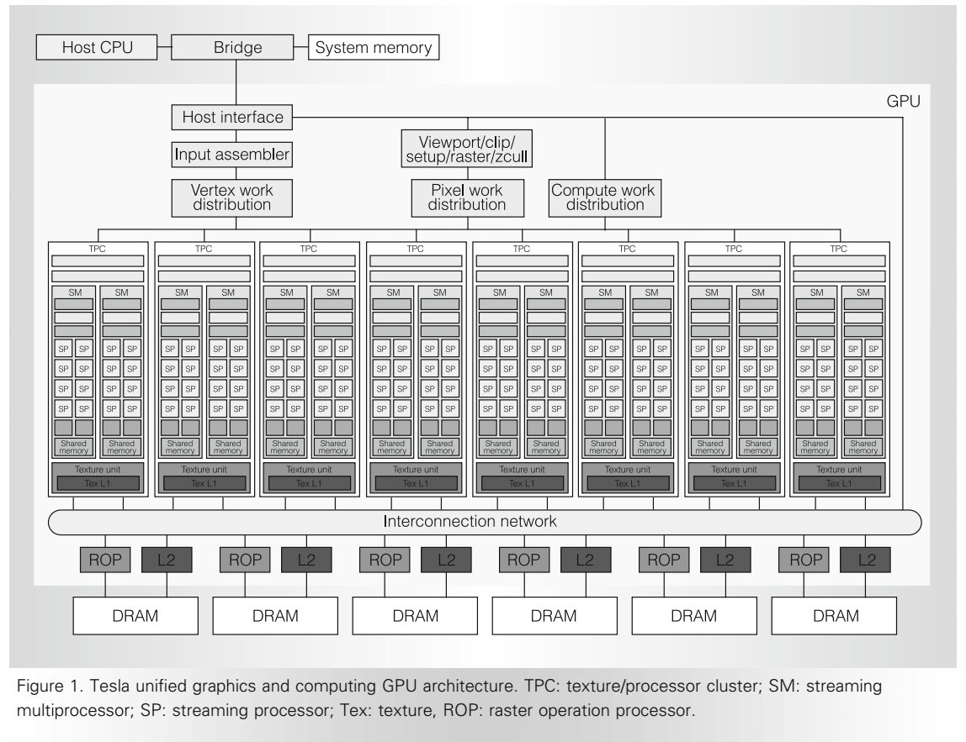
1) The scalable memory system consists of external DRAM control and fixed-function raster operation processors (ROPs) that perform color and depth frame buffer operations directly on memory.
2) GPU’s scalable streaming processor array (SPA) performs all the GPU’s programmable calculations. An interconnection network carries computed pixel-fragment colors and depth values from the SPA to the ROPs
3) The input assembler collects geometric primitives (points, lines, triangles, line strips, and triangle strips) and fetches associated vertex input attribute data.
4) The work distribution units forward the input assembler’s output stream to the array of processors, which execute vertex, geometry, and pixel shader programs, as well as computing programs. The vertex and compute work distribution units deliver work to processors in a round-robin scheme. Pixel work distribution is based on the pixel location

Each TPC contains a geometry controller, an SM controller (SMC), two streaming multiprocessors (SMs), and a texture unit.
1) The geometry controller maps the logical graphics vertex pipeline into recirculation on the physical SMs by directing all primitive and vertex attribute and topology flow in the TPC.
2) SM consists of eight streaming processor (SP) cores, two specialfunction units (SFUs), a multithreaded instruction fetch and issue unit (MT Issue), an instruction cache, a read-only constant
cache, and a 16-Kbyte read/write shared memory
3) The SM uses the TPC texture unit as a third execution unit and uses the SMC and ROP units to
implement external memory load, store, and atomic accesses.

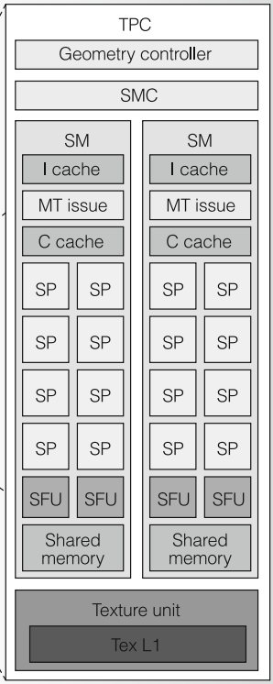

4) To efficiently execute hundreds of threads in parallel while running several different programs, the SM is hardware multithreaded. It manages and executes up to 768 concurrent threads in hardware with zero scheduling overhead. Each SM manages a pool of 24 warps, with a total of 768 threads.

Fermi 架构
Streaming Multiprocessor (SM)
1) 32 CUDA cores per SM, 4x over GT200, 16 SMs of 32 cores each
2) Dual Warp Scheduler simultaneously schedules and dispatches instructions
from two independent warps
3) 64 KB of RAM with a configurable partitioning of shared memory and L1 cache
4) Designed for Double Precision
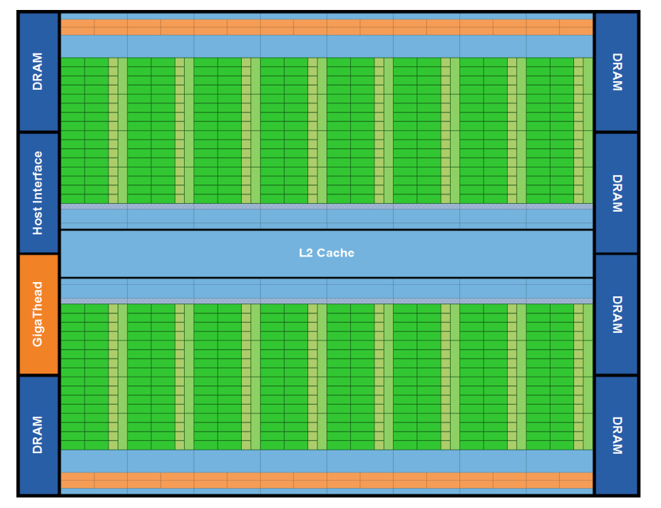
1) The GigaThread global scheduler distributes thread blocks to SM thread schedulers.
2) Fermi features a 768 KB unified L2 cache that services all load, store, and texture requests
3) The GPU has six 64-bit memory partitions, for a 384-bit memory interface, supporting up to a total of 6 GB of GDDR5 DRAM memory
4) On the Fermi architecture, different kernels of the same CUDA context can execute concurrently, allowing maximum utilization of GPU resources. Kernels from different application contexts can still run sequentially with great efficiency thanks to the improved context switching performance.
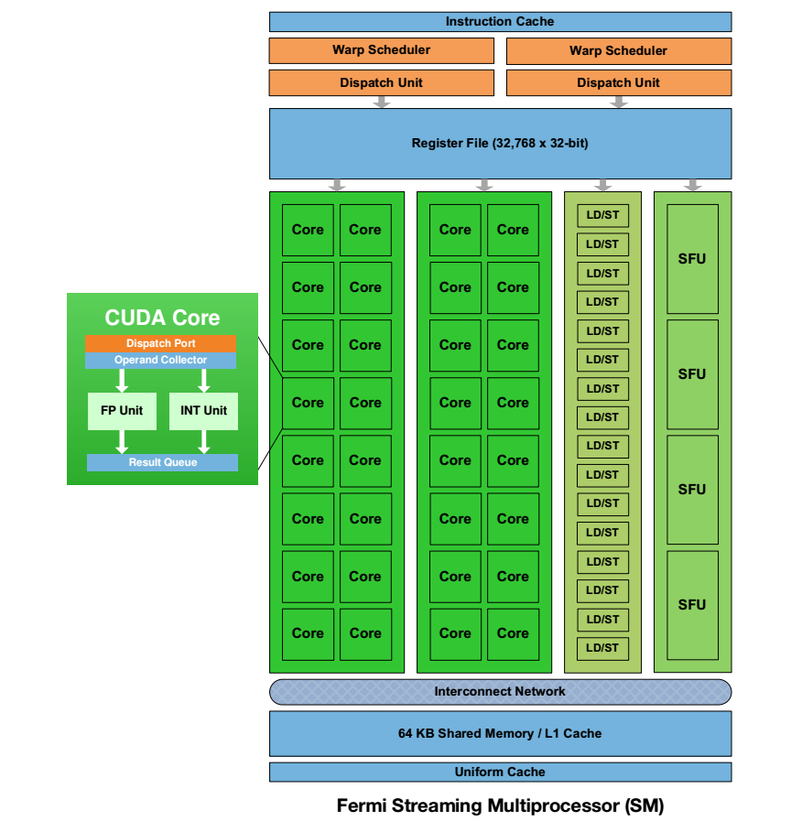
1) Each SM has 16 load/store units, allowing source and destination addresses to be calculated
for sixteen threads per clock.
2) 4 Special Function Units (SFUs) execute transcendental instructions such as sin, cosine,
reciprocal, and square root. Each SFU executes one instruction per thread, per clock; a warp
executes over eight clocks.
3) Up to 16 double precision fused multiply-add operations can be performed per SM, per clock.
4) Each SM features two warp schedulers and two instruction dispatch units, allowing two warps to be issued and executed concurrently.
Fermi’s dual warp scheduler selects two warps, and issues one instruction from each warp to a group of sixteen cores, sixteen load/store units, or four SFUs.
5) G80 and GT200 have 16 KB of shared memory per SM. In the Fermi architecture, each SM has 64 KB of on-chip memory that can be configured as 48 KB of Shared memory with 16 KB of L1 cache or as 16 KB of Shared memory with 48 KB of L1 cache
