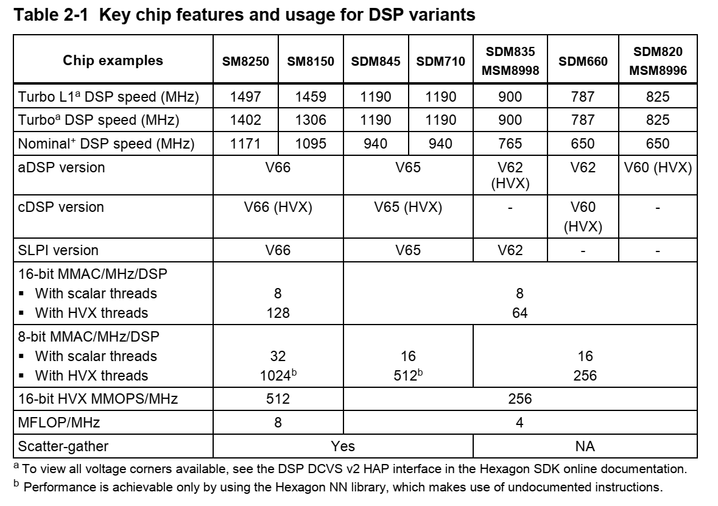
All DSPs include a scalar unit, and some DSPs also include a HVX unit for extended vectorized support
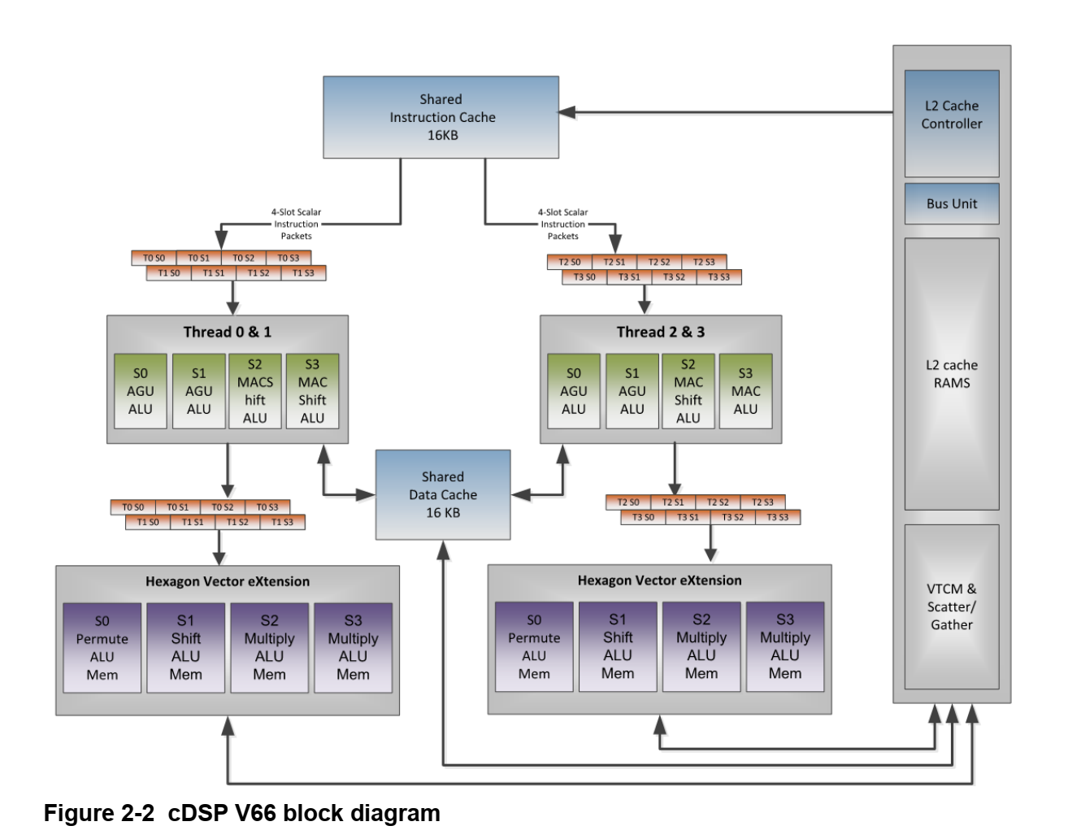
4 DSP hardware threads,:
- Each DSP hardware thread has access to the Hexagon scalar units, which performs fixed-point and floating operations on single or pairs of 32-bit registers
- Each Data Unit is capable of performing a load or store up to 64-bit wide, or 32-bit scalar ALU operation
- Each Execution Unit is capable of 16/32/64-bit vectorized multiply, ALU, bit manipulation, shift or floating-point operations
V66之前，所有的EU共享一套标量浮点和乘法器资源，所以所有的combined硬件线程在每一个cycle只能最多执行一个硬件操作。从V66开始，每个cluster都有了它自己的一套浮点和乘法器计算资源。
A cluster refers to a pair of threads (Thread 0&1 and Thread 2&3). Within a cluster, the
two threads typically commit instruction packets on alternating clock cycles because
most instructions require at least two clock cycles to complete 交替发射，交替执行

HVX is an optional coprocessor that adds 128-byte vector processing capabilities to the scalar DSP unit. Scalar hardware threads use the HVX coprocessor by accessing an HVX register file, also referred as HVX context. Two 128-byte HVX contexts are available on all HVX-enabled aDSPs and cDSPs up through the SM8250 device

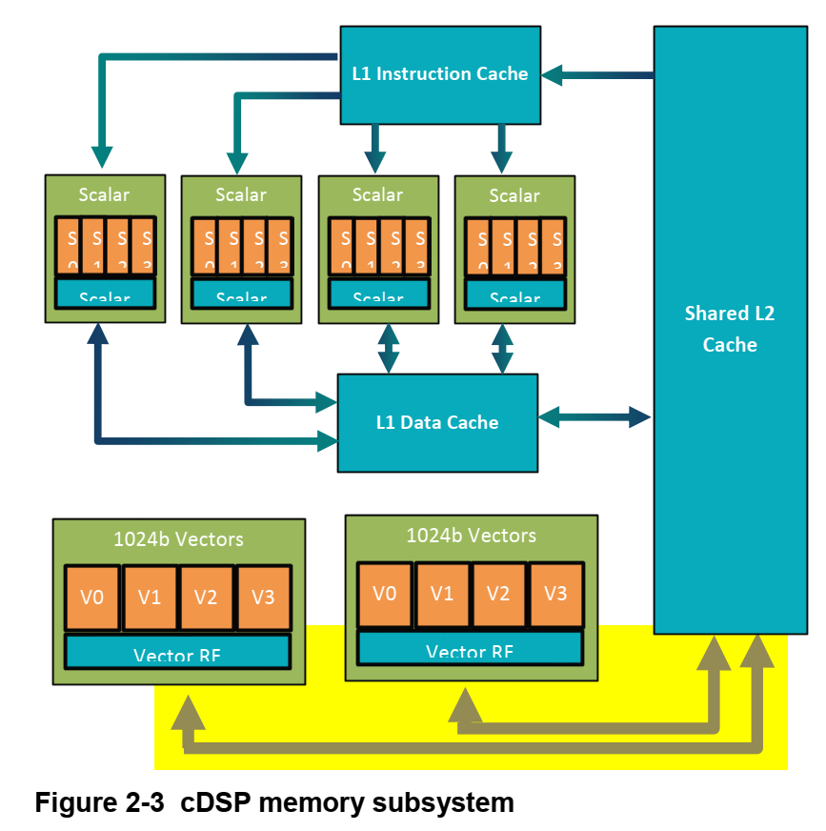
The cDSP has a two-level cache memory subsystem. L1 is only accessible to the scalar unit, making L2 the second level memory for the scalar unit and the first level memory for the HVX coprocessor.
On SM8150 and SM8250 devices, the L2 memory size is extended to 1 MB
The SDM845 and newer devices also include a 256 KB Vector Tightly Coupled Memory (VTCM) that sustains a higher throughput than L2. This memory can be used as a scratch buffer to achieve higher performance. VTCM is also required as the source and destination of a few select operations such as scatter-gather.

Each hardware thread is capable of executing a packet of up to four instructions in a given thread cycle. Instructions occurring in a packet executes in parallel, making it possible within one packet to consume a register and update its content at the same time.
The simplest way to understand the impact of resource constraints on grouping with V66 is to think simply in terms of slots. Because of the resources they use, each type of instruction can only execute on one specific slot, out of four available. For example, logical and multiply operations consume either slot 2 or 3, whereas a load instruction consumes either slot 0 or 1. This means that at most two logical operations, or one logical and one multiply operation, or two multiply operations can execute in a single packet
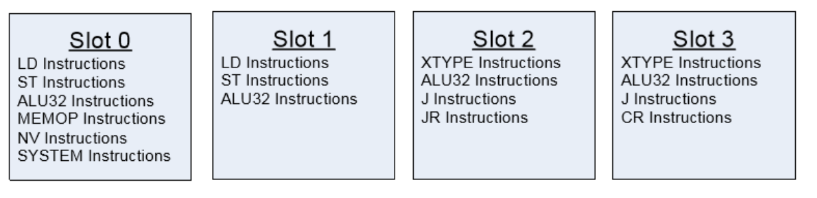
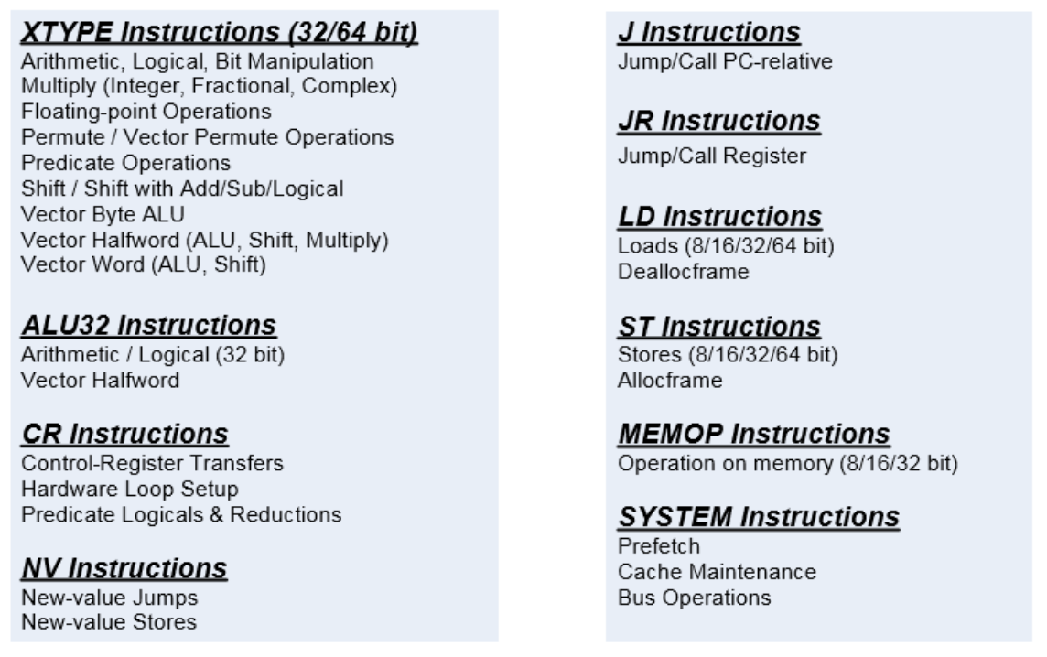

Each hardware thread is capable of executing a packet of up to four instructions in a
given thread cycle. Instructions occurring in a packet executes in parallel, making it
possible within one packet to consume a register and update its content at the same
time.
Scalar instruction packing rules：resource constraints
The simplest way to understand the impact of resource constraints on grouping with V66
is to think simply in terms of slots. Because of the resources they use, each type of
instruction can only execute on one specific slot, out of four available. For example,
logical and multiply operations consume either slot 2 or 3, whereas a load instruction
consumes either slot 0 or 1. This means that at most two logical operations, or one
logical and one multiply operation, or two multiply operations can execute in a single
packet.
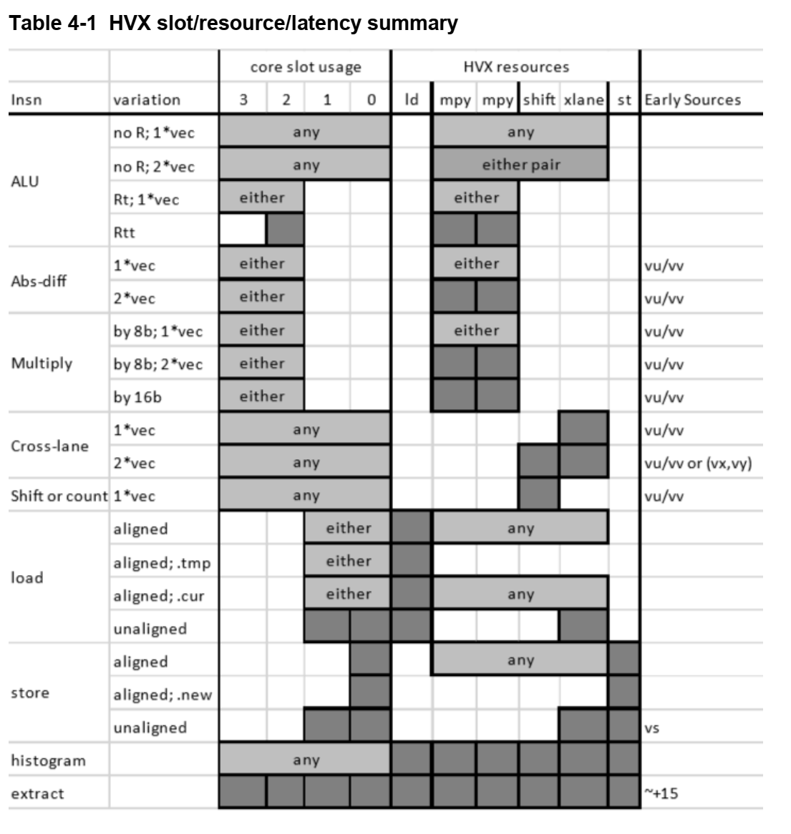
Unlike scalar stores, you cannot group two HVX stores in a single packet

HVX features
- Vector length：1024-bit vectors (128B)
- Vector contexts：A vector context consists of a vector register file, vector predicate file, and the ability to execute instructions using this state。Multiple hardware threads can execute in parallel, each with a different vector context
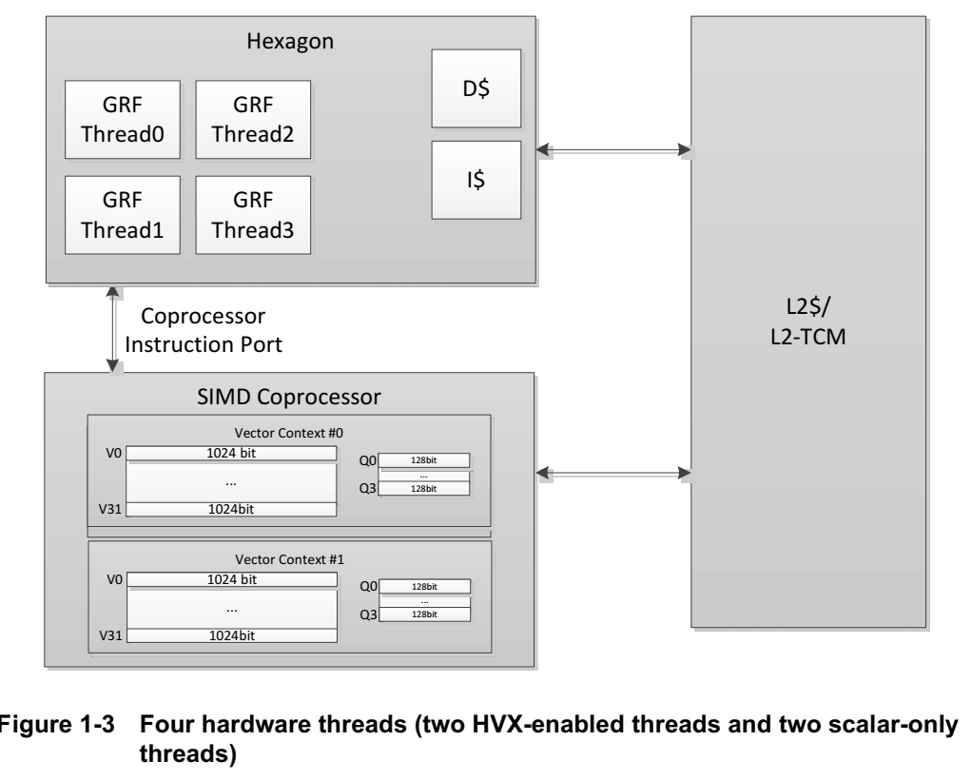
The Hexagon scalar core can contain any number of hardware threads greater or equal to
the number of vector contexts. In this configuration, two of the threads can execute 128 vector instructions, while the other two threads can execute scalar-only instructions.
- Memory access: The HVX memory instructions (referred to as VMEM instructions) use the Hexagon general registers (R0-R31) to form addresses that access memory
- Vector registers : HVX has two sets of registers: Data registers consist of 32 vector length registers ; Predicate registers consist of 4 registers each with 1 bit per byte of vector length, Vector predicate registers hold the result of vector compare instruction
- Vector compute instructions: Vector instructions process vector register data in SIMD fashion

HVX memory access alignment:
- When using a general VMEM load or store, the least-significant bits of the address are ignored
VMEM(R0) = V1 // Store to R0 & ~(0x3F) 4字节对齐？
- Unaligned loads and stores are also explicitly supported through the VMEMU instruction
V0 = VMEMU(R0) // Load a vector from R0 regardless of alignment

HVX local memory: VTCM
HVX also supports a local memory called VTCM, which is used for scratch buffers and
scatter/gather operations. Use VTCM for intermediate vector data, or as a temporary buffer. It serves as the input or output of the scatter/gather instructions. Gather for HVX is a vector copy from non-contiguous addresses to an aligned contiguous vector location. If the input data of gather is in DDR, it must first be copied to VTCM and then gathered from there. Gather cannot be done directly on DDR or L2$ contents. Vector gather (vgather) operations transfer elemental copies from a large region in VTCM to a smaller vector-sized region in VTCM. Each instruction can gather up to 64 elements.
HVX is designed to work with L2 cache, L2TCM, or VTCM. Memory should be marked as L2-cacheable for L2 cache data and uncached for data that resides in L2TCM or VTCM.

Marking an instruction non-temporal indicates to the micro-architecture that the data is no longer needed after the instruction. The cache memory system uses this information to inform replacement and allocation decisions. On the last use of data, use the “:nt” attribute.

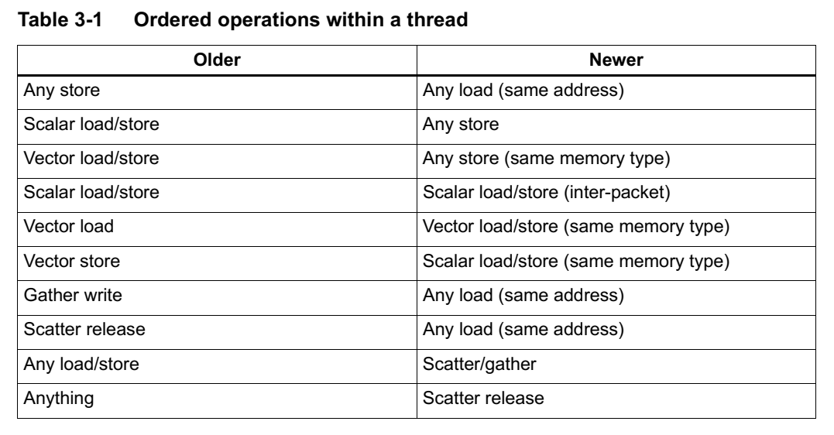

The HVX vector processor is attached directly to the L2 cache. VMEM loads/stores move data to/from L2 and do not use L1 data cache. To ensure coherency with L1, VMEM stores check L1 and invalidate on hit.

A VMEM load instruction that follows a VMEM store to the same address incurs a storeto-load penalty. The store must fully reach L2 before the load starts, thus the penalty can be quite large. To avoid store-to-load stalls, there should be approximately 15 packets of intervening work.

L2FETCH is best performed in sizes less than 8 KB and should be issued at least several hundred cycles prior to using the data.
It is common for algorithms to use the vector engine to produce some results that must be further processed on the scalar core. The best practice is to use VMEM stores to get the data into L2, then use DCFETCH to get the data in L1, followed by scalar load instructions. The DCFETCH can be executed anytime after the VMEM store, however, software should budget at least 30 cycles before issuing the scalar load instruction.

Minimize the density of scatter and gather instructions. Spread out these instructions in a larger loop rather than concentrating them in a tight loop.

Distribute accesses across the intra-vector address range (lower address bits). Even distribution across the least significant inter-vector address bits can also be beneficial. For V66, address bits [7:1] are important to avoid conflicts.

HVX provides six resources for vector instruction execution: load, store, shift, permute, two multiply. VLIW packets cannot oversubscribe resources. An instruction packet can contain up to four instructions, plus an endloop.
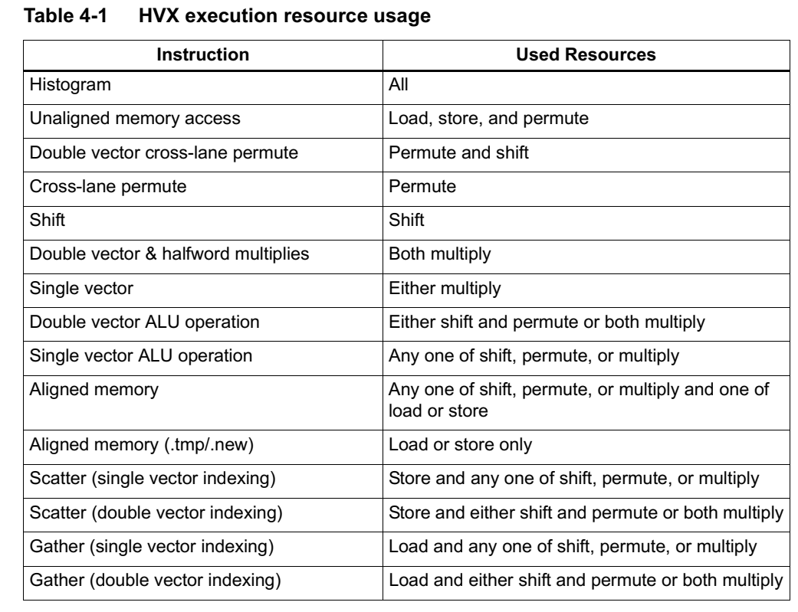
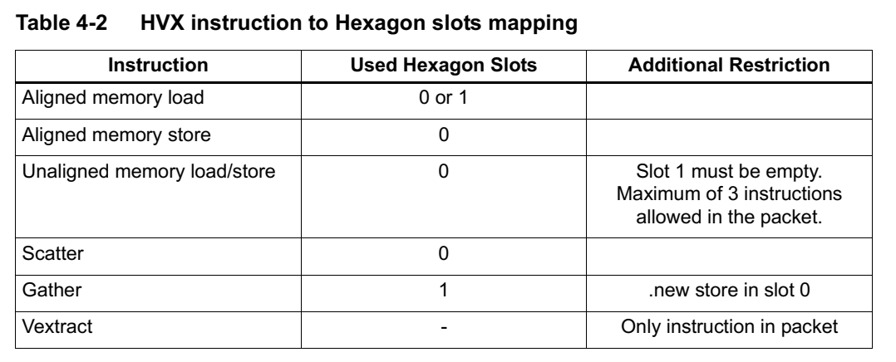
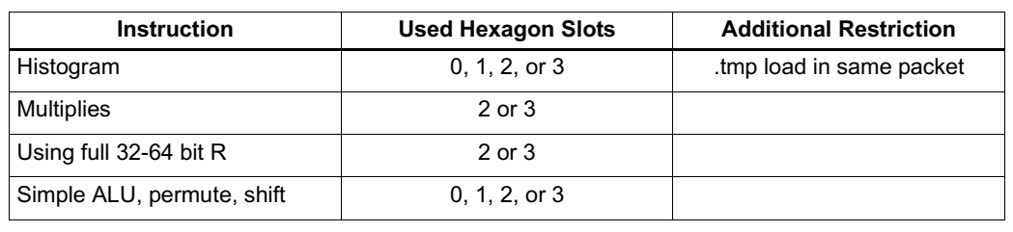

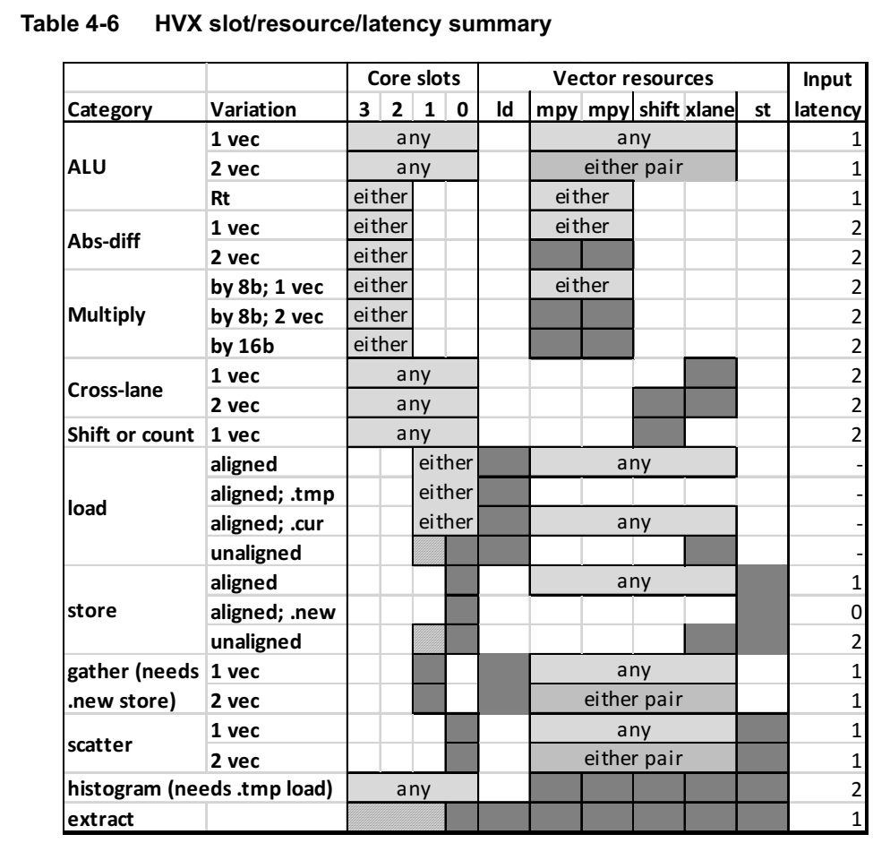

Hexagon DSP
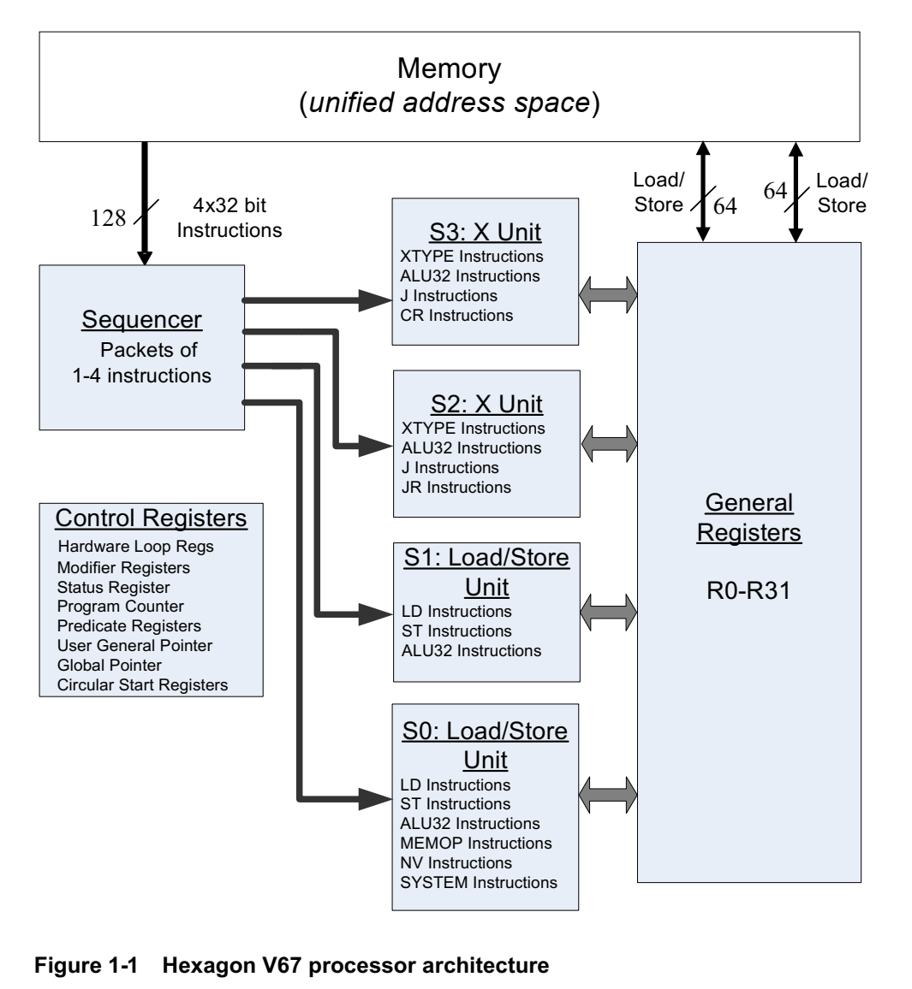

In many cases, a predicate or general register can be both generated and used in the same
instruction packet. This feature is expressed in assembly language by appending the suffix
“.new” to the specified register.

