Development environment configuration

一. Set Environment variable
You can read the readme-first.doc and readme-second.doc.
二. Setup the GIT Environment :
- Copy the Dev tools \\192.168.1.19\Development\Stratus\Software\Git-1.8.3-preview20130601.exe.
- Setup the Git with default config.
- Config Git account.
> git config – global user.name “Stratus-Presentation-API@agumentum.com"
> git config – global user.email “stratusapi123”
- Create your workspace. For example path: ”D:\workspace”
- Clone the repository into the workspace.
> git clone https://github.com/Stratus-Presentation-API/CloudMgmtSDK.git
> git clone https://github.com/Stratus-Presentation-API/CloudMgmtApi.git
> git clone https://github.com/Stratus-Presentation-API/CloudCommon.git
> git clone https://github.com/Stratus-Presentation-API/spc-presentation-api.git
> git clone https://github.com/Stratus-Presentation-API/spc-ui-implementation.git

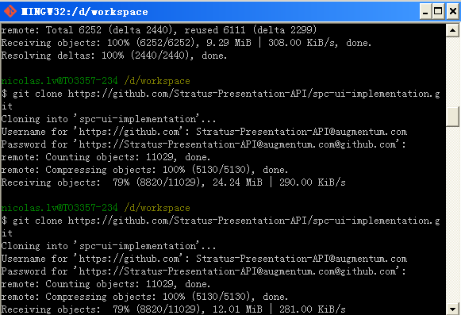

三. Import the workspace to your eclipse:
- Import maven project to your eclipse.
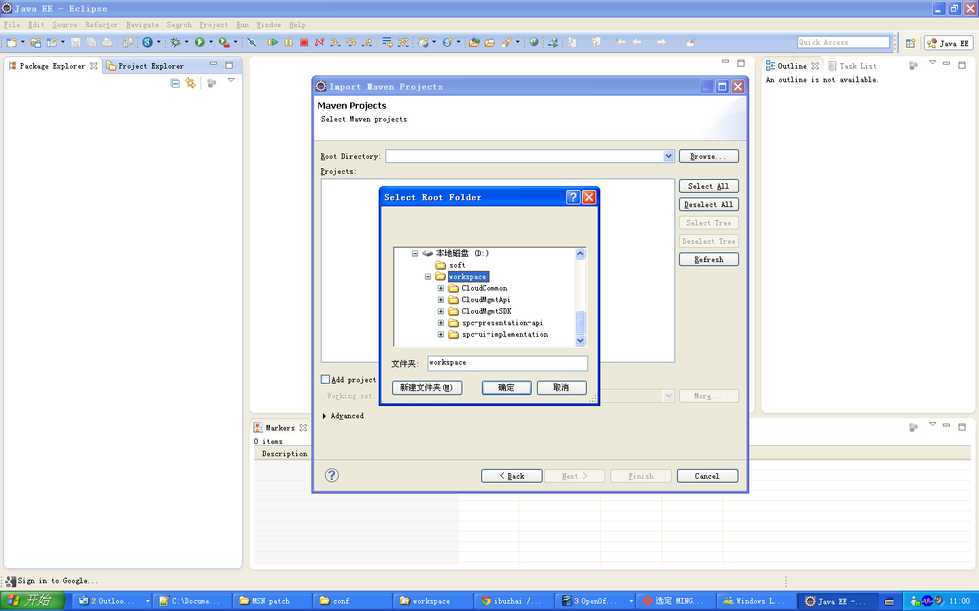
Then will appear error following PNG

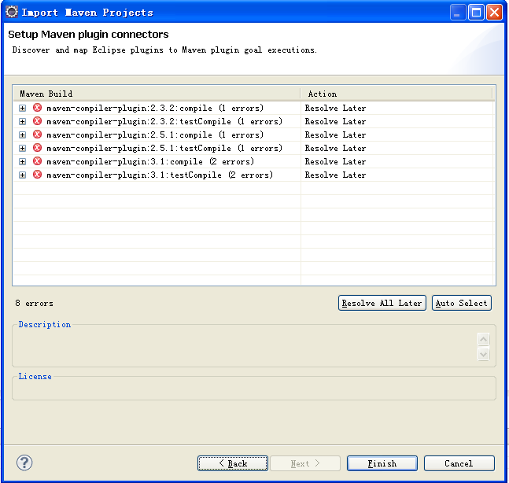

If import error, see the error information, you will find that the maven environment error, ignore this, and click the finish button.

Fix error.
First use the hot key “Alt + F5” to update maven project, then maven will fetch the jar libs from the maven center.

If success, you will not see the error on your project,

If failure, then you need to add a element mirror to your maven settings xml and the profile element. And you also can see the template from the \\192.168.1.19\Development\Stratus\Documents\API design\settings.xml

<mirror>
<id>nexus</id>
<mirrorOf>*</mirrorOf>
<name>nexus</name>
<url>http://192.168.1.105:8081/nexus/content/repositories/central/</url>
</mirror>
At last also use the hot key “Alt + f5” to refresh your workspace.

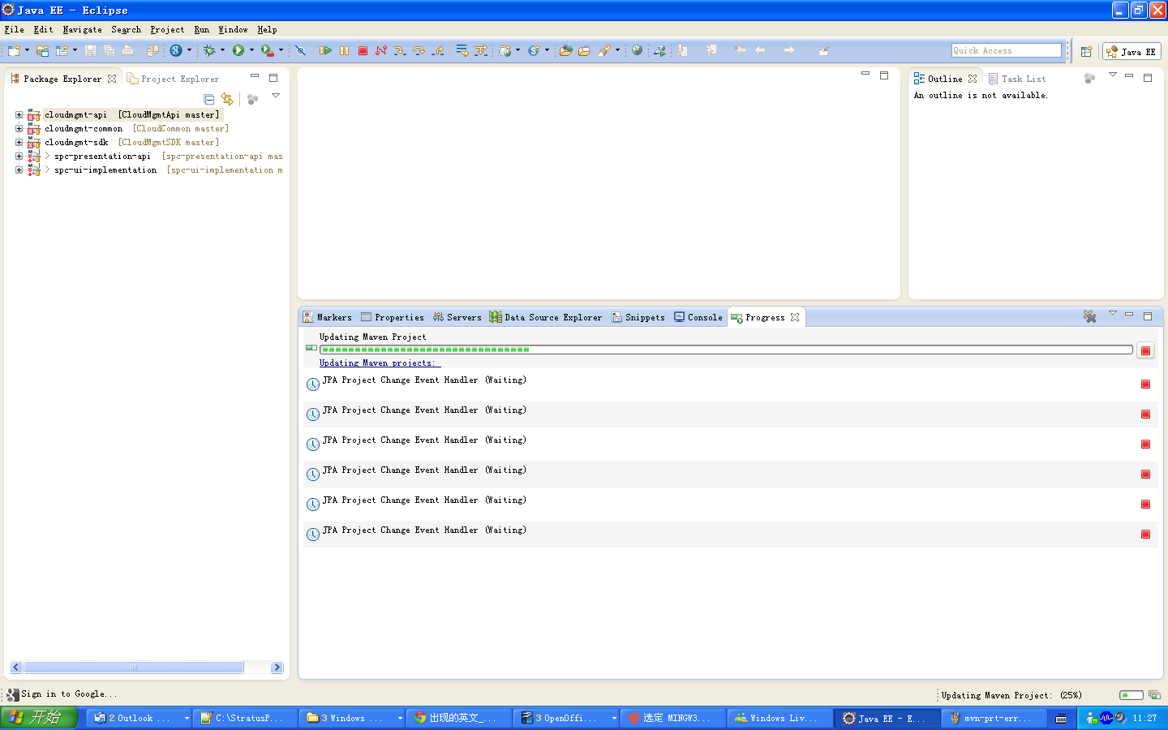

四. DB Enviroment:
- Copy \\192.168.1.19\Development\Stratus\From customer\131025\CloudMgmtDeploy1.zip.
- Unzip to C root.
- Remove the C:\CloudMgmtDeploy1\DataStax Community\data folder.
- Copy \\192.168.1.19\Development\Stratus\From customer\elasticsearch-0.90.7.zip.
- Unzip to C root.
- Remove the C:\elasticsearch-0.90.7\data folder.

五. Python install
- Set up python \\192.168.1.19\Development\Stratus\Software\python-2.7.3.msi.

六. Install jetty plugins in eclipse and init DB

- Find “jetty” in marketplace.
- Add “jetty” plugin to the eclipse.
- Start data base server : "C:\CloudMgmtDeploy1\DataStax Community\apache-cassandra\bin\cassandra.bat".
- Start elasticsearch server : “C:\elasticsearch-0.90.7\bin\elasticsearch.bat”
- Send GET request: http://localhost:8080/api/user/dbinit/SAMPLE/NOCLOUD

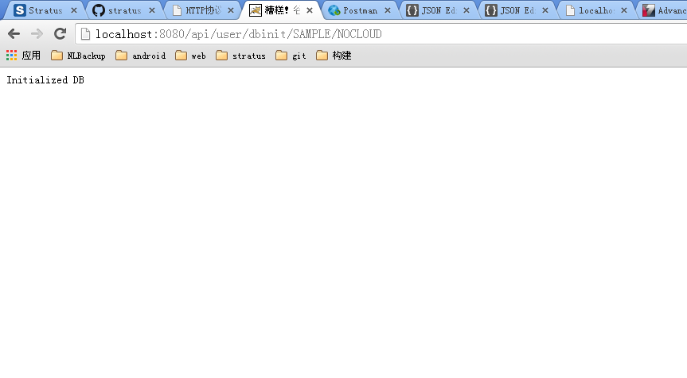
If you look this , that means your cassandra db init successed.
- Run cmd : "C:\CloudMgmtDeploy1\DataStax Community\python\python.exe" "C:\CloudMgmtDeploy1\DataStax Community\apache-cassandra\bin\cqlsh"
- Run cmd : desc keyspaces;
- And chose a database “cloudmgmttx”, excute cmd : use cloudmgmttx;
- Excute cmd : select cloudprovideridentifier from cloudmgmttx.cloudprovider;
- Excute cmd : update cloudmgmttx.cloudprovider set keystoneendpoint='http://192.168.234.2:5000/v2.0' where cloudprovideridentifier=[uuid];

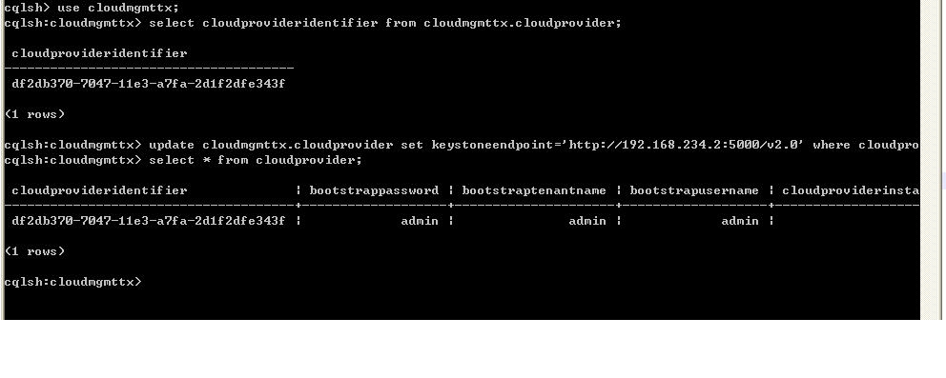

- Setup the chrome Postman tool - the rest client, you can get it from Google store.
- Right click the cloudmgmt-api project, chose the “run” menu and select the menu “Run Configuration...”.

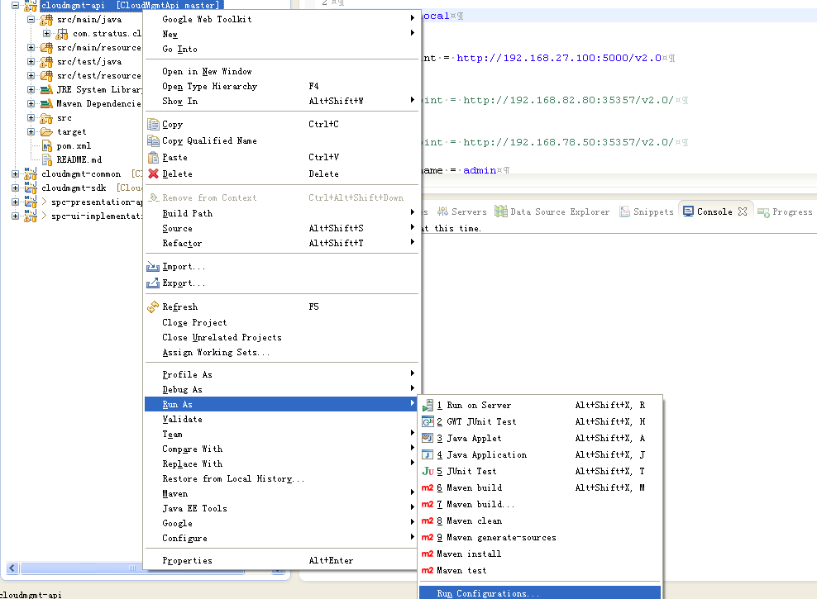

- Create a Jetty server and run.

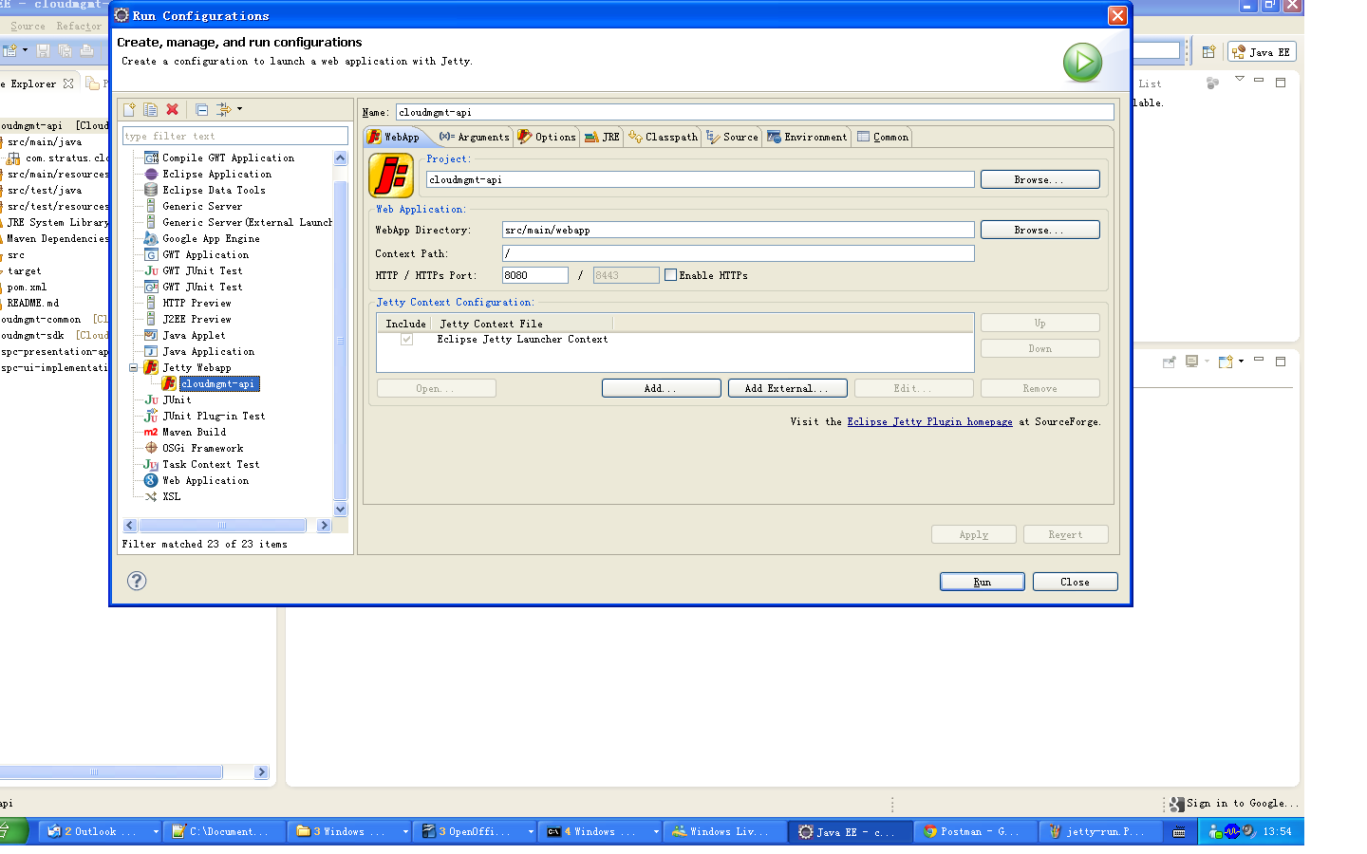

- Using the Postman tool to try login, and get the authtoken UUID.
POST: http://localhost:8080/api/user/login
with body:
{
“login”:{
“username”:”IT Admin”,
“password”:”pwd”
}
}
If you look following PNG , that mean you successed.
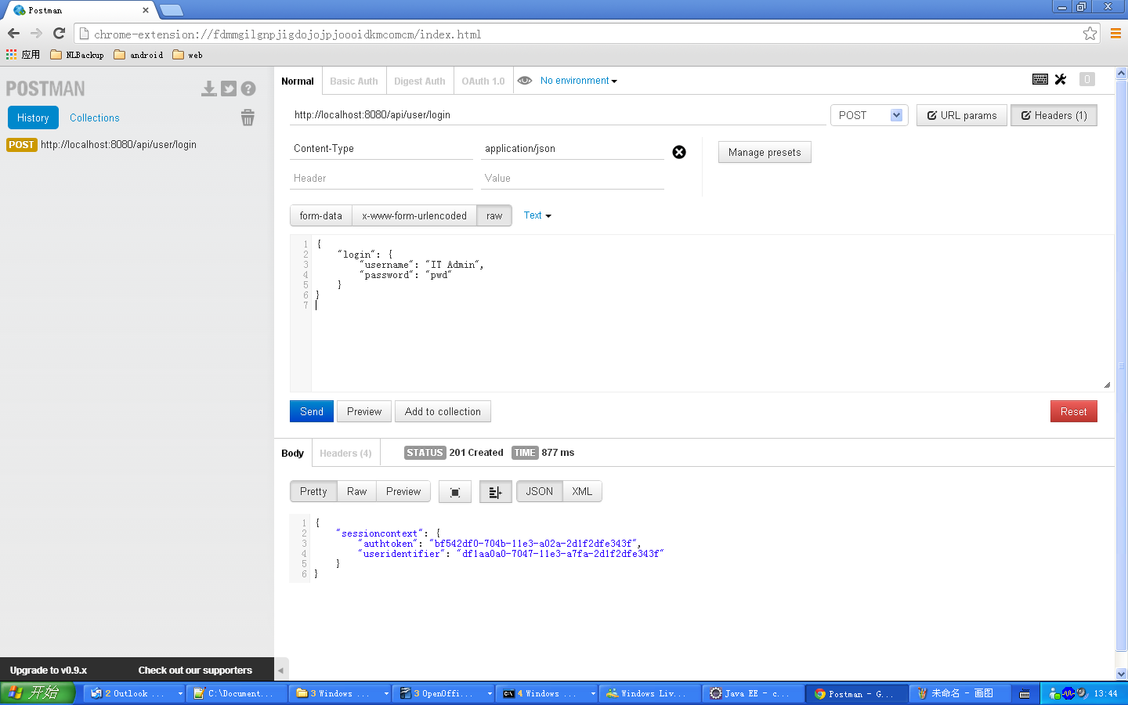

七. Package and install
Use Maven cmd to generate CloudMgmtApi project to root war and remove the war the jetty webapps package.
- Select the D:\workspace\CloudMgmtSDK package.
- Run cmd: mvn clean
- Run cmd: mvn package -DskipTests
- Run cmd: mvn install -DskipTests
- Select the D:\workspace\CloudCommon package.
- Run cmd: mvn clean
- Run cmd: mvn package -DskipTests
- Run cmd: mvn install -DskipTests
- Select the D:\workspace\CloudMgmtApi package.
- Run cmd: mvn clean
- Run cmd: mvn package
- Copy the root.war to the jetty webapps package.
- Select the D:\workspace\spc-presentation-api package.
- Run cmd: mv clean
- Run cmd: mvn package -DskipTests
- Copy the spc-presentation-api.war to the jetty webapps package
- Start the jetty server, and using the Postman to to try login.

POST: http://localhost:8080/spc-presentation-api/login
with body:
{
“login”:{
“username”:”IT Admin”,
“password”:”pwd”
}
}
If you look the following PNG, that means you can access the server.

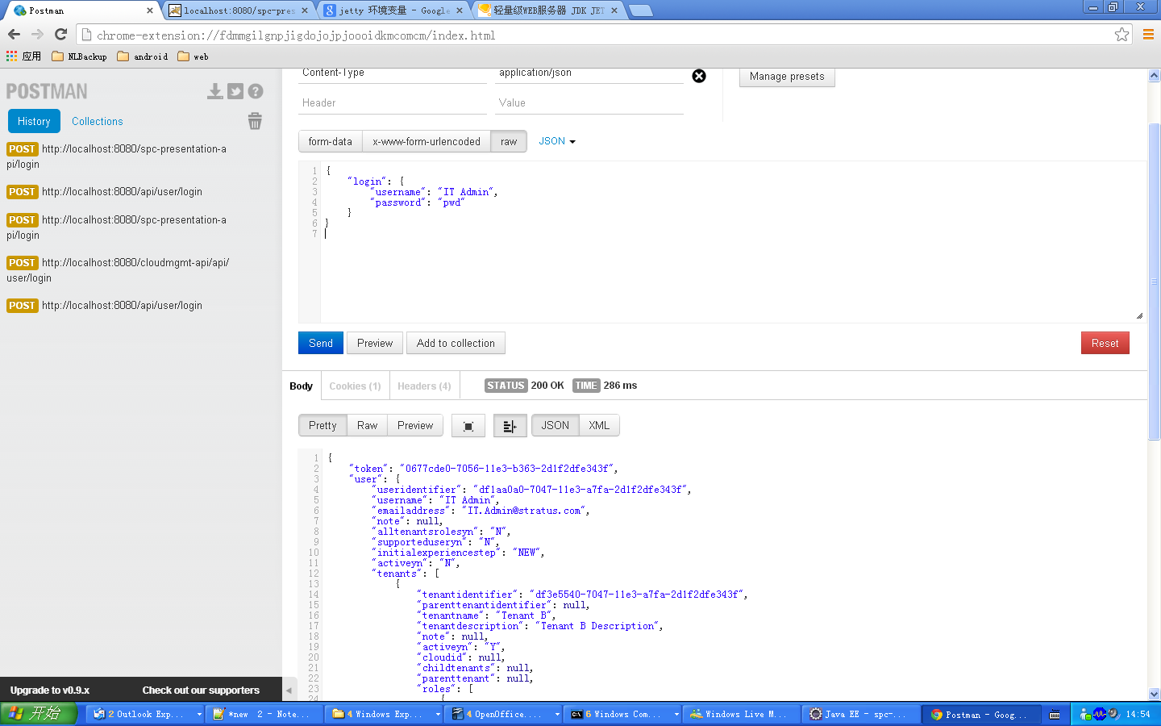
- D:\workspace\spc-ui-implementation>mvn clean
- D:\workspace\spc-ui-implementation>mvn package -DskipTests
- Copy the cloud war to jetty wabapps package
- Open browse and input http://localhost:8080/cloud
If you look the following PNG, means success.

