Development environment configuration

一. Set Environment variable
You can read the readme-first.doc
二. Eclipse configuration :
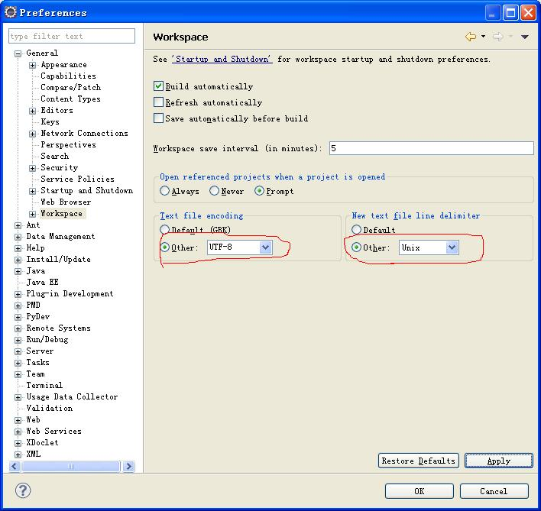
1、windows->Preferences.->general->Workspace，

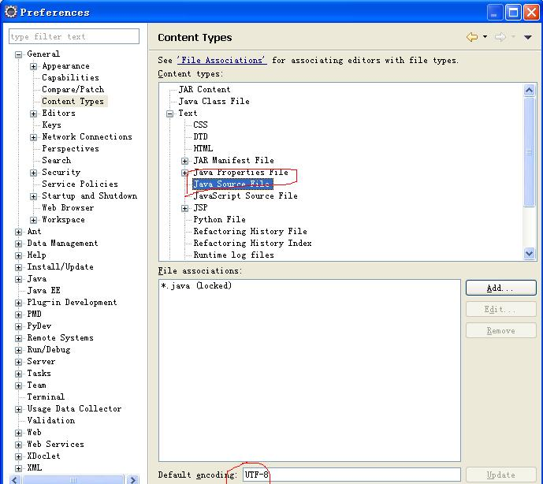
2、windows->Preferences.->general->Content Types，

3、windows->Preferences.->general->Editors->text editors，

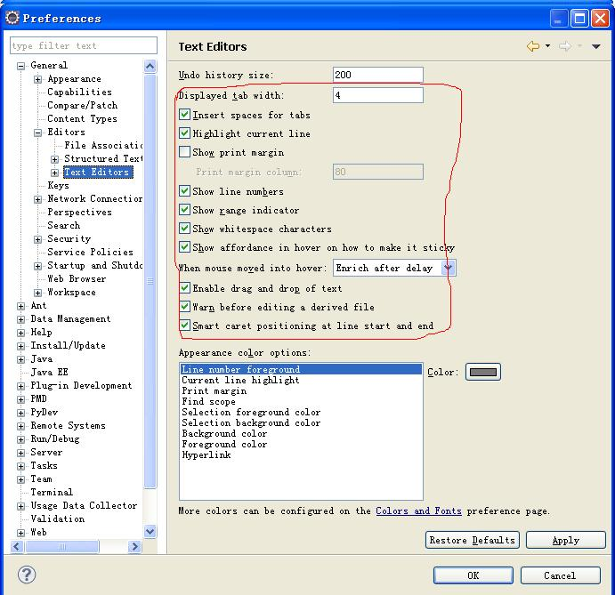
- Create a new style, and then edit it

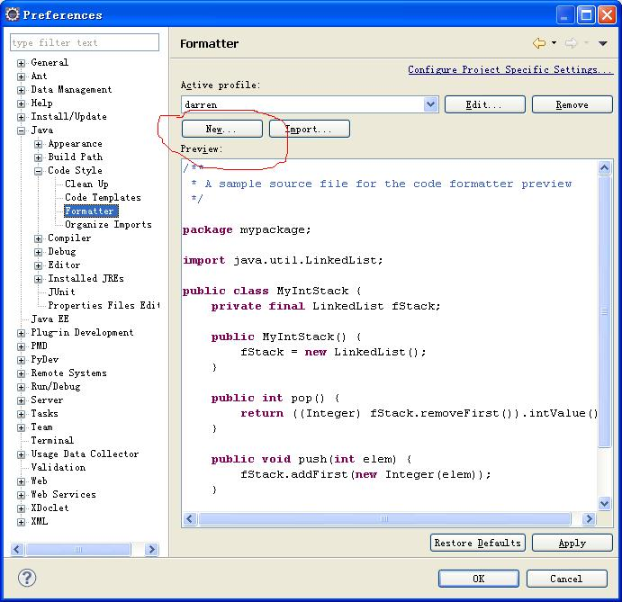

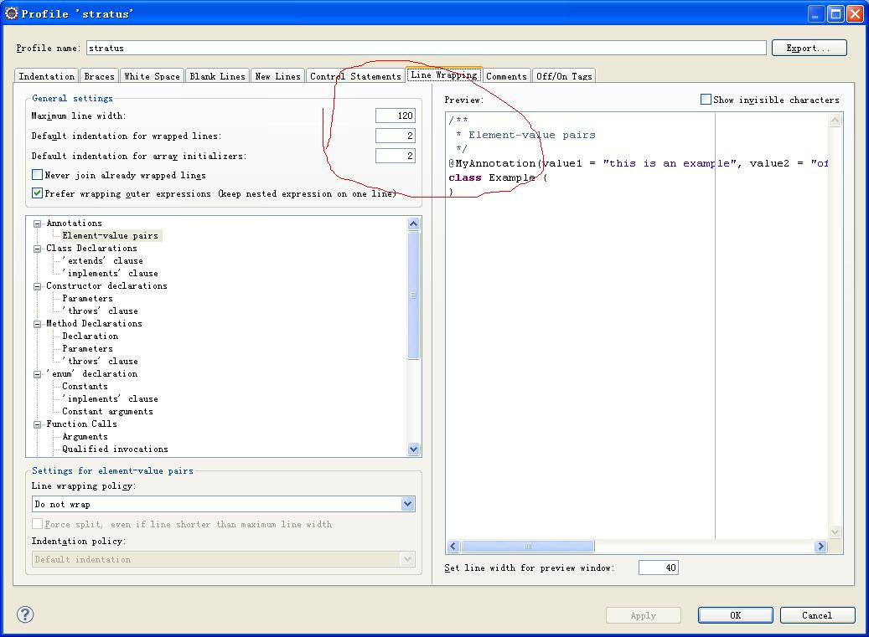
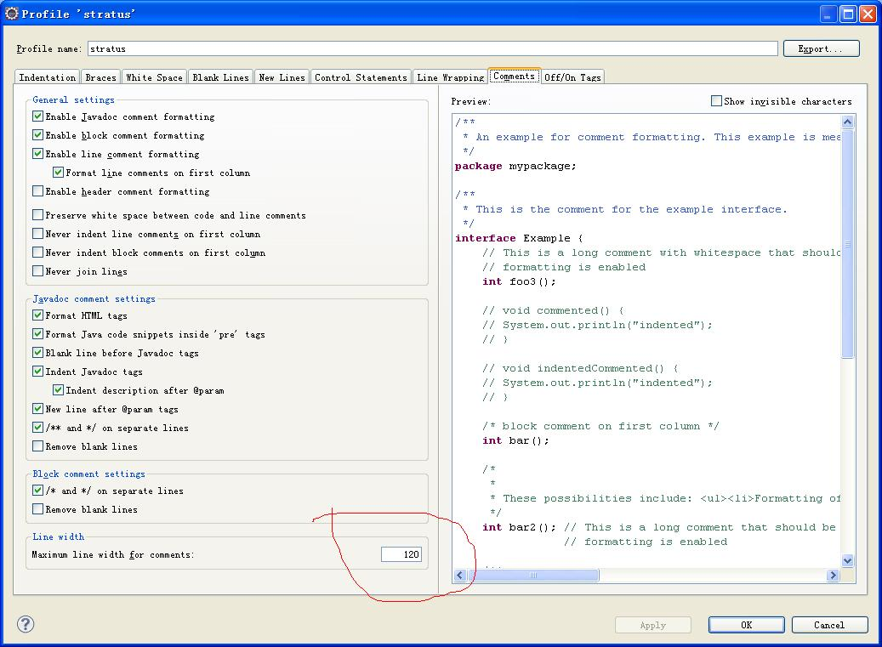

5. Edit the new style
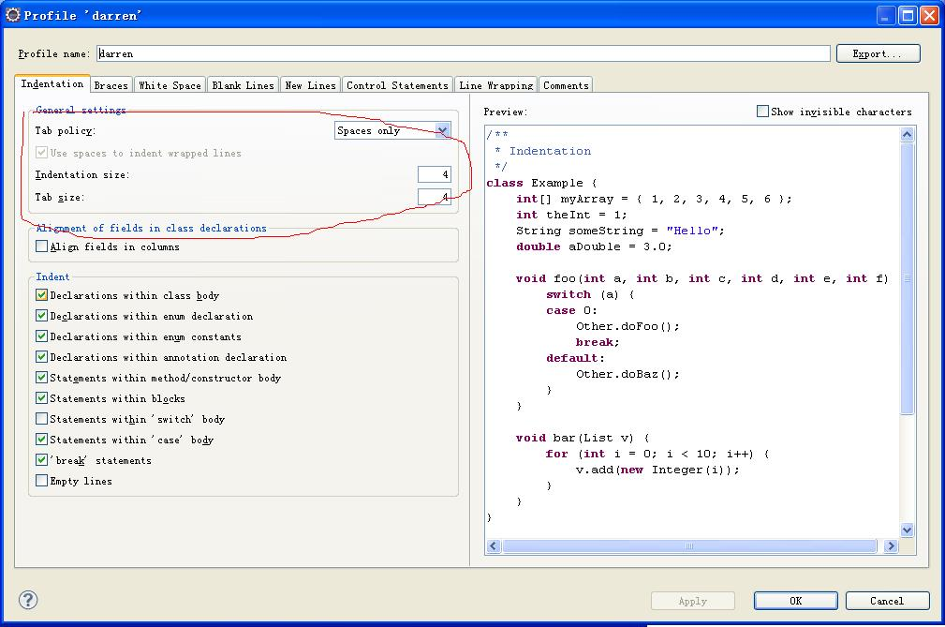

6. Modify JSP file coding

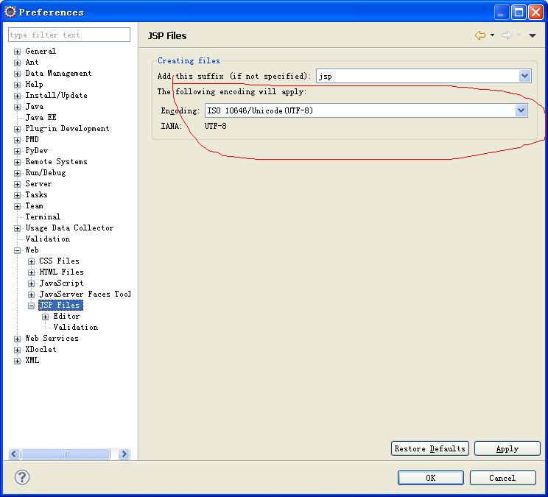

三. Set the eclipse plugin
1.Set the maven
window-》preferences-》maven-》installations
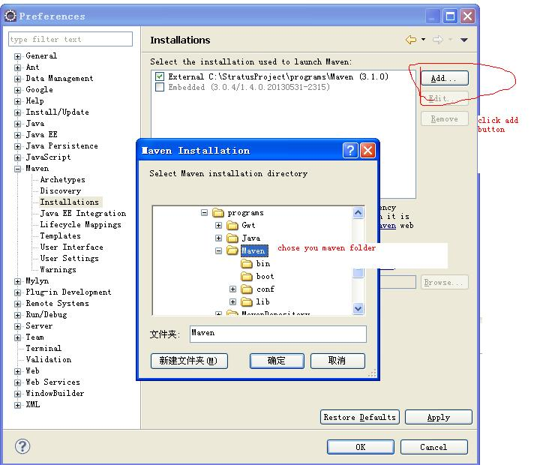
window-》preferences-》maven-》user Settings
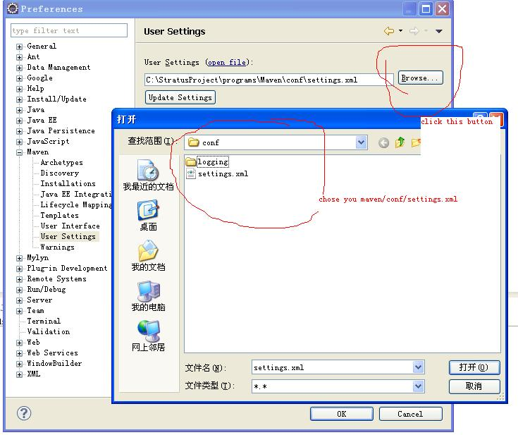

2.Set the gwt plugin
use this url to add the gwt plugin
http://dl.google.com/eclipse/plugin/4.3
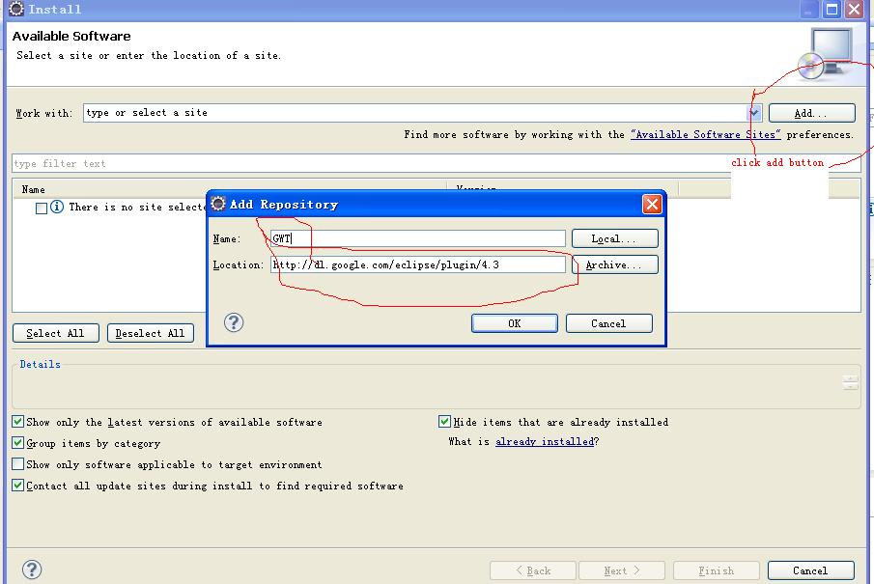
after you finish install this plugin

window-》preferences-》google-》web tookit
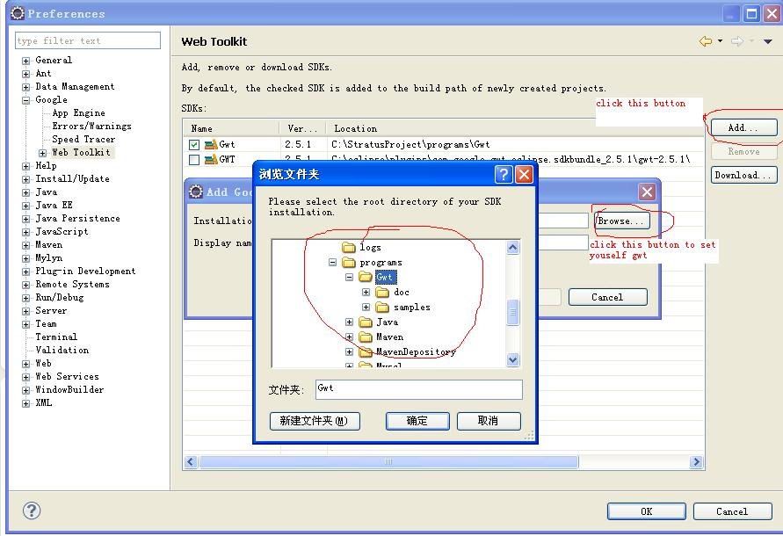

Now the eclipse set is finish，but you can't create gwt project and jersey project
let us set the gwt-maven-plugin and jerser-maven-webapp plugin

1.set gwt-maven-plugin
copy this line code to your console

mvn archetype:generate -DarchetypeGroupId=org.codehaus.mojo -DarchetypeArtifactId=gwt-maven-plugin -DarchetypeVersion=2.5.1

if show this
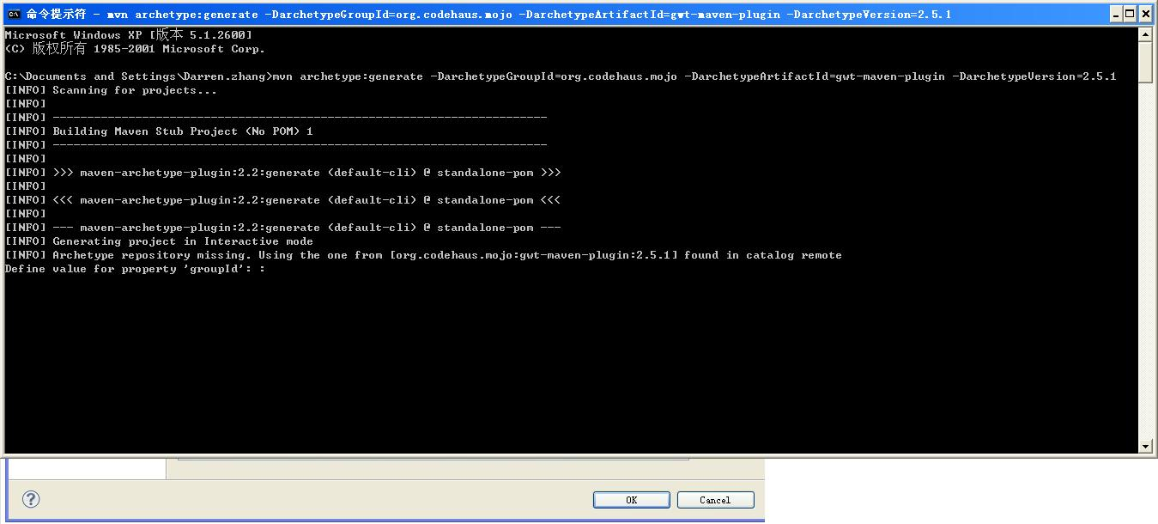

that mean you have install success

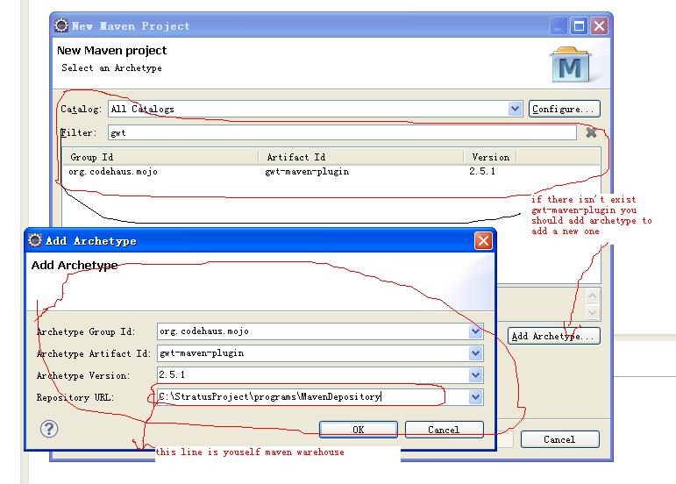
2.set jerser-maven-webapp
copy this line code to your console

mvn archetype:generate -DarchetypeGroupId=org.glassfish.jersey.archetypes -DarchetypeArtifactId=jersey-quickstart-webapp -DarchetypeVersion=2.2
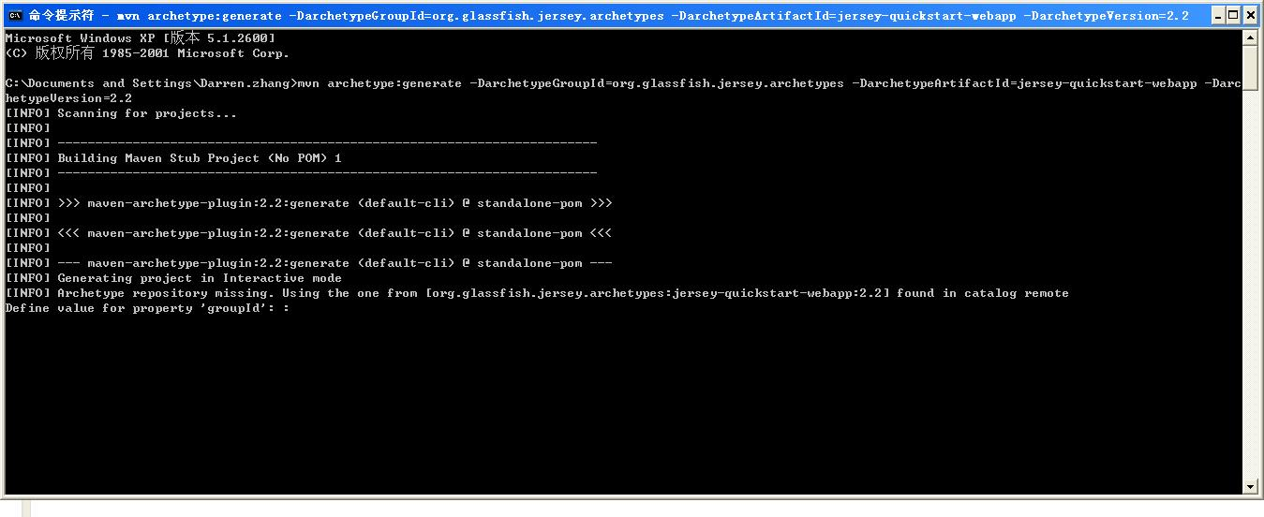
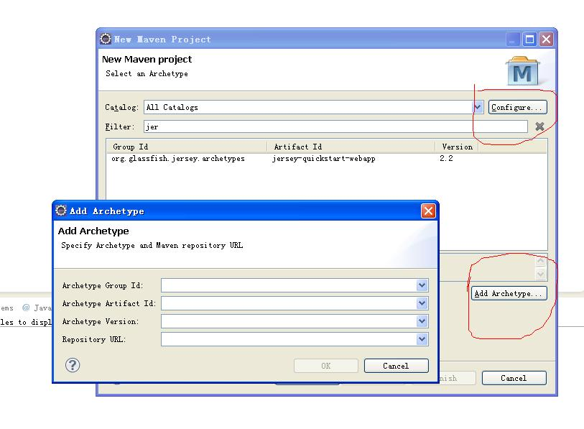
this set same with the top

OK now you can create yous first gwt project and jersey project

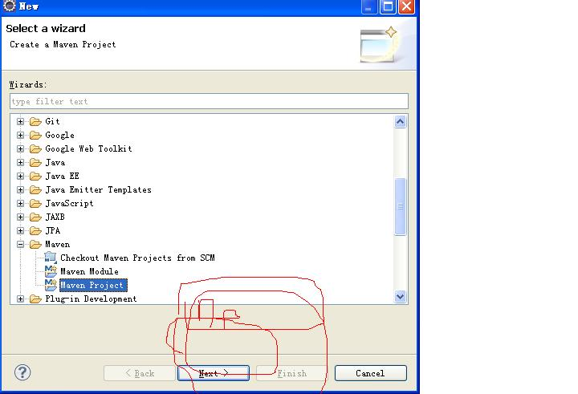

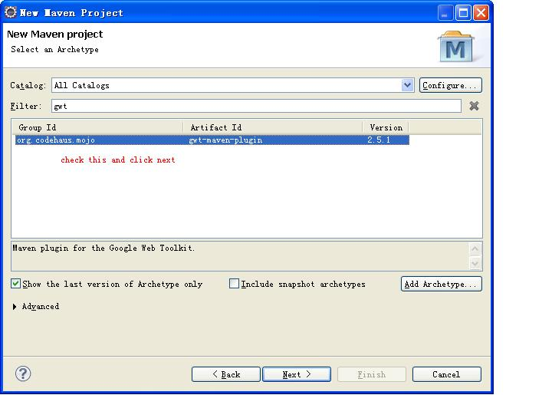

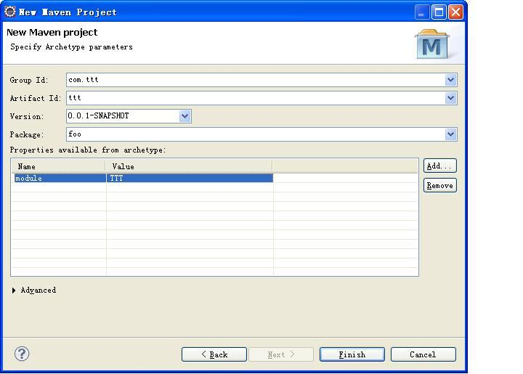
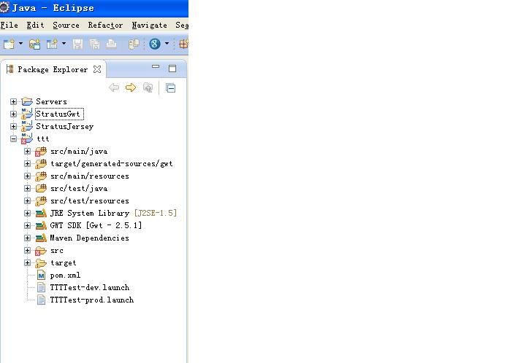

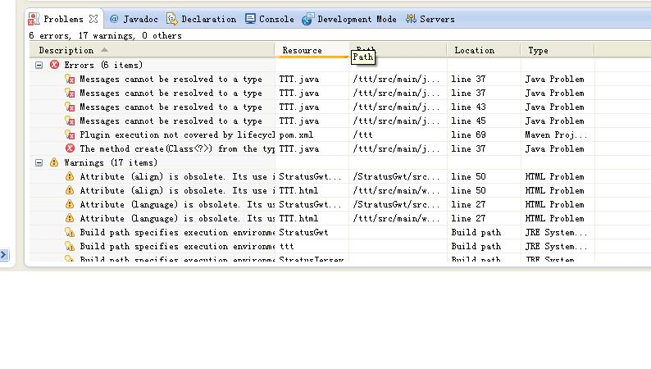
you will find there are some error,but don't warry

open you consol and set the path to your project folder like this

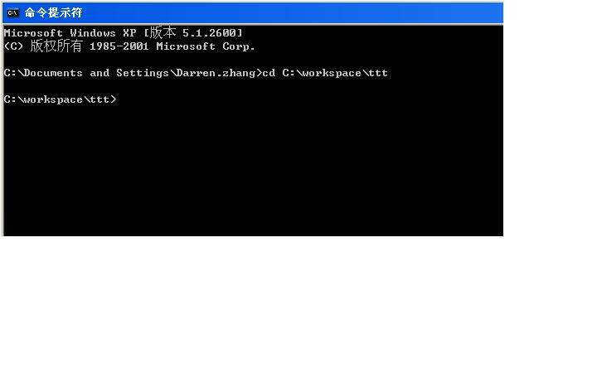

input mvn gwt:generateAsync
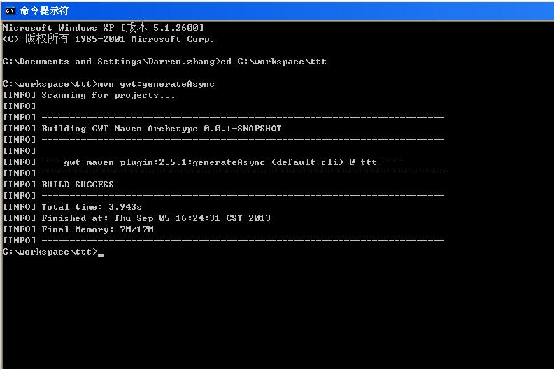
if you look this , that mean your set success

then
input mvn gwt:i18n
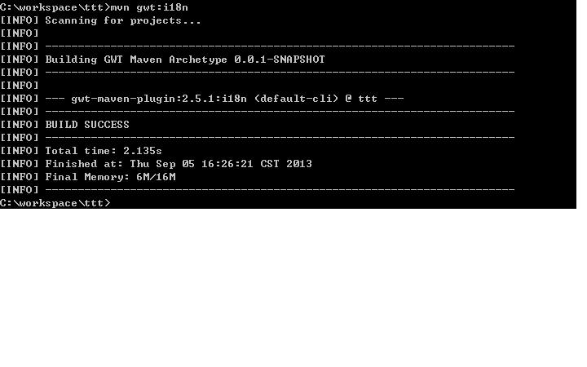
now refresh your project you will find your error is only one left

then open your pom.xml file

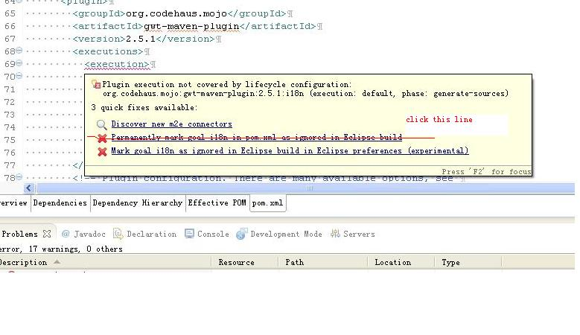
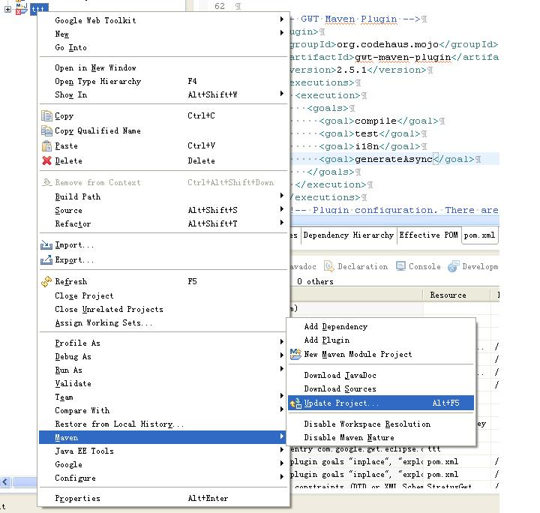
now there is no error exist

then you can run you app use this way
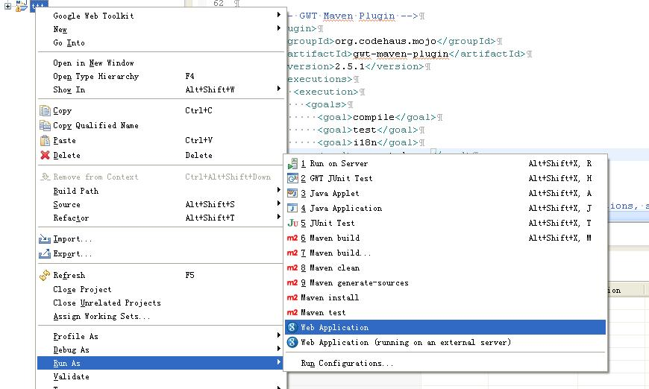

you can open you brower in this way
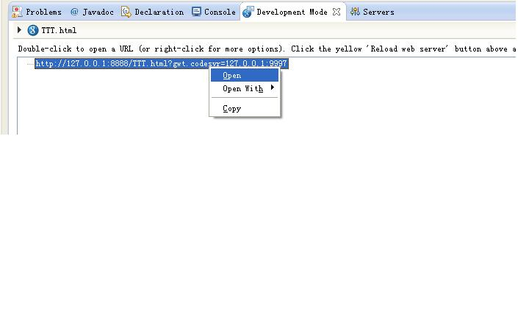
the result is
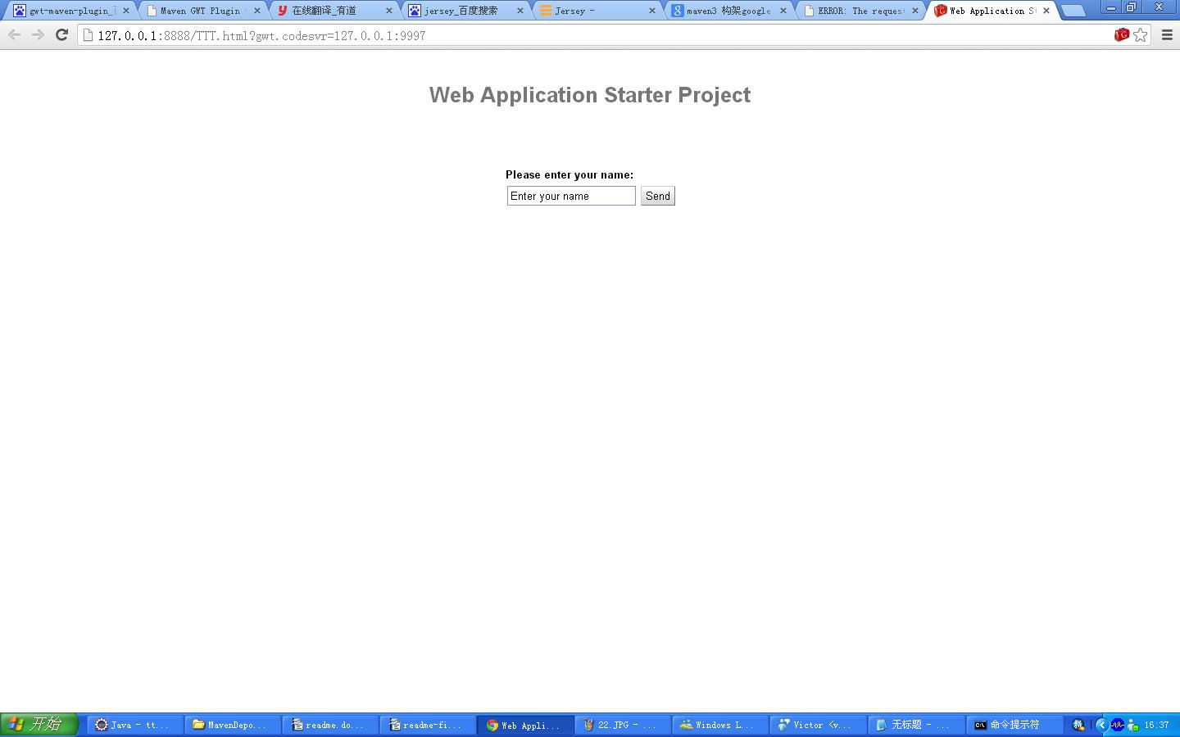
but you need install a plugin first
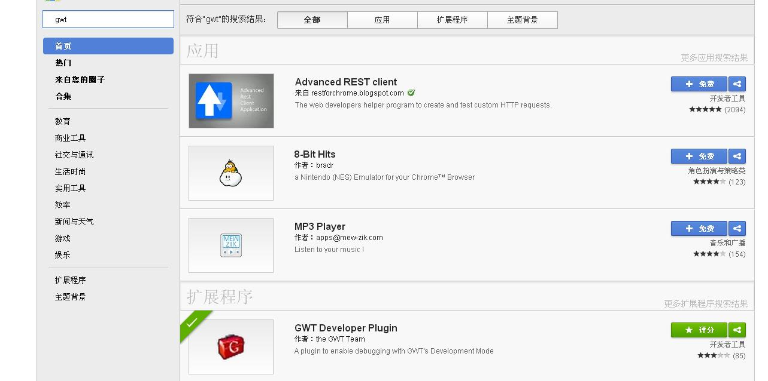

if you want to compile you project ,you can do it like this

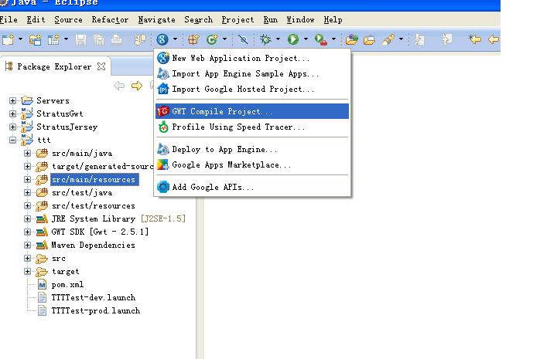
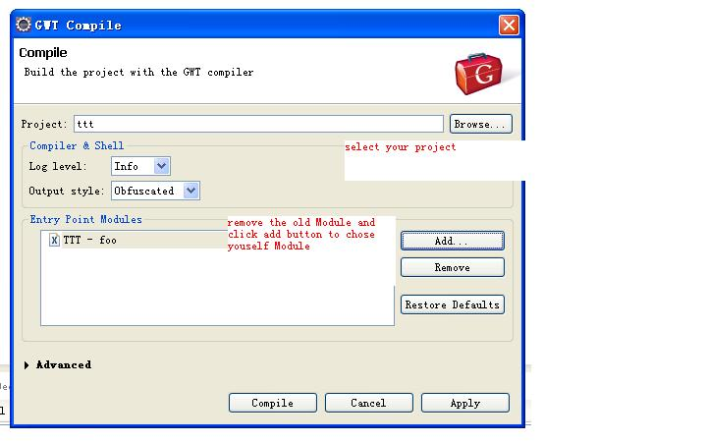
OK the gwt project has been finished

next, let us see the jersey project

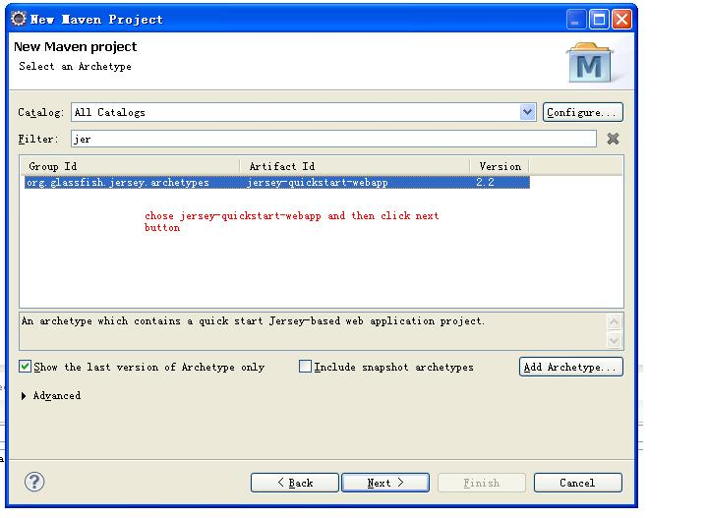
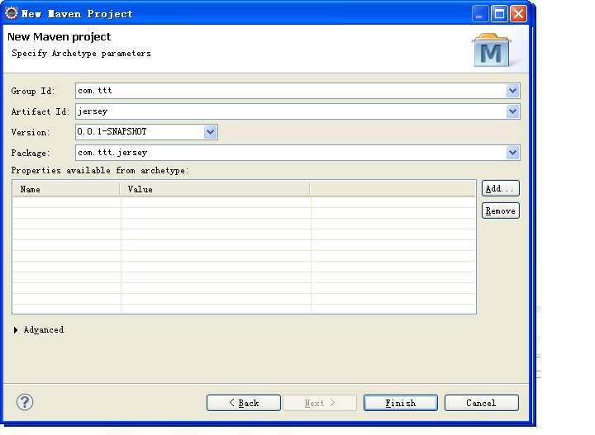

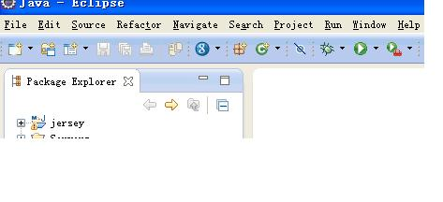
your project has been chreted, you can run it in tomcat

