* First, create an app for this bot on <https://apps.twitter.com/>.



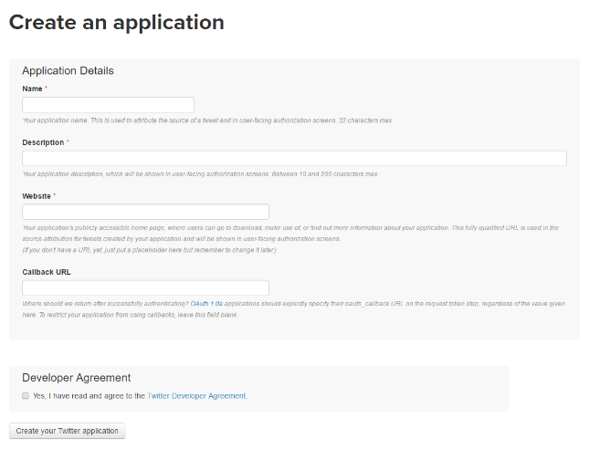

* Then you will get you keys.

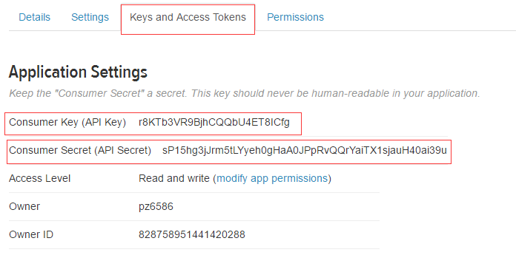

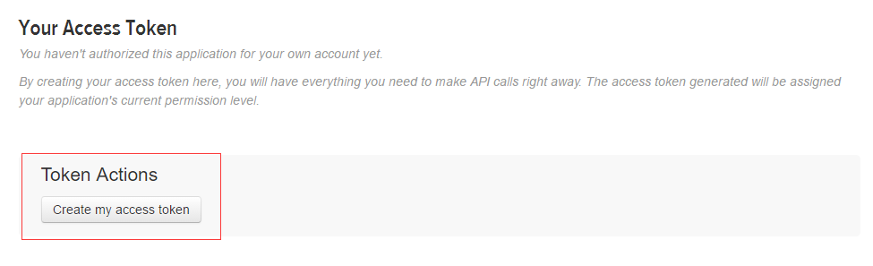

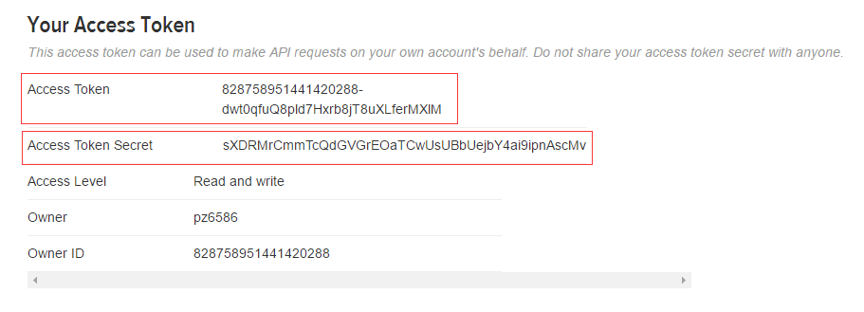

* Write these 4 keys in config.json.

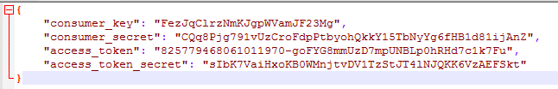

* Customize events in events.json.

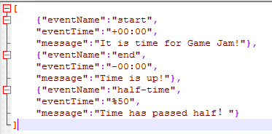

* Write the event name, event time and event pre-scripted message in this JSON file. There are 3 kinds of event time. “+01:23” means this event happens in 1 hours 23 minutes after the game jam starts. “-02:34” means this event will be triggered in 2 hours 34 minutes before the end of game jam. “%50” means the event happens when it has passed 50% of total time.
* After you finished these preparation, you can start to run twitterbot.js. This script is written in Node.js. So if you haven’t installed a Node.js runtime environment, go to <https://nodejs.org/> download one. We also need two libs which are used in our twitterbot. They are “twit” and “fs”. You can install it by npm command: “npm install twit” and “npm install fs”.
* signedusers.json is used to store the data of signed up users in case that server crashes and we lose the data in memory.
* log.txt stores the log information. If the program crashes you can check the log file.