SELECT

ksmc,

st_astext(geom_data),

ST_SRID(geom_data)

FROM

test where ksmc = '小南海水泥厂磨盘沟石灰石矿'

小南海水泥厂磨盘沟石灰石矿 MULTIPOLYGON(((345270.872041976 3251656.15445951,345266.800111624 3251656.00832541,345262.791503329 3251655.16467128,345258.937408179 3251653.64279435,345255.325729769 3251651.47709471,345252.038377023 3251648.71711219,345249.150362308 3251645.42544462,345245.981531461 3251640.27311342,345243.281704326 3251634.78469718,345241.078372701 3251629.01606322,345239.39391002 3251623.02564191,345238.245395355 3251616.8743293,345237.644426435 3251610.6245922,345237.59711013 3251604.33977025,345238.104056827 3251598.08367717,345234.731166498 3251579.34763196,345230.746675153 3251560.76633257,345226.156176554 3251542.36583023,345220.966135148 3251524.17196487,345215.183794751 3251506.21006729,345208.817186623 3251488.50555732,345201.875293349 3251471.08314381,345194.367966908 3251453.96722467,345186.305490728 3251437.18179311,345177.699365634 3251420.75042685,345168.561609896 3251404.696198,345168.720056987 3251404.47853424,345169.558303044 3251402.81957671,345152.340227104 3251368.69536933,345130.261283594 3251355.94966924,345113.550328776 3251353.00609923,345105.679517512 3251353.11367556,345098.315094961 3251356.3862893,345087.225029632 3251358.12385919,345082.273068101 3251358.19155237,345034.957217064 3251382.90156595,345032.034955364 3251385.84044299,345027.933182292 3251390.65456661,345027.194304681 3251391.69639392,345020.227923629 3251395.89761348,345013.519700993 3251400.61246487,345007.098536552 3251405.82080747,345000.991984492 3251411.49992626,344995.226355721 3251417.6256273,344989.82661822 3251424.1713417,344986.562249737 3251432.83296805,344983.832508514 3251441.73429368,344981.650608311 3251450.83245638,344980.027043142 3251460.08373374,344978.969587357 3251469.44354309,344978.483389748 3251478.86693889,344978.570710283 3251488.30851659,344980.621453124 3251510.09294665,344982.648305849 3251508.91971347,344983.082933829 3251508.71412451,344979.82245015 3251515.16067808,344972.294661344 3251531.23553044,344967.280774012 3251544.05447726,344965.002550101 3251546.45414315,344962.850638118 3251549.00106602,344960.739114631 3251548.8434753,344958.63620928 3251549.09871578,344956.603401063 3251549.75936464,344954.700171335 3251550.80605973,344952.982091935 3251552.20822375,344951.499440239 3251553.92498072,344950.295549269 3251555.90587666,344949.405617909 3251558.09328915,344948.855583733 3251560.42304115,344948.661638602 3251562.82729952,344948.829367607 3251565.23548437,344949.353880216 3251567.57745833,344950.219823814 3251569.78452363,344951.402036047 3251571.79240477,344952.180342545 3251577.00429558,344953.61849529 3251582.0326445,344955.685573076 3251586.76897839,344958.336939744 3251591.1110949,344961.515323633 3251594.9653413,344965.152329513 3251598.24858814,344969.169337821 3251600.89011165,344971.38908217 3251602.71457155,344973.776852648 3251604.23676937,344976.300839064 3251605.43639822,344980.681725608 3251610.42708416,345006.523726892 3251627.23274305,345006.923556458 3251627.48475622,345009.613070844 3251632.77880602,345012.710783882 3251637.77468887,345016.191237296 3251642.43116921,345020.025782549 3251646.71004683,345053.809579673 3251666.6962167,345056.608932651 3251667.87554298,345059.541669082 3251668.49310733,345062.521943506 3251668.53093708,345065.462305632 3251667.98783467,345068.276587553 3251666.87973713,345070.88234224 3251665.23918409,345073.203187665 3251663.1142885,345075.171055643 3251660.56711039,345076.728274111 3251657.67263124,345077.829181347 3251654.51544099,345078.441501596 3251651.18812387,345077.28004685 3251625.96537908,345085.540912876 3251615.07748547,345097.997834535 3251624.16018891,345106.073486134 3251643.81847022,345111.700804738 3251648.17468668,345116.963920674 3251653.08973936,345121.820184308 3251658.52352418,345126.230389015 3251664.43220022,345130.158591168 3251670.76779338,345133.573081624 3251677.47898094,345133.199358852 3251683.88523825,345133.435731566 3251690.30260302,345134.279419183 3251696.65552403,345135.720489642 3251702.86924592,345137.741958961 3251708.8707054,345140.320064239 3251714.58932522,345155.149871835 3251734.75565525,345169.563754388 3251755.31061774,345170.002614549 3251756.59781461,345186.457736431 3251785.36213199,345195.895827952 3251797.66251898,345203.194450711 3251798.41642415,345209.996923581 3251802.94091525,345215.865894407 3251799.48345861,345227.834552254 3251809.45180845,345249.970234486 3251805.77218426,345263.14092712 3251795.46056971,345271.990565978 3251793.6510286,345282.226835274 3251785.06810012,345283.428952939 3251764.78820562,345290.684602525 3251754.55739626,345291.840638929 3251730.90085419,345279.618379921 3251702.36111041,345270.872041976 3251656.15445951))) 4490

小南海水泥厂磨盘沟石灰石矿 MULTIPOLYGON(((345169.558303044 3251402.81957671,345168.720056987 3251404.47853424,345168.561609896 3251404.696198,345177.699365634 3251420.75042685,345186.305490728 3251437.18179311,345194.367966908 3251453.96722467,345201.875293349 3251471.08314381,345208.817186623 3251488.50555732,345215.183794751 3251506.21006729,345220.966135148 3251524.17196487,345226.156176554 3251542.36583023,345230.746675153 3251560.76633257,345234.731166498 3251579.34763196,345238.104056827 3251598.08367717,345237.59711013 3251604.33977025,345237.644426435 3251610.6245922,345238.245395355 3251616.8743293,345239.39391002 3251623.02564191,345241.078372701 3251629.01606322,345243.281704326 3251634.78469718,345245.981531461 3251640.27311342,345249.150362308 3251645.42544462,345252.038377023 3251648.71711219,345255.325729769 3251651.47709471,345258.937408179 3251653.64279435,345262.791503329 3251655.16467128,345266.800111624 3251656.00832541,345270.872041976 3251656.15445951,345279.544616302 3251621.80671852,345292.712539798 3251606.55248031,345384.456215936 3251581.03757878,345383.954478184 3251576.37624922,345379.374752078 3251533.82543232,345378.389483097 3251520.90835348,345373.50619516 3251456.88719875,345372.169337277 3251439.36079274,345377.800262594 3251398.95239444,345378.572781163 3251393.40869297,345305.182221038 3251425.33172255,345270.888785617 3251313.95473222,345179.237045265 3251340.70054307,345178.639893929 3251347.46296115,345177.599206659 3251380.04473769,345174.966172134 3251392.11713747,345172.146611779 3251397.69720251,345172.050762289 3251397.88698636,345169.558303044 3251402.81957671))) 4490

SELECT

ksmc,

ST_AsEWKT (geom_data),

ST_SRID (geom_data)

FROM

test

WHERE

ksmc = '小南海水泥厂磨盘沟石灰石矿'

小南海水泥厂磨盘沟石灰石矿 SRID=4490;MULTIPOLYGON(((345270.872041976 3251656.15445951,345266.800111624 3251656.00832541,345262.791503329 3251655.16467128,345258.937408179 3251653.64279435,345255.325729769 3251651.47709471,345252.038377023 3251648.71711219,345249.150362308 3251645.42544462,345245.981531461 3251640.27311342,345243.281704326 3251634.78469718,345241.078372701 3251629.01606322,345239.39391002 3251623.02564191,345238.245395355 3251616.8743293,345237.644426435 3251610.6245922,345237.59711013 3251604.33977025,345238.104056827 3251598.08367717,345234.731166498 3251579.34763196,345230.746675153 3251560.76633257,345226.156176554 3251542.36583023,345220.966135148 3251524.17196487,345215.183794751 3251506.21006729,345208.817186623 3251488.50555732,345201.875293349 3251471.08314381,345194.367966908 3251453.96722467,345186.305490728 3251437.18179311,345177.699365634 3251420.75042685,345168.561609896 3251404.696198,345168.720056987 3251404.47853424,345169.558303044 3251402.81957671,345152.340227104 3251368.69536933,345130.261283594 3251355.94966924,345113.550328776 3251353.00609923,345105.679517512 3251353.11367556,345098.315094961 3251356.3862893,345087.225029632 3251358.12385919,345082.273068101 3251358.19155237,345034.957217064 3251382.90156595,345032.034955364 3251385.84044299,345027.933182292 3251390.65456661,345027.194304681 3251391.69639392,345020.227923629 3251395.89761348,345013.519700993 3251400.61246487,345007.098536552 3251405.82080747,345000.991984492 3251411.49992626,344995.226355721 3251417.6256273,344989.82661822 3251424.1713417,344986.562249737 3251432.83296805,344983.832508514 3251441.73429368,344981.650608311 3251450.83245638,344980.027043142 3251460.08373374,344978.969587357 3251469.44354309,344978.483389748 3251478.86693889,344978.570710283 3251488.30851659,344980.621453124 3251510.09294665,344982.648305849 3251508.91971347,344983.082933829 3251508.71412451,344979.82245015 3251515.16067808,344972.294661344 3251531.23553044,344967.280774012 3251544.05447726,344965.002550101 3251546.45414315,344962.850638118 3251549.00106602,344960.739114631 3251548.8434753,344958.63620928 3251549.09871578,344956.603401063 3251549.75936464,344954.700171335 3251550.80605973,344952.982091935 3251552.20822375,344951.499440239 3251553.92498072,344950.295549269 3251555.90587666,344949.405617909 3251558.09328915,344948.855583733 3251560.42304115,344948.661638602 3251562.82729952,344948.829367607 3251565.23548437,344949.353880216 3251567.57745833,344950.219823814 3251569.78452363,344951.402036047 3251571.79240477,344952.180342545 3251577.00429558,344953.61849529 3251582.0326445,344955.685573076 3251586.76897839,344958.336939744 3251591.1110949,344961.515323633 3251594.9653413,344965.152329513 3251598.24858814,344969.169337821 3251600.89011165,344971.38908217 3251602.71457155,344973.776852648 3251604.23676937,344976.300839064 3251605.43639822,344980.681725608 3251610.42708416,345006.523726892 3251627.23274305,345006.923556458 3251627.48475622,345009.613070844 3251632.77880602,345012.710783882 3251637.77468887,345016.191237296 3251642.43116921,345020.025782549 3251646.71004683,345053.809579673 3251666.6962167,345056.608932651 3251667.87554298,345059.541669082 3251668.49310733,345062.521943506 3251668.53093708,345065.462305632 3251667.98783467,345068.276587553 3251666.87973713,345070.88234224 3251665.23918409,345073.203187665 3251663.1142885,345075.171055643 3251660.56711039,345076.728274111 3251657.67263124,345077.829181347 3251654.51544099,345078.441501596 3251651.18812387,345077.28004685 3251625.96537908,345085.540912876 3251615.07748547,345097.997834535 3251624.16018891,345106.073486134 3251643.81847022,345111.700804738 3251648.17468668,345116.963920674 3251653.08973936,345121.820184308 3251658.52352418,345126.230389015 3251664.43220022,345130.158591168 3251670.76779338,345133.573081624 3251677.47898094,345133.199358852 3251683.88523825,345133.435731566 3251690.30260302,345134.279419183 3251696.65552403,345135.720489642 3251702.86924592,345137.741958961 3251708.8707054,345140.320064239 3251714.58932522,345155.149871835 3251734.75565525,345169.563754388 3251755.31061774,345170.002614549 3251756.59781461,345186.457736431 3251785.36213199,345195.895827952 3251797.66251898,345203.194450711 3251798.41642415,345209.996923581 3251802.94091525,345215.865894407 3251799.48345861,345227.834552254 3251809.45180845,345249.970234486 3251805.77218426,345263.14092712 3251795.46056971,345271.990565978 3251793.6510286,345282.226835274 3251785.06810012,345283.428952939 3251764.78820562,345290.684602525 3251754.55739626,345291.840638929 3251730.90085419,345279.618379921 3251702.36111041,345270.872041976 3251656.15445951))) 4490

小南海水泥厂磨盘沟石灰石矿 SRID=4490;MULTIPOLYGON(((345169.558303044 3251402.81957671,345168.720056987 3251404.47853424,345168.561609896 3251404.696198,345177.699365634 3251420.75042685,345186.305490728 3251437.18179311,345194.367966908 3251453.96722467,345201.875293349 3251471.08314381,345208.817186623 3251488.50555732,345215.183794751 3251506.21006729,345220.966135148 3251524.17196487,345226.156176554 3251542.36583023,345230.746675153 3251560.76633257,345234.731166498 3251579.34763196,345238.104056827 3251598.08367717,345237.59711013 3251604.33977025,345237.644426435 3251610.6245922,345238.245395355 3251616.8743293,345239.39391002 3251623.02564191,345241.078372701 3251629.01606322,345243.281704326 3251634.78469718,345245.981531461 3251640.27311342,345249.150362308 3251645.42544462,345252.038377023 3251648.71711219,345255.325729769 3251651.47709471,345258.937408179 3251653.64279435,345262.791503329 3251655.16467128,345266.800111624 3251656.00832541,345270.872041976 3251656.15445951,345279.544616302 3251621.80671852,345292.712539798 3251606.55248031,345384.456215936 3251581.03757878,345383.954478184 3251576.37624922,345379.374752078 3251533.82543232,345378.389483097 3251520.90835348,345373.50619516 3251456.88719875,345372.169337277 3251439.36079274,345377.800262594 3251398.95239444,345378.572781163 3251393.40869297,345305.182221038 3251425.33172255,345270.888785617 3251313.95473222,345179.237045265 3251340.70054307,345178.639893929 3251347.46296115,345177.599206659 3251380.04473769,345174.966172134 3251392.11713747,345172.146611779 3251397.69720251,345172.050762289 3251397.88698636,345169.558303044 3251402.81957671))) 4490

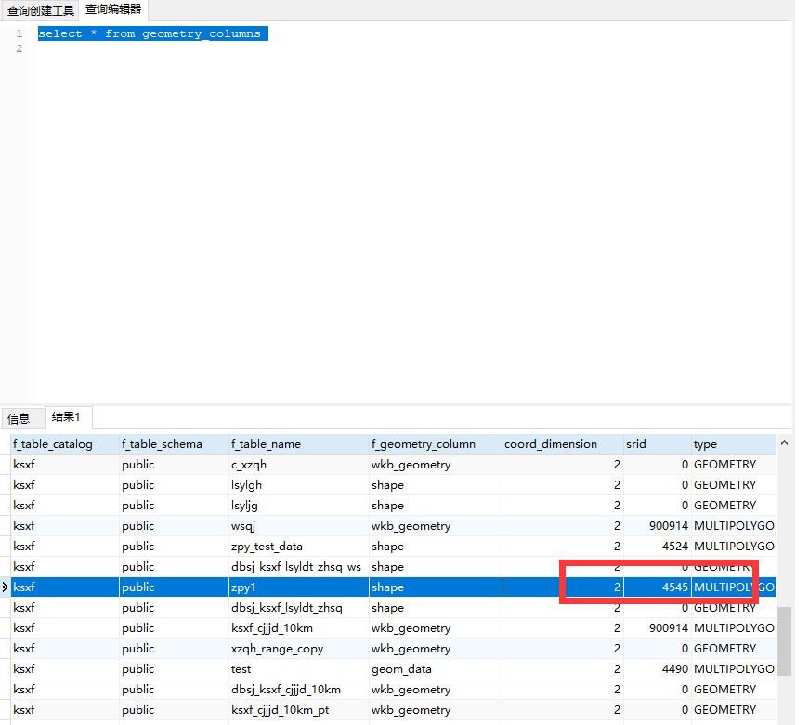

数据重新录入为4545，解决了经纬度问题。

SELECT

ST_AsText (ST_Transform(shape, 4326))

FROM

zpy1

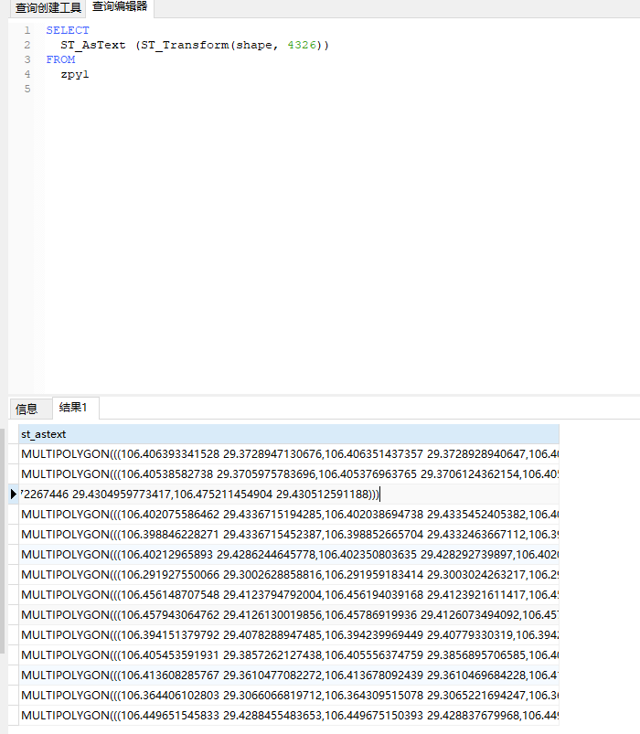

SELECT

*

FROM

zpy1 as t1

INNER JOIN zpy_test as t2 ON st_intersects(st_transform (shape, 4326),st_transform (t2.wkb_geometry, 4326))

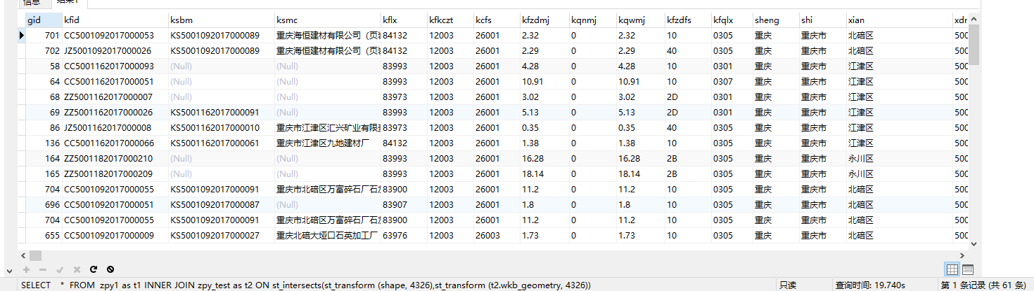

UPDATE lsyldt_1

SET test1 = '自然保护区'

WHERE

lsyldt_1.objectid = ANY (

SELECT

t1.objectid

FROM

lsyldt_1 AS t1

INNER JOIN zpy_test AS t2 ON st_intersects (

st_transform (st_setsrid(shape, 4326), 4326),

st_transform (t2.wkb_geometry, 4326)

)

)

根据自然保护区与矿山是否相交，给矿山赋值为自然保护区。

SELECT

*

FROM

lsyldt_1 as t1

INNER JOIN sslthc_all_ssgzq18 AS t2 ON st_intersects (

st_setsrid (t1.shape, 4490) :: geography,

st_setsrid (t2.wkb_geometry, 4490) :: geography

) = TRUE

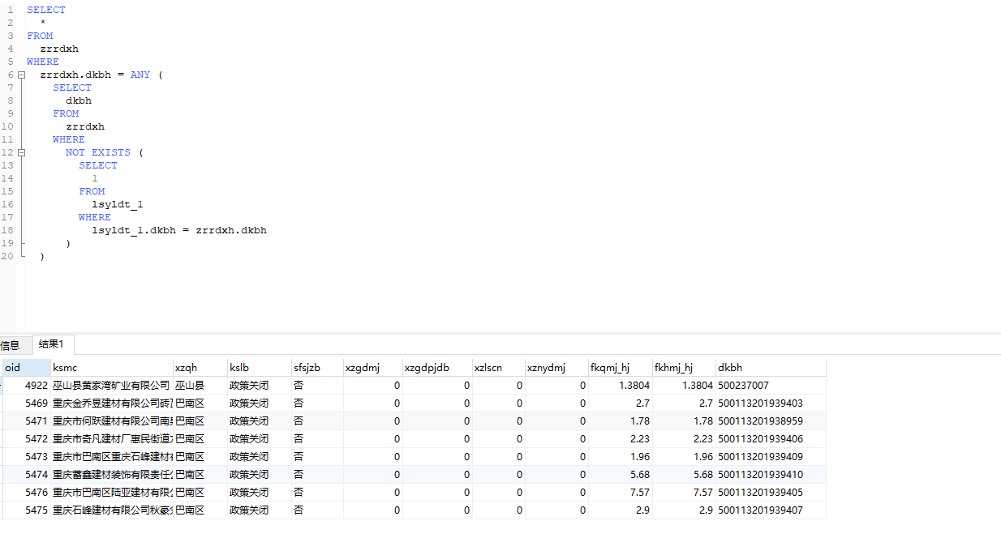

SELECT

st_asgeojson (st_setsrid(shape, 4326))

FROM

lsyldt_1

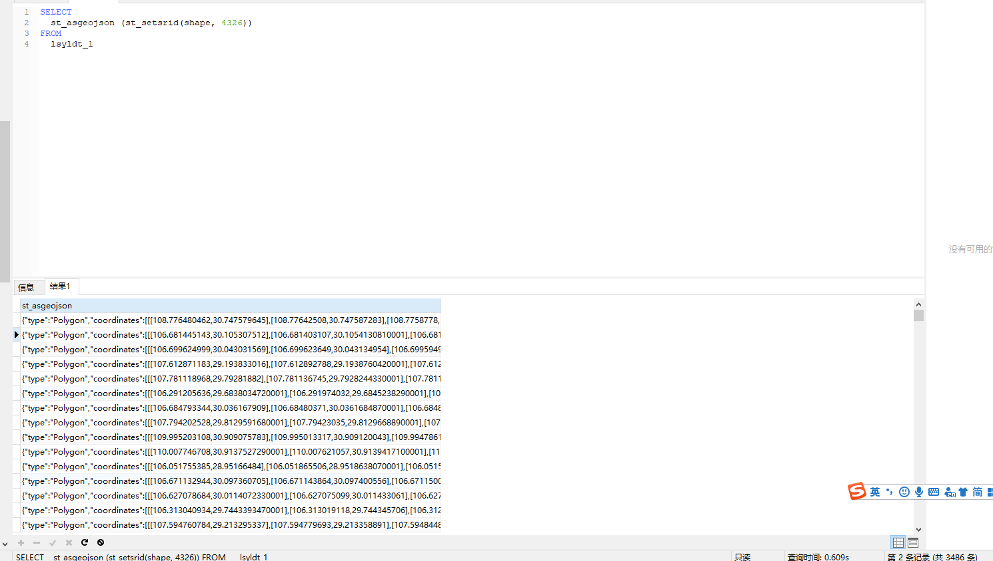

SELECT

geo_mj,

st_area (

st_transform (

st_setsrid (shape, 4490),

4545

)

) AS a1,

st_area (

st_transform (

st_setsrid (shape, 4490),

3857

)

) AS a2

FROM

lsyldt_1

SELECT

st_contains (

st_polygon (

st_geomfromtext (

'linestring(307243.533 3230632.455,312270.627 3231029.33,309174.996 3226584.321,307243.533 3230632.455)'

),

4545

),

st_point (106.0525, 29.1475)

)

判断点在面里面，谨记同一个SRID，谨记geometry ，是来自于text的，所以不能写st_polygon，这种类型。

SELECT

st_contains (

st_geomfromtext (

'POLYGON ((372723.036709 3346715.983050,503822.554226 3356006.514404,410863.206632 3302843.339074,372723.036709 3346715.983050))',

4545

),

st_geometryfromtext (

'POINT(430675.834787 3329797.420177)',

4545

)

)

SELECT

ksmc

FROM

lsyldt_1 AS t1

INNER JOIN sslthc_all_zrbhq9 AS t2 ON st_intersects (

st_setsrid (t1.shape, 4490) :: geography,

st_setsrid (t2.wkb_geometry, 4490) :: geography

) = TRUE;

根据是否相交赋值属性值

UPDATE lsyldt_1

SET ssgzq_intersects = '1'

WHERE

objectid IN (

SELECT

lsyldt_1.objectid

FROM

lsyldt_1 as t1

INNER JOIN sslthc_all_ssgzq18 AS t2 ON st_intersects (

st_setsrid (t1.shape, 4490) :: geography,

st_setsrid (t2.wkb_geometry, 4490) :: geography

) = TRUE

)

PG转换成shp

<https://blog.csdn.net/gdp12315_gu/article/details/52191319>

./pgsql2shp -f "/home/kmcb/gc.shp" -h localhost -u postgres -P postgres ksxf public.gc

./pgsql2shp -f "/home/kmcb/gcxh.shp" -h localhost -u postgres -P postgres -g pmzb ksxf "select * from gc" 事先建kmcb文件夹，以及gc.shp文件，会自动生成附属文件

这种方式是通过添加一行，来形成投影的坐标，然后导出为shp,就是已经有投影坐标系的shp。比较迅速，快捷。

UPDATE lsyldt_1 SET shape = st_setsrid(shape, 900914)

ST_Centroid （求中心点）

SELECT

SUM (mj),

COUNT (objectid),

(

SELECT

NAME

FROM

c_xzqh t1

WHERE

t1.no = T .qxdm

)

FROM

lsyldt_1 T

WHERE

ssgzq_intersects = '03'

GROUP BY

Qxdm

