With as 的用法

WITH cr AS (

SELECT

fid

FROM

lsylgkjbxxdtl1 A

WHERE

dkbh IN (

SELECT DISTINCT

dkbh

FROM

lsyldt_1

WHERE

dkbh IN (

SELECT DISTINCT

dkbh

FROM

lsylgkjbxxdtl1

WHERE

fid IN (

SELECT DISTINCT

oid

FROM

lsylgkjbxx

)

)

)

AND fid IN (

SELECT

fid

FROM

lsylgkjbxxdtl1

GROUP BY

fid

HAVING

COUNT (fid) = 1

)

)

select * from lsylgkjbxxdtl1 A INNER JOIN cr on A.fid = cr.fid

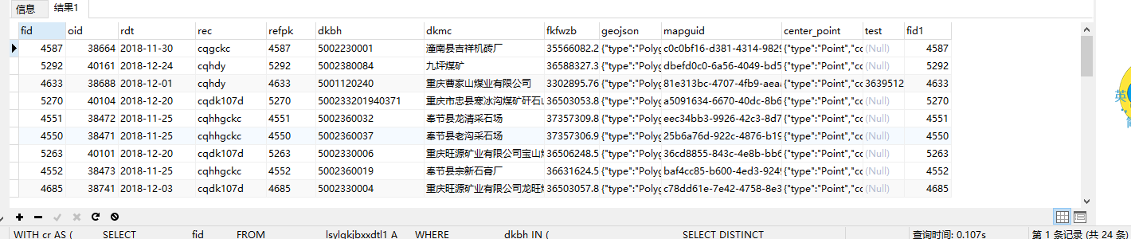求出来的是fid与oid都是一一对应，而不重复的。

Select与insert表

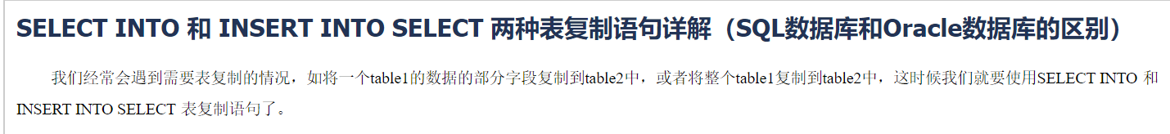

<https://www.cnblogs.com/mq0036/p/4155136.html?tdsourcetag=s_pctim_aiomsg>

insert into port_dept (no,name,xzqh_no) select * from (select distinct dept_no,keshi,xzqh from testrenyuan) d order by d.dept_no

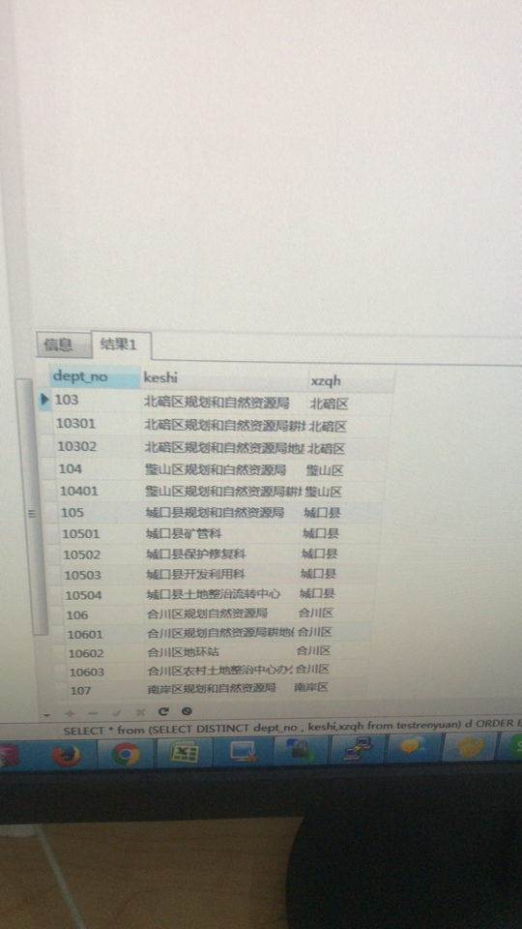

首先选择出不重复的当做一个语句，然后从不重复的选择里面排序。