Problem 1.4

1. Let $f(x)=sign(w^{T}x)$ where $w=(3.0,-4.0,5.0)$. The true classification is as below:

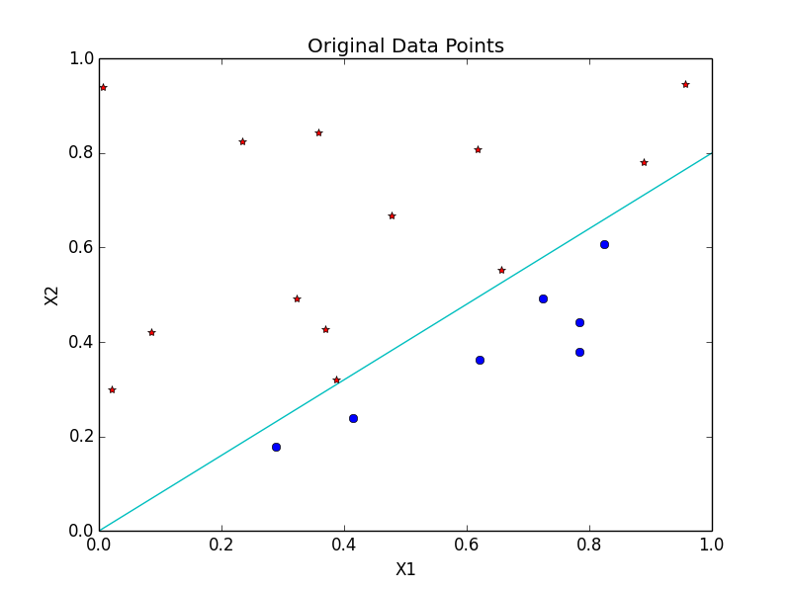

The red star labeled points are positive, while the blue balls are negative. The true separating line is plotted in sky-blue.

1. For the data set in part a, run the PLA:

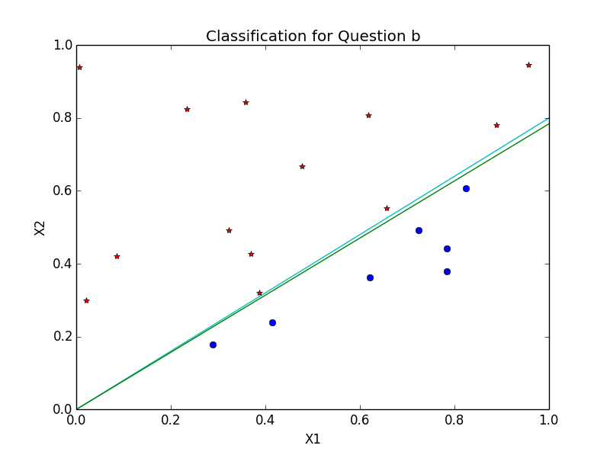

The green line is the separating lines given by the PLA.

The initialization $w(0)=(1.0,1.0,1.0)$

The number of iterations before converging is **35:**



The target function f is quite close to the final hypothesis g.

1. For another data set with size 20:

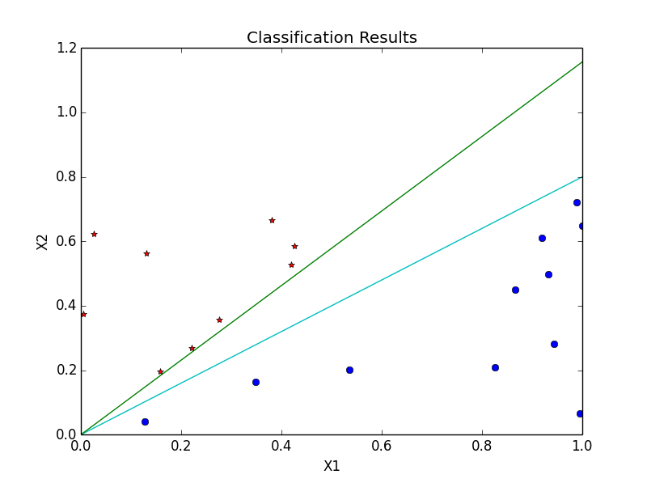



It takes **25** iterations for convergence. However, the hypothesis g (green) is a little far from the target function f (sky-blue).

1. For the data set with size 100:

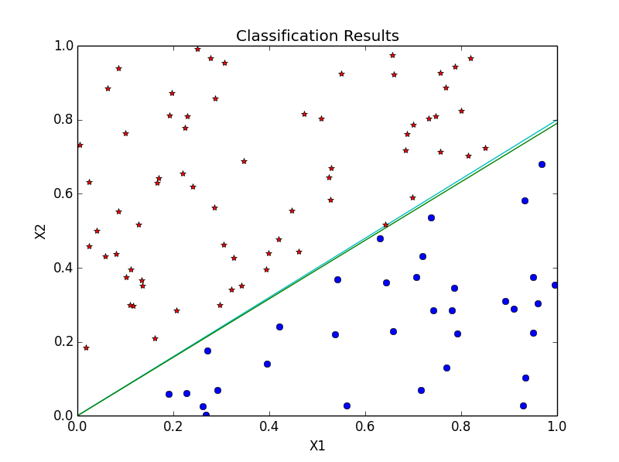

It takes **213** iterations for convergence. Compared with the result in part b and part c, it takes more updates before converging, and the final hypothesis should be more close to the target function.

1. For the data set with size 1000:

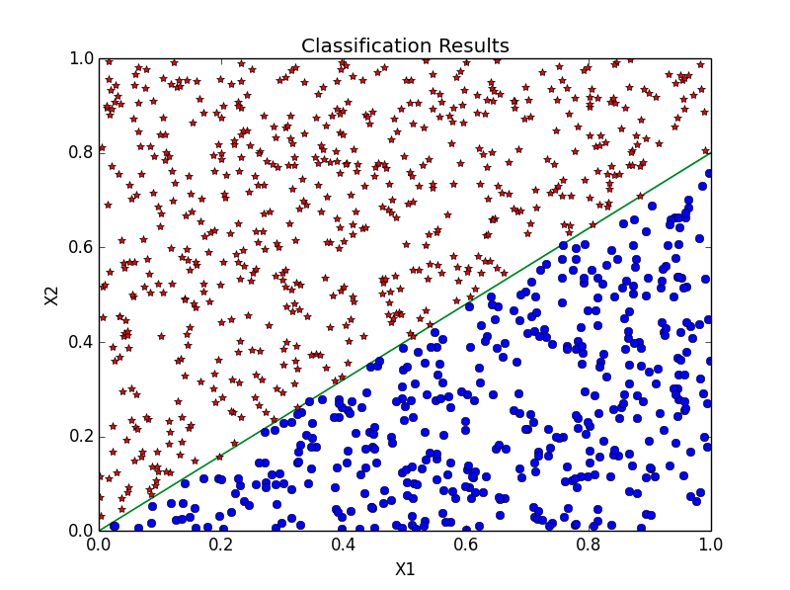

It takes **436** iterations for convergence. Compared with the result in part b, part c and part d, it takes more updates before converging, and the final hypothesis is very close to the target function.