**Exercise 1.10**

1. The $μ$ for all the coins should be **0.5**.
2. The histograms are plotted as below:

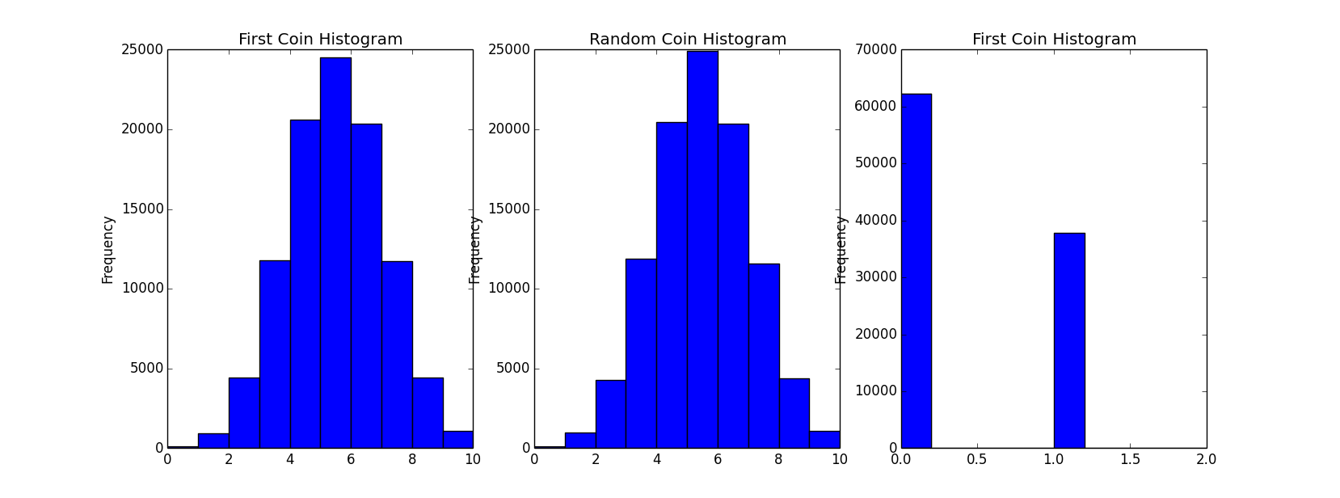

It is concluded that the histograms of the first coin and a random coin in 1e5 iterations look similar, almost symmetrically distributed and the centers are around 5 times.

However, the one with minimum frequency of heads only takes two values: 0 times or 1 time.

1. The following three plots show the Hoeffding bounds and the probabilities for different values of $ε$. One thing to note is that the hoeffding bounds will goes to 0 if $ε>0.5$.

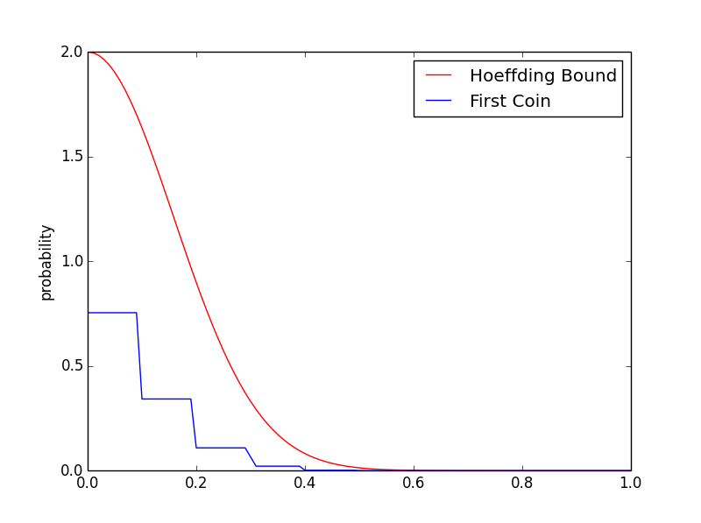

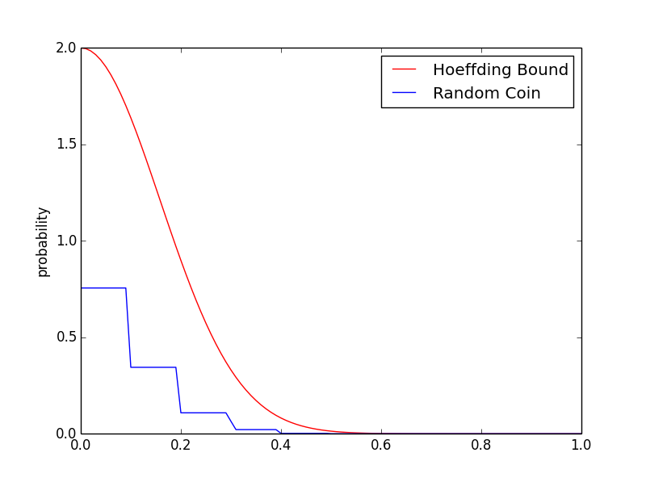

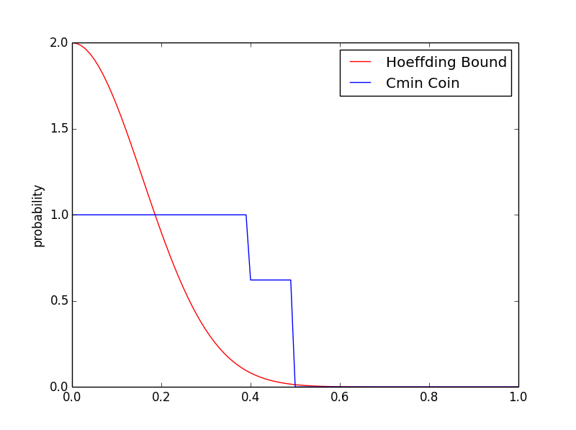

1. From part c, we can tell that the coins $C1 and Crand$ obeys the Hoeffding bound while the coin $Cmin$ doesn’t.

For both coins $C1 and Crand$, the expectation of $v$ is $v_{1}=v_{rand}=0.5$, the Hoeffding inequality applies to them since they are independent.

However, the coin $Cmin$ is dependent on all the other samples as it has the minimum frequency, so the hypothesis is not fixed. In other words, it is not randomly drew so the hoeffding inequality doesn’t apply.

1. It can also be seen in this way: there are 1000 bins and each bin has 10 marbles, each marble with fair chance to be red or green. The fraction of red marbles in the first bin is independent with that in the other bins, so it is with that in any random bins. However, the fraction of red marbles in the bin which has the least number of red marbles are dependent on other bins, so the Hoeffding inequality does not apply.

Problem 1.7

b)

