**(c)**

The output is:

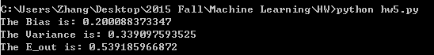

So the bias is 0.2001, the variance is 0.3391, $E_out$ is 0.5392.

From the simulation result we have $E_out=Bias+Variance$.

The figure is as below aa:

