**Problem 3.1**

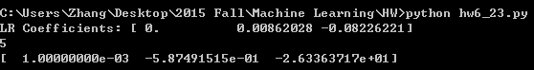

1. The PLA result is as below:

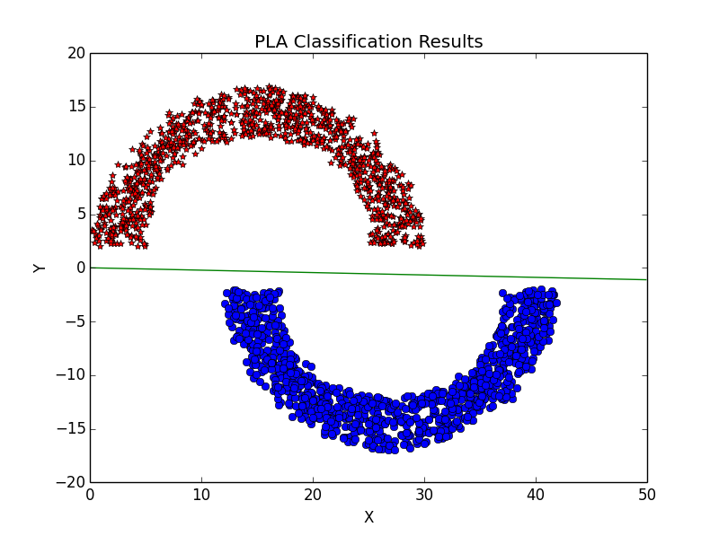

The coefficient is $w=(0.001,-0.5875,-26.34)$

1. The linear regression result is as below:

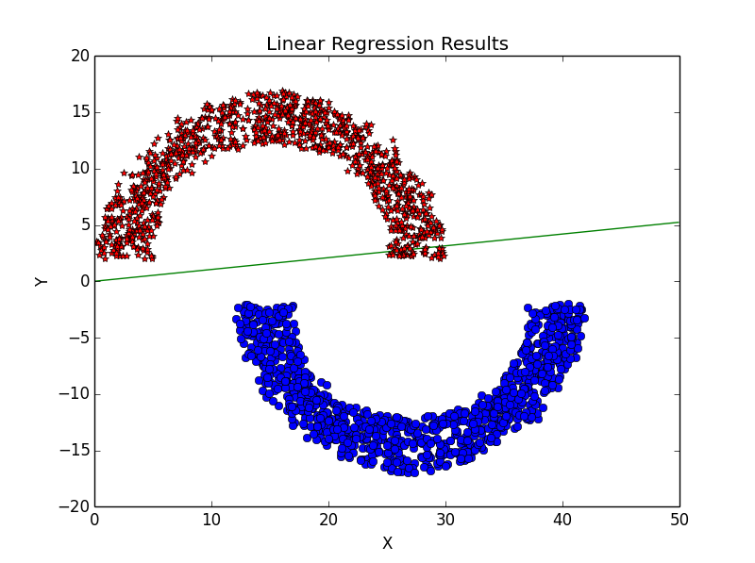

It can be seen that the linear regression may have misclassifications while PLA will not when the samples are linearly separable.

**Problem 3.2**

The number of iterations to converge V.S. the “sep” is as below:

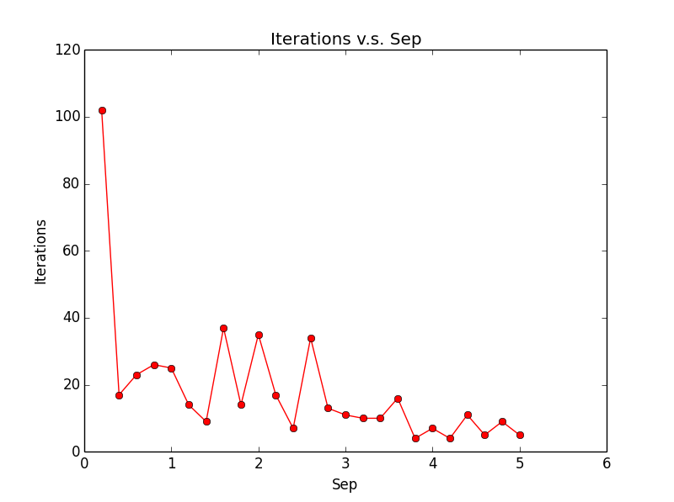

It can be seen that the number of iterations takes to converge decrease dramatically when the distance between two classes get larger, and when $sep=0.2$, it takes more than 100 iterations to converge while it only takes around 10 iterations when $sep>4$.

Problem 6.

1. Have to use Matlab for simplicity. The plot of the two digits are as below:

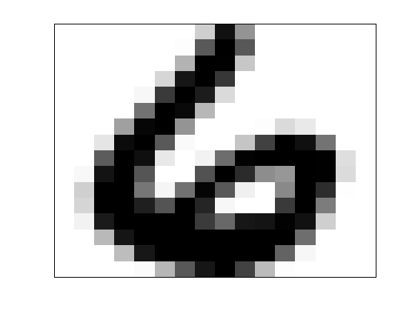 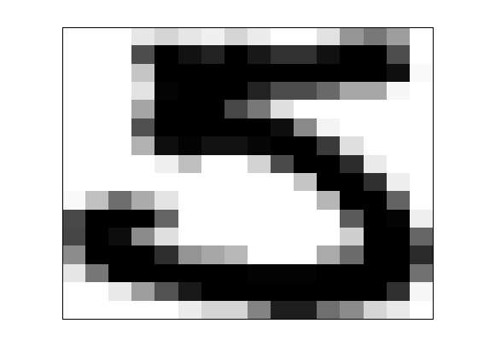

2. The classification for the training dataset is as below:

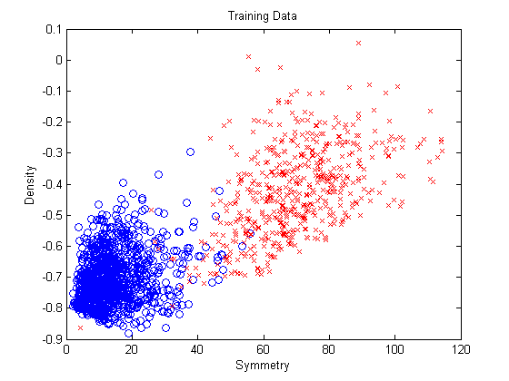

The classification for the testing dataset is as below:

