**Machine Learning: Section 6100**

**HW 9**

***Pu Zhang (661536015)***

1. **8th Order Polynomial**

The dimensions of Z are $300*45$, where 300 is the sample size of training data, 45 is the number of features constructed polynomials.

1. **Overfitting**

I used the ***scikit-learn*** package for polynomial transformation, linear regression, cross validation and regularization in following questions.

The following figure shows the classification decision boundary without any regularization:

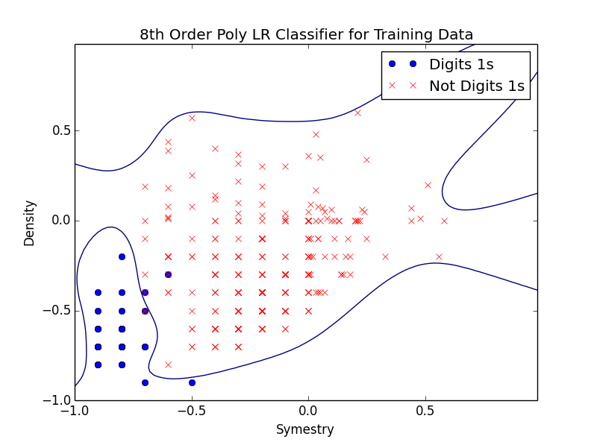

I think it is overfitting, since the decision boundary is too complex.

1. **Regularization**

The plot with Ridge regularization ($λ=2$) is as below:

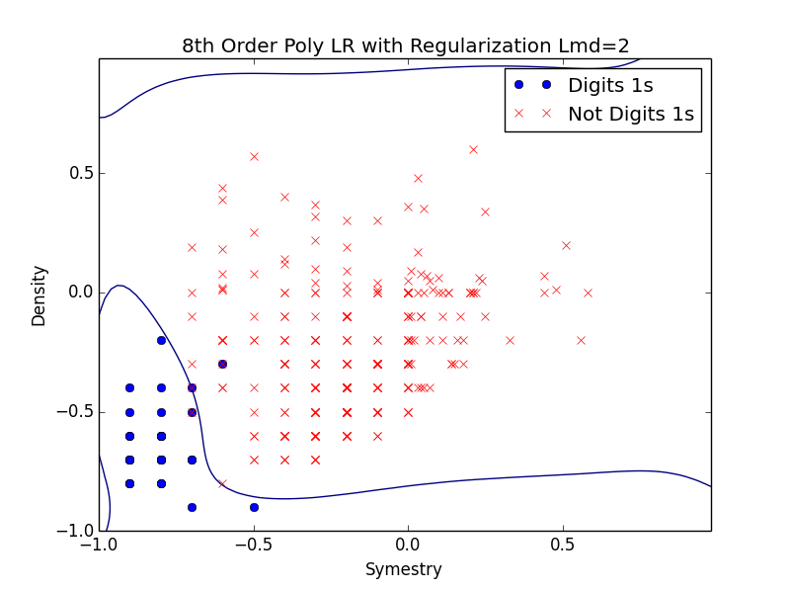

It is much better than that in part 2 where no regularization is performed. However, there still might be overfitting issued.

1. **Cross Validation**

The following figure plots the $E_{test}$ and $E_{CV}$ with different value of $λ$ using leave one cross validation. When there is no regularization, the CV error is large due to Equation 4.13.

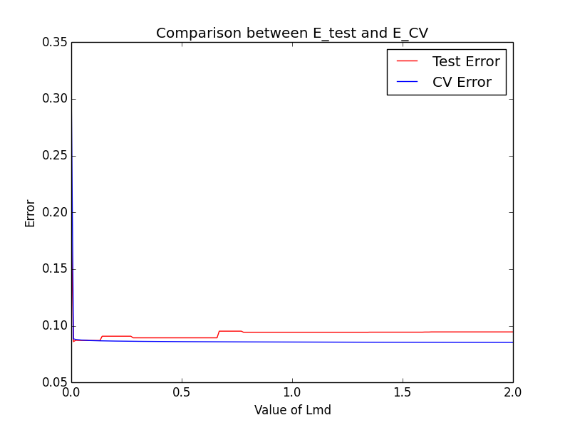

It can be seen that $E_{test}$ and $E_{CV}$ have the same trend at this range of $λ$. $E_{CV}$ doesn’t change too much as the value of $λ$ increases above a certain value but $E_{test}$

goes up a little bit as too much regularization is placed.

1. **Pick $λ$**

In part 4, the optimal value $λ^{*}=0.55$ based on $E_{CV}$. The corresponding leaving one out CV regression gives a decision boundary as below:

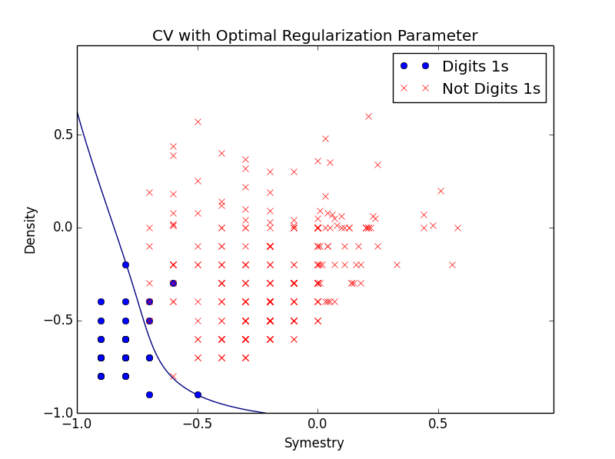

This one looks much better in terms of the complexity of proposed classifier.

1. **Estimate $E_{out}$**

