**Motion Detection Sensor and Raspberry Pi**

1. **Problem Statement**

In this project, a PIR motion sensor is built to detect motions around the sensor. The occurring time and durations of the motions are then collected by the sensor and read by the raspberry pi. The Pi uses these data for further statistical analysis.

The motion detection sensor system can be widely used in alarming systems, or any queuing systems in service management field, to collect service data, such as service rate and arrival rate. The collected data can be used for further analysis and thus help the operators to make decisions.

1. **Preparation**

In this project, we use an infrared motion sensor and a Raspberry pi to implement our system. Here is the link to the description of the sensor:

<http://www.adafruit.com/search?q=motion+sensor&b=1>

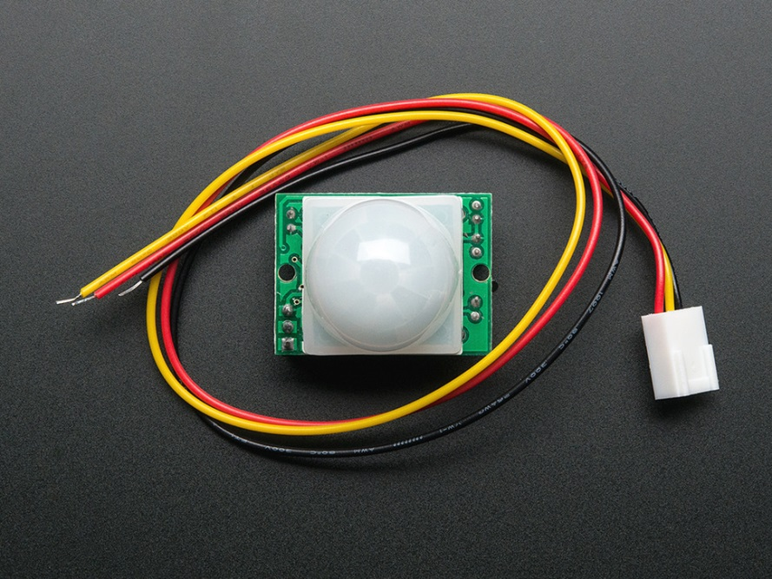

After we get our sensor and raspberry pi, we assemble them together as the figure below:

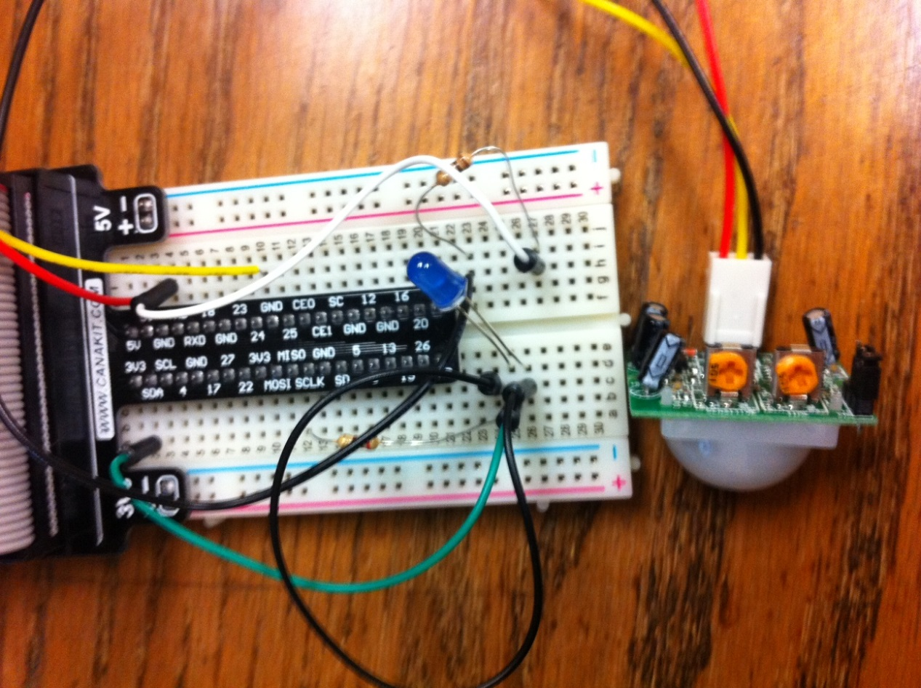

1. **Website (Django) Application**

We built the django application using GPIO command to receive signals output by the sensor and then read them by Django and upload all data including statistical analysis to the website.

1. **Further Analysis**

The data collected can be used to estimate the arrival rate or service rate in a service system, we can build different probabilistic models based on the data collected and fit them to find optimal parameters, thus help the manager to better model the system and make decisions.