Stage2

# UML Class Diagram

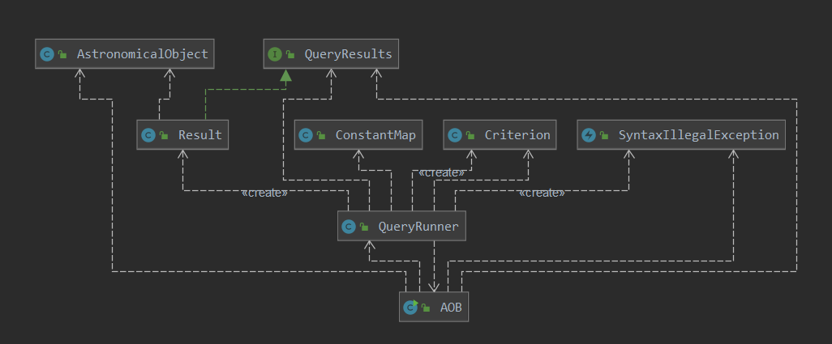

# Design Justification

QueryRunner class is the main functional class of execute query sentences. The run() method in this class can verify and execute a query sentence, filtering and return astronomical objects which can satisfy query criteria by a Result class.

Result class implements QueryResults interface. This class defines two lists as class fields which are used to save query result objects and objects’ id separately.

ConstantMap is a pre-defined data dictionary, which contains the mapping relations between query names and astronomical objects’ properties. This is the main tool to verify whether query sentences are legal.

Criterion class is used to format query criterion.

SyntaxIllegalException is a self-defined exception used to throw out illegal query sentence information during execution of QueryRunner.

# Choice of Collection

ArrayList is used in this part to save results and criteria.

# Summary

In this stage, I mainly use Generics and Reflection to implement requirements and reduce redundant code. By using these concepts, I understand the sense of inheritance structure further. According to the feature of polymorphism, using super classes’ reference to refer to sub classes’ instance makes QueryRunner more general. So, it can adapt to different kinds of astronomical objects and avoid duplicate codes.