ID2207 - Modern Methods in Software Engineering

Homework 1

Group 5

September 2025

Homework 1

Question 1: Use Case Diagrams

Manage Salary Raise Request involves three main actors: Developer, Manager, and Financial Manager.
The process begins when the Developer logs into the system and creates a raise request. The system displays the request form, the Developer fills in the justification, and then submits it. The system forwards the request to the Manager.
The Manager reviews the request. This review always includes Check Performance Report and Check Raise Priority, both modeled as <<include>> use cases since they are mandatory parts of the decision. Based on the results, the Manager makes a decision. The decision can either be Approve Raise Request or Reject Raise Request, which are modeled as generalizations of Manager Decision.
If the Manager rejects the request, the process ends. If the Manager approves, the request is forwarded to the Financial Manager. The Financial Manager then checks the budget. If the budget is insufficient, the process <<extend>>s to Postpone Raise. Otherwise, the Financial Manager finalizes the decision.
Finally, the system notifies the Developer with the result of the request. The possible outcomes are Approved, Rejected, or Postponed.

Use case description:

Name:ManageSalaryRaiseRequest

Participating actors:
- Developer
- Manager
- Financial Manager

Entry Conditions:
- Developer logins to the system.
- System validates the developer credentials.
- Developer has accessed the “Create Raise Request” functionality.

Exit Conditions:
Developer receives the final result ------ Approved / Postponed / Rejected

Quality Conditions:
The system should be available and function without unexpected interruptions.

Event Flow:
- Developer chooses “Create Raise Request”.
- System displays the request form.
- Developer fills in the raise justification and submits the request.
- System displays the new request to the manager
- Manager reviews the request.
- Manager checks the performance report.
- if there are problems in the performance report -> Manager executes “Reject Raise Request”
- Manager checks the salary raise priority among team members.
- if there are conflicts in priorities -> Manager executes “Reject Raise Request”.
- if no conflicts -> Manager executes “Approve Raise Request” and forwards the request to the Financial Manager.
- System displays the request to the Financial Manager.
- Financial Manager evaluates the budget.
- if the budget is insufficient -> Financial Manager executes “Postpone Raise”.
- Financial Manager executes “Finalize Decision”.
- System notifies the Developer with the final result.

Use Case Diagram:

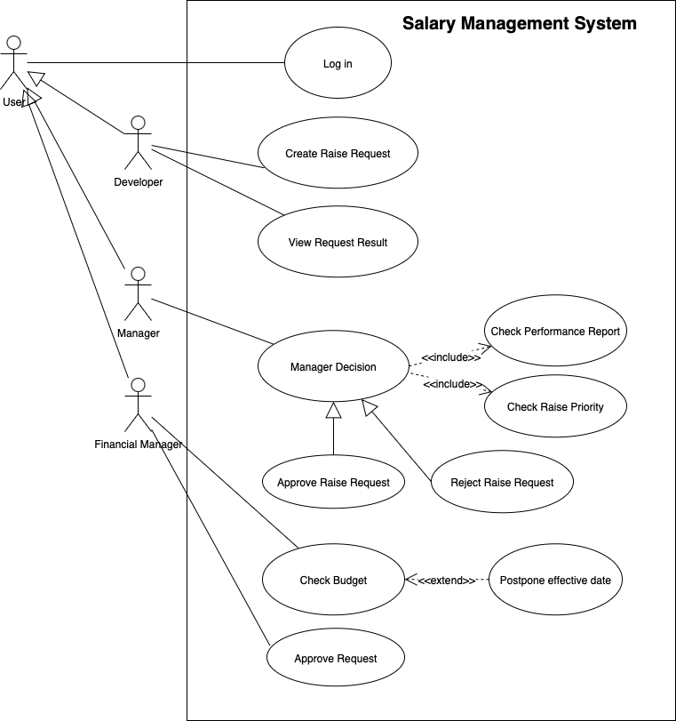
Figure 1 : Use case diagram

Question Two: Class Diagrams

In question 2, we use class diagrams to address the needs of the manager, including which contributes to the conflict of the salary raise requests and how to negotiate it with the developers. The most important thing is to build a core class, the Negotiation, to lead other classes. The Negotiation class contains several properties such as ID, Date and Names, and an operation function to help manager optionally add the priority parts. Then, the Negotiation comprises 2 parts: History and Conflict. The relationship between the Negotiation class and the History class is aggregation. And the Negotiation is composed of the Conflict, which is also composed of Performance Report, Priority and Insufficient Budget to elaborate on the reasons for not approving salary increase requests.

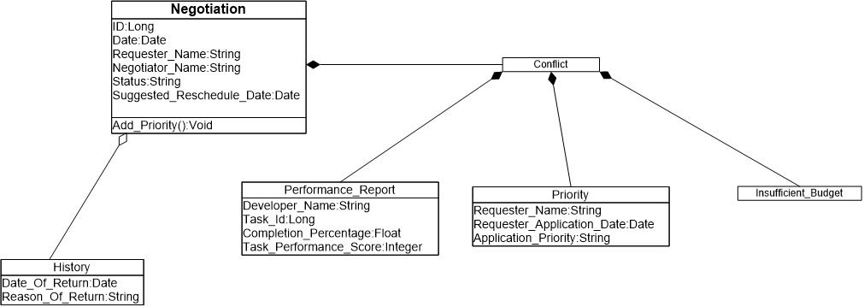
Figure 2 : Class diagram

Question Three: Sequence Diagrams

There are 3 actors in the event of requesting nurses for emergency: James (Doctor), John and Sam(Nurse). The whole system is composed of 3 parts: A request control, an emergency request form and an SMS service.

First, James logins to request control and creates an emergency request form and select name of the nurses and sends form. Then Request Control activate SMS service, look up the contact information and call the SMS service to send SMS to nurses. After SMS service successfully sends the message, it notifies Request Control about its success and then the Request Control notifies the doctor James that nurses are informed. When the nurses read the SMS message, they go to the assigned room.

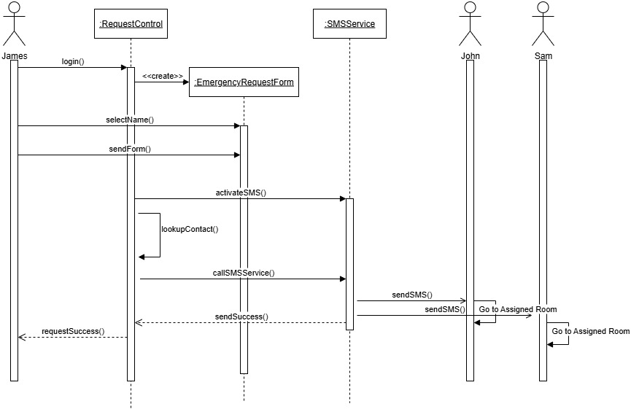
Figure 3 : Sequence diagram

Question Four: Activity Diagrams

The activity diagram tells the story about an employee ordering medical materials from an online system. The main branch consists of an employee, online system, payment gateway and delivery department as is suggested in the homework description.
The activity diagram is self-explanatory, but we will explain how we decide to handle special cases in detail.
- The requested materials are not available in online systems.
The online system will check item availability after receiving the order. If it is not available, the system will notify the employee about the failure, and the employee can choose between modifying the order and giving up this order.
- The wrong materials were ordered (wrong package delivered)
When wrong materials were ordered, the employee will find out during “check items” and he/she notifies the online system. After the online system confirms, the employee can notify the delivery department to pick up the package. After the wrong package is returned to the store, the online system returns the money to the employee.
- The delivery man didn’t reach the address, and he/she returned the package.
If delivery is not successful, the package will be returned to the store, and the online store will return money to the employee.
- Parallel Flows
We use only one parallel flow in the diagram. When the online system confirms the payment from the employee. Online system warehouse will prepare the items, and at the same time the online system will notify the delivery department of the delivery details. Then when both tasks are finished, delivery department starts to deliver the package.
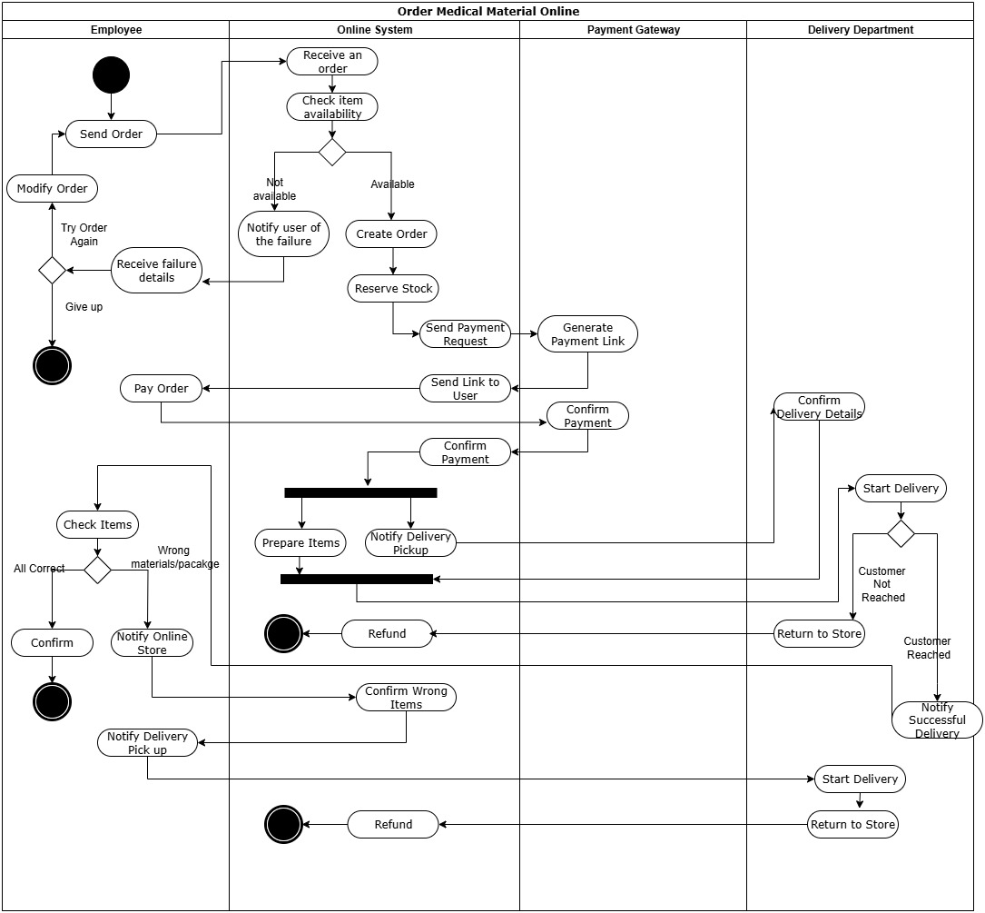
Figure 4 : Activity diagram

