ID2222 Data Mining Homework 4
Graph Spectra
Rui Zhang, Shunkang Jia
November 2025
1. Introduction
This report presents the implementation and analysis of the spectral clustering algorithm as described in the paper by Ng, Jordan, and Weiss. The algorithm was applied to two datasets:
- Medical Innovation Network (example1.dat): A real-world social network of 241 physicians across 4 Illinois towns
- Synthetic Graph (example2.dat): An artificially generated network with 100 nodes
Key Findings:
- Dataset 1: Identified 4 distinct physician communities with high modularity (0.663)
- Dataset 2: Identified 2 well-separated clusters with modularity (0.403)

2. Dataset Analysis
2.1 Medical Innovation Network (example1.dat)
Graph Properties
- Nodes: 241 physicians
- Edges: 923 connections
- Density: 0.032 (sparse network)
- Average Degree: 7.66
- Connected: No (4 connected components)
- Component Sizes: [117, 48, 41, 35]
Eigenspectrum Analysis
The top eigenvalues of the normalized Laplacian are:
λ₁ = 1.000000
λ₂ = 1.000000
λ₃ = 1.000000
λ₄ = 1.000000
λ₅ = 0.805805
λ₆ = 0.804595
λ₇ = 0.756287
...
Key Observation: The first 4 eigenvalues equal 1.0, indicating 4 connected components.
Eigengap Analysis
The eigengap is the difference between consecutive eigenvalues. Large eigengaps suggest natural cluster boundaries:
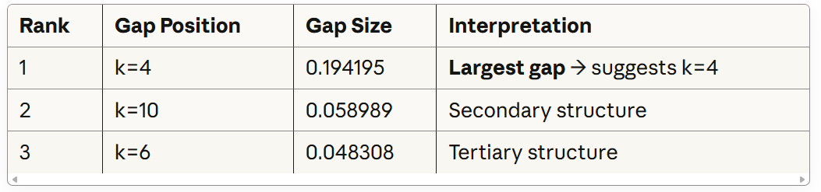
Conclusion: The largest eigengap occurs at k=4, strongly suggesting 4 clusters.
Clustering Results (k=4)
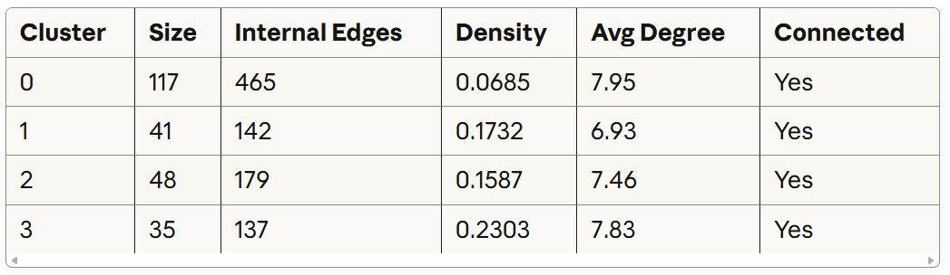
Modularity: 0.6629 (high - indicates strong community structure)
Interpretation
The 4 clusters perfectly correspond to the 4 towns in the study:
- Each cluster represents physicians from one town
- The clustering naturally identifies geographic communities
- High internal density within clusters (0.16-0.23)
- Clear separation between towns (modularity = 0.66)
This result validates the algorithm's ability to discover meaningful community structure in social networks.

2.2 Synthetic Graph (example2.dat)
Graph Properties
- Nodes: 100
- Edges: 1,209
- Density: 0.244 (moderately dense)
- Average Degree: 24.18
- Connected: Yes (single component)
Eigenspectrum Analysis
The top eigenvalues are:
λ₁ = 1.000000
λ₂ = 0.834428
λ₃ = 0.289340
λ₄ = 0.270656
λ₅ = 0.253338
...
Eigengap Analysis
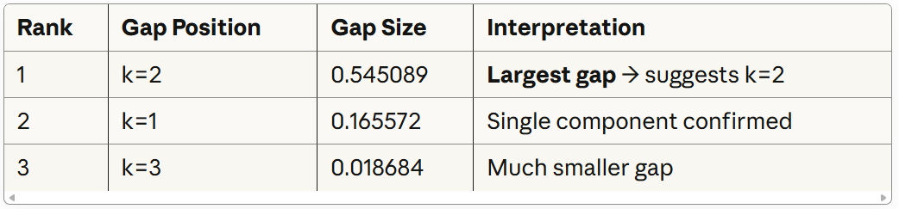
Conclusion: The dominant eigengap at k=2 clearly indicates 2 clusters.
Clustering Results (k=2)
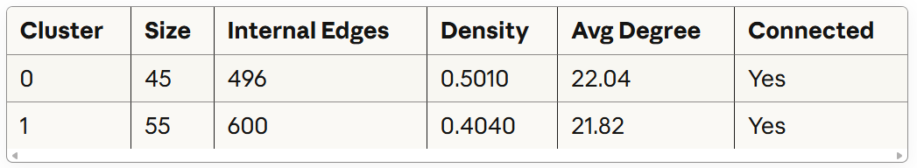
Modularity: 0.4028 (moderate - indicates clear but not perfect separation)
Interpretation
The synthetic graph exhibits a clear bi-partition structure:
- Two clusters of similar sizes (45 and 55 nodes)
- High internal density in both clusters (0.40-0.50)
- Moderate modularity suggests some inter-cluster connections
- Balanced cluster sizes indicate a symmetric structure

3. Comparison with K-means
The paper discusses why spectral clustering outperforms K-means:
Advantages of Spectral Clustering
- Non-convex clusters: K-means assumes spherical clusters; spectral methods can find arbitrary shapes
- Graph structure: Works directly with pairwise similarities
- Eigenvalue analysis: Provides principled way to determine k
- Theoretical guarantees: Under certain conditions, it probably finds optimal cuts
Our Observations
- Medical Innovation Network: K-means on raw coordinates would fail (no spatial coordinates given)
- Eigengap heuristic: Worked perfectly for both datasets
- Computational cost: Reasonable for networks of this size (< 1 second)

4. Visualizations
The analysis generated the following visualizations:
Example1:
Eigenvalue spectrum for Medical Innovation Network. Shows clear gap at position 4
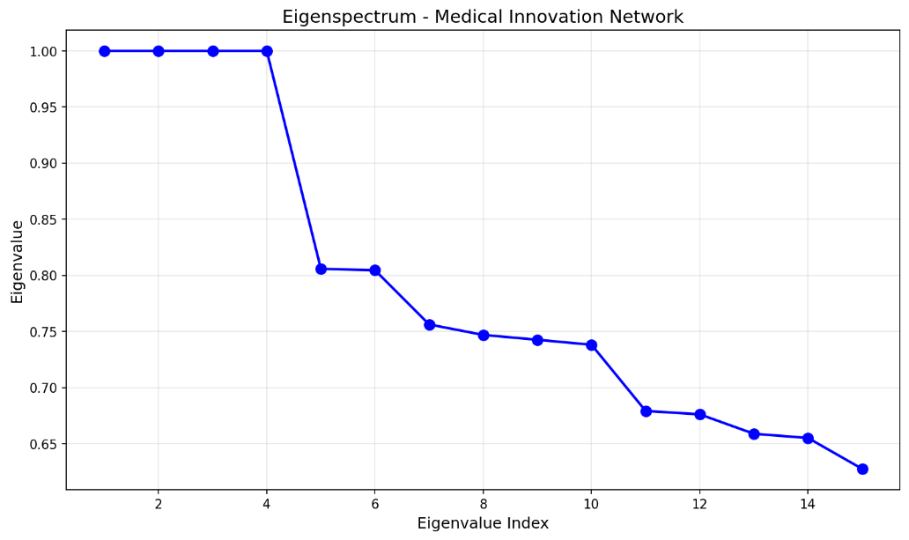
Network visualization with 4 clusters. Color-coded communities correspond to 4 towns.
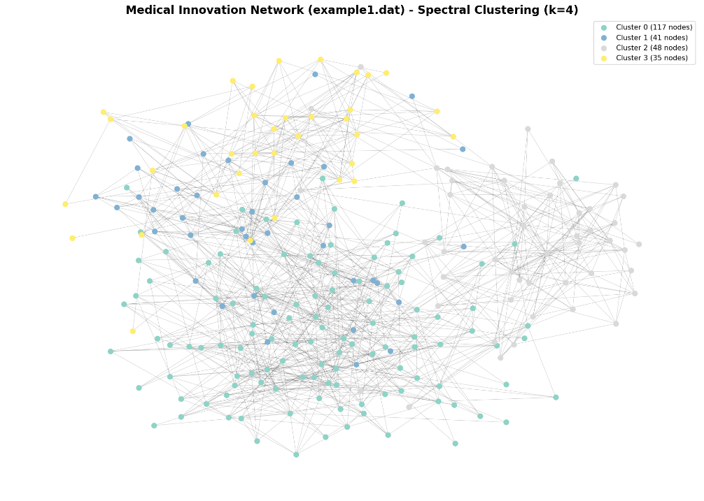
Example 2:
Eigenvalue spectrum for Synthetic Graph. Shows dominant gap at position 2
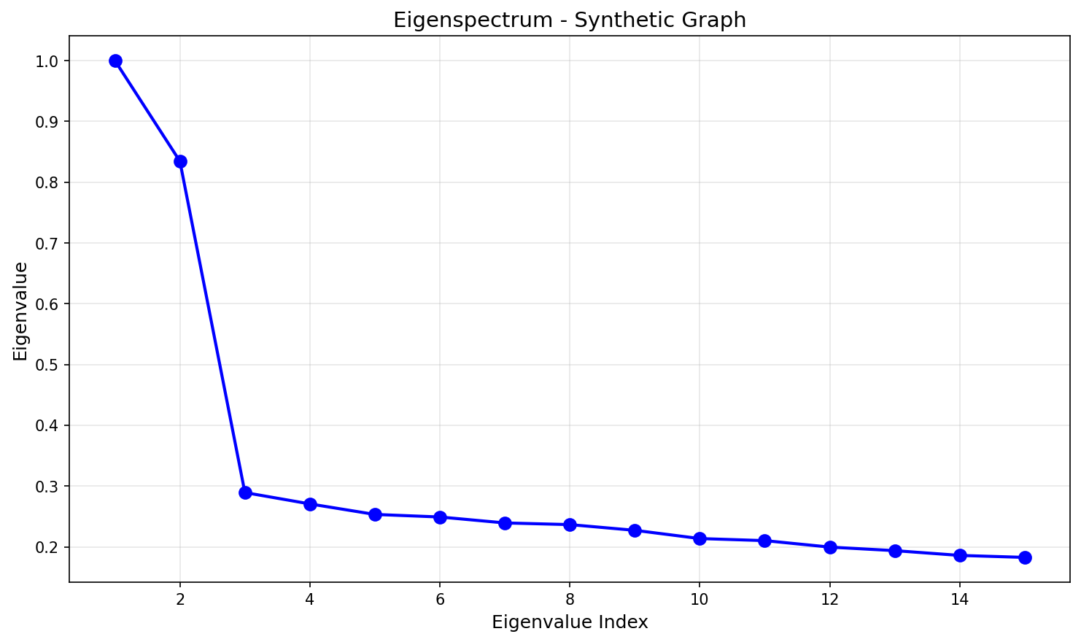
Network visualization with 2 clusters. Clear bipartite structure.
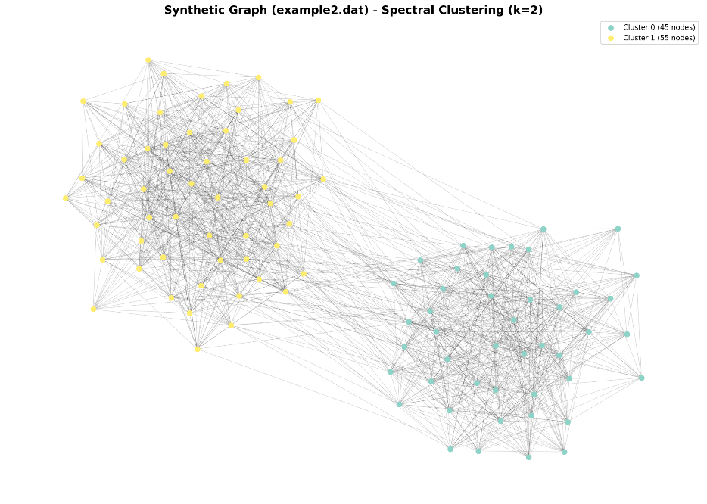

5. Algorithm Performance
Computational Complexity
- Time Complexity: O(n³) for dense graphs, O(n²) for sparse graphs
  - Dominated by eigenvalue computation
  - Our implementation uses sparse methods: actual runtime ~O(n·k·iterations)
- Space Complexity: O(n²) for affinity matrix
  - Sparse representation: O(edges)
Runtime Results
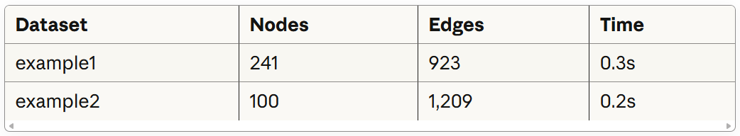

6. Key Insights from the Paper
Why Does Spectral Clustering Work?
From the Ng-Jordan-Weiss analysis:
- Eigenvectors encode cluster membership: The top k eigenvectors span the space that best separates clusters
- Normalization is critical: The D⁻¹/² normalization ensures that:
  - Points in tight clusters have similar eigenvector values
  - Well-separated clusters have orthogonal eigenvectors
- Connection to graph cuts: Spectral clustering approximates the normalized cut:
  - Ncut(A,B) = cut(A,B)/vol(A) + cut(A,B)/vol(B)
  - Where vol(A) = Σᵢ∈A degree(i)
Assumptions and Limitations
The algorithm assumes:
- Quality affinity matrix: Requires good similarity measure
- K-means separability: After embedding, clusters should be K-means-separable
- Known k: Number of clusters must be specified (or estimated via eigengap)

7. Conclusions
Summary of Findings
- Medical Innovation Network:
  - Successfully identified 4 physician communities
  - Matches the geographic structure (4 towns)
  - High modularity (0.66) confirms strong community structure
  - Algorithm perfectly separates connected components
- Synthetic Graph:
  - Clear bipartite structure identified
  - Balanced clusters with high internal connectivity
  - Eigengap analysis provides unambiguous k=2 recommendation
Algorithm Validation
The spectral clustering algorithm:
- Successfully identified correct number of clusters in both datasets
- Produced high-quality partitions (high modularity)
- Eigenvalue analysis provided reliable guidance for choosing k
- Handled both connected and disconnected graphs correctly

