待完成实验内容

部分一: Tri-Z算法实现

1. Image processing i.e. Gamma/ Color Normalization

2. Gradient Computation

The gradient of pixel (x,y)

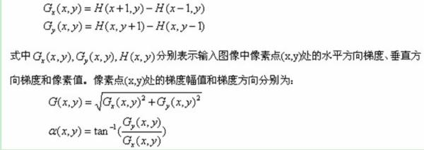

3.Divide the image into several cells that contain n*n pixel, i.e. n = 6

4. Orientation Binning/ 为每个细胞建立梯度直方图

将梯度方向分成m个bins

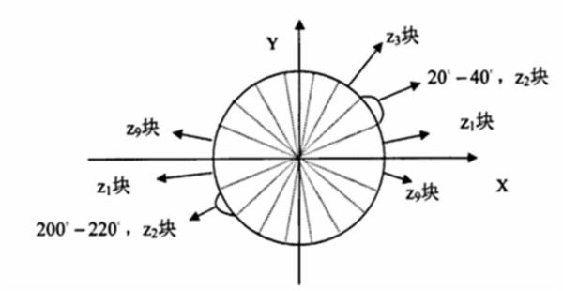

5. Descriptor

从center cell 开始, 逐层计算每层的descriptor. 第k层的descriptor 由两部分组成.第一部分:每个bin的值是4k个cell在此bin的平均值.第二部分: 4k个cell在此bin的variance. 最终从第一层起，将所有的各层的descriptor串联起来，形成本图最终的descriptor. (特征向量)

(注:第一部分的descriptor 仅1部分组成,因为第二部分全0)

|  |  |  |  |  |  |  |
| --- | --- | --- | --- | --- | --- | --- |
|  |  |  |  |  |  |  |
|  |  |  |  |  |  |  |
|  |  |  |  |  |  |  |
|  |  |  |  |  |  |  |
|  |  |  |  |  |  |  |
|  |  |  |  |  |  |  |
|  |  |  |  |  |  |  |

Fig. The first layer. The shadow part represents the center pixel

|  |  |  |  |  |  |  |
| --- | --- | --- | --- | --- | --- | --- |
|  |  |  |  |  |  |  |
|  |  |  |  |  |  |  |
|  |  |  |  |  |  |  |
|  |  |  |  |  |  |  |
|  |  |  |  |  |  |  |
|  |  |  |  |  |  |  |
|  |  |  |  |  |  |  |

Fig. The second layer of the image that contains 4*2= 8 cells.

部分二:

Tri-Z算法的具体参数如下(分别试一下两两组合,然后把最好的参数对应的结果填到exp1的表格中)

* cell size: 3*3/ 4*4/ 6*6/8*8/10*10
* bin：9/12/15/18

LBP和LCP的代码是用matlab编写的,见附件

#exp1 The first four row: prediction accuracies for the sample classes, respectively(即视作2分类问题). Acc & Sensitivity & Specificity & AUC (视作4分类问题的准确性/灵敏度等, AUC: Area Under the receiver operator characteristic Curve)

|  |  |  |  |  |
| --- | --- | --- | --- | --- |
|  | LBPri | LCP | Tri-Z | Tri-Z+LCP |
| Normal |  |  |  |  |
| Gastric poly |  |  |  |  |
| gastric ulcer |  |  |  |  |
| Gastritis |  |  |  |  |
| Acc |  |  |  |  |
| Sensitivity |  |  |  |  |
| Specificity |  |  |  |  |
| AUC |  |  |  |  |

**Table.**

#exp2

用各种分类算法进行分类

具体分类算法可参考下图

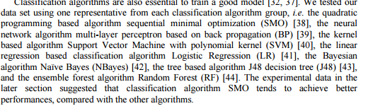

|  |  |  |  |  |  |
| --- | --- | --- | --- | --- | --- |
|  | SMO | BP | LR | RF | SVM |
| normal |  |  |  |  |  |
| gastric poly |  |  |  |  |  |
| gastric ulcer |  |  |  |  |  |
| gastritis |  |  |  |  |  |
| Acc |  |  |  |  |  |

**Table**

#exp

|  |  |  |  |  |  |
| --- | --- | --- | --- | --- | --- |
|  | SMO | BP |  |  |  |
| Acc |  |  |  |  |  |
| Sensitivity |  |  |  |  |  |
| Specificity |  |  |  |  |  |
| AUC |  |  |  |  |  |