Q1: Implement the voting phase of 2PC, **using python**.

1. Define vote request and respone:

1. Define vote function

1. Build up communication between coordinator and participants

1. Send vote request and receive vote commit form participants

1. Result:

CMD: python -m grpc_tools.protoc --proto_path=proto --python_out=. --grpc_python_out=. proto/twopc.proto

docker-compose up --build

Q2: Implement the decision phase of 2PC, **using node.**

1. The coordinator collects all votes from the participants

1. If Coordinator receive all RPC decide, call Python GlobalDecision

1. Coordinator receive all RPC decide from participants

1. Result:Coordinator request voting, and receive commit from all participants

Coordinator send global decision to all participants, and all participant locally commits the transaction.

Q3. Implement the leader election of a simplified version of Raft, using python.

1. Define vote and appendEntries message

1. Define raft node attributes

1. If a follower fail to receive heartbeat or election ack, it adds term by 1 and become a candidate voted for itself and send **RequestVote to other nodes.**

1. If candidate receives a majority of votes, it becomes the leader and begins sending periodic **AppendEntries**

1. Simulation:

Init 5 nodes as follower

If node3 fail to receive heartbeat, add its term by 1 and become candidate. Send vote request to other node.

Other node response request vote call by node3 after compare its term.



After receive majority of ack, node3 becomes leader.( we do not need ack by node5)



Node3 send appendEntries to other nodes, and other nodes receive it.

Q4. Implement the log replication of a simplified version of Raft, **using node.**

1. If client call a operation, but follower receive it. The operation will be forwarded to leader.

1. If a leader receive operators, create new entry of appendEntries and multicast appendEntries.

1. Once leader received majority of acks, response the client operation have been executed.

1. Client send operation to server.

1. Simulation:

CMD: node client.js 0.0.0.0:5001 "doSomething"

Node 1 is leader and receive operation from client. Multicast to other followers

Followers received request and respone ack to leader

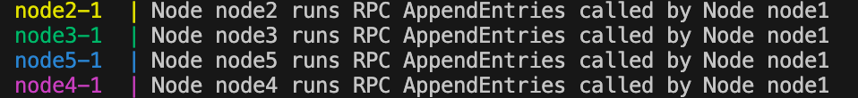

Leader received majority of ack, response to client.



Client got response



CMD: node client.js 0.0.0.0:5002 "doSomething2"

Client send to a follower( node2).

