**Report**

**//===========================================**

**// Name: Shaohu Zhang**

**// Compiler used: gcc on Linux server**

**//===========================================**

This C program is to implement a simple shell which has some functions as shown below:

* display the prompt <Zhang> before command line;
* read a command and its argument(s);
* exit the shell;
* continue reading the next command.

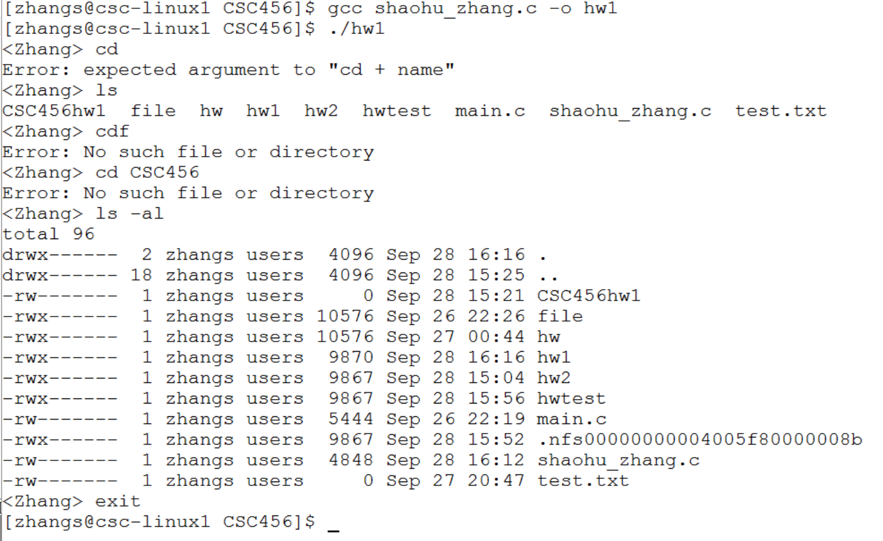

Functions:

bool shell_cd(char **args) //function to valid "cd" command

int shell_exit(char **args) // function to valid "exit" command

char *read_command_line(void){ //function to read user command

char **split_command_line(char *line) //function to split command line to character

int execute_command(char **args) //function to execute a user command

To run this program:

gcc shaohu_zhang.c –o hw1

./hw1

To exit the shell, please type ‘exit ‘.

This program can accept other Linux command, for example, type ‘ls’, the shell will print file list in the existing folder.