作业

1. 在“用户系统”的数据库创建表：员工表（emp）包括的字段：empno员工号/ename员工姓名/job工作/mgr上级编号/hiredate受雇日期/sal薪金/comm佣金/deptno部门编号)

|  |
| --- |
| create table emp  (empno varchar(10) primary key,  ename varchar(10),  job varchar(10),  mgr varchar(10),  hiredate datetime,  sal varchar(10),  comm varchar(10),  deptno varchar(10)  ) |

1. 插入的数据如下：

|  |
| --- |
| insert into emp values('7499' , 'ALLEN' , ‘SALESMAN’,’7698’,'2022-2-20' ,1600,300, '30');  insert into emp values('7521' , 'WARD' , ‘SALESMAN’,’7698’,'2022-2-22' ,1250,500, '30');  insert into emp values('7654' , 'MARTIN' , ‘SALESMAN’,’7698’,'2022-9-28' ,1250,1400, '20');  insert into emp values('7844' , 'TURNER' , ‘SALESMAN’,’7698’,'2022-9-8' ,1500,0, '30');  insert into emp(empno,ename,job,mgr,hiredate,sal,deptno) values('7698' , 'BLAKE' , ‘MANAGER’,’7839’,'2022-5-1' ,2850 '30');  insert into emp(empno,ename,job,mgr,hiredate,sal,deptno) values('7900' , 'JAMES' , ‘CLERK’,’7698’,'2022-12-3' ,900,'10');  insert into emp(empno,ename,job,mgr,hiredate,sal,deptno) values('7100' , 'JAMES' , ‘CLERK’,’7698’,'2022-12-3' ,900,'20'); |

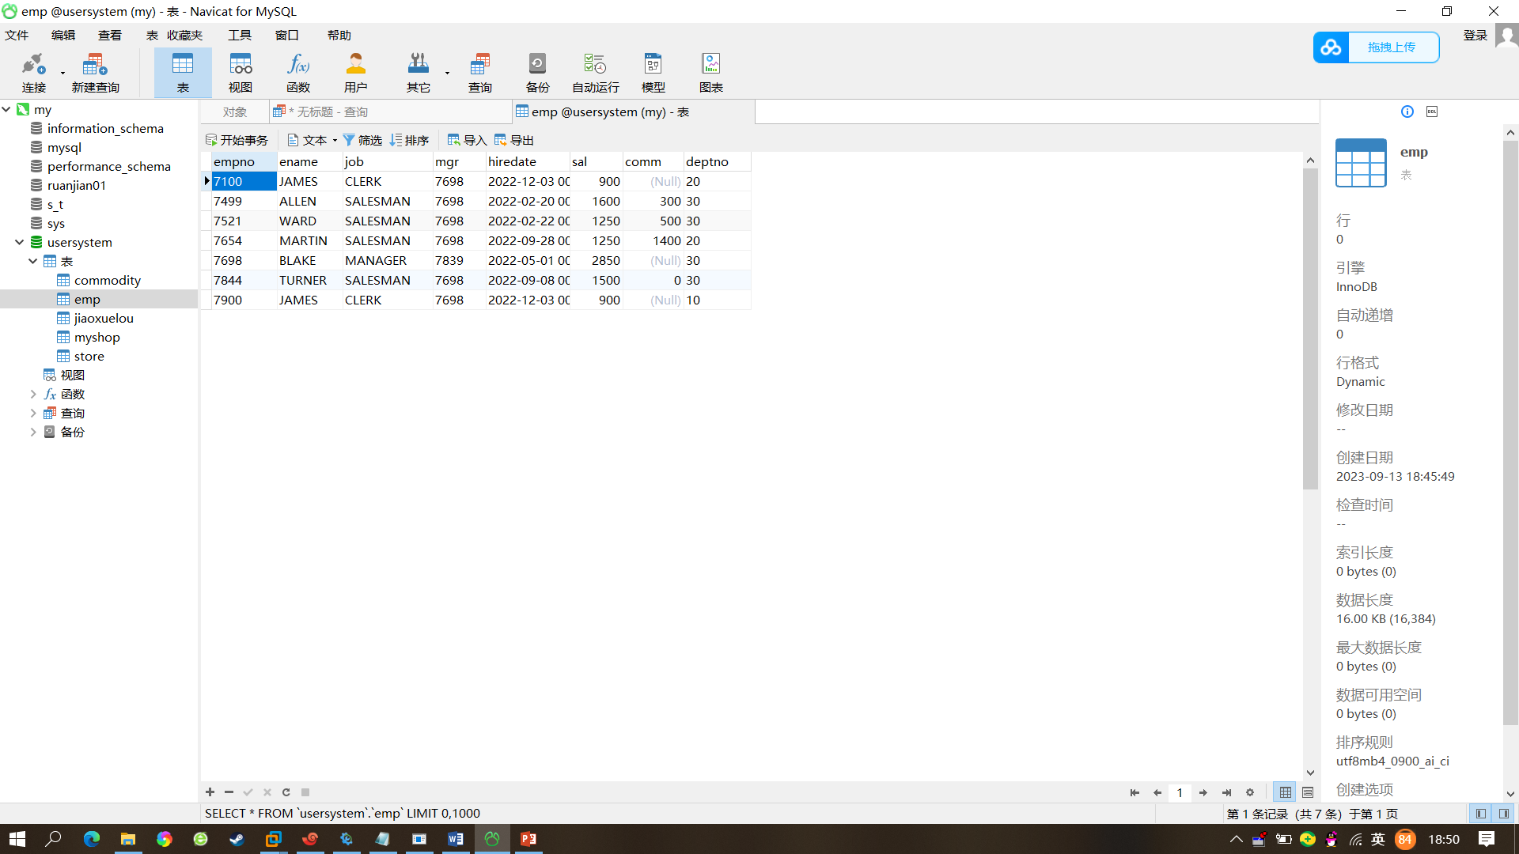

完成下面查询：

1. 查询出所有部门并不能重复

|  |
| --- |
| select distinct deptno  from emp; |

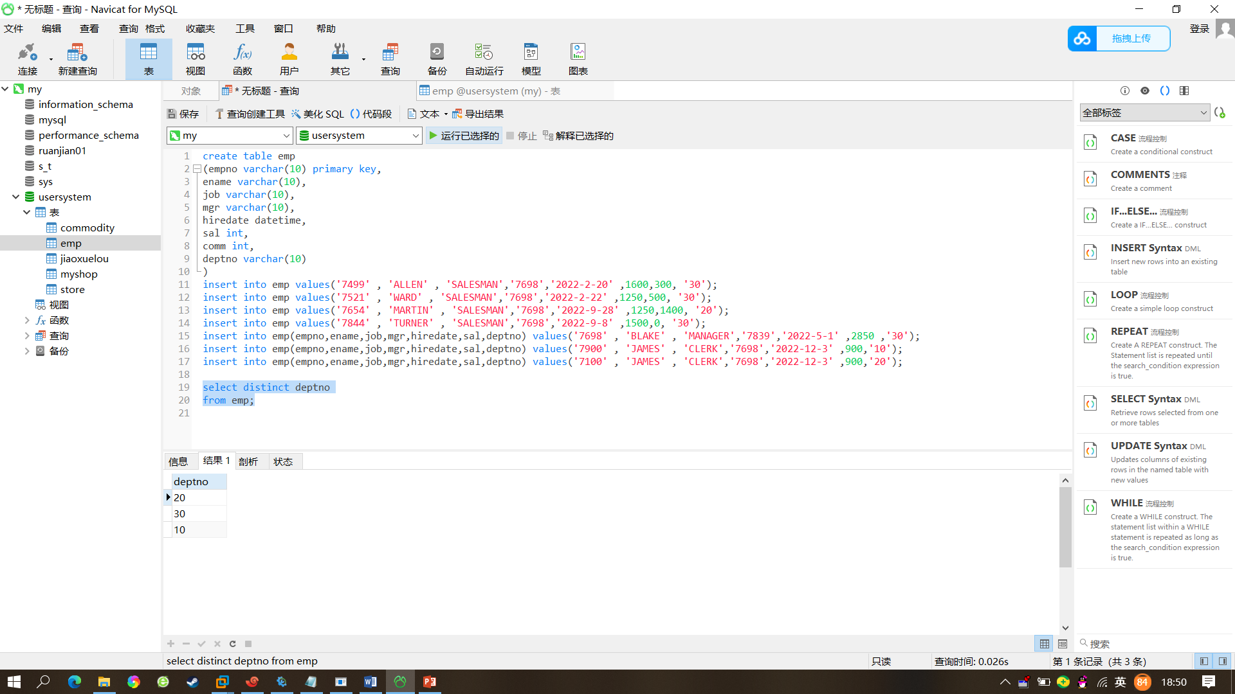

1. 选择部门30中的雇员

|  |
| --- |
| select *  from emp  where deptno=’30’; |

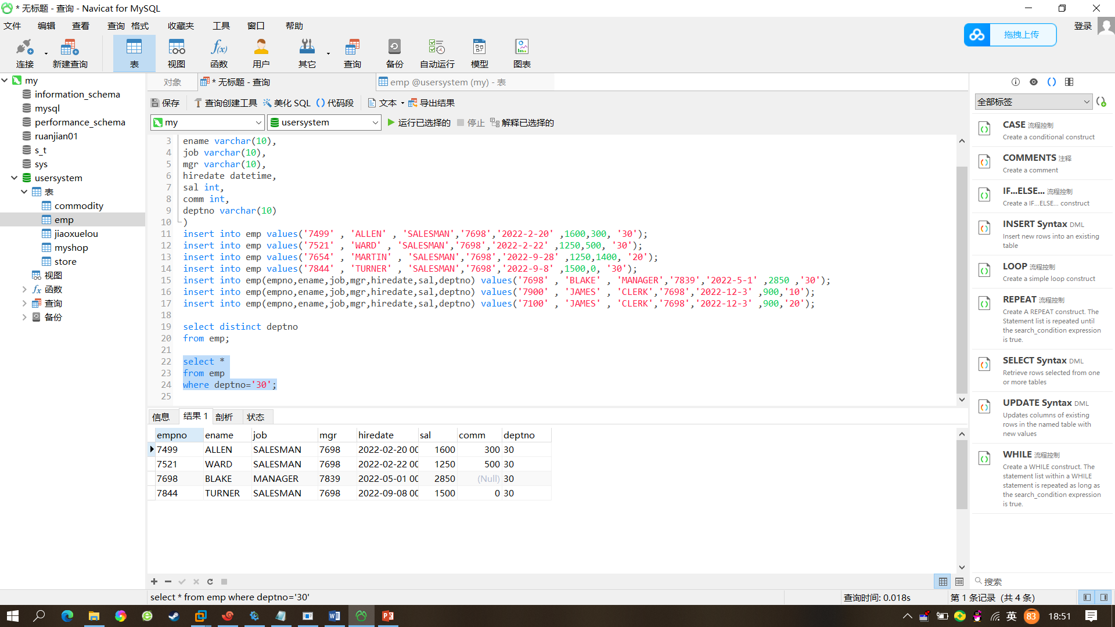

1. 列出所有办事员的姓名、编号和部门

|  |
| --- |
| select ename,empno,deptno  from emp  where job=’CLERK’ |

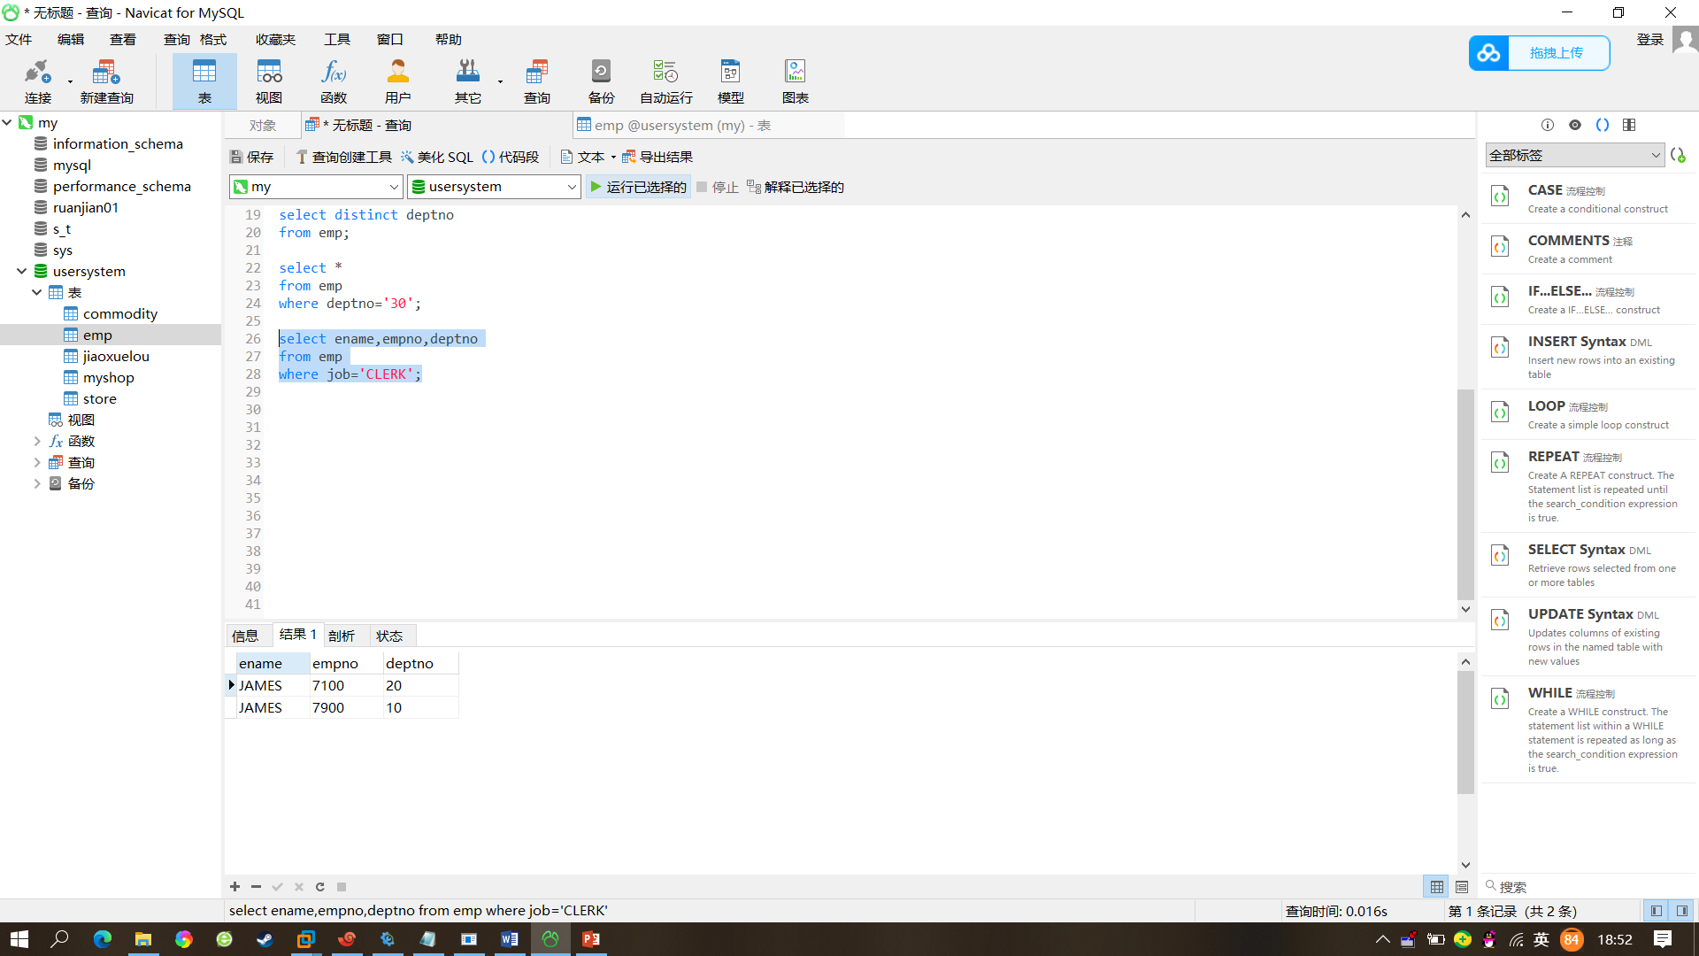

1. 找出佣金高于薪金的雇员

|  |
| --- |
| select *  from emp  where comm>sal |

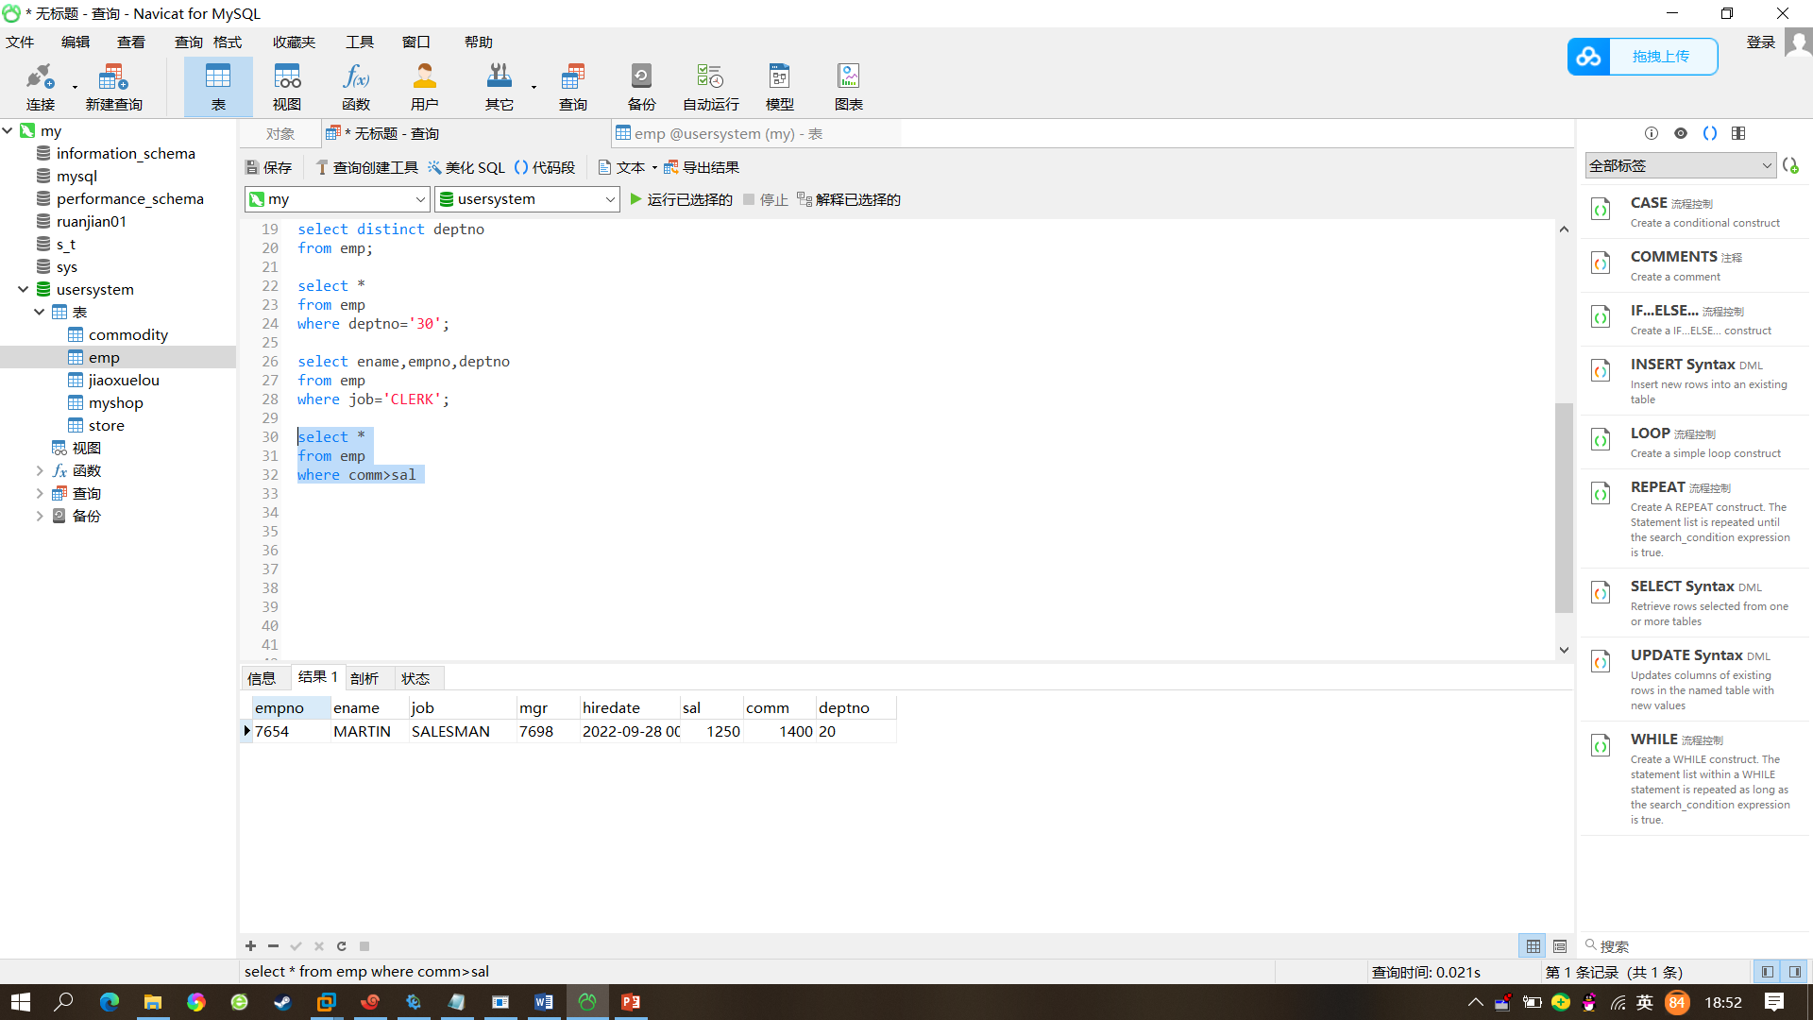

1. 找出佣金高于薪金60%的雇员

|  |
| --- |
| select *  from emp  where comm>0.6*sal |

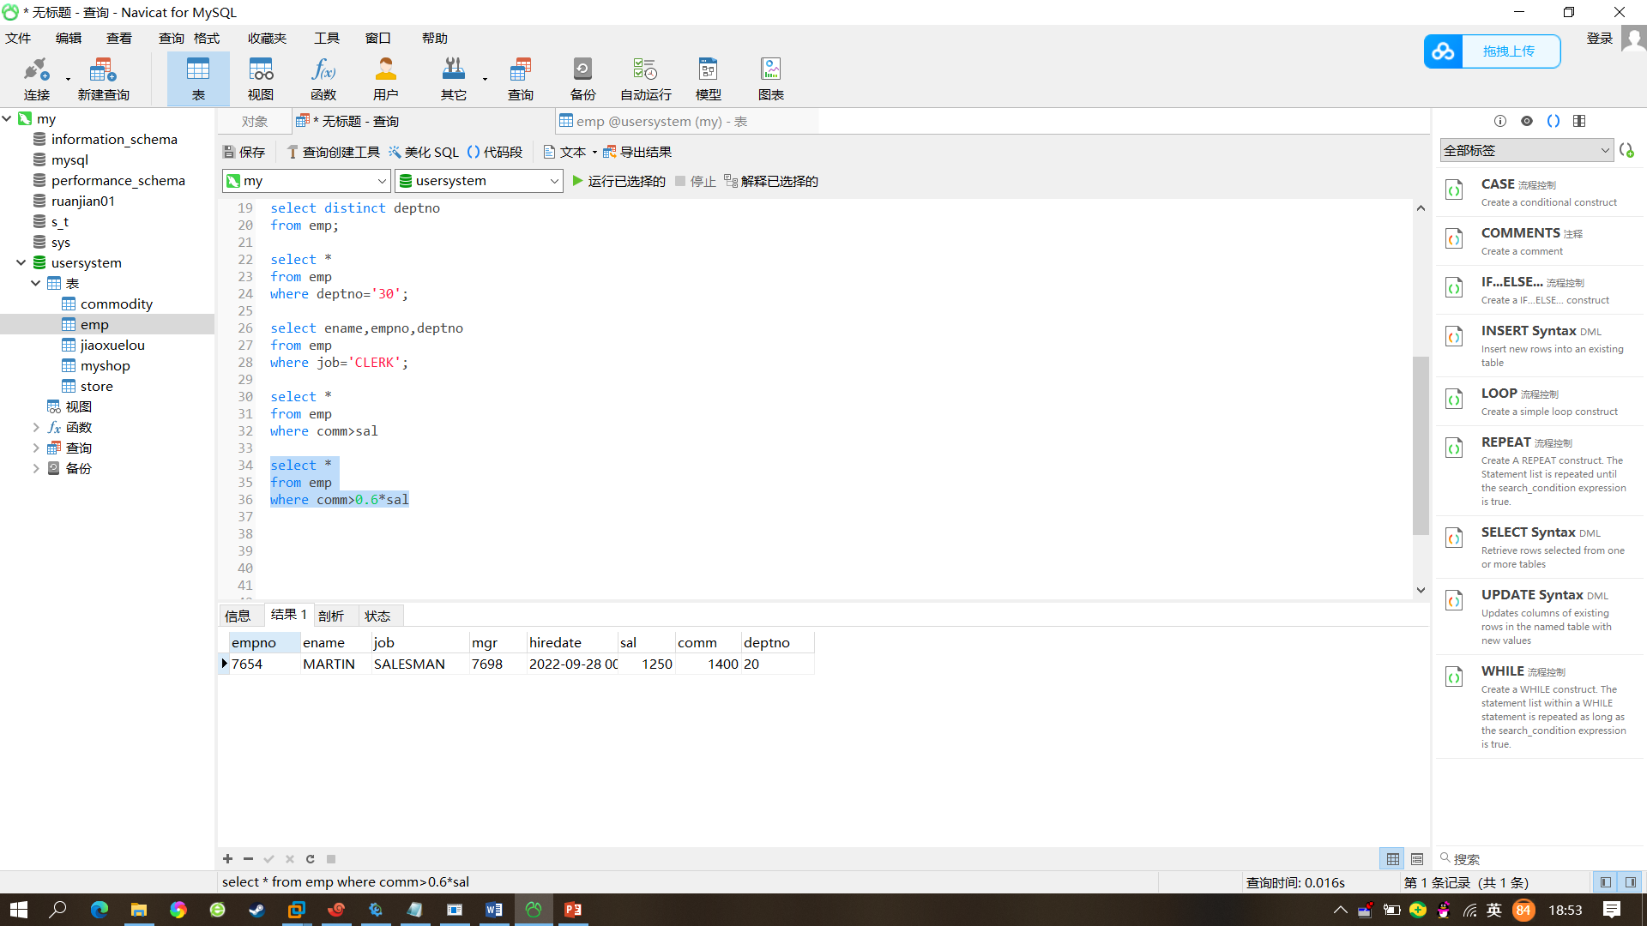

1. 找出部门10中所有经理和部门20中的所有办事员的详细资料

|  |
| --- |
| select*  from emp  where deptno=’10’ and job=’MANAGER’ or deptno=’20’ and job=’CLERK’ |

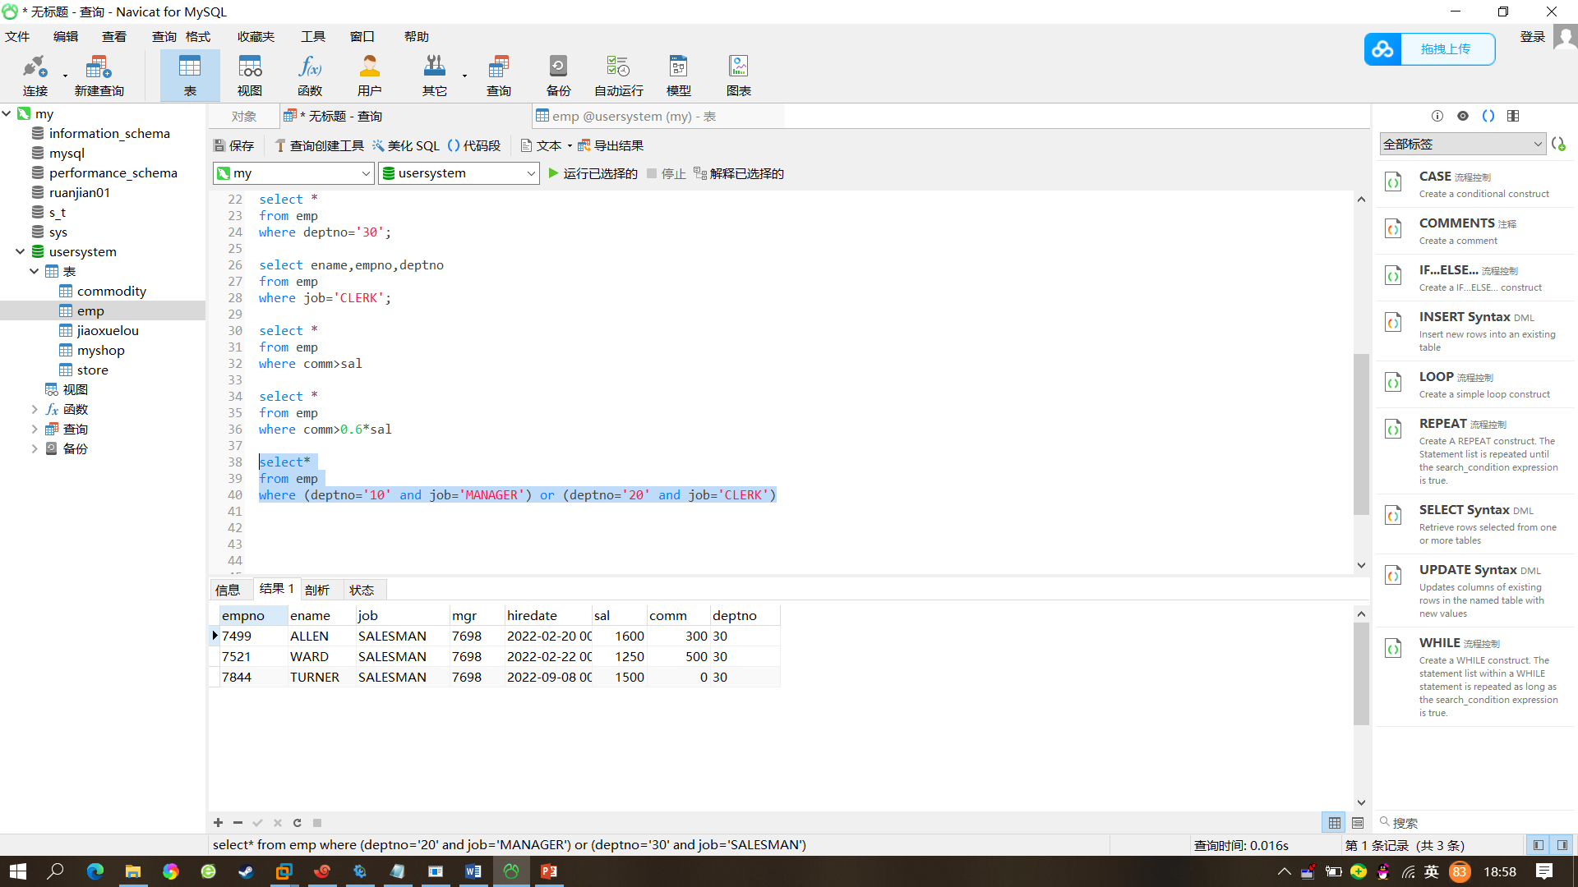

1. 找出收取佣金的雇员的不同工作

|  |
| --- |
| select*  from emp  where |

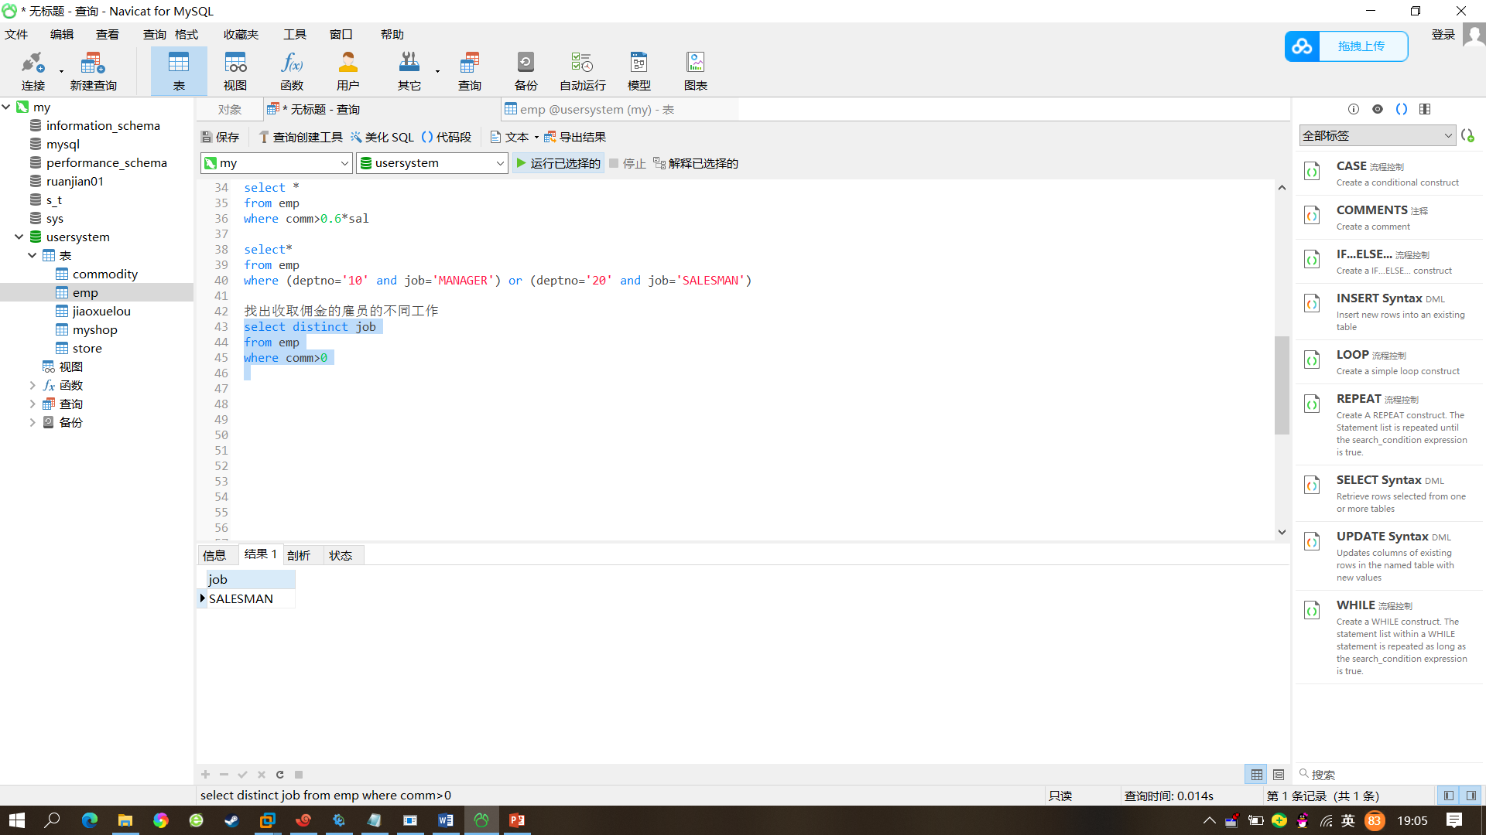

1. 找出不收取佣金或收取的佣金低于100的雇员

|  |
| --- |
| select *  from emp  where comm<100 |

