Theme/Template (4 popular system)

Discuz:
- Template file .htm files could be multiple-included, and nested-included.
- Easy template syntax, like asp, easy to understand.
- Generate template by internal logic to .aspx files. Want to be faster, no user control, Discuz.Common: PageTemplate -> ReplaceSpecialTemplate.
- Multiple-template could be existed at same time. User could define his own preferred template.
- HttpModule, HttpContext.RewritePath.
- Template, Variable. -> For a specific template.

BlogEngine:
- Very simple template structure. No quite clear Server side template concept, template is the jQuery template, and is operated by Javascript. In time plugin ability, just search the theme folder.
- Theme is supported by Asp.Net MasterPageFile, BlogEngine use the BlogBasePage base page structure, for each page to set the MasterPage, lifeway just need to set the default page MasterPage.
- Component to theme, CommentView, and PostView are templated by the UserControl.ascx files. Base class: UserControl, ICallbackEventHandler, at runtime OnLoad function get the template file and render to string, get it by ICallbackEventHandler interface GetCallbackResult function. -> for lifeway service?
- Runat=”server” header, Basepage set the CSS Handler to set the CSS file from the template folder and compress it, or if do not want to compress it, just the Master page CSS related file path. And image could be loaded from the CSS file.
- Good class structures: CommentViewBase -> CommentView.ascx, PostViewBase -> PostView, all Base classes are UserControl, to render the partial HTML, at run time to instance the UserControl and inject this control by Asp.Net policy well match the Asp.Net policy.

Wordpress:
- Wordpress template working flow chart.
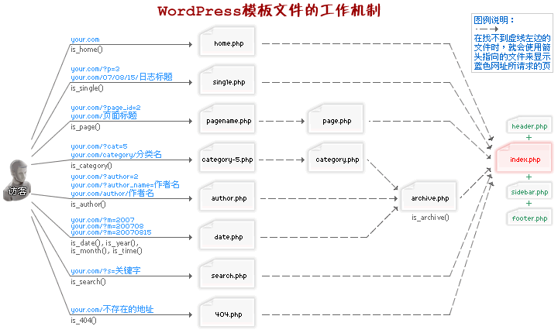
(Another image is the last version from word press official site.)

- Wordpress is driven by pages, display pages from the specific theme, load theme from configuration, theme folder: wp-content/themes/{ specific Them}.
- Template could be multiple/nested included, and this style well match php file including policy.
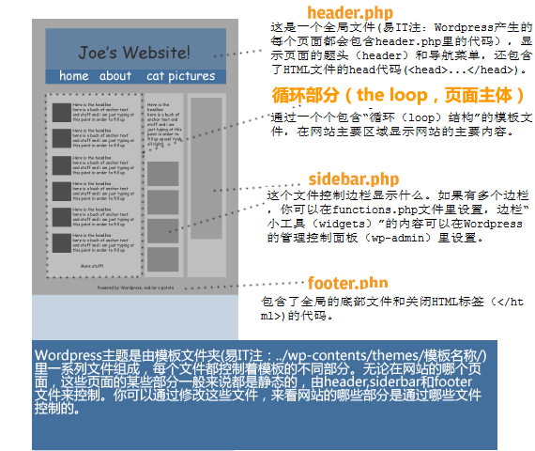

- Good Template pattern design, BlogEngine same as it. Extract all style to Style.css, the Style.css will manage layout and outlook, and separate the comment, and other functionalities.
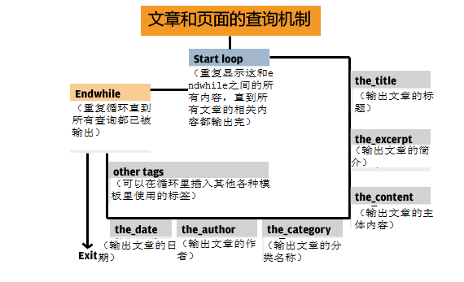
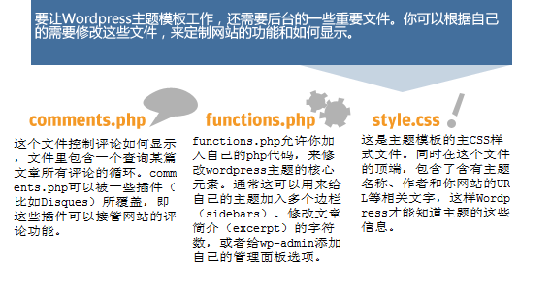
- Reference:
http://yoast.com/wordpress-theme-anatomy/
http://codex.wordpress.org/Templates
http://xiaopan.cc/wordpress-zhuti-jiegou.html
http://blog.designlinks.cn/wordpress/how-wop-works.html

Orchard:
- Good Theme and Template design, using Asp.NET MVC and Razor rendering syntax, very clear structure, and very well match Asp.Net rendering policy.
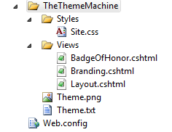
- Default page’s layout is defined in a single file layout.cshtml by Razor. Multiple zones use conditional statements. The conditional statements cause only the zones to be rendered for which content is provided. If you don't provide the content, the rendered page will not contain the zone.
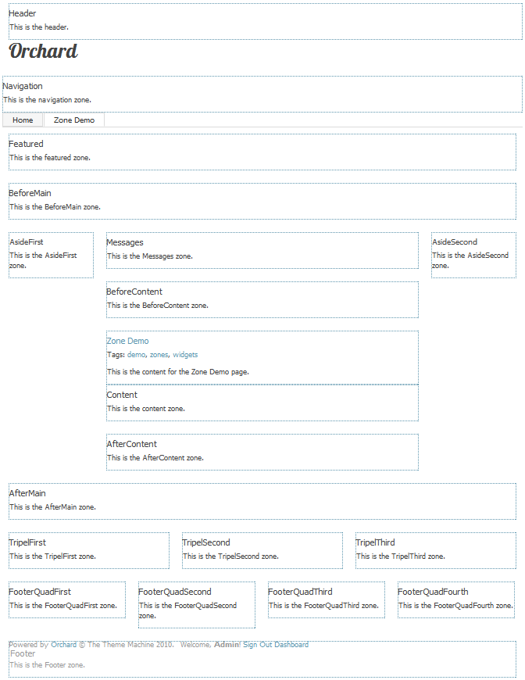

- Whole site major features are defined by one CSS file: Site.css.
- Create a customized theme, need to copy any files that intend to change, don't need to copy any files that do not intend to change , a customized theme inherits from its parent theme, Orchard first looks to that theme to resolve files, and if not found, it will look to the parent (BaseTheme) to find the files instead
- Orchard create theme by command-line CodeGen utility, and them copy modify intend parts. (Orchard template folder structure)
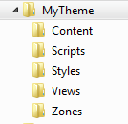
- Reference:
http://www.orchardproject.net/docs/Customizing-the-default-theme.ashx?HL=theme
http://www.orchardproject.net/docs/themes.ashx?HL=theme
-End.

