PNI BLE FOTA

Rev | Description | By | Date
A | Initial release | Kevin Chen | 12/12/2016

SCOPE
The document contain detail design information about the PNI BLE FOTA development.

Block Diagram

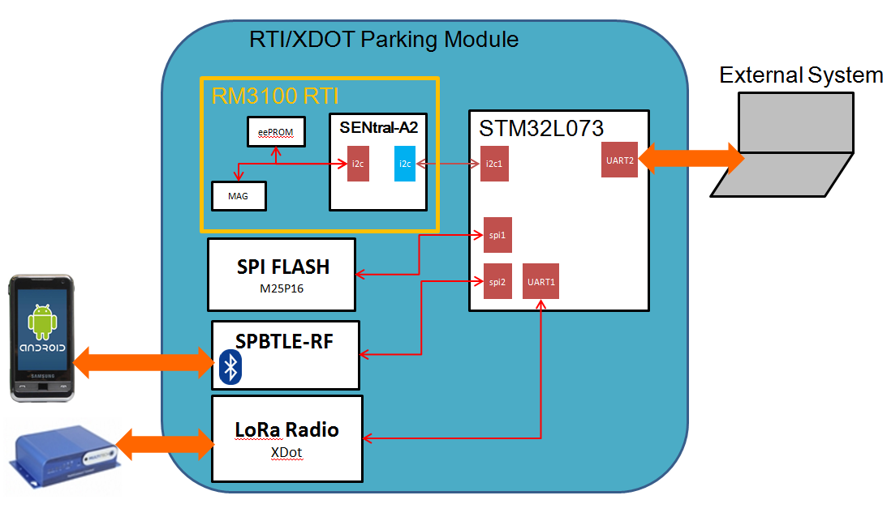

PNI BLE FOTA Packets and Flow:
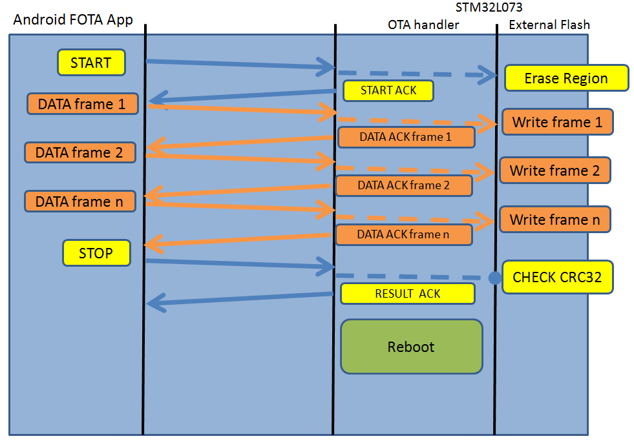

Commands:
- Start Command (12 bytes)
<START CMD(1 byte)><CRC8(1bytes)><Fw size(4bytes)><FW frames(2bytes)><FW CRC(2bytes)> <FW Type(2bytes)>
- START CMD – 0x10
- CRC8 –
private static byte crc8(int crc, byte[] bytes) {
for (byte b : bytes) {
crc += b;
}
return (byte) crc;
}

- FW Size - size of firmware
- FW frame – number of frame(16 bytes per frame)
- FW CRC – Not used
- FW Type –
  - MCU – 0x01
  - A2/RTI module – 0x02
  - BLE module – 0x03
  - XDot – 0x04
  - MFG Test – 0x05

- Data Command(20 bytes)
<DATA CMD(1 byte)><CRC8(1bytes)><frame ID(2bytes)><data frame(16bytes)>
- DATA CMD – 0x20
- CRC8 – same as START CMD
- Frame ID – 0x0001 ~ 0xFFFF
- Data Frame – 16 bytes

- Stop Command(4bytes)
<STOP CMD(1 byte)><CRC8(1bytes)><fwCrc(2bytes)>
- STOP CMD – 0x03
- CRC8 – same as START CMD
- fwCrc – not used

ACK Commands:
- START CMD ACK
<CMD ACK(1 byte)><CRC8(1bytes)><ACK Status(1bytes)><Frame ID(2bytes)>
- CMD ACK – 0x04
- CRC8 – 0x00 (not used)
- ACK Status
  - OK – 0x00
  - RETRY – 0x01(not used)
  - ERROR – 0x02
- Frame ID – Not used

- DATA CMD ACK(5 bytes)
<CMD ACK(1 byte)><CRC8(1bytes)><ACK Status(1bytes)><Frame ID(2bytes)>
- CMD ACK – 0x04
- CRC8 – 0x00 (not used)
- ACK status
  - OK – 0x00
  - RETRY – 0x01 (not used)
  - ERROR – 0x02
- Frame ID – received frame ID

- RESULT ACK(3 bytes)
<RESULT ACK(1 byte)><CRC8(1bytes)><Result Status(1bytes)>
- RESULT ACK – 0x05
- CRC8 – 0x00 (not used)
- Result Status
  - FOTA/DFU PASS – 0x00
  - FOTA/DFU FAIL – 0x01
  - REBOOT – 0x02
Example log:
Part1 Part2
UART2 Initialized
I2C1 Initialized
SPI Initialized

PNI Sensor Corp based on MOTENV1:
Version 2.1.0
STM32L073RZ-Nucleo board
Sensors Board not present -> Emulated
Parking Host - V00.04.02.043!!!
Compilerd Jan 17 2017 08:18:24 (IAR)
Debug Connection Enabled
Debug Notify Trasmission Enabled
BlueNRG version: 49, 1809
SERVER: BLE Stack Initialized
Board type=IDB05A1 HWver=49, FWver=7.1.a
BoardName= PNIV041
BoardMAC = c0:58:47:66:33:34

Console Service W2ST added successfully
PNI Dfu Service added successfully
>>>>>>CONNECTED 4a:e0:eb:30:14:ee
[DBG] DfuPktCharHandle + 2
att_data:0x01 0x00
[DBG] OtaDfuStartCmdHandler()
[DBG]: size:66495, frame count = 4156, CRC = 0000
Erasing Flash...End FLASH Erase 767 Sectors of 128KB
[DBG] OtaDfuStartCmdAck()
[DBG] FOTA programing............................................................................................................................................................................. .................................................................................................................................................................................................. ................................................
Checking Flash CRC...Match
OTA Firmware will be installed at next board reset
PNI Parking Module will restart in 5 seconds

PNI Parking/L073 BOOTLOADER(0.2.0.6)

Look for update OTA image...Found

------Prepare update firmware------
Erasing old firmware...Done
Update new firmware....................................................................................................................................................................... .................................................................................................................................................................................................. .................................................................................................................................................................................................. ..............................................................................................................................Done

Clear Magic Number...Done
Finish update!!!
Reboot in 2sec...
PNI Parking/L073 BOOTLOADER(0.2.0.6)

Look for update OTA image...Not Found

Booting PNI firmware...

UART2 Initialized
I2C1 Initialized
SPI Initialized

PNI Sensor Corp based on MOTENV1:
Version 2.1.0
STM32L073RZ-Nucleo board
Sensors Board not present -> Emulated
Parking Host - V00.04.02.042!!!
Compilerd Jan 16 2017 16:21:02 (IAR)
Debug Connection Enabled
Debug Notify Trasmission Enabled
BlueNRG version: 49, 1809
SERVER: BLE Stack Initialized
Board type=IDB05A1 HWver=49, FWver=7.1.a
BoardName= PNIV041
BoardMAC = c0:58:47:66:33:34

Console Service W2ST added successfully
PNI Dfu Service added successfully

Boot Process – Internal Flash ONLY
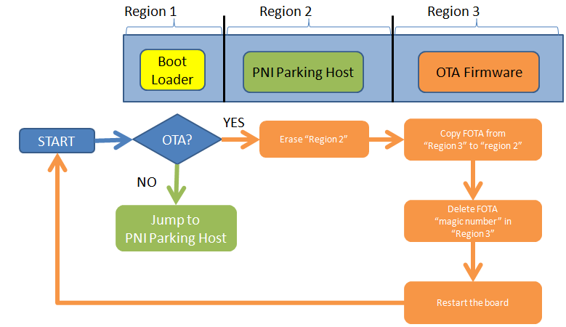

On any board reset, the board starts executing the boot loader.
The boot loader checks whether a FOTA is available: the check is based on the presence
of a "magic number" at the beginning of the third Flash region.
If there is a FOTA available, the bootloader:
1. erases the second Flash region (containing the PNI Parking Host firmware)
2. replaces its content with the OTA Firmware
3. erases the “magic number” used to check FOTA presence
4. restarts the board
If there is no FOTA available, the boot loader jumps directly to the PNI Parking Host firmware.

Dual images(External SPI Flash) – Stable and OTA
Fail safe environment – always have backup copy of the image
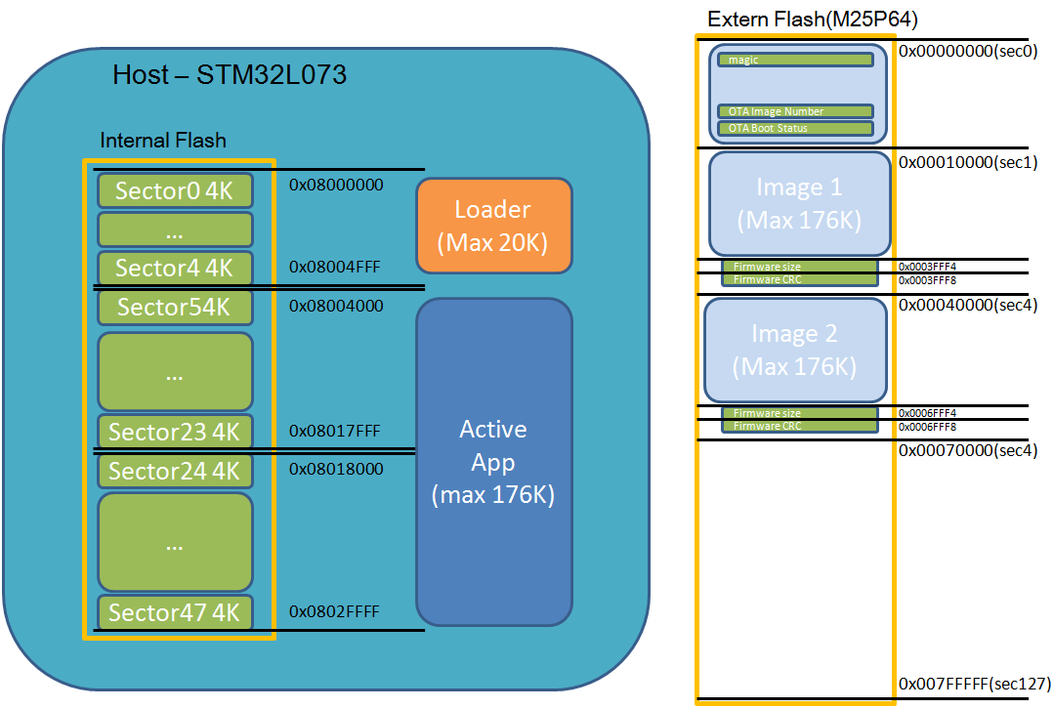

PNI FOTA Boot Process - Bootloader

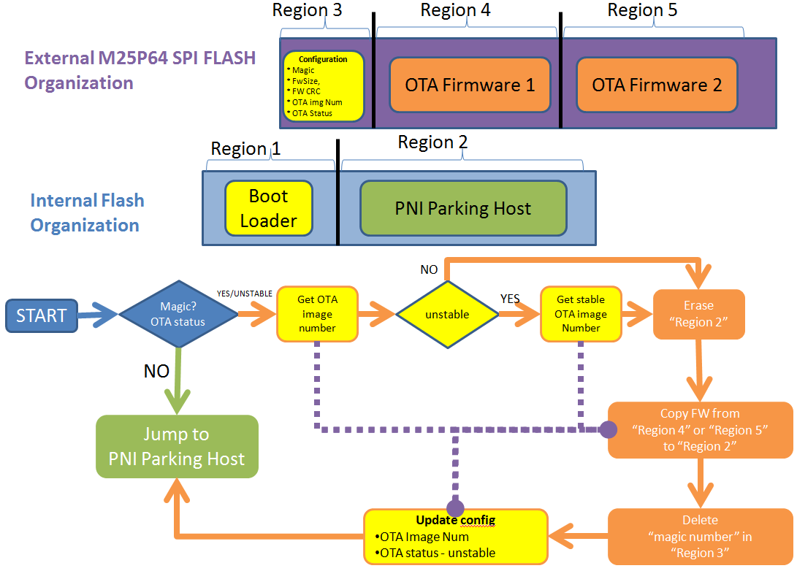
On any board reset, the board starts executing the boot loader.
The boot loader checks whether a FOTA is available: the check is based on the presence of a "magic number" which is sector 0 in the external flash memory. Bootloader also check “OTA Status” to determine previous OTA image was stable or not.

If there is a FOTA available, the bootloader will update new OTA firmware from external flash to PNI parking Host in Region2.
If OTA status is unstable, the booloader will recover previous stable firmware back to PNI parking HOST in region2.

- Check magic and OTA status
- Get OTA image number
- For “recovery”, OTA image number will be changed to stable image number
- erases the region 2 Internal Flash region (containing the PNI Parking Host firmware)
- copy OTA firmware and replaces content in region 2
- verify CRC in region 2
- erase region 3 to clear “magic number”
- update OTA image number and OTA status to unstable.
- Jump and Execute PNI Host Firmware in Region 2

PNI FOTA: Parking Host FOTA Process
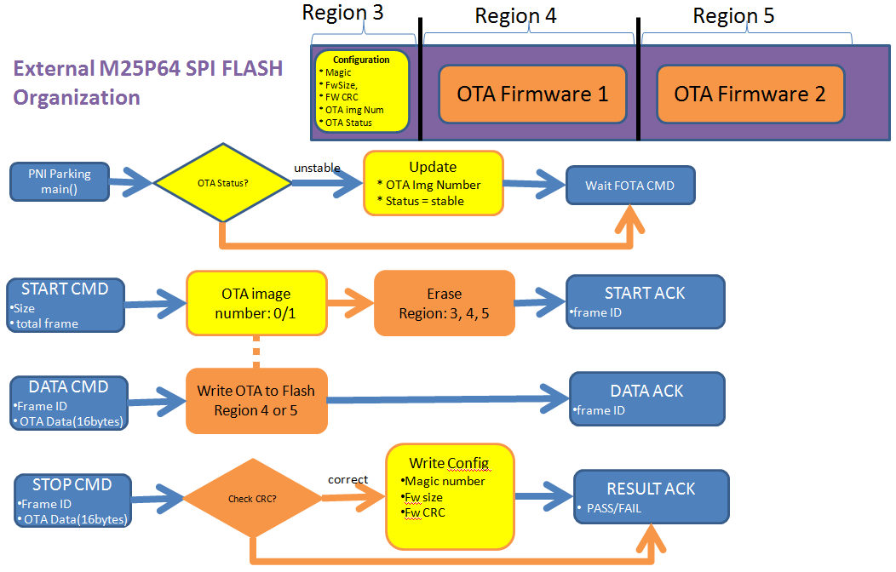
On any board reset, the board starts executing the boot loader. The boot loader will jump to parking host. Parking Host will be responsible for FOTA. In order to have failure safe FOTA, a dual image update is must. 2 additional variables added into the configuration region.
- “OTA Image Number” to track which region should be use for saving OTA firmware
- “OTA status” to track OTA image was able to correctly boot up and execute

Starting from V0.6.0, the parking host will be checking “OTA status” field and tag it with stable if the firmware was able to run up to certain location in the code. If the code never executed to stable location in the code, on reboot, the FOTA bootloader will recover the parking host back to the stable version.

Example Log: Failure image.

Uploading unstable firmware
Initialize SPI2...Done
Detecting SPI Flash(MP25P64)...Found

PNI Parking/L073 BOOTLOADER(0.4.0.16)

Look for update OTA image...Not Found!!
Booting PNI firmware...

UART2 Initialized
I2C1 Initialized
SPI Initialized
Initialize SPI2...Done
Detecting SPI Flash(MP25P64)...Found

PNI Sensor Corp based on MOTENV1:
Version 2.1.0
STM32L073RZ-Nucleo board
Sensors Board not present -> Emulated
Parking Host - V00.06.01.064!!!
Compilerd Jan 24 2017 14:20:49 (IAR)
Debug Connection Enabled
Debug Notify Trasmission Enabled
BlueNRG version: 49, 1809
SERVER: BLE Stack Initialized
Board type=IDB05A1 HWver=49, FWver=7.1.a
BoardName= PNIV041
BoardMAC = c0:5a:47:66:33:34

Console Service W2ST added successfully
PNI Dfu Service added successfully
>>>>>>CONNECTED 65:83:a0:a0:f:29
[DBG] DfuPktCharHandle + 2
att_data:0x01 0x00
[DBG] DfuPktCharHandle + 2
att_data:0x01 0x00
[DBG] OtaDfuStartCmdHandler()
[DBG]: size:12857, frame count = 804, CRC = 0000
[DBG] OtaDfuStartCmdAck()
[DBG] FOTA External Flash programing(ota2)................................................................................Last frame
Checking FOTA CRC...Match(0x78653ED0)
[DBG] OtaDfuStartCmdAck()
PNI Parking Module will restart in 5 seconds

Restart – In L073 bootloader(Magic Number Set)
Initialize SPI2...Done
Detecting SPI Flash(MP25P64)...Found

PNI Parking/L073 BOOTLOADER(0.4.0.16)

Look for update OTA image...Found
------Prepare update firmware------
Erasing old firmware...Done
Update new firmware(ota2)...fw size(0x0006FFF4): 12857[0x00003239]
............................................................................................................Done
Verify CRC...fw CRC(0x.08X): 0x0006FFF8[0x78653ED078653E]
Match(0x78653ED0)
Clear Magic Number...Done
restore config...Done
Finish update!!!
Boot in 2sec...

Booting PNI firmware...

Firmware Hang – Press hardware “RESET” button
Initialize SPI2...Done
Detecting SPI Flash(MP25P64)...Found

PNI Parking/L073 BOOTLOADER(0.4.0.16)

Look for update OTA image...Problem last OTA update
------Restore stable OTA image(1)------
Erasing old firmware...Done
Update new firmware(ota1)...fw size(0x0003FFF4): 67571[0x000107F3]
....................................................................................................................................................................................................................................................................................................................................................................................................................................................................................................................................................................................Done
Verify CRC...fw CRC(0x.08X): 0x0003FFF8[0x72CA1CBD72CA1C]
Match(0x72CA1CBD)
Clear Magic Number...Done
restore config...Done
Finish update!!!
Boot in 2sec...

Booting PNI firmware...
Booting Stable firmware

UART2 Initialized
I2C1 Initialized
SPI Initialized
Initialize SPI2...Done
Detecting SPI Flash(MP25P64)...Found

PNI Sensor Corp based on MOTENV1:
Version 2.1.0
STM32L073RZ-Nucleo board
Sensors Board not present -> Emulated
Parking Host - V00.06.01.064!!!
Compilerd Jan 24 2017 14:20:49 (IAR)
Debug Connection Enabled
Debug Notify Trasmission Enabled
BlueNRG version: 49, 1809
SERVER: BLE Stack Initialized
Board type=IDB05A1 HWver=49, FWver=7.1.a
BoardName= PNIV041
BoardMAC = c0:5a:47:66:33:34

Console Service W2ST added successfully
PNI Dfu Service added successfully

Support Different types of firmware update- BLE firmware update
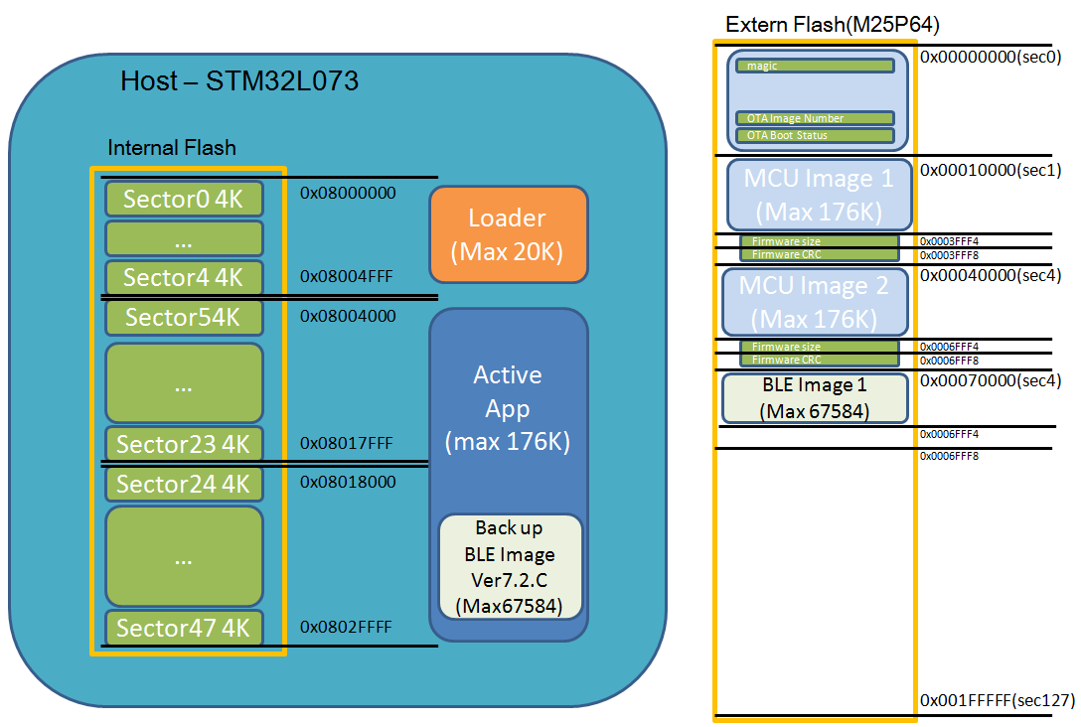

PNI BLE FOTA: Parking Host FOTA Process – BLE Stack (V0.7.0)
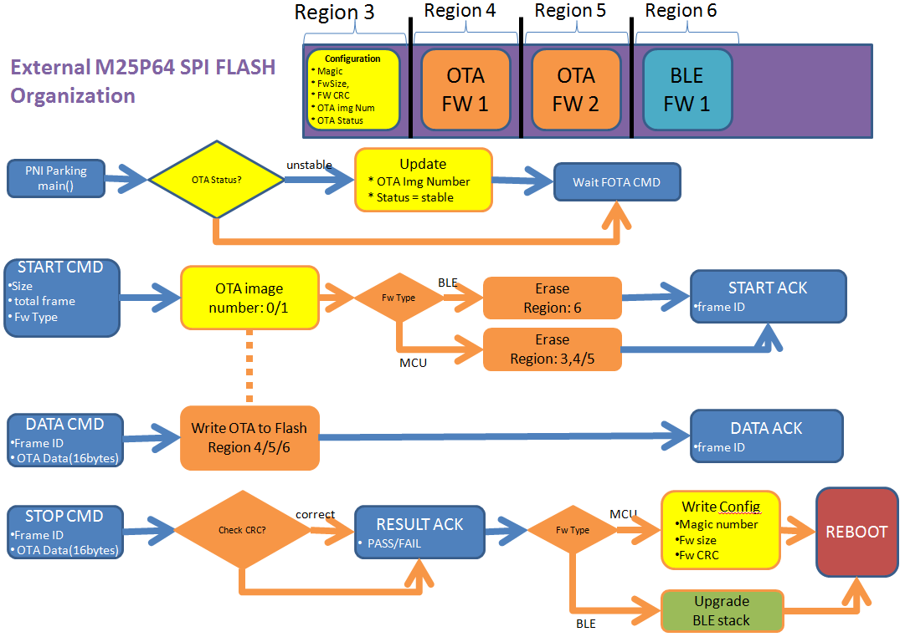

Support Different types of firmware update- A2 firmware Update
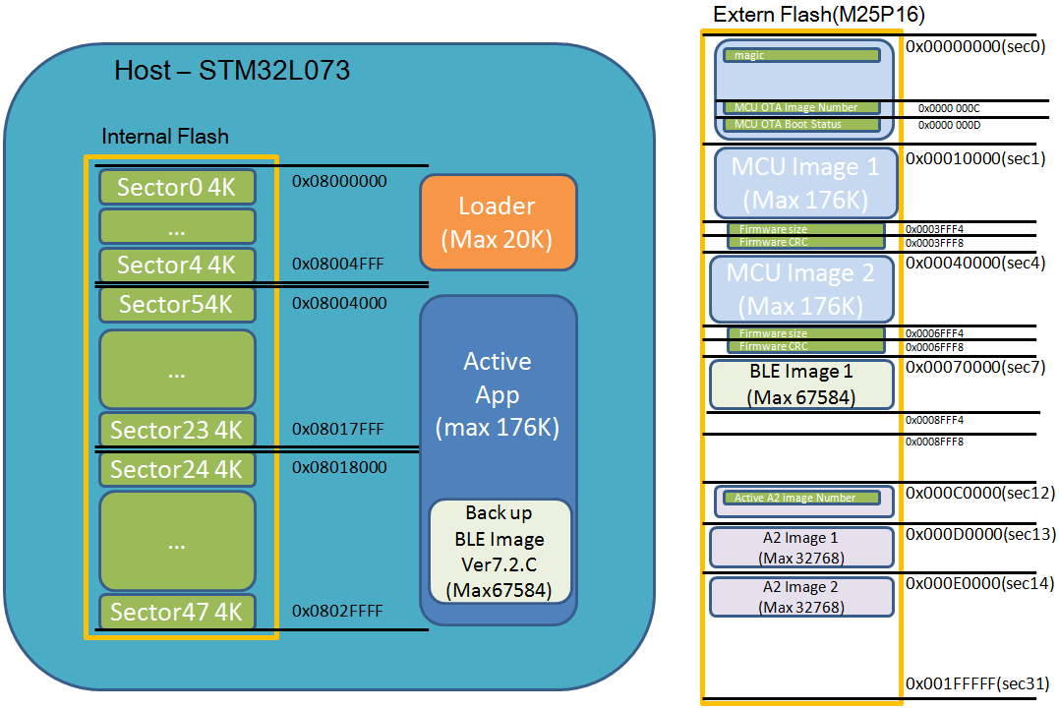

PNI A2/RTI FOTA: Parking Host FOTA Process

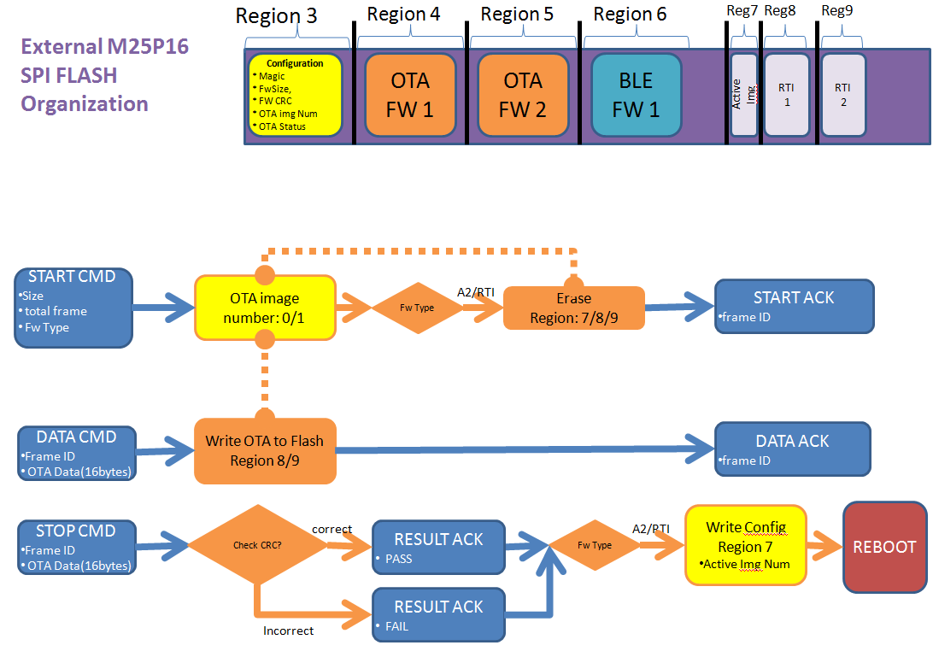

[0.2.4.46]Support Dual BLE image – remove the backup BLE image in Active App
