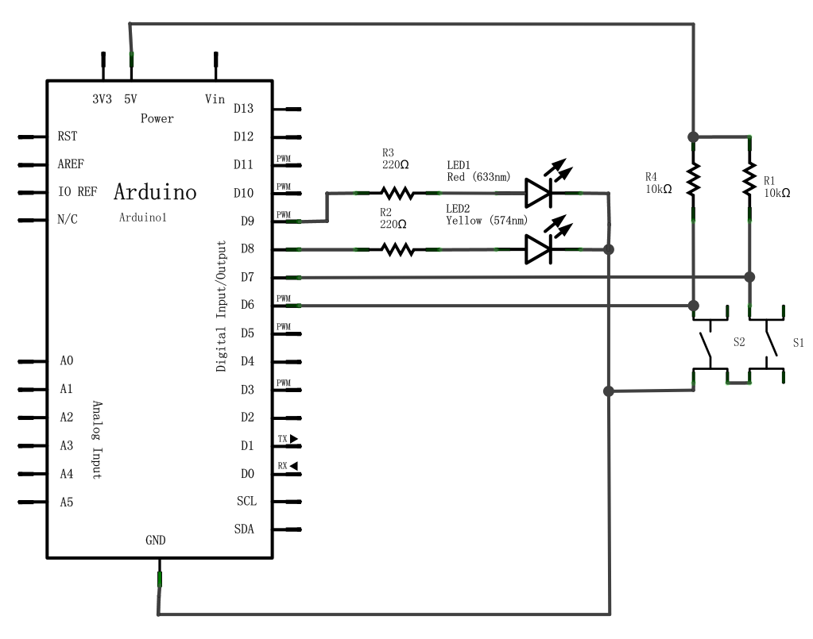 Made by Siyan Zhang

Pressure Tester

10-02-2012