Resume
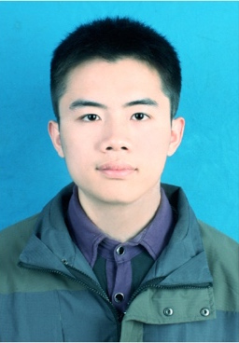
Name ： Zhang Song
Gender ： Male
Birthday ： 1992.04
Age ： 24岁
Graduate School：
University of Science and Technology of China(M.S.)(985,211)，
Northwestern Polytechnical University(B.S.)(985,211)
Major ：
Software Engineering(M.S.)，
Software Engineering(B.S.)
Address ： China-Hefei
Mobile ： 13105812653
E-mail ： sa514164@mail.ustc.edu.cn
English ： CET-6(568)，CET-4(564)，TOFEL(87)
实习公司： 阿里巴巴菜鸟网络

___·Educational_Background·_________________________________________________

2014/09--2017/03 USTC Software Engineering M.S.
2009/09--2013/7 NWPU Software Engineering B.S.

___·Internship_Experience·____________________________________________________

2015/05--2015/07 Lotuseed Corporation Data Technology Development
2015/07--2016/07 Alibaba Cainiao Network Corporation Service Reserch&Development

___· Self_Appraisal·____________________________________________________________

Continuous study in NWPU & USTC，Solid technology background of computer software，Experienced programming skills
Regular thinking and summary of technology，Willing to study new knowledge and challenge
Accustomed to increasing effiency under pressure，Happy to cooperate and communicate，Brave to drive changes

