【福利帖】2013年最新TOEIC托业价值128元官方模拟试题（语法部分）

参加了三月份的托业考试，复习了整整两个月，成绩还不错，968分，比我六级成绩高了整整一倍。复习经验在这里不想多说，网上的经验贴实在是太多了。为了造福学弟学妹们，现把我的复习资料奉献给大家~换一点儿百度文库积分哈~

发福利咯：

1、四本复习书+配套MP3（大家可以登录[www.115.com](http://www.115.com)进行下载，账号308455927，密码是toeic123）

2、大家报名的时候可以申请20元优惠券！两天就能收到哦！（发送”姓名+考试城市”到toeicchina@126.com），小小透露一下，你收到的将不止是优惠券！

3、一套价值128元的TOEIC官方在线模拟题（这个在托业官网上可以买到，应该是一年一更新），难度和机考难度相当，更有针对性。废话不多说，下面是模拟题的部分截图，大家也可以加入TOEIC考试交流群获取更多信息（102143451）。

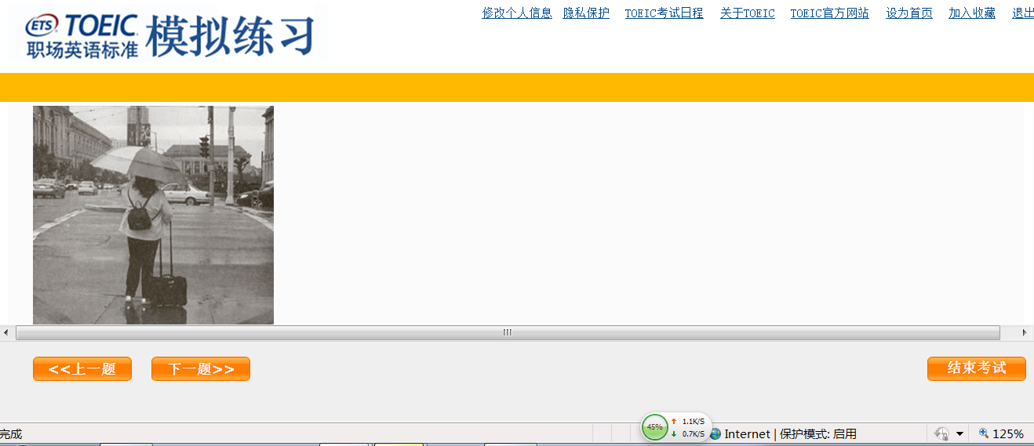

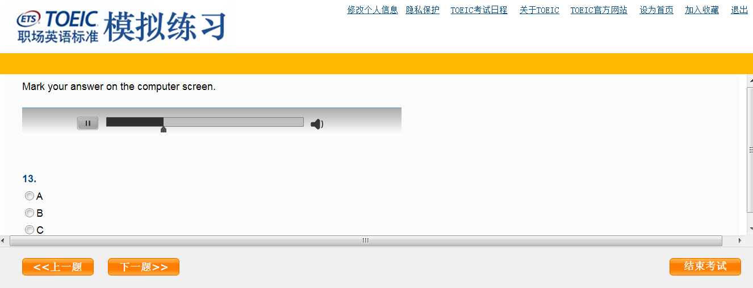

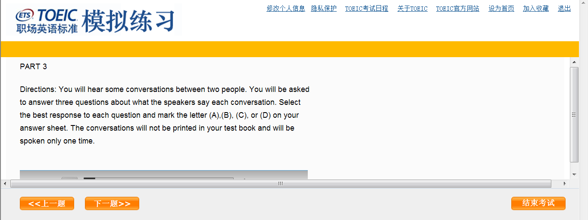

101

The new office computers were delivered last Tuesday, but they are still sitting in ______original boxes.   
A they  
B them  
C their  
D themselves

**102.**

_____ up-to-date weather information in your local area, please visit our Web site at www.hillsideweather.com.   
A In  
B For  
C To  
D Of

**103.**

The publications department has assembled a team of language experts to oversee the ____of our Spanish-language employee manuals.

A translate  
B translates  
C translated  
D translation

**104.**

Because the telephone company received so many_____ about its new wireless headsets, they were removed from the market after just one week.   
A complaints  
B damages  
C charges  
D operations

105.

_____of the photographs in the exhibit were taken at or near the artist’s home in southern India.

A Most  
B Almost  
C Another  
D Other

**106.**

Ms.Andrews will need to lease an apartment in _______ Florence or Pisa until the historic conservation project is completed.   
A and  
B both  
C neither  
D either

**107.**

This evening’s ____ will be provided by the Croft Brothers, a well-known local jazz trio. A entertain  
B entertainment  
C entertained  
D entertains

**108.**

Conference participants are encouraged to ____ a room at one of the area hotels before June 1.

A register  
B generate  
C reserver  
D participate

**109.**

We have received a check for one year’s subscription to Business magazine and will send _____the first issue shortly.  
A you  
B your  
C yours  
D yourself

**110.**

While Angela Suzuki is out of the country, her______ is being answered by her assistant, Robert Chen.

A production  
B correspondence  
C preparation  
D occupation

以下资料已更新，在原有汇总的基础上、添加了一些新的删掉些过时的。。  
筒子们可以在该帖中快速找到所需要的备考资料。  
  
**温馨提示：**  
一定要根据自己的基础以及时间安排选择适合自己的备考资料，可借鉴些[**备考经验**](http://club.topsage.com/thread-3174684-1-1.html)，以便找到自己的方法。  
**贵精不在多**，提高的关键不是你做了多少题，而是真正内化了多少。  
做题的同时一定要多总结多积累。  
  
**托业教程：**  
  
[托业考试一本通（第三版）](http://club.topsage.com/thread-3144235-1-1.html)  
[最新托业考试胜策](http://club.topsage.com/thread-2325450-1-1.html)  
[新托业冲刺本领书](http://club.topsage.com/thread-2350826-1-1.html)  
  
**托业考试指南：**  
  
[新托业考试官方指南标准试卷](http://club.topsage.com/thread-2282357-1-1.html)（2套）【外研社】  
[新托业考试官方指南听力、阅读](http://club.topsage.com/thread-2282345-1-1.html)【外研社】  
[新托业备考攻略 标准试卷](http://club.topsage.com/thread-3148191-1-1.html)【外研+牛津】  
[新托业备考攻略 听力、阅读](http://club.topsage.com/thread-3155915-1-1.html)  
[新托业最新指南](http://club.topsage.com/thread-2351844-1-1.html)【人大】  
[托业考试官方指南](http://club.topsage.com/thread-2772741-1-1.html)【北语】  
[新托业考试指南（3）](http://club.topsage.com/thread-2301425-1-1.html)【科学出版社】  
  
**托业机考：**  
  
[托业机考指南](http://toeic.cn/exam/simulation)  
[托业机考模拟](http://club.topsage.com/thread-3000559-1-1.html)  
部分机考经验帖：  
[新托业机考经验](http://club.topsage.com/thread-2987649-1-1.html)  
[20110828托业机考经验谈](http://club.topsage.com/thread-2573270-1-1.html)  
  
**托业模拟题集：**  
  
[新托业Superb全真模拟试题集2](http://club.topsage.com/thread-2992641-1-1.html)（人大6套）  
[新托业Tomato 全真模拟试题集 3](http://club.topsage.com/thread-3008527-1-1.html)（10套）  
[瞄准新托业_全真模拟试题篇](http://club.topsage.com/thread-3185953-1-1.html)（6套）  
[新托业TOEIC题库本领书](http://club.topsage.com/thread-200775-1-1.html)  
[新托业备考指南及模考精解](http://club.topsage.com/thread-2321865-1-1.html)  
  
**托业听力：**  
  
[托业听力19天高频句子](http://club.topsage.com/thread-2901256-1-1.html)（听力常见语句背诵表）  
[新托业全真题库Part1、2、3、4](http://club.topsage.com/thread-2578019-1-1.html)  
[新托业听力详解及实战试题](http://club.topsage.com/thread-2920025-1-1.html)  
[XDF托业听力专项突破](http://club.topsage.com/thread-2740205-1-1.html)  
[XDF托业听力全真模拟1000题](http://club.topsage.com/thread-2740213-1-1.html)  
[瞄准新托业_听力篇](http://club.topsage.com/thread-3191697-1-1.html)  
[Barron美国英语发音训练手册](http://club.topsage.com/thread-232968-1-1.html)  
  
**托业阅读：**  
  
[新托业阅读详解及实战试题](http://club.topsage.com/thread-2275937-1-1.html)  
[新托业全真题库Part5、6](http://club.topsage.com/thread-2322916-1-1.html)  
[新托业全真题库Part 7](http://club.topsage.com/thread-2328523-1-1.html)  
[30天征服新托业阅读](http://club.topsage.com/thread-2279752-1-1.html)  
[XDF托业阅读全真模拟1000题](http://club.topsage.com/thread-2990855-1-1.html)  
[新托业阅读高分攻略](http://club.topsage.com/thread-2480294-1-1.html)  
  
**托业语法词汇：**  
  
[新托业语法和词汇详解及实战试题](http://club.topsage.com/thread-2318192-1-1.html)  
[瞄准新托业_语法词汇篇](http://club.topsage.com/thread-3193372-1-1.html)  
[新托业语法本领书](http://club.topsage.com/thread-2323936-1-1.html)  
[托业必备语法](http://club.topsage.com/thread-2480273-1-1.html)  
[托业考试（TOEIC）语法高分](http://club.topsage.com/thread-2480277-1-1.html)  
  
[新东方托业990分核心词汇](http://club.topsage.com/thread-2740190-1-1.html)  
[新托业词汇必备](http://club.topsage.com/thread-2327779-1-1.html)  
[30天征服新托业词汇](http://club.topsage.com/thread-2480251-1-1.html)  
[新托业词汇本领书](http://club.topsage.com/thread-2332319-1-1.html)  
[Barron英英释义托业必备词汇表](http://club.topsage.com/thread-246931-1-1.html)  
[托业核心600词全英文解释](http://club.topsage.com/thread-207653-1-1.html)  
[新托业2000主题词攻克听力、阅读](http://club.topsage.com/thread-2277753-1-1.html)  
[TOEIC（托业）8000词汇逻辑辨证记忆](http://club.topsage.com/thread-2321831-1-1.html)  
  
**托业口语：**  
  
[新托业口语备考策略](http://club.topsage.com/thread-2351831-1-1.html)  
[新托业职场英语发言详解](http://club.topsage.com/thread-2480289-1-1.html)  
  
**托业写作：**  
  
[新托业写作备考策略](http://club.topsage.com/thread-2351836-1-1.html)  
[30天征服新托业写作](http://club.topsage.com/thread-2480243-1-1.html)  
[新托业职场英语写作详解](http://club.topsage.com/thread-2351841-1-1.html)

[**精品托业资料汇总**](http://club.topsage.com/thread-2355735-1-1.html)  
[**托业资料推荐与托业教材点评**](http://club.topsage.com/thread-2945472-1-1.html)  
[**托业高分经验汇总【2011年终结版】**](http://club.topsage.com/thread-2708432-1-1.html)  
[**托业高分经验汇总【2012年版】**](http://club.topsage.com/thread-2893058-1-1.html)  
  
  
**2013/3：**  
[2013.3.17南京，心得与体会](http://club.topsage.com/thread-3213755-1-1.html)  
[3.17，坐标魔都，470+455经验分享](http://club.topsage.com/thread-3226054-1-1.html)  
[(2013.3.17南京)一个月十九套题---->495+470](http://club.topsage.com/thread-3226193-1-1.html)  
[【2013.3.17 天津】工科生英语菜鸟3周复习465+455经验贴](http://club.topsage.com/thread-3226208-1-1.html)  
[轮到我分享了，广州3.17，900分（490+410）](http://club.topsage.com/thread-3226676-1-1.html)  
[2013.03.17 武汉 950(490+460) 真情回馈大家论坛](http://club.topsage.com/thread-3229249-1-1.html)  
[3.17 华农考场 890 465+425](http://club.topsage.com/thread-3229592-1-1.html)  
[回馈论坛：3.17——武汉华科925（听力470，阅读455）](http://club.topsage.com/thread-3229559-1-1.html)  
  
**2013/1：**  
[2013.01.20 托业听读考试915=445+470 上海考区（内含机考突发状况）](http://club.topsage.com/thread-3170452-1-1.html)  
[2013.01.20托业考试930（450+480）经验总结](http://club.topsage.com/thread-3184293-1-1.html)  
[2012.12.16 帝都970（听力495）迟到的帖子](http://club.topsage.com/thread-3184812-1-1.html)

**①下载地址>>>请戳↓↓**  
**新托业Superb全真模拟试题集2.PDF(传说中的人大六套题)**<http://club.topsage.com/forum.php?mod=viewthread&tid=2316774&fromuid=5120683>  
  
**新托业Superb全真模拟试题集2听力MP3**<http://club.topsage.com/forum.php?mod=viewthread&tid=2323908&fromuid=5120683>  
  
**②网盘下载地址>>>请戳↓↓**[**【新托业Superb全真模拟试题集2PDF】**](http://kuai.xunlei.com/d/q7qtDgJe.gD25v1Q897?p=13366)[**MP3下载>>>**](http://pan.baidu.com/share/link?shareid=205507&uk=1746944808)