Su Zhang

Latent Dirichlet AllocationExplanations

***Show the inferred beta vectors and indicate how they map to the true topics above.***

The true topics distribution (beta) is below figure:

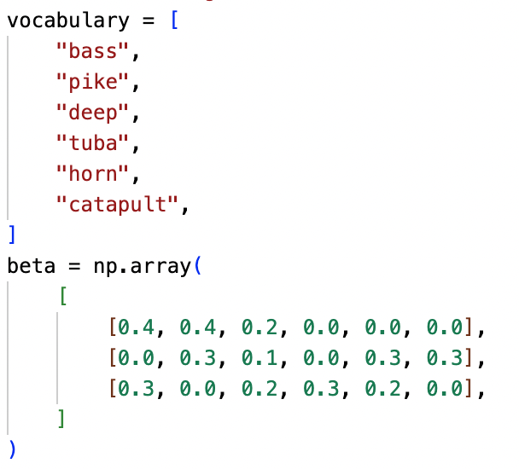

The inferred beta output is below:

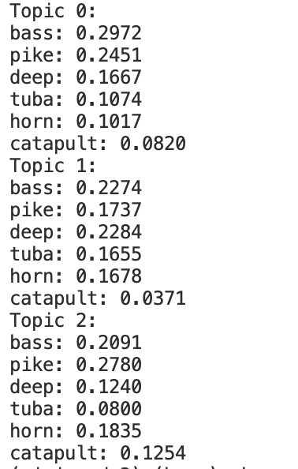

As the training process is unsupervised learning, the topic orders of inferred beta are not necessarily the same with the topic orders of input beta. From the above specific output, we could tell that the inferred beta’s topic 0 matched relatively well with the input beta’s topic 0 (first row) – with “bass” and “pike” being the highest frequency, and “tube”, “horn”, and “catapult” being the lowest frequency.

For the inferred beta’s topic 1, it seemed that the best match is the input beta’s topic 2 (third row). However, “pike” should have lower frequency and “tuba” should have higher frequency, and thus not a complete match.

For the inferred beta’s topic 2, it seemed that the best match is the input beta’s topic 1 (second row). However, “bass” should have lower frequency and “horn” and “catapult” should have higher frequency, and thus not a complete match.

I think the key reasons for the mismatch between input beta and inferred beta are because the corpus is relatively small and training data is limited, leading to limited accuracy of output. If we could enlarge the training data, I believe the trained output would be closer to the true topics distribution.