|  |
| --- |
|  |
| The Documentation |
| [Type the document subtitle] |
|  |
| **[Your Name]** |
| **[Pick the date]** |

[Type the abstract of the document here. The abstract is typically a short summary of the contents of the document. Type the abstract of the document here. The abstract is typically a short summary of the contents of the document.]

Table of Contents

[To update the table of contents, right click the message below and select Update Field (F9 on PC, ⌥⌘U on Mac).]

**No table of contents entries found.**

页面

页面树目录

index  
 接收协议  
 串口232/485端口配置  
 CAN总线端口配置  
 NET端口配置

index

接收协议

用户界面

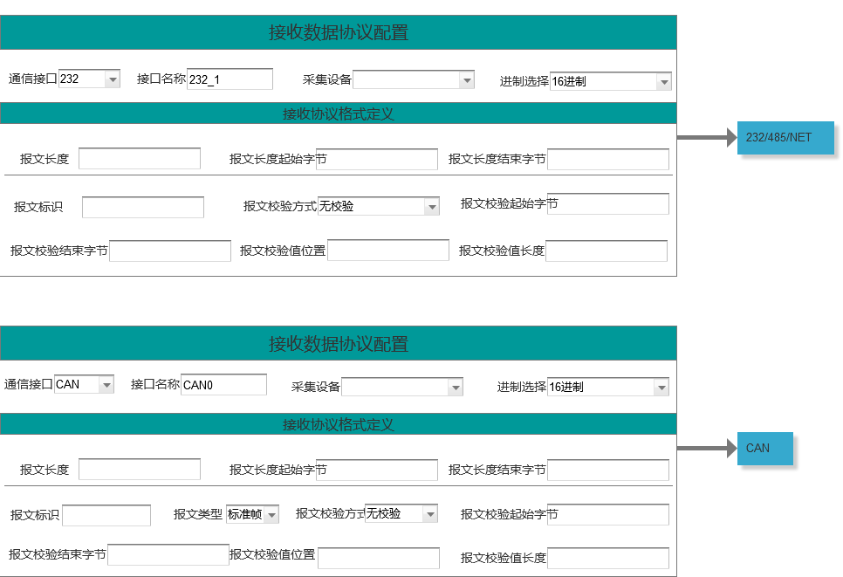

串口232/485端口配置

用户界面

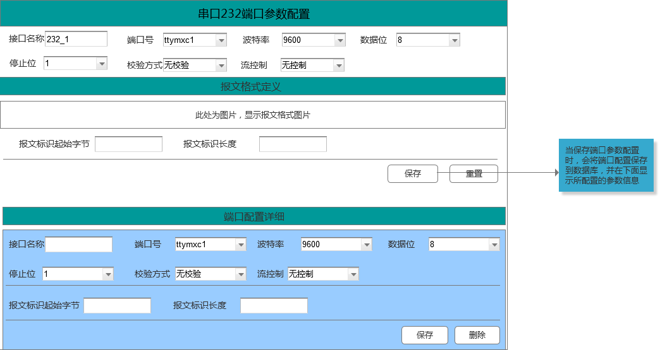

CAN总线端口配置

用户界面

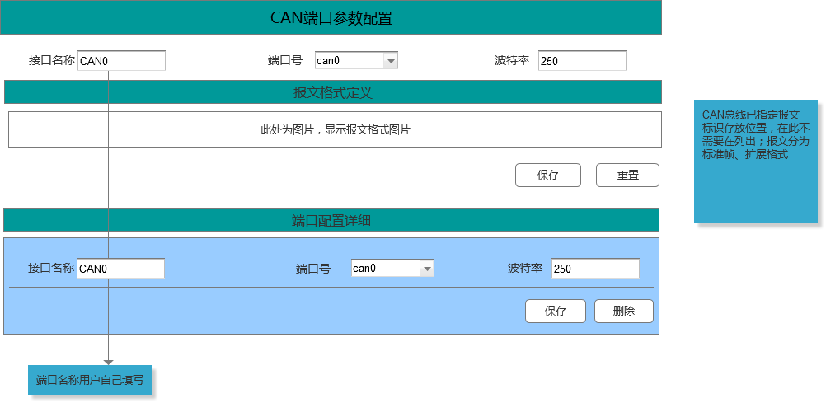

NET端口配置

用户界面

