2021年6月29日 Python基础 第三天作业

1. 正则表达式测试 1

字符串为MAC地址表内容: '166 54a2.74f7.0326 DYNAMIC Gi1/0/11'

代码：

import re  
  
vlan = 'VLAN ID'  
mac = 'MAC'  
type = 'Type'  
interface = 'Interface'  
str1 = '166 54a2.74f7.0326 DYNAMIC Gi1/0/11'  
re1 = re.match('(\d{1,4})\s+([0-9a-fA-F]{4}(\.[0-9a-fA-F]{4}){2})\s+([A-Z]{7})\s+(\w+.*\d)', str1).groups()  
  
  
print(f'{vlan:15}' + ':' + re1[0])  
print(f'{mac:15}' + ':' + re1[1])  
print(f'{type:15}' + ':' + re1[3])  
print(f'{interface:15}' + ':' + re1[4])

执行结果：

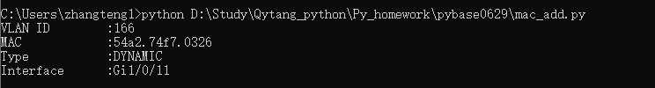

1. 正则表达式测试 2

字符串为ASA防火墙show conn（查看连接内容): 'TCP server 172.16.1.101:443 localserver 172.16.66.1:53710, idle 0:01:09, bytes 27575949, flags UIO'

代码：

import re  
  
str1 = 'TCP server 172.16.1.101:443 localserver 172.16.66.1:53710, idle 0:01:09, bytes 27575949, flags UIO'  
  
re_match = re.match(  
 '([A-Z]{3})\s+[a-z]{6}\s+(\d{1,3}.\d{1,3}.\d{1,3}.\d{1,3}:\d{1,5})\s+\w{11}\s+(\d{1,3}.\d{1,3}.\d{1,3}.\d{1,3}:\d{1,5}),\s+\w{4}\s+([0-2]:[0-2][0-3]:[0-5][0-9]),\s+\w{5}\s+(\d{8}),\s+\w{5}\s+([A-Z]{3})',  
 str1).groups()  
print(f'{"protcol":15}:' + re_match[0])  
print(f'{"server":15}:' + re_match[1])  
print(f'{"localserver":15}:' + re_match[2])  
print(f'{"idle":15}:' + re_match[3])  
print(f'{"bytes":15}:' + re_match[4])  
print(f'{"flags":15}:' + re_match[5])

打印结果：

