Python基础 第五天作业

1. 正则表达式练习：查看linux网关

代码：

import os  
import re  
  
str = '''  
Kernel IP routing table  
Destination Gateway Genmask Flags Metric Ref Use Iface  
0.0.0.0 192.168.13.254 0.0.0.0 UG 100 0 0 eth0  
192.168.13.0 0.0.0.0 255.255.255.0 U 100 0 0 eth0'''  
  
  
re1 = re.findall('\d{1,3}\.\d{1,3}\.\d{1,3}\.\d{1,3}',str)  
print('网关为：'+re1[1])

运行结果：



2、列表作业：L2是L1的排序（由小到大）

代码：

l1 = [4,5,7,1,3,9,0]  
l2 = sorted(l1)  
  
for i in range(len(l1)):  
 print(l1[i],l2[i])

运行结果：

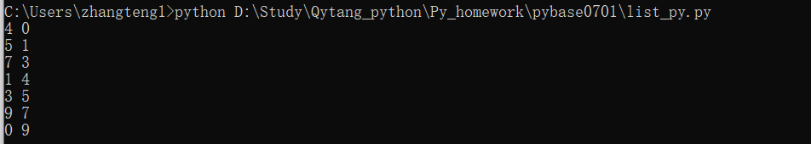

首先用os.popen执行linux命令ifconfig [你的网卡名]:如果你没有linux可以使用我下面提供的输出:

ens160: flags=4163<UP,BROADCAST,RUNNING,MULTICAST> mtu 1500

inet 172.16.66.166 netmask 255.255.255.0 broadcast 172.16.66.255

inet6 fe80::250:56ff:feab:59bd prefixlen 64 scopeid 0x20<link>

ether 00:50:56:ab:59:bd txqueuelen 1000 (Ethernet)

RX packets 174598769 bytes 1795658527217 (1.6 TiB)

RX errors 1 dropped 24662 overruns 0 frame 0

TX packets 51706604 bytes 41788673420 (38.9 GiB)

TX errors 0 dropped 0 overruns 0 carrier 0 collisions 0

然后用正则表达式找到IP，掩码，广播和MAC地址，紧接着通过一种假设找到网关IP地址[你可以有你的假设](网关的前三段来至于IP地址)，并且ping网关，测试是否可达

代码：

import re  
import os  
  
str ='''eth0: flags=4163<UP,BROADCAST,RUNNING,MULTICAST> mtu 1500  
 inet 192.168.13.29 netmask 255.255.255.0 broadcast 192.168.13.255  
 inet6 fe80::250:56ff:fe8b:8e82 prefixlen 64 scopeid 0x20<link>  
 ether 00:50:56:8b:8e:82 txqueuelen 1000 (Ethernet)  
 RX packets 213964305 bytes 870058624044 (810.3 GiB)  
 RX errors 0 dropped 3456 overruns 0 frame 0  
 TX packets 175417068 bytes 26985966902 (25.1 GiB)  
 TX errors 0 dropped 0 overruns 0 carrier 0 collisions 0'''  
  
  
  
  
ipv4_add = re.findall('\d{1,3}\.\d{1,3}\.\d{1,3}\.\d{1,3}',str)[0]  
netmask = re.findall('\d{1,3}\.\d{1,3}\.\d{1,3}\.\d{1,3}',str)[1]  
broadcast = re.findall('\d{1,3}\.\d{1,3}\.\d{1,3}\.\d{1,3}',str)[2]  
mac_add = re.findall('((([a-f0-9]{2}:){5})|(([a-f0-9]{2}-){5}))[a-f0-9]{2}',str)  
  
  
format_string = '{:<10}:{}'  
print(format_string.format('ipv4_add', ipv4_add))  
print(format_string.format('netmask', netmask))  
print(format_string.format('broadcast', broadcast))  
print(format_string.format('mac_add', mac_add[0][0][:-1]))  
  
ipv4_gw = '192.168.13.25'  
ping_result = os.popen('ping '+ ipv4_gw +' -c 1').read()  
re_ping_result = re.findall('(\d{1,3}\.\d{1,3}\.\d{1,3}\.\d{1,3})',  
 ping_result)  
print('\n我们假设网关IP地址为最后一位为254，因此网关IP地址为：'+ ipv4_gw +'\n')  
if re_ping_result:  
 print('网关可达！')  
else:  
 print('网关不可达！')

运行结果：

