Python基础 第六天作业

1. 字典课堂作业，把防火墙状态信息表存为字典!

代码：

import re  
#  
asa_conn = "TCP Student 192.168.189.167:32806 Teacher 137.78.5.128:65247, idle 0:00:00, bytes 74, flags UIO\n TCP Student 192.168.189.167:80 Teacher 137.78.5.128:65233, idle 0:00:03, bytes 334516, flags UIO"  
asa_dict = {}  
re_result = re.match('\w{3}\s+\w{7}\s+(\d{1,3}\.\d{1,3}\.\d{1,3}\.\d{1,3}):(\d{5})\s+\w{7}\s+(\d{1,3}\.\d{1,3}\.\d{1,3}\.\d{1,3}):(\d{5}).*bytes\s+(\d+).*flags\s+(\w{3})\\n\s+\w{3}\s+\w{7}\s+(\d{1,3}\.\d{1,3}\.\d{1,3}\.\d{1,3}):(\d{1,5})\s+\w{7}\s+(\d{1,3}\.\d{1,3}\.\d{1,3}\.\d{1,3}):(\d{5}).*bytes\s+(\d+).*flags\s+(\w*)\s*',asa_conn).groups()  
key1 = re_result[0],re_result[1],re_result[2],re_result[3]  
val1 = re_result[4],re_result[5]  
asa_dict[key1]=val1  
key2 = re_result[6],re_result[7],re_result[8],re_result[9]  
val2 = re_result[11],re_result[10]  
asa_dict[key1]=val1  
asa_dict[key2]=val2  
print('\n\n打印字典\n')  
print(asa_dict)  
print('\n\n格式化打印输出\n')  
src='src'  
src_ip='src_ip'  
dst = 'dst'  
dst_ip = 'dst_ip'  
bytes_name = 'bytes_name'  
flags = 'flags'  
format_str1 =('%5s : %-20s |%10s : %-10s |%10s : %-10s |%10s : %-10s|' % ('src',key1[0],'src_p',key1[1],'dst',key1[2],'dst_p',key1[3]))  
format_str2 =('%7s : %-20s |%10s : %-10s' % ('bytes',val1[0],'flags',val1[1]))  
format_str3 =('%5s : %-20s |%10s : %-10s |%10s : %-10s |%10s : %-10s|' % ('src',key2[0],'src_p',key2[1],'dst',key2[2],'dst_p',key2[3]))  
format_str4 =('%7s : %-20s |%10s : %-10s' % ('bytes',val2[0],'flags',val2[1]))  
print(format_str1)  
print(format_str2)  
print('='*110)  
print(format_str1)  
print(format_str2)  
print('='*110)

运行结果：

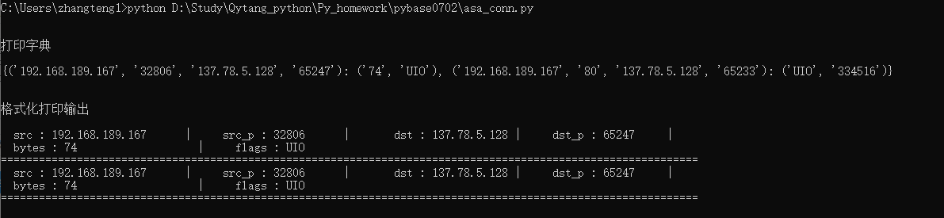

1. 接口排序

代码：

port_list = ['eth 1/101/1/42','eth 1/101/1/26','eth 1/101/1/23','eth 1/101/1/7','eth 1/101/2/46','eth 1/101/1/34','eth 1/101/1/18','eth 1/101/1/13','eth 1/101/1/32','eth 1/101/1/25','eth 1/101/1/45','eth 1/101/2/8']  
print(sorted(port_list,key=lambda port:port[1:]))

运行结果：

