Python基础 第十四天作业

1. 把五天前的日期和时间，存入一个用当前日期和时间命名的文件中

代码：

import datetime  
import os  
import time  
  
now = datetime.datetime.now()  
now_format = now.strftime('%Y-%m-%d_%H-%M-%S')  
str_now = str(now_format).replace(' ', '_').split('.')[0].replace(':', '-')  
file_name = 'save_fivedayago_time_' + now_format + '.txt'  
file = open(file_name, 'w')  
file.close()  
before_5day = now - datetime.timedelta(days=5)  
str_before_five = str(before_5day).replace(' ', '_').split('.')[0].replace(':', '-')  
os.rename('save_fivedayago_time_' + str_now + '.txt', 'save_fivedayago_time_' + str_before_five + '.txt')

运行结果：

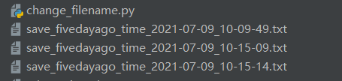

2. 为SSH登录脚本配置选项

代码：

from argparse import ArgumentParser  
import paramiko  
  
def ssh_cli(ip,username,password,port=22,cmd='ls'):  
 ssh = paramiko.SSHClient()  
 ssh.load_system_host_keys()  
 ssh.set_missing_host_key_policy(paramiko.AutoAddPolicy())  
 ssh.connect(ip,port=port,username=username,password=password,timeout=5,compress=True)  
 stdin,stdout,stderr = ssh.exec_command(cmd)  
 x = stdout.read().decode()  
 return x  
  
if __name__ == '__main__':  
 usage = 'usage:python Simple_SSH_Client -i ipaddr -u username -p password -c command'  
 parser = ArgumentParser(usage=usage)  
 parser.add_argument('-i','--ipaddress',dest='ipaddress',help='IP ADDR SSH Server',default='1.1.1.1',type=str)  
 parser.add_argument('-u','--username',dest='username',help='SSH Username',default='root',type=str)  
 parser.add_argument('-p','--password',dest='password',help='SSH Password',default='123456',type=str)  
 parser.add_argument('-c','--command',dest='command',help='Shell Command',default='ls',type=str)  
  
#  
 args = parser.parse_args()  
 ssh_rev=ssh_cli(args.ipaddress,args.username,args.password,cmd=args.command)  
 print(ssh_rev)

运行结果：



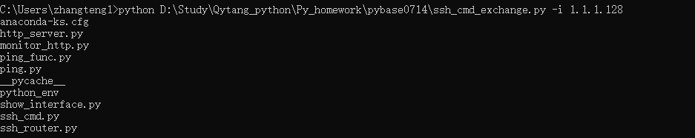

3. 练习使用Pyinstaller，把上一题的SSH小程序制作成为exe的可执行程序

