Python基础 第十五天作业

1. SQLlite练习 "一个学员信息查询系统

代码：

import _sqlite3  
  
homework_dict = [{'姓名':'学员1','年龄':33,'作业数':1},  
 {'姓名':'学员2','年龄':35,'作业数':5},  
 {'姓名':'学员3','年龄':22,'作业数':22},]  
  
conn = _sqlite3.connect('homeworkdb.sqlite')  
cursor = conn.cursor()  
#  
# cursor.execute('create table homework_info (姓名 varchar(40),年龄 int,作业数 int)')  
# cursor.execute('insert into homework_info(姓名,年龄,作业数) values("学员1",33,1)')  
# cursor.execute('insert into homework_info(姓名,年龄,作业数) values("学员2",35,5)')  
# cursor.execute('insert into homework_info(姓名,年龄,作业数) values("学员3",22,22)')  
# for teacher in homework_dict:  
# name = teacher['姓名']  
# age = teacher['年龄']  
# homework = teacher['作业数']  
# conn.commit()  
  
user_notify = '''  
请输入查询选项：  
输入1 ：查询整个数据库  
输入2 ：基于姓名查询  
输入3 ：基于年龄查询  
输入4 ：基于作业数查询  
输入0 ：退出  
'''  
while True:  
 print(user_notify)  
 user_input = input('请选择：')  
 if user_input == '1':  
 cursor.execute('select * from homework_info')  
 results = cursor.fetchall()  
 for teacher in results :  
 print(f'学员姓名：{teacher[0]} 学员年龄：{teacher[1]} 学员作业数:{teacher[2]}')  
 elif user_input =='2':  
 user_sn = input('请输入学员姓名：')  
 if not user_sn:  
 continue  
 cursor.execute(f'select * from homework_info where 姓名="{user_sn}"')  
 results =cursor.fetchall()  
 if not results:  
 print('学员信息未找到！')  
 for teacher in results:  
 print(f'学员姓名：{teacher[0]} 学员年龄：{teacher[1]} 学员作业数:{teacher[2]}')  
 elif user_input=='3':  
 user_age = input('搜索大于输入年龄的学员，请输入学员年龄：')  
 if not user_age:  
 continue  
 cursor.execute(f'select * from homework_info where 年龄>"{user_age}"')  
 results = cursor.fetchall()  
 if not results:  
 print('学员信息未找到！')  
 for teacher in results:  
 print(f'学员姓名：{teacher[0]} 学员年龄：{teacher[1]} 学员作业数:{teacher[2]}')  
 elif user_input=='4':  
 user_homework = input('搜索大于输入作业数的学员，请输入作业数：')  
 if not user_homework:  
 continue  
 cursor.execute(f'select * from homework_info where 作业数>"{user_homework}"')  
 results = cursor.fetchall()  
 if not results:  
 print('学员信息未找到！')  
 for teacher in results:  
 print(f'学员姓名：{teacher[0]} 学员年龄：{teacher[1]} 学员作业数:{teacher[2]}')  
 elif user_input=='0':  
 break  
 else:  
 print('输入错误，请重试')

运行结果：

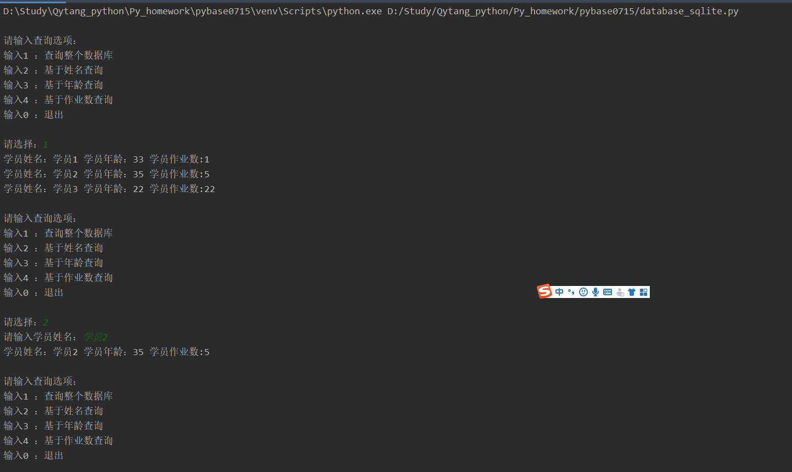

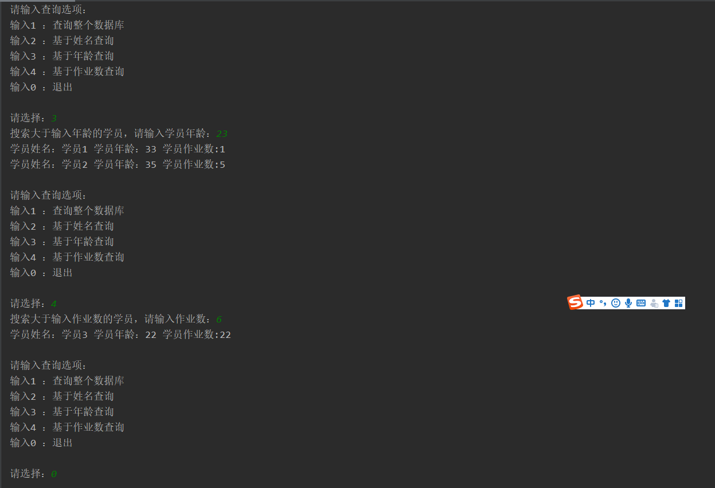

2. 安装SQLITE图形化工具DB Browser来查询数据库

