**经典网络协议 第四天作业**

1. **安装matplotlib模块并测试饼状图**

**解决matplotlib模块,linux环境中文乱码问题**

* 1. 首先Windows没有乱码问题!不需要解决!
  2. 如何获取{**路径**}?

import matplotlib  
{**路径**} = matplotlib.matplotlib_fname()

* 1. 在Windows系统搜索找到simhei.ttf文件
  2. 把simhei.ttf文件拷贝到linux路径"{**路径** 去掉'/matplotlibrc'}/fonts/ttf"目录
  3. 删除"~/.cache/matplotlib"的缓冲目录
  4. {修改"**路径**"}

font.family : sans-serif  
font.sans-serif : **SimHei**, Bitstream Vera Sans, Lucida Grande, Verdana, Geneva, Lucid, Arial, Helvetica, Avant Garde, sans-serif  
axes.unicode_minus，将True改为False，作用就是解决负号'-'显示为方块的问题

* 1. 重启一下Linux和PyCharm进行测试

**原始参考文档:**

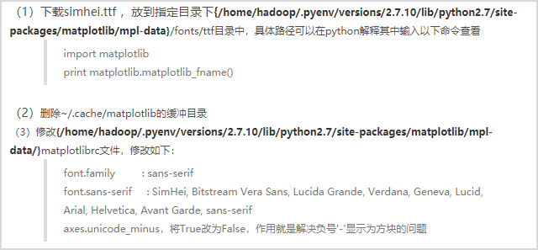

**代码:**

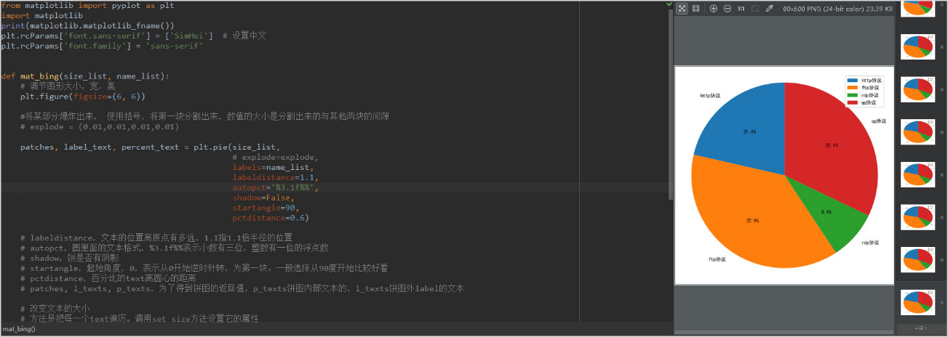 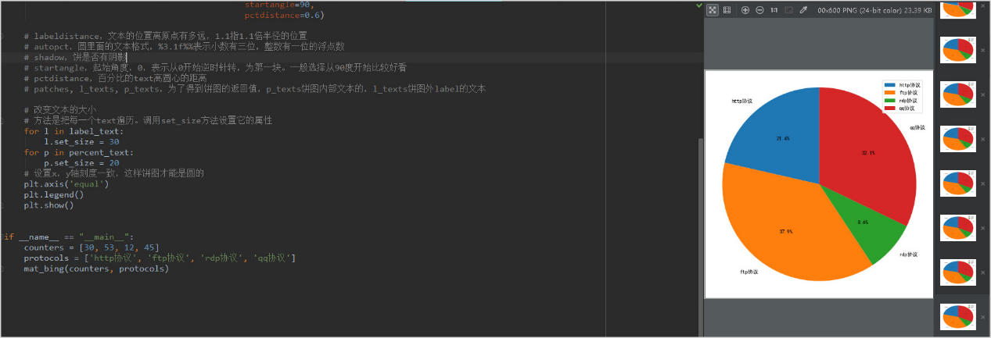

代码：

1. 安装matplotlib模块并测试饼状图

import matplotlib  
from matplotlib import pyplot as plt  
  
print(matplotlib.matplotlib_fname())  
plt.rcParams['font.sans-serif'] = ['SimHei']  
plt.rcParams['font.family'] = 'sans-serif'  
def mat_bing(size_list,name_list):  
 plt.figure(figsize =(6, 6))  
 patches,label_text,percent_test = plt.pie(size_list,  
 labels=name_list,  
 labeldistance=1.1,  
 autopct = '%3.1f%%',  
 shadow = False,  
 startangle=90,  
 pctdistance=0.6)  
 for l in label_text:  
 l.set_size = 30  
 for p in percent_test:  
 l.set_size = 20  
 plt.axis('equal')  
 plt.legend()  
 plt.show()  
  
if __name__ == '__main__':  
 counters = [30,53,12,45]  
 protocols = ['http协议','ftp协议','rdp协议','qq协议']  
 mat_bing(counters,protocols)

运行结果：

