# Proj1phase2 Report

Zhang Tianjia (20681874)

## Introduction

I apply the minimum snap trajectory method to covert the paths to trajectories for the UAV to follow. The method is based on the minimum optimization problems:



Where  is the vector including all the coefficients of the 7th-order polynomials which can represent each segment trajectory.  has  rows, which represent waypoint position constraints, derivative continuity constraints(position, velocity, acceleration and jerk), starting point and ending point constraints, respectively.

## Result

The PD parameters of the controller remain the same as those in Proj1phase1.



**The figure for the path1 and path2 is**



1. (b)

**Figure 1: Path and state of flight following path 1(a) and path 2(b)**

 

Path 3 and path 4 are generated by myself. Path 3 is derived from path 2 with variance in the z-axis direction. Path 4 is a heart line.



1. (b)

**Figure 2: Path and state of flight following path 3(a) and path 4(b)**

 

## Analysis

The controller with the previous determined parameters has good performance on the four paths. From the simulation of path 2, we can see that the minimum snap method can smooth the path because the actual path is more like a circle than a rectangle. The comparation in the simulation of path 2 between minimum snap method and piecewise polynomial method is shown below.

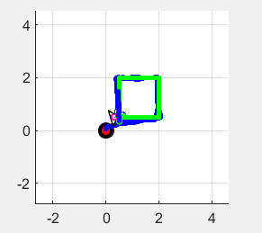 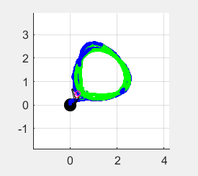

1. Piecewise polynomial method (b) minimum snap method

**Figure 3: The comparation between the two method in following path 2**