Howdy!

I am Treefish from Texas. The creative aspect of web design brings me to the Nanodegree program.

I have been a microbiological researcher and a college instructor. I hope to hone skills to present contents in an engaging way to students or other audiences. For example, I tried to write [a song about Kawasaki Disease](https://soundcloud.com/zhangtreefish/kawasaki-disease4-21) to engage my microbiology students and had quite some success, and so I thought what if I went further and created cartoons. I found that I could only do very limited things in places such as GoAnimate without actually learning programming. I prepared myself by taking the programming courses in Kahn Academy, and finally am here to start this fascinating journey with you guys.

* 87 views at Kawasaki Disease.
* Once you have a Google+ account, request to join our [Front-End Web Developer Nanodegree Community](https://plus.google.com/communities/117736402989322525566).
* Check out [Participating in Hangouts On Air](https://docs.google.com/document/d/1YrKy5zjQNdyDFRMDaIne_0UAq8MVls1Kv3_hf56B0Zg/pub) to learn how to attend office hours and other events.
* 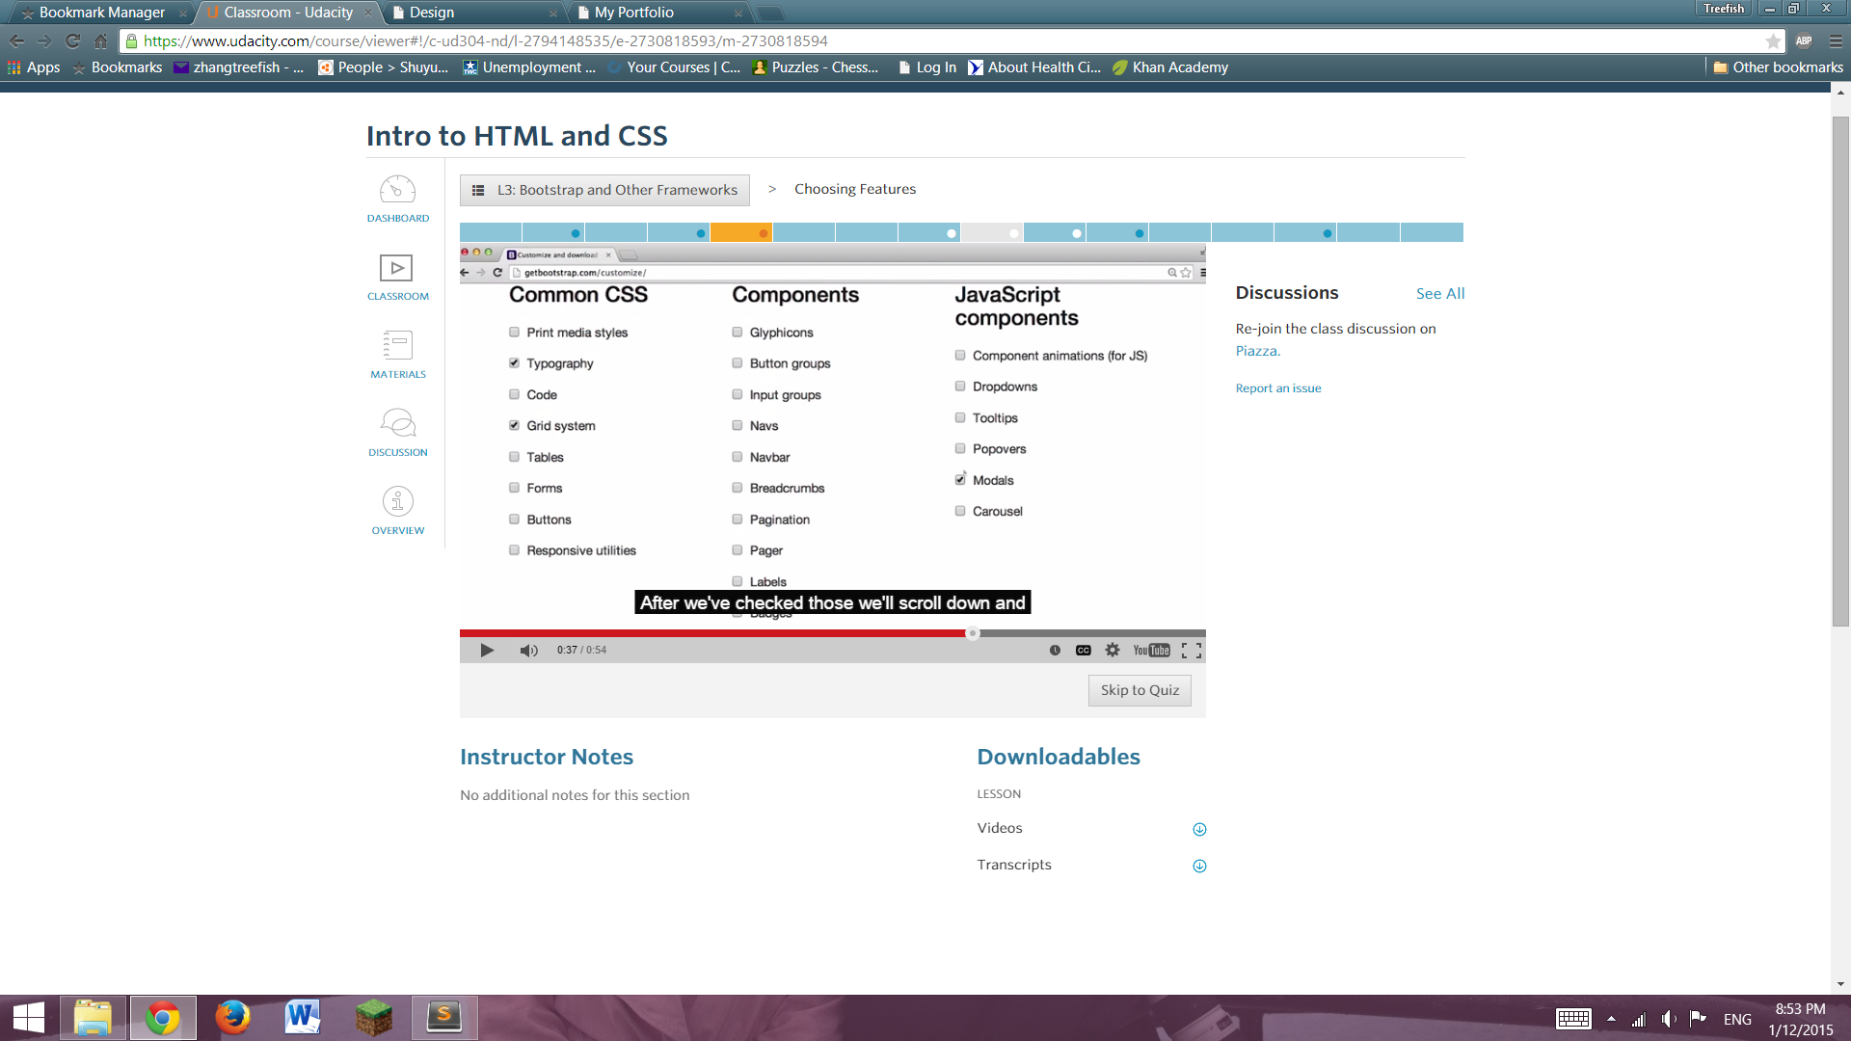

GetBootstrap.com/customize page; The attribute for “link” is “href”, and the attribute for “script” is “src”.

1/14/15: in Window Command prompt, do cd; the FC oldfile newfile;