**Codeforces Round #299 (Div. 2)**

A. Tavas and Nafas

time limit per test

1 second

memory limit per test

256 megabytes

input

standard input

output

standard output

Today Tavas got his test result as an integer score and he wants to share it with his girlfriend, Nafas.

His phone operating system is Tavdroid, and its keyboard doesn't have any digits! He wants to share his score with Nafas via text, so he has no choice but to send this number using words.



He ate coffee mix without water again, so right now he's really messed up and can't think.

Your task is to help him by telling him what to type.

**Input**

The first and only line of input contains an integer *s* (0 ≤ *s* ≤ 99), Tavas's score.

**Output**

In the first and only line of output, print a single string consisting only from English lowercase letters and hyphens ('-'). Do not use spaces.

**Sample test(s)**

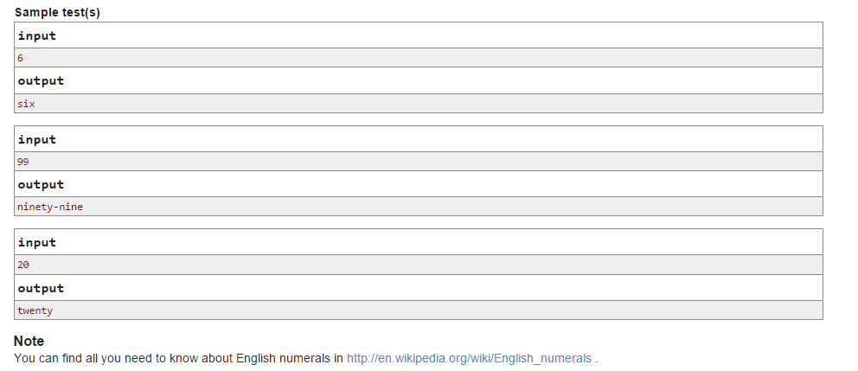

B. Tavas and SaDDas

time limit per test

1 second

memory limit per test

256 megabytes

input

standard input

output

standard output

*Once again Tavas started eating coffee mix without water! Keione told him that it smells awful, but he didn't stop doing that. That's why Keione told his smart friend, SaDDas to punish him! SaDDas took Tavas' headphones and told him: "If you solve the following problem, I'll return it to you."*



The problem is:

You are given a *lucky number* *n*. *Lucky numbers* are the positive integers whose decimal representations contain only the lucky digits 4 and 7. For example, numbers **47**, **744**, **4** are lucky and **5**, **17**, **467** are not.

If we sort all lucky numbers in increasing order, what's the 1-based index of *n*?

Tavas is not as smart as SaDDas, so he asked you to do him a favor and solve this problem so he can have his headphones back.

**Input**

The first and only line of input contains a lucky number *n* (1 ≤ *n* ≤ 109).

**Output**

Print the index of *n* among all lucky numbers.

**Sample test(s)**

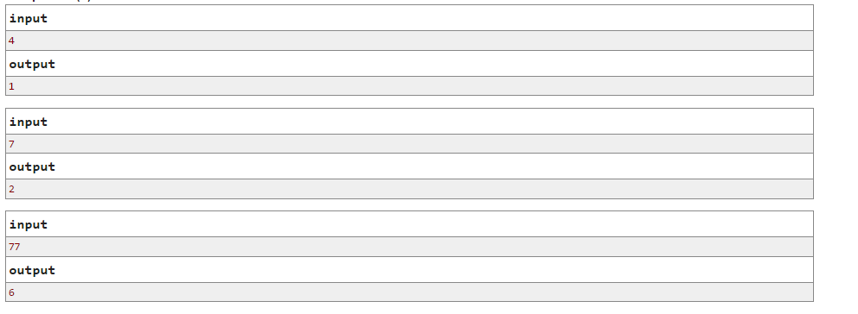

C. Tavas and Karafs

time limit per test

2 seconds

memory limit per test

256 megabytes

input

standard input

output

standard output

*Karafs is some kind of vegetable in shape of an 1 × h rectangle. Tavaspolis people love Karafs and they use Karafs in almost any kind of food. Tavas, himself, is crazy about Karafs.*



Each Karafs has a positive integer height. Tavas has an infinite **1-based** sequence of Karafses. The height of the *i*-th Karafs is *si* = *A* + (*i* - 1) × *B*.

For a given *m*, let's define an *m*-bite operation as decreasing the height of at most *m* distinct not eaten Karafses by 1. Karafs is considered as eaten when its height becomes zero.

Now SaDDas asks you *n* queries. In each query he gives you numbers *l*, *t* and *m* and you should find the largest number *r* such that *l* ≤ *r* and sequence *sl*, *sl*+ 1, ..., *sr* can be eaten **by performing *m*-bite no more than *t* times** or print -1 if there is no such number *r*.

**Input**

The first line of input contains three integers *A*, *B* and *n* (1 ≤ *A*, *B* ≤ 106, 1 ≤ *n* ≤ 105).

Next *n* lines contain information about queries. *i*-th line contains integers *l*, *t*, *m* (1 ≤ *l*, *t*, *m* ≤ 106) for *i*-th query.

**Output**

For each query, print its answer in a single line.

**Sample test(s)**

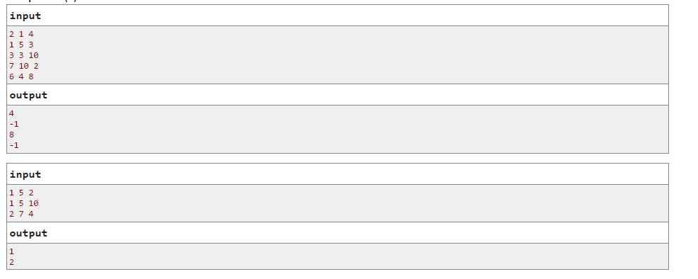

D. Tavas and Malekas

time limit per test

2 seconds

memory limit per test

256 megabytes

input

standard input

output

standard output

*Tavas is a strange creature. Usually "zzz" comes out of people's mouth while sleeping, but string s of length n comes out from Tavas' mouth instead.*



Today Tavas fell asleep in Malekas' place. While he was sleeping, Malekas did a little process on *s*. Malekas has a favorite string *p*. He determined all positions *x*1 < *x*2 < ... < *xk* where *p* matches *s*. More formally, for each *xi* (1 ≤ *i* ≤ *k*) he condition *sxisxi* + 1... *sxi* + |*p*| - 1 = *p* is fullfilled.

Then Malekas wrote down one of subsequences of *x*1, *x*2, ... *xk* (possibly, he didn't write anything) on a piece of paper. Here a sequence *b* is a subsequence of sequence *a* if and only if we can turn *a* into *b* by removing some of its elements (maybe no one of them or all).

After Tavas woke up, Malekas told him everything. He couldn't remember string *s*, but he knew that both *p* and *s* only contains lowercase English letters and also he had the subsequence he had written on that piece of paper.

Tavas wonders, what is the number of possible values of *s*? He asked SaDDas, but he wasn't smart enough to solve this. So, Tavas asked you to calculate this number for him.

Answer can be very large, so Tavas wants you to print the answer modulo 109 + 7.

**Input**

The first line contains two integers *n* and *m*, the length of *s* and the length of the subsequence Malekas wrote down (1 ≤ *n* ≤ 106 and 0 ≤ *m* ≤ *n* - |*p*| + 1).

The second line contains string *p* (1 ≤ |*p*| ≤ *n*).

The next line contains *m* space separated integers *y*1, *y*2, ..., *ym*, Malekas' subsequence (1 ≤ *y*1 < *y*2 < ... < *ym* ≤ *n* - |*p*| + 1).

**Output**

In a single line print the answer modulo 1000 000 007.

**Sample test(s)**

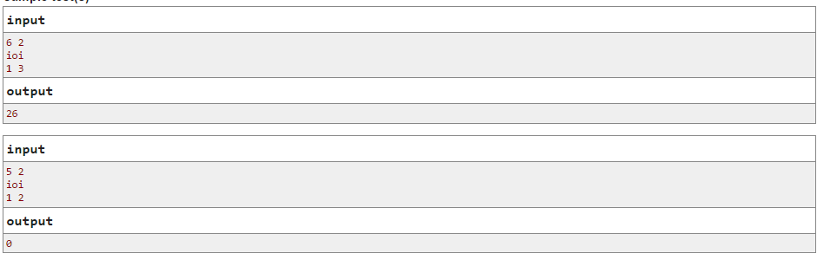

**Note**

In the first sample test all strings of form "ioioi?" where the question mark replaces arbitrary English letter satisfy.

Here |*x*| denotes the length of string x.

Please note that it's possible that there is no such string (answer is 0).

E. Tavas and Pashmaks

time limit per test

1 second

memory limit per test

256 megabytes

input

standard input

output

standard output

*Tavas is a cheerleader in the new sports competition named "Pashmaks".*



This competition consists of two part: swimming and then running. People will immediately start running *R* meters after they finished swimming exactly *S* meters. A winner is a such person that nobody else finishes running before him/her (there may be more than one winner).

Before the match starts, Tavas knows that there are *n* competitors registered for the match. Also, he knows that *i*-th person's swimming speed is *si*meters per second and his/her running speed is *ri* meters per second. Unfortunately, he doesn't know the values of *R* and *S*, but he knows that they are real numbers greater than 0.

As a cheerleader, Tavas wants to know who to cheer up. So, he wants to know all people that might win. We consider a competitor might win if and only if there are some values of *R* and *S* such that with these values, (s)he will be a winner.

Tavas isn't really familiar with programming, so he asked you to help him.

**Input**

The first line of input contains a single integer *n* (1 ≤ *n* ≤ 2 × 105).

The next *n* lines contain the details of competitors. *i*-th line contains two integers *si* and *ri* (1 ≤ *si*, *ri* ≤ 104).

**Output**

In the first and the only line of output, print a sequence of numbers of possible winners in increasing order.

**Sample test(s)**

