*Project #6 DNSCAN*

**Team: 1. Zhangtuxin 1155101156 2.Huang anheng 1155105238 3. Sun haopeng 1155105207**

**Goal**

Implement the DBSCAN algorithm discussed in Lecture 8.

**Dataset**

A txt format file which contains (x, y) value tuples represent the x and y coordinates of data points. The visualization of those data points are shown in the Figure 1.

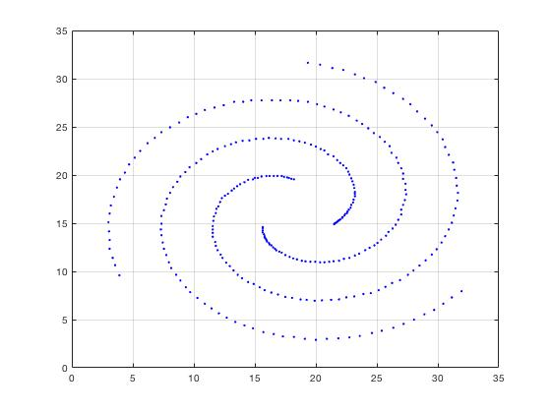

Figure Original Data Points

**Task**

Partition the dataset into 3 clusters.

**Method**

In our project, we use DBSCAN algorithm to cluster those data points. The details of algorithm are same as what we have learned from the lecture.

The challenge is how to exactly get 3 clusters instead of less or more. We try to use two for-loops to change the parameters with a reasonable range. And this method does work.

The source files are included in the submission files.

**Deliverables**

As shown in the Figure 2, we successfully divide those data points into 3 clusters.

Cluster 1: Pink, Cluster 2: Red, Cluster 3:Blue

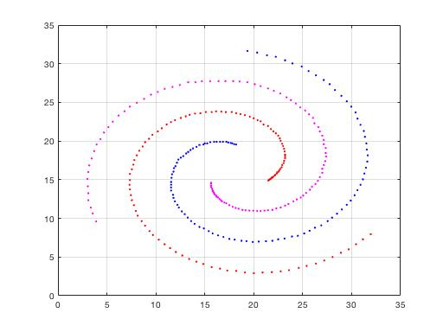

Figure Clustering Result