Q1.

Q2.

1. Equations for calculating 3D point cloud (camera frame) from a depth image

$$X_{ci}=\frac{Z_{ci}}{f_{x}}\left(X_{pixel}-cx\right); Y_{ci}=\frac{Z_{ci}}{f_{y}}\left(Y_{pixel}-cy\right); Z_{ci}=D$$

Where $f_{x}$ and $f_{y}$ are the focal lengths, $cx$ and $cy$ are the principal point.

1. Equations for transforming the obtained point cloud to the world coordinate frame

$$\left[\begin{matrix}X_{S} \\ \begin{matrix}Y_{S} \\ Z_{S} \\ 1\end{matrix}\end{matrix}\right]= T_{C,R}^{-1} \left[\begin{matrix}X_{ci} \\ \begin{matrix}Y_{ci} \\ Z_{ci} \\ 1\end{matrix}\end{matrix}\right]$$

Where $T_{C,R}^{-1}$ is the inverse of the extrinsic matrix.

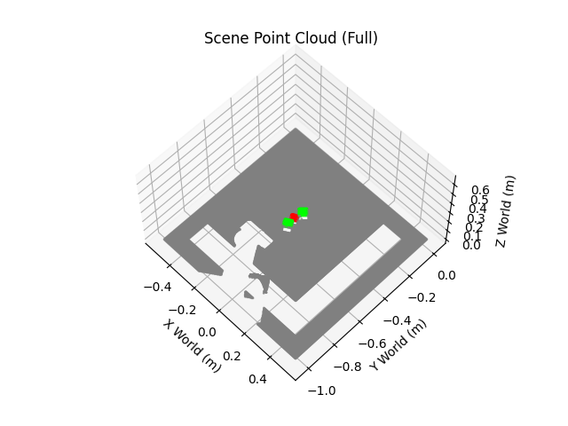

Q3.