Neo4j新建BOM语句

create(a1:BOM{name:'主BOM'})

create(a2:BOM{name:'整体BOM'})

create(a3:BOM{name:'生产BOM'})

create(a4:BOM{name:'原料BOM'})

create(b1:BOM1{name:'桌面'})

create(b2:BOM1{name:'四条腿'})

create(b3:BOM1{name:'制造桌面木板'})

create(b4:BOM1{name:'制造桌面的木框'})

create(b5:BOM2{name:'大木板'})

create(b6:BOM2{name:'木条类型1'})

create(b7:BOM2{name:'木条类型2'})

create(b8:BOM2{name:'钉子和胶水'})

create(a1)<-[:BELONGS_TO]-(a2)

create(a1)<-[:BELONGS_TO]-(a3)

create(a1)<-[:BELONGS_TO]-(a4)

create(a3)<-[:BELONGS_TO]-(b1)

create(a3)<-[:BELONGS_TO]-(b2)

create(b1)<-[:BELONGS_TO]-(b3)

create(b1)<-[:BELONGS_TO]-(b4)

create(b3)<-[:BELONGS_TO]-(b5)

create(b4)<-[:BELONGS_TO]-(b6)

create(b2)<-[:BELONGS_TO]-(b7)

create(a2)<-[:BELONGS_TO]-(a3)

create(a2)<-[:BELONGS_TO]-(b8)

create(a4)<-[:BELONGS_TO]-(b5)

create(a4)<-[:BELONGS_TO]-(b6)

create(a4)<-[:BELONGS_TO]-(b7)

create(a4)<-[:BELONGS_TO]-(b8)

1. 新建完成输入:match p=(a:BOM{name:'主BOM'})<-[:BELONGS_TO*]-() return p

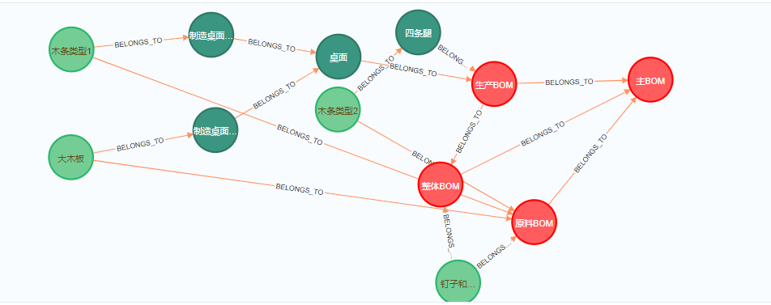

1. 只是查询整体BOM:match p=(a:BOM{name:'整体BOM'})<-[:BELONGS_TO*]-() return p

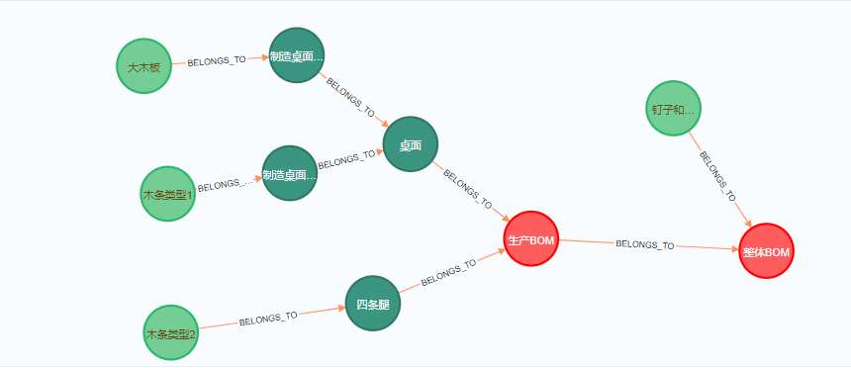

3.只是查询生产BOM：match p=(a:BOM{name:'生产BOM'})<-[:BELONGS_TO*]-() return p

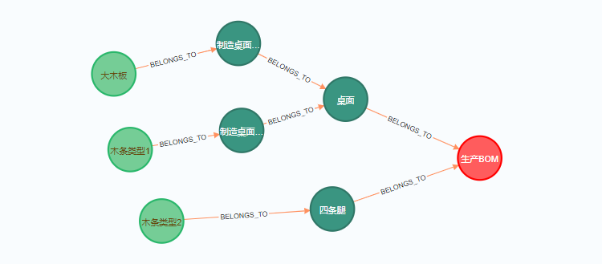4.只是查询原料BOM：match p=(a:BOM{name:'原料BOM'})<-[:BELONGS_TO*]-() return p

